XBRL GL Next Taxonomy Framework

— Part 2: XBRL 2.1 palette taxonomy
Document status: Draft — For Collaborative Review
Author: Nobuyuki SAMBUICHI
Role: Advisor to XBRL Japan
Project: XBRL GL Next
Distribution: Private project repository — invited participants only
This document is a draft under development by Nobuyuki SAMBUICHI, Advisor to XBRL Japan, for collaborative review within the XBRL GL Next project. It is shared through a private GitHub repository with invited project participants. It has not been approved or endorsed as an official specification by XBRL Japan, XBRL Europe, XBRL International, or any other organization.
Copyright and license terms under review.

Current design baseline for collaborative review
The following statements define the current PoC baseline used when interpreting this draft. Earlier text that describes an official publication, a final contract, or an unregistered artefact is superseded by this baseline for the collaborative review.
- Semantic model: The semantic model consists only of the Foundational Semantic Model (FSM), Business Semantic Model (BSM), and Logical Hierarchical Model (LHM). Their current PoC column contracts contain 14, 15, and 17 columns respectively. The BSM does not contain an element column.
- LHM: The Logical Hierarchical Model represents the complete logical hierarchy for the target domain and may contain GL, Sales, AR, AP, and other modules. It is the final layer of the semantic model.
- Syntax binding and HMD: A Hierarchical Model Definition (HMD) is introduced only for syntax binding. It is a document structure derived from a specified root Class in the LHM and its reachable properties; it is not a semantic-model layer or an alias for the LHM. For example, a Sales Invoice HMD is derived from the Sales Invoice Class in the LHM. XSD, linkbases, JSON metadata, and CSV layouts are syntax-binding artefacts. The proposed semantic-binding and syntax-binding sheets are provisional proposals subject to PoC implementation and collaborative review, and are not final contracts.
- Artefact status: The taxonomy dated 2026-12-31 is a technical validation baseline, not an official release. Modules, profiles, registries, taxonomy packages, and other artefacts not registered in the private repository are planned, prototype, or not yet registered as applicable.
Repository version: private collaborative review draft.
Editors: SAMBUICHI, Nobuyuki
Contributors: invited project participants (individual names not yet confirmed for publication).

Status
This document is a draft under development by Nobuyuki SAMBUICHI, Advisor to XBRL Japan, for collaborative review within the XBRL GL Next project. It is shared through a private GitHub repository with invited project participants. It has not been approved or endorsed as an official specification by XBRL Japan, XBRL Europe, XBRL International, or any other organization.

Abstract
This document defines Part 2 of the XBRL GL Next Taxonomy Framework specification. Part 2 specifies the serialisation-specific rules and artefacts required to represent the XBRL GL semantic model using XBRL 2.1 tuple-based XBRL XML. It defines the palette taxonomy approach used to assemble modular content models into a deterministic entry point (profile), and the associated schema and linkbase conventions required for validation and interoperability. Part 2 is intended to be used together with Part 1 (general technical and modelling rules).
Table of Contents
Current design baseline for collaborative review 1
Status 1
Abstract 2
1 Language independence 4
2 Introduction 4
2.1 Scope of this document 4
2.2 Terminology and document conventions 4
2.3 Relationship to Parts 1 and 3 4
3 Requirements and motivation 4
3.1 Baseline: 2015 palette taxonomy and extension approach 5
3.2 Motivation: systematic cross-jurisdiction comparability and shared semantics 5
3.3 Requirements introduced/strengthened by this Part 5
4 Modules and Profiles 7
4.1 Common business-domain modules for granular reporting 7
4.2 Module root elements 7
5 Palette taxonomy 8
5.1 Purpose 8
5.2 XBRL 2.1 / XML realisation (palette schema) 8
5.2.1 Palette Entry Point Selection 9
5.2.2 Palette for Accounting Ledger 10
5.2.3 Palette for Business Transaction 12
5.3 Palette principle (modular selection) 15
5.4 Relationship to extensions and the aligned pool 15
5.5 Tuple content-model specialisation and extension 15
5.6 Content models 15
6 How to create extensions within the XBRL GL Next Taxonomy Framework 16
6.1 Public extensions including aligned extensions 16
6.2 Private extensions for distinct or local use 17
Appendix A (illustrative) Extending the Tuple-Based (XBRL XML) Taxonomy 18
A.1 Purpose and scope 18
A.2 Files and roles in the tuple-based package 18
A.3 Recommended extension pattern 18
A.3.1 Create an extension schema (do not edit the pool) 18
A.3.2 Extend structures using xs:extension (preferred) 18
A.3.3 Assemble the extension in the profile schema 19
A.4 Restrictions and constraints in tuple-based taxonomies 19
A.5 Checklist for tuple-based extension packages 19
A.6 Example 19
A.6.1 cor-party-pool.xsd 19
A.6.2 cor-party-pool.xsd 20
Appendix B References 23
Appendix C (illustrative) Intellectual property status 24
Appendix D (illustrative) Document history 25
Appendix E (illustrative) Errata corrections in this document 26

1 Language independence
This collaborative review draft is written in English and the preferred spelling convention is UK English.

2 Introduction

2.1 Scope of this document
This document specifies requirements for the XBRL 2.1 palette taxonomy realisation of the XBRL GL taxonomy framework, including:
- the structure and naming of tuple-based taxonomy modules and their compiled content models;
- palette taxonomy entry points that assemble required and optional modules into a declared profile;
- the use of xs:import for compiled tuple content models and xs:include for anchor-point definition schemas used by linkbases;
- linkbase requirements (including label, reference, and presentation) and the anchor-point mechanisms required to support them in a modular palette architecture;
- validation expectations for a declared profile, including which module combinations are permitted and how profile constraints are enforced in tuple-based form; and
- conformance requirements for taxonomy packages and instance documents that claim compliance with this Part.
This document does not define jurisdiction-specific filing rules, authority-specific submission interfaces, or operational exchange procedures. It does not define OIM-based serialisations (xBRL-CSV or xBRL-JSON), which are specified in Part 3.

2.2 Terminology and document conventions
The key words "MUST", "MUST NOT", "REQUIRED", "MUST", "MUST NOT", "SHOULD", "SHOULD NOT", "RECOMMENDED", "MAY", and "OPTIONAL" in this document are to be interpreted as described in RFC 2119.
Illustrative examples and counterexamples (if provided) are explicitly marked. Italics are used for rhetorical emphasis only and do not convey any special conformance meaning.

2.3 Relationship to Parts 1 and 3
This Part 2 defines serialisation rules for XBRL 2.1. The relationship between parts is:
- XBRL GL Next Taxonomy Framework — Part 1: General rules;
- XBRL GL Next Taxonomy Framework — Part 2: XBRL 2.1 palette taxonomy;
- Part 3: serialisation-specific rules for XBRL Open Information Model (OIM), including xBRL-CSV and xBRL-JSON, and OIM taxonomy artefacts.

3 Requirements and motivation
This Part defines requirements for XBRL 2.1 (tuple-based) palette taxonomies within the XBRL GL Next Taxonomy Framework. It builds on the 2015 XBRL GL architecture in which a complete taxonomy is “compiled” by assembling module schemas via a palette schema, using xs:import/xs:include because element content models vary by module combination.

3.1 Baseline: 2015 palette taxonomy and extension approach
The 2015 XBRL GL framework provides:
- a modular taxonomy structure where modules are assembled through a palette schema (the plt-*.xsd entry point) and connected using xs:include and xs:import.
- guidance for extensions, distinguishing between extensions intended for broader reuse (“public extensions”) and extensions used only in closed communities (“private extensions”).
- an architecture in which modules supply both content-model artefacts and anchor-point definitions used by linkbases.

3.2 Motivation: systematic cross-jurisdiction comparability and shared semantics
While the 2015 approach supports modular assembly and extension, it does not, by itself, ensure that independently extended palette taxonomies remain comparable across jurisdictions (for example, where similar concepts are implemented differently, or where code list values evolve independently).
Accordingly, this Part is motivated by the framework’s goal that:
- a single shared semantic model can be represented consistently across legacy tuple/XBRL 2.1 serialisations and OIM-based serialisations (xBRL-CSV/xBRL-JSON), enabling deterministic transformation within a profile’s bounds.
- extensions intended for reuse are handled through an aligned extension governance mechanism (aligned registry + aligned pool), so that jurisdictions can converge on harmonised definitions (including associated classes/properties and—where applicable—code lists), preserving semantic equivalence and comparability.

3.3 Requirements introduced/strengthened by this Part
The following table maps the requirements from the Requirements Specification to their support and implementation in this part of the framework.
Table 1 ― Mapping of xBRL GL Requirements
Requirement ID | Requirement Name | Supported in Part 2 (XML Realisation)
GL-REQ-0001 | Common use cases | The baseline module set includes bus (Business), taf (Tax report), and usk (US ＆UK accounting requirements) to cover these use cases.
GL-REQ-0002 | Bridge from transactional standards to reporting | The palette taxonomy assembles modules that allow drill-down/roll-up structures needed for this bridge.
GL-REQ-0003 | General ledger and subsidiary ledgers | The cor and bus modules provide the content models for general accounting records and business objects.
GL-REQ-0006 | Non-financial extensions | The ehm (Enhanced measurable items) module is defined to support quantitative/statistical records.
GL-REQ-0101 | Core structure centred on journal entry | The cor module defines the core structure (document info, entity info, entry header/detail) required by every profile.
GL-REQ-0104 | Amounts, currencies, quantities... | The muc (Multicurrency) module provides multicurrency detail structures and properties.
GL-REQ-0105 | Tax modelling | The taf (Tax report) module adds structures and properties required for tax reporting.
GL-REQ-0201 | Modular taxonomy architecture | Part 2 defines the specific baseline module set (cor, bus, ehm, etc.) and how they are assembled.
GL-REQ-0202 | Cross-jurisdiction alignment | Defines btx schemas which import the core and apply extensions derived from the aligned pool.
GL-REQ-0204 | Localisation ownership & governance | Jurisdiction modules must use distinct namespaces and document relationships to the international basis.
GL-REQ-0205 | Backward compatibility | Jurisdiction modules must declare versioning and migration info where backward compatibility cannot be maintained.
GL-REQ-0301 | Support for XML and OIM | Part 2 specifically defines the rules for the XBRL 2.1 / XML realisation.
GL-REQ-0303 | Deterministic transformability | The palette schema reflects the hierarchy generated by the graph-walk from the BSM to the LHM.
GL-REQ-0402 | Clear profile definitions | The palette taxonomy (plt) acts as the machine-readable entry point that declares the profile.

4 Modules and Profiles
The taxonomy framework MUST be modular. A “module” is a named, separately maintained taxonomy component that defines and/or extends classes (sets), properties, and related constraints. These components are intended to be assembled into a specific jurisdiction or programme profile.
Key requirements for modules include:
- Stable Identification: Modules MUST be identified by a stable module identifier (e.g., cor, btx, sta).
- Dependency Declaration: Modules MUST declare their dependencies so that a processor can determine the correct assembly order for the profile.
- Identifier Naming: The string “gl-“ MUST be omitted from module identifiers and related namespace prefixes; for example, the cor module identifier MUST use the namespace prefix cor.
- Profile Realisation: The combination of modules is formally declared in a Profile Sheet (Excel spreadsheet), which contains the FSM, BSM, and LHM layers used to generate the final taxonomy.
Detailed rules for the semantic model layers, including the Foundational Semantic Model (FSM) and Business Semantic Model (BSM) that underpin these modules, are provided in Part 1, Chapter 7.

4.1 Common business-domain modules for granular reporting
In the revised xBRL GL 2.0 framework, the modular architecture is designed to support a wide range of business domains while maintaining clarity and ease of extension. By selecting a specific set of properties for suitable business domains, the taxonomy becomes more understandable and easier to extend for granular reporting beyond accounting entries.
These modules define common capabilities for reporting and exchanging granular data beyond traditional accounting entries while remaining reusable across different jurisdictions and industries
- btx (Business transaction): Represents operational events that originate accounting entries, such as orders, shipments, invoices, and payments4. It captures the business-level semantics and identifiers necessary for consistent traceability between operational systems and accounting records.
- sta (Statistical reporting): Provides structures for non-monetary, quantitative reporting, including work hours, tCO₂ (carbon emissions), and usage or consumption measures6. This module supports the reporting of sustainability and performance metrics that are linked to or derived from granular transactional data.
- lnk (Linkage context data): Provides the bridging structures and identifiers required to map detailed xBRL GL data to external end-reporting requirements, such as XBRL financial reporting (FR) taxonomies or other XML schema-based frameworks8. It enables consistent cross-referencing and roll-up from granular records to summary regulatory reports.

4.2 Module root elements
To ensure these domains can be reported independently, the framework specifies unique root elements for each module rather than anchoring everything on the core ledger:
- btx module: MUST use btx:businessTransactions as its root element.
- sta module: MUST use sta:statisticalReports as its root element.
These root declarations are formally managed through the Profile Sheet (the Excel spreadsheet containing FSM, BSM, and LHM layers), which serves as the master manifest for the specific domain implementation.

5 Palette taxonomy

5.1 Purpose
The XBRL GL Next Taxonomy Framework is modular. Different use cases and jurisdictions require different combinations of modules. A palette taxonomy provides a deterministic, machine-readable declaration of that combination (the profile), so preparers, processors, and validators can rely on a consistent and repeatable entry point.
In the XBRL 2.1 tuple architecture, this role is implemented by a palette schema in the palette namespace (`plt`). The palette schema points to the selected tuple content model assembly and exposes the anchor points used by linkbases (label, reference, presentation).

5.2 XBRL 2.1 / XML realisation (palette schema)
For XBRL 2.1 tuple-based taxonomies, the palette taxonomy MUST be realised as an XML Schema entry point (a palette schema) in the dedicated palette namespace (`plt`).
In the revised 2026 framework, the palette taxonomy is the stable schema reference for instance documents (referenced by xsi:schemaLocation and/or link:schemaRef). It identifies which module schemas and content-model schemas—compiled directly from the LHM—are in scope for a given profile. The palette taxonomy is intended to assemble and expose module content without introducing new semantic concepts.
Rules:
- A palette schema MUST import exactly one profile-specific content-model entry point derived from the LHM.
- It MUST NOT contain reporting concept declarations (facts); these remain in module-specific schemas.
- It MUST define or include anchor-point definitions (labels, references) required by linkbases for the assembled modules.
Where extensions are required, an extension taxonomy author MUST first define extension classes and properties at the semantic model level (extending the FSM and specialising into a BSM) before constructing the LHM structures and regenerating module schemas. The XML Schema representations MAY use any appropriate pattern (e.g., for example, standalone complex type definitions) provided they faithfully implement the LHM and preserve profile constraints.
Aligned extension content-model assembly (btx-content-2026-12-31.xsd):
- includes the extension declaration schemas under gl/btx/ (i.e. the btx element declarations referenced by linkbases and used in instance documents); and
- collects the compiled content-model types for the extension modules, as generated from the LHM.
NOTE: This document does not mandate the use of xs:restriction or xs:extension for these types. Any XML Schema pattern that preserves the LHM structures and profile constraints is acceptable, as long as XBRL 2.1 allows it.

5.2.1 Palette Entry Point Selection
Figure 1 shows the import and include relationships among the taxonomy schemas.
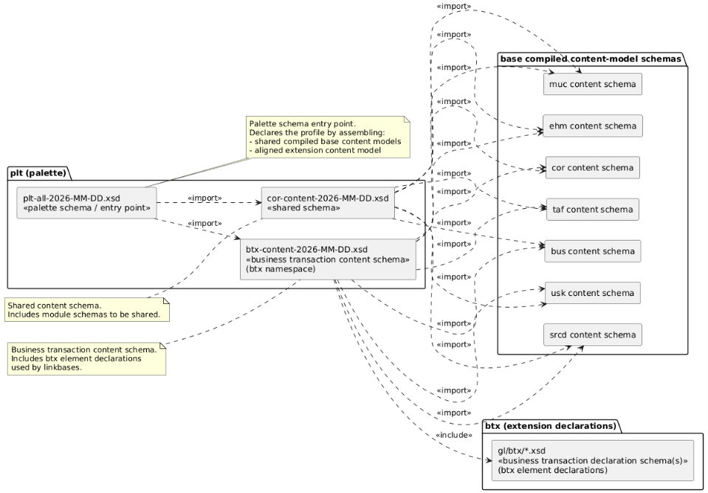
Figure 1 ― Palette taxonomy
The updated logic for the Palette entry point correctly reflects the framework's requirement for domain-specific root modules. In the revised architecture, the palette no longer forces all data into a single ledger structure but allows for independent reporting of business transactions or statistical data.
5.2.1 Palette Entry Point Selection (XBRL 2.1)
The palette entry point (plt-all-2026-12-31.xsd) serves as the stable schema reference for instance documents. It MUST import exactly one profile-specific content-model entry point derived from the LHM (Logical Hierarchical Model) defined in the Profile Sheet.
Depending on the business domain required by the profile, the palette schema will perform one of the following imports:
- For Accounting Entries (Core):
xs:import the shared schema plt-content-2026-12-31.xsd.
This provides the cor:accountingEntries root element for general ledger and journal reporting.
- For Business Transactions (btx):
xs:import the aligned schema btx-content-2026-12-31.xsd (in the btx namespace).
This establishes btx:businessTransactions as the root element for operational documents like orders and invoices.
- For Statistical Reports (sta):
xs:import the aligned schema sta-content-2026-12-31.xsd (in the sta namespace).
This establishes sta:statisticalReports as the root for non-monetary or ESG-related reporting.
Domain | Profile Root Element | Palette Schema
Accounting Ledger | cor:accountingEntries | Imports plt-content
Business Transaction | btx:businessTransactions | Imports btx-content
Statistical Report | sta:statisticalReports | Imports sta-content
This selection mechanism, governed by the Profile Sheet, ensures that the taxonomy remains understandable and optimized for the specific reporting requirement.

5.2.2 Palette for Accounting Ledger
For the accounting ledger, cor:accountingEntriesComplexType.
- gl/plt/plt-all-2026-12-31.xsd (palette schema)
<?xml version="1.0" encoding="UTF-8"?>
<!-- (c) XBRL International. See http://www.xbrl.org/legal -->
<xs:schema
targetNamespace="http://www.xbrl.org/int/gl/plt/2026-12-31"
attributeFormDefault="unqualified" elementFormDefault="qualified"
xmlns:xs="http://www.w3.org/2001/XMLSchema"
xmlns:xlink="http://www.w3.org/1999/xlink"
xmlns:xbrli="http://www.xbrl.org/2003/instance"
xmlns:link="http://www.xbrl.org/2003/linkbase">
<xs:import namespace="http://www.xbrl.org/2003/linkbase" schemaLocation="http://www.xbrl.org/2003/xbrl-linkbase-2003-12-31.xsd"/>
<xs:annotation>
<xs:appinfo>
<link:linkbaseRef xlink:type="simple"
xlink:href="../cor/lang/cor-2026-12-31-label.xml"
xlink:title="Label Links, all"
xlink:role="http://www.xbrl.org/2003/role/labelLinkbaseRef"
xlink:arcrole="http://www.w3.org/1999/xlink/properties/linkbase"/>

… label linkbases for modules …

</xs:appinfo>
</xs:annotation>
<xs:import namespace="http://www.xbrl.org/int/gl/cor/2026-12-31"
schemaLocation="cor-content-2026-12-31.xsd"/>
</xs:schema>
- cor-content-2026-12-31.xsd (shared schema)
<?xml version="1.0" encoding="UTF-8"?>
<!-- (c) XBRL International. See http://www.xbrl.org/legal -->
<xs:schema
targetNamespace="http://www.xbrl.org/int/gl/cor/2026-12-31"
elementFormDefault="qualified" attributeFormDefault="unqualified"
xmlns:xs="http://www.w3.org/2001/XMLSchema"
xmlns:xbrli="http://www.xbrl.org/2003/instance"
xmlns:cor="http://www.xbrl.org/int/gl/cor/2026-12-31"
xmlns:bus="http://www.xbrl.org/int/gl/bus/2026-12-31"
xmlns:muc="http://www.xbrl.org/int/gl/muc/2026-12-31"
xmlns:taf="http://www.xbrl.org/int/gl/taf/2026-12-31"
xmlns:ehm="http://www.xbrl.org/int/gl/ehm/2026-12-31"
xmlns:lnk="http://www.xbrl.org/int/gl/lnk/2026-12-31"
xmlns:usk="http://www.xbrl.org/int/gl/usk/2026-12-31">
<xs:import namespace="http://www.xbrl.org/2003/instance" schemaLocation="http://www.xbrl.org/2003/xbrl-instance-2003-12-31.xsd"/>
<xs:import namespace="http://www.xbrl.org/int/gl/bus/2026-12-31" schemaLocation="bus-content-2026-12-31.xsd"/>
<xs:import namespace="http://www.xbrl.org/int/gl/muc/2026-12-31" schemaLocation="muc-content-2026-12-31.xsd"/>
<xs:import namespace="http://www.xbrl.org/int/gl/taf/2026-12-31" schemaLocation="taf-content-2026-12-31.xsd"/>
<xs:import namespace="http://www.xbrl.org/int/gl/ehm/2026-12-31" schemaLocation="ehm-content-2026-12-31.xsd"/>
<xs:import namespace="http://www.xbrl.org/int/gl/lnk/2026-12-31" schemaLocation="lnk-content-2026-12-31.xsd"/>
<xs:import namespace="http://www.xbrl.org/int/gl/usk/2026-12-31" schemaLocation="usk-content-2026-12-31.xsd"/>
<!-- include concept definition for item and tuple -->
<xs:include schemaLocation="../cor/cor-2026-12-31.xsd"/>
<xs:complexType name="accountingEntriesComplexType">
<xs:complexContent>
<xs:restriction base="xs:anyType">
<xs:sequence>
<xs:element ref="cor:documentInfo" minOccurs="1" maxOccurs="1"/>
<xs:element ref="cor:entityInformation" minOccurs="0" maxOccurs="1"/>
<xs:element ref="cor:entryHeader" minOccurs="0" maxOccurs="unbounded"/>
</xs:sequence>
</xs:restriction>
</xs:complexContent>
</xs:complexType>

…

</xs:schema>
Figure 2 shows Schema view of cor:accountingEntries.
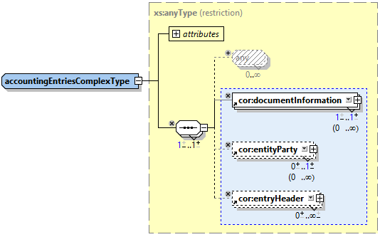
Figure 2 ― Schema view of cor:accountingEntries

5.2.3 Palette for Business Transaction
For the business transaction, btx:businessTransactions ComplexType can constrain the base model by removing cor:entryHeader and replacing it with btx:transactionHeader, while keeping the overall semantics aligned and the profile constraints explicit.
- gl/plt/plt-all-2026-12-31.xsd (palette schema)
<?xml version="1.0" encoding="UTF-8"?>
<!-- (c) XBRL International. See http://www.xbrl.org/legal -->
<schema targetNamespace="http://www.xbrl.org/int/gl/plt/2026-12-31"
attributeFormDefault="unqualified" elementFormDefault="qualified"
xmlns="http://www.w3.org/2001/XMLSchema"
xmlns:link="http://www.xbrl.org/2003/linkbase"
xmlns:xlink="http://www.w3.org/1999/xlink"
xmlns:plt="http://www.xbrl.org/int/gl/btx/2026-12-31">
<import namespace="http://www.xbrl.org/2003/linkbase" schemaLocation="http://www.xbrl.org/2003/xbrl-linkbase-2003-12-31.xsd"/>
<annotation>
<appinfo>
<link:linkbaseRef xlink:type="simple"
xlink:href="../btx/lang/btx-2026-12-31-label.xml"
xlink:title="Label Links, all"
xlink:role="http://www.xbrl.org/2003/role/labelLinkbaseRef"
xlink:arcrole="http://www.w3.org/1999/xlink/properties/linkbase"/>

… label linkbases for modules …

</appinfo>
</annotation>
<import namespace="http://www.xbrl.org/int/gl/btx/2026-12-31"
schemaLocation="btx-content-2026-12-31.xsd"/>
</schema>
- btx-content-2026-12-31.xsd (aligned schema)
<?xml version="1.0" encoding="UTF-8"?>
<!-- (c) XBRL International. See http://www.xbrl.org/legal -->
<schema
targetNamespace="http://www.xbrl.org/int/gl/btx/2026-12-31"
elementFormDefault="qualified" attributeFormDefault="unqualified"
xmlns="http://www.w3.org/2001/XMLSchema"
xmlns:xlink="http://www.w3.org/1999/xlink"
xmlns:xbrli="http://www.xbrl.org/2003/instance"
xmlns:ehm="http://www.xbrl.org/int/gl/ehm/2026-12-31"
xmlns:cor="http://www.xbrl.org/int/gl/cor/2026-12-31"
xmlns:muc="http://www.xbrl.org/int/gl/muc/2026-12-31"
xmlns:taf="http://www.xbrl.org/int/gl/taf/2026-12-31"
xmlns:bus="http://www.xbrl.org/int/gl/bus/2026-12-31"
xmlns:lnk="http://www.xbrl.org/int/gl/lnk/2026-12-31"
xmlns:btx="http://www.xbrl.org/int/gl/btx/2026-12-31">
<import namespace="http://www.xbrl.org/2003/instance" schemaLocation="http://www.xbrl.org/2003/xbrl-instance-2003-12-31.xsd"/>
<import namespace="http://www.xbrl.org/int/gl/ehm/2026-12-31" schemaLocation="ehm-content-2026-12-31.xsd"/>
<import namespace="http://www.xbrl.org/int/gl/cor/2026-12-31" schemaLocation="cor-content-2026-12-31.xsd"/>
<import namespace="http://www.xbrl.org/int/gl/muc/2026-12-31" schemaLocation="muc-content-2026-12-31.xsd"/>
<import namespace="http://www.xbrl.org/int/gl/taf/2026-12-31" schemaLocation="taf-content-2026-12-31.xsd"/>
<import namespace="http://www.xbrl.org/int/gl/bus/2026-12-31" schemaLocation="bus-content-2026-12-31.xsd"/>
<import namespace="http://www.xbrl.org/int/gl/lnk/2026-12-31" schemaLocation="lnk-content-2026-12-31.xsd"/>
<include schemaLocation="../btx/btx-2026-12-31.xsd"/> <!-- item data type -->
…
<!-- tuple data type -->
<complexType name="businessTransactionsComplexType">
<complexContent>
<restriction base="anyType">
<sequence>
<element ref="cor:documentInformation"/>
<element ref="cor:entityParty" minOccurs="0"/>
<element ref="btx:transactionHeader" minOccurs="0" maxOccurs="unbounded"/>
</sequence>
<attribute name="id" type="ID"/>
</restriction>
</complexContent>
</complexType>
…

</xs:schema>
Figure 3 shows the Schema view of btx:accountingEntriesComplexType. This type extends btx:accountingEntriesRestrictionType by adding btx:transactionHeader. The restriction type is defined as a restriction of cor:accountingEntriesComplexType that removes cor:entryHeader.
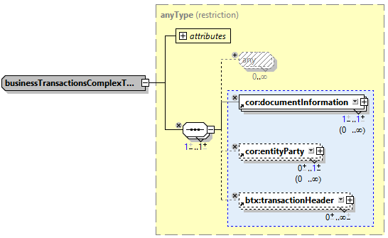
Figure 3 ― Schema view of btx:transactionEntriesComplexType
In the updated arrangement:
- the palette schema (`plt`) provides the entry point and the anchor-point definitions used by linkbases; and
- the business transaction (extension) content schema (`btx`) includes the business transaction (btx) concept definitions.
Conceptually, `plt` provides a “palette of colour tubes” (a compiled set of reusable tuple content models). A jurisdiction or use-case assembly reuses that base by
- restricting the imported tuple content model to the required subset and then
- extending it with additional classes/properties in the extension namespace.
Rules:
- A palette schema MUST import exactly one profile-specific content-model entry point (typically a `plt` or `btx` content schema) that deterministically represents the selected module combination.
- A palette schema MUST NOT contain reporting concept declarations (elements/types for facts); it only provides an entry point and assembly wiring. Reporting concepts remain declared in the corresponding module schemas.
- The palette schema MUST define or include the anchor-point definitions required by linkbases (labels, references, presentation) for the assembled modules.
- Where different module selections require different compiled tuple content models, the palette schema MUST select the correct assembly by importing the corresponding `btx` content entry point for the declared profile.
Note: Supporting imports of base XBRL infrastructure schemas (e.g., `xbrli`, `xlink`) are permitted where required, but they do not change rule (a).

5.3 Palette principle (modular selection)
The palette taxonomy provides the practical selection mechanism that corresponds to the modular architecture: it allows a taxonomy user to select a consistent set of modules for a report, without changing the meaning of the underlying concepts.

5.4 Relationship to extensions and the aligned pool
The palette taxonomy MUST clearly identify jurisdiction modules and MUST declare whether the profile includes:
- shared concepts only;
- aligned extensions registered in an aligned pool; and/or
- distinct local extensions.
Where an extension is intended for cross-jurisdiction reuse, it MUST be proposed and managed as an aligned extension through the aligned pool mechanism, so that semantic equivalence and comparability can be maintained across jurisdictions (and duplication avoided).

5.5 Tuple content-model specialisation and extension
In the XBRL 2.1 architecture, jurisdiction-specific tailoring is achieved in the content-model layer as a physical binding of the LHM. The extension content schema (ext) represents the results of the semantic specialization performed in the BSM.
The framework distinguishes between:
1. Module Schemas: Declare the semantic elements and types.
2. Content-Model Schemas: Assemble those elements into tuple structures based on the graph-walk results.

5.6 Content models
Content-model schemas (for example, `*-content-YYYY-MM-DD.xsd`) vary by profile, depending on which modules are assembled and which constraints apply. The set of semantic element declarations does not change solely because a profile changes; rather, the tuple content models and/or constraints change.
Accordingly, this framework distinguishes between:
- module schemas that declare elements, types, and other artefacts; and
- content-model schemas that assemble tuple content models as XML Schema type definitions for a declared profile.

6 How to create extensions within the XBRL GL Next Taxonomy Framework
Creating extensions within this framework requires additional steps compared with monolithic taxonomies because:
- the taxonomy is modular, and
- tuple content models are assembled according to a palette/profile (and, in the 2015 architecture, via palette case folders).
Taxonomy-building tools MAY implement assistance for this workflow. Where such support is not available, a manual process using XML (or text) editing tools will be necessary.
This section distinguishes:
- public extensions (intended for publication/reuse), and
- private extensions (intended for closed use).
It also distinguishes extension intent as:
- aligned extensions (intended for cross-jurisdiction reuse and managed through an aligned pool/registry), and
- distinct extensions (local/private, not intended for reuse).

6.1 Public extensions including aligned extensions
A public extension is a new module intended to be incorporated into the published framework and become part of that framework.
Public extensions intended for reuse across jurisdictions SHOULD be managed as aligned extensions through an aligned pool/registry so that semantic equivalence and comparability can be maintained across jurisdictions.
The steps involved in creating a public extension are as follows (where xxx is the three-character module code and yyyy-mm-dd is the publication date):
- Select a palette/profile case that most closely resembles the desired end product and copy the palette schema and the relevant xxx-content-…xsd files as the starting point.
- Create a new palette case directory (e.g., case-x-y-z) and place the selected palette artefacts into it.
- Create the new module taxonomy: define concepts, create the lang folder and linkbases. Complex type definitions MUST be defined as global complexTypes.
- Separate the module into:
- xxx-yyyy-mm-dd.xsd (element declarations), and
- xxx-content-yyyy-mm-dd.xsd (content model declarations relevant to the module).
- Create the module directory and move the module schema and linkbases into that directory.
- Add an <include> in xxx-content-yyyy-mm-dd.xsd to include xxx-yyyy-mm-dd.xsd.
- Update relative paths in linkbases and schemas accordingly.
- Update the palette case content model schemas to incorporate the new module’s elements into the appropriate content models (typically content models for elements declared in cor-content-…xsd).
- Ensure presentation (and other) linkbases reflect the content model modifications made in step 8.
OIM considerations (in addition to the above, where an OIM profile is provided):
- Provide or update the palette profile for the corresponding profile so that OIM-based processors can assemble and validate the same module combination (including any required constraints) without relying on tuple/XML content model compilation.
Aligned pool considerations (where reuse is intended):
- For extensions intended for cross-jurisdiction reuse, register the new classes/properties/code lists (as applicable) through the aligned pool/registry process, and reference the aligned pool version in the relevant palette profile.

6.2 Private extensions for distinct or local use
A private extension is one that is for use in a closed system and not published generally. Those seeking to create private extensions should follow the usual XBRL extension process with the following points to note:
- A project extension MUST use a namespace controlled by its maintainer and MAY add extension concepts to the selected palette content model.
- A project extension MUST NOT claim control of an XBRL International namespace or imply endorsement by XBRL International.
- Private extensions MUST NOT alter any of the officially supplied palette directories. Any changes to XBRL International namespaces MUST be effected in a newly created palette directory for the extension. Files from official palette directories MAY be copied into the new palette directory as necessary.
OIM considerations:
- Where a private extension is intended to be used with OIM serialisations, an equivalent private profile declaration MUST be provided (palette profile constraints) so that OIM validation and processing apply the same module selection and restrictions as the tuple/XML palette case.
- (illustrative)
Extending the Tuple-Based (XBRL XML) Taxonomy
  - Purpose and scope
This appendix provides a practical tutorial for extending the tuple-based xBRL GL taxonomy defined in Part 2. It illustrates the recommended approach using a pool-and-profile pattern, where:
- the pool schema defines reusable concepts and structures (e.g., cor-party-pool.xsd); and
- the profile schema assembles and constrains a concrete package for an implementation (e.g., cor-party-profile.xsd).
The approach is additive: extensions introduce new elements/types without modifying or removing existing international components.
  - Files and roles in the tuple-based package
The tuple-based extension workflow assumes the following artefact roles:
- Pool schema: cor-party-pool.xsd
Defines reusable complex types, global elements, and model fragments that may be reused by multiple profiles.
- Profile schema: cor-party-profile.xsd
Defines the profile entry point (or profile-specific wrapper types) that select and assemble content from the pool.
This pattern supports backward-compatible evolution: the pool remains a stable palette of reusable building blocks, while profiles define the concrete “package”.
  - Recommended extension pattern
    - Create an extension schema (do not edit the pool)
To add new business requirements (for example, adding a new party attribute such as tradingName), create a new extension schema in an extension namespace (or a controlled local namespace within the same module family). The extension schema SHOULD:
- import the base pool schema (cor-party-pool.xsd); and
- define only the additional elements/types required by the extension.
This avoids editing the international pool and ensures clean governance.
    - Extend structures using xs:extension (preferred)
For tuple-based taxonomies, structural growth SHOULD be implemented using XML Schema xs:extension. This keeps the base model intact while allowing additive content.
Typical steps:
- Identify the base complexType to be extended (in the pool).
- Define a new derived complexType in the extension schema using xs:extension.
- Add new child elements in the extension content model with appropriate multiplicities.
- Expose the derived structure via a profile element/type.
Guidance
- xs:extension is the preferred mechanism for adding new content.
- xs:restriction MAY be used for profile-specific tightening (e.g., restricting enumerations), but SHOULD be used sparingly because it can reduce interoperability and reuse.
    - Assemble the extension in the profile schema
After defining new types/elements, update the profile schema (cor-party-profile.xsd) to use the extended types in the profile assembly. Two common patterns are:
- Type substitution in profile wrapper types: the profile references the extended type as the type of the profile element; or
- Profile-specific root composition: the profile root structure includes both base pool components and extension components.
The profile schema MUST remain a valid entry point for the DTS and MUST import both the pool schema and the extension schema.
  - Restrictions and constraints in tuple-based taxonomies
Tuple-based taxonomies can express constraints in several ways:
- XML Schema constraints (e.g., minOccurs/maxOccurs, simple type restrictions)
- Profile assembly choices (include only what the profile needs)
- XBRL validation rules (if applicable, via formula or other mechanisms)
In practice, xBRL GL profiles SHOULD prefer assembly-based constraints (profile selects structures) over heavy schema restriction, to preserve reuse across jurisdictions.
  - Checklist for tuple-based extension packages
When publishing an extension:
- The extension schema imports the pool schema and introduces new elements/types only.
- The profile schema imports the pool schema and the extension schema.
- Names and identifiers follow the naming conventions in Part 1 (unique, stable, module-prefixed).
- Instances remain valid against the profile entry point.
- Backward compatibility is maintained (base pool remains unchanged).
  - Example
    - cor-party-pool.xsd
<?xml version="1.0" encoding="UTF-8"?>
<schema targetNamespace="http://example.org/xbrl/gl/cor"
elementFormDefault="qualified" attributeFormDefault="unqualified"
xmlns="http://www.w3.org/2001/XMLSchema"
xmlns:xbrli="http://www.xbrl.org/2003/instance"
xmlns:cor="http://example.org/xbrl/gl/cor">
<import namespace="http://www.xbrl.org/2003/instance"
schemaLocation="http://www.xbrl.org/2003/xbrl-instance-2003-12-31.xsd"/>
<!-- Child items / tuples (simplified) -->
<element name="PartyName" type="xbrli:stringItemType"
substitutionGroup="xbrli:item" xbrli:periodType="instant" abstract="false"/>
<element name="Address" type="xbrli:stringItemType"
substitutionGroup="xbrli:item" xbrli:periodType="instant" abstract="false"/>
<element name="Contact" type="xbrli:stringItemType"
substitutionGroup="xbrli:item" xbrli:periodType="instant" abstract="false"/>
<element name="TaxRegistration" type="xbrli:stringItemType"
substitutionGroup="xbrli:item" xbrli:periodType="instant" abstract="false"/>
<element name="AuthorityRegisteredIdentifier" type="xbrli:stringItemType"
substitutionGroup="xbrli:item" xbrli:periodType="instant" abstract="false"/>
<!-- Rich Party tuple type in the pool -->
<complexType name="PartyType">
<sequence>
<element ref="cor:PartyName" minOccurs="0" maxOccurs="1"/>
<element ref="cor:Address" minOccurs="0" maxOccurs="unbounded"/>
<element ref="cor:Contact" minOccurs="0" maxOccurs="unbounded"/>
<element ref="cor:TaxRegistration" minOccurs="0" maxOccurs="unbounded"/>
<element ref="cor:AuthorityRegisteredIdentifier"
minOccurs="0" maxOccurs="unbounded"/>
</sequence>
</complexType>
<element name="Party" type="cor:PartyType"
substitutionGroup="xbrli:tuple" nillable="false"/>
</schema>
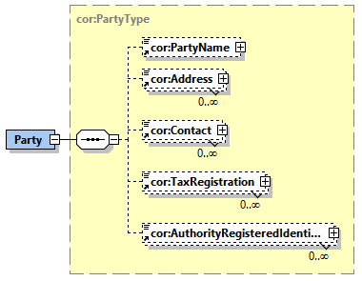
    - cor-party-pool.xsd
<?xml version="1.0" encoding="UTF-8"?>
<schema targetNamespace="http://example.org/xbrl/gl/cor"
elementFormDefault="qualified" attributeFormDefault="unqualified"
xmlns="http://www.w3.org/2001/XMLSchema"
xmlns:xbrli="http://www.xbrl.org/2003/instance"
xmlns:cor="http://example.org/xbrl/gl/cor">

<import namespace="http://www.xbrl.org/2003/instance"
schemaLocation="http://www.xbrl.org/2003/xbrl-instance-2003-12-31.xsd"/>

<!-- Same namespace => include, not import -->
<include schemaLocation="cor-party-pool.xsd"/>

<!-- Restricted Party type (removes Contact) -->
<element name="TradingName" type="xbrli:stringItemType"
substitutionGroup="xbrli:item" xbrli:periodType="instant" abstract="false"/>

<!-- Step 1: restriction removes Contact -->
<complexType name="PartyTypeNoContact">
<complexContent>
<restriction base="cor:PartyType">
<sequence>
<element ref="cor:PartyName" minOccurs="0" maxOccurs="1"/>
<element ref="cor:Address" minOccurs="0" maxOccurs="unbounded"/>
<element ref="cor:TaxRegistration" minOccurs="0" maxOccurs="unbounded"/>
<element ref="cor:AuthorityRegisteredIdentifier"
minOccurs="0" maxOccurs="unbounded"/>
</sequence>
</restriction>
</complexContent>
</complexType>

<!-- Step 2: extension adds TradingName (appended) -->
<complexType name="PartyTypeProfile">
<complexContent>
<extension base="cor:PartyTypeNoContact">
<sequence>
<element ref="cor:TradingName" minOccurs="0" maxOccurs="1"/>
</sequence>
</extension>
</complexContent>
</complexType>

<!-- Profile-specific Party tuple element -->
<element name="PartyProfile" type="cor:PartyTypeProfile"
substitutionGroup="xbrli:tuple" nillable="false"/>
</schema>
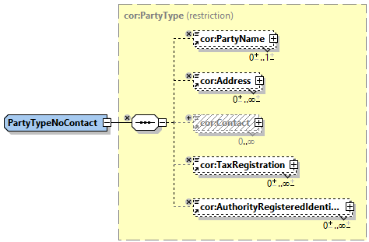
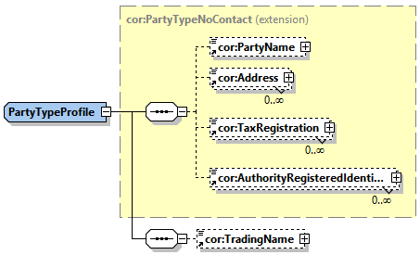
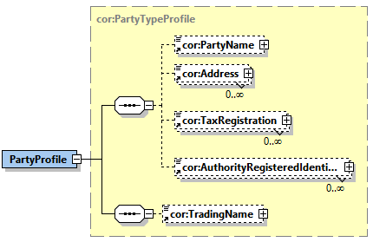

- References
(Reference list under collaborative review. Official XBRL specifications are available at https://specifications.xbrl.org/.)
RFC2119 | The Internet Engineering Task Force (IETF). "Key words for use in RFCs to Indicate Requirement Levels, March 1997"  Scott Bradner.  (See http://www.ietf.org/rfc/rfc2119.txt)
SCHEMA-1 | World Wide Web Consortium (W3C). "XML Schema Part 1: Structures"  (See http://www.w3.org/TR/xmlschema-1/)
TRP | XBRL International Inc. (XII). "XBRL Taxonomy Recognition Process, 28 October 2004"  Peter Calvert, and Joseph MacDonald.  (See https://xbrl.org/taxonomyrecognition/taxonomy-recognition-acknowledgement-process-2013-04-09.htm)
XBRL | XBRL International Inc. (XII). "Extensible Business Reporting Language (XBRL) 2.1 Specification with corrected errata dated 2 July 2008"  Phillip Engel, Walter Hamscher, Geoff Shuetrim, David vun Kannon, and Hugh Wallis.  (See https://specifications.xbrl.org/)
XLINK | World Wide Web Consortium (W3C). "XML Linking Language (XLink) Version 1.0."  Steve DeRose, Eve Maler, and David Orchard.  (See http://www.w3.org/TR/xlink/)
GLTFTA | XBRL GL Taxonomy Framework Technical Architecture 2015  Gianluca Garbellotto, Eric E. Cohen, Masatomo Goto, and Toshimitsu Suzuki  (See https://www.xbrl.org/int/gl/2015-03-25/GLTFTA-REC-2015-03-25.html)

- (illustrative)
Intellectual property status
Copyright and license terms are under review. This draft is shared only with invited project participants through the private project repository. No permission for public redistribution or publication is granted by this draft notice.
References to external specifications and other third-party materials remain subject to the terms of their respective rights holders.
This draft does not claim approval, endorsement, publication, or official status by XBRL Japan, XBRL Europe, XBRL International, or any other organization.
- (illustrative)
Document history
Date | Author | Details
6 January 2026 | SAMBUICHI, Nobuyuki | v0.1 Initial collaborative review draft.
- (illustrative)
Errata corrections in this document
This appendix records editorial corrections incorporated into this collaborative review draft. The entries have not been approved or endorsed by XBRL Japan, XBRL Europe, XBRL International, or any other organization.
No errata have been incorporated into this document.

