Project Name:
AWS Serverless Invoice Processing System
Name: Prajakta Sangle
Project Overview
This project is a serverless invoice processing system built using AWS services. Users can log in securely, upload invoices, and the system automatically extracts text using AWS Textract.
Architecture Diagram
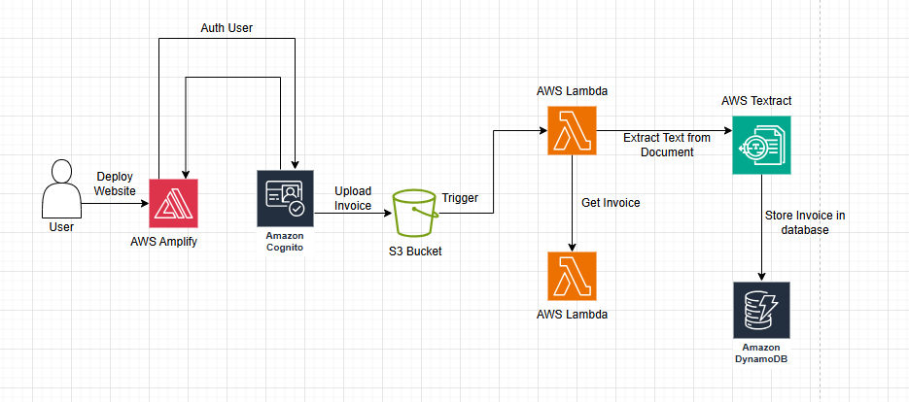
Step 1: Fontend and Backend Code
<!DOCTYPE html>
<html>
<head>
<title>Invoice Processing App</title>
<style>
body {
font-family: Arial;
text-align: center;
margin-top: 50px;
}
button {
padding: 10px 20px;
margin: 10px;
font-size: 16px;
}
</style>
</head>

<body>

<h1>Invoice Processing System</h1>

<button onclick="login()">Login</button>

<br><br>

<input type="file" id="fileInput">
<button onclick="uploadFile()">Upload Invoice</button>

<p id="status">Status: Not connected</p>

<!-- AWS SDK -->
<script src="https://sdk.amazonaws.com/js/aws-sdk-2.1481.0.min.js"></script>

<script>

// =============================
// 🔹 CONFIGURATION
// =============================

const cognitoDomain = "https://ap-south-1s6ljqlqjp.auth.ap-south-1.amazoncognito.com";
const clientId = "1s43sg7s9riogrkfq0o948k7f8";
const redirectUri = "https://staging.d3mesf9lmfo3rw.amplifyapp.com";

const region = "ap-south-1";
const identityPoolId = "ap-south-1:09024afb-2a98-4280-9012-f4ff2267cd7e"; // <-- your identity pool id
const userPoolId = "ap-south-1_s6lJQlqJP"; // <-- your user pool id
const bucketName = "vbuckettttqq"; // <-- your bucket name

// =============================
// 🔹 LOGIN FUNCTION
// =============================

function login() {
const url =
cognitoDomain +
"/login?client_id=" +
clientId +
"&response_type=token" +
"&scope=openid+email+phone&redirect_uri=" +
redirectUri;

window.location.href = url;
}

// =============================
// 🔹 GET ID TOKEN FROM URL
// =============================

function getIdToken() {
const hash = window.location.hash.substring(1);
const params = new URLSearchParams(hash);
return params.get("id_token");
}

// =============================
// 🔹 UPLOAD FUNCTION
// =============================

function uploadFile() {

const idToken = getIdToken();

if (!idToken) {
alert("Please login first!");
return;
}

const fileInput = document.getElementById("fileInput");
const file = fileInput.files[0];

if (!file) {
alert("Please select a file first");
return;
}

document.getElementById("status").innerText = "Getting credentials...";

AWS.config.region = region;

AWS.config.credentials = new AWS.CognitoIdentityCredentials({
IdentityPoolId: identityPoolId,
Logins: {
[`cognito-idp.${region}.amazonaws.com/${userPoolId}`]: idToken
}
});

// Get temporary credentials
AWS.config.credentials.get(function (err) {

if (err) {
console.error("Credential error:", err);
alert("Credential Error: " + err.message);
document.getElementById("status").innerText = "Credential Failed ❌";
return;
}

console.log("Credentials obtained ✅");

const s3 = new AWS.S3({
apiVersion: "2006-03-01",
params: { Bucket: bucketName }
});

const params = {
Key: "invoices/" + Date.now() + "_" + file.name,
Body: file,
ContentType: file.type
};

document.getElementById("status").innerText = "Uploading...";

s3.upload(params, function (err, data) {

if (err) {
console.error("Upload error:", err);
alert("Upload Error: " + err.message);
document.getElementById("status").innerText = "Upload Failed ❌";
} else {
console.log("File uploaded:", data.Location);
document.getElementById("status").innerText = "Upload Success ✅";
}

});

});
}

</script>

</body>
</html>
Step 2 — Amplify Hosting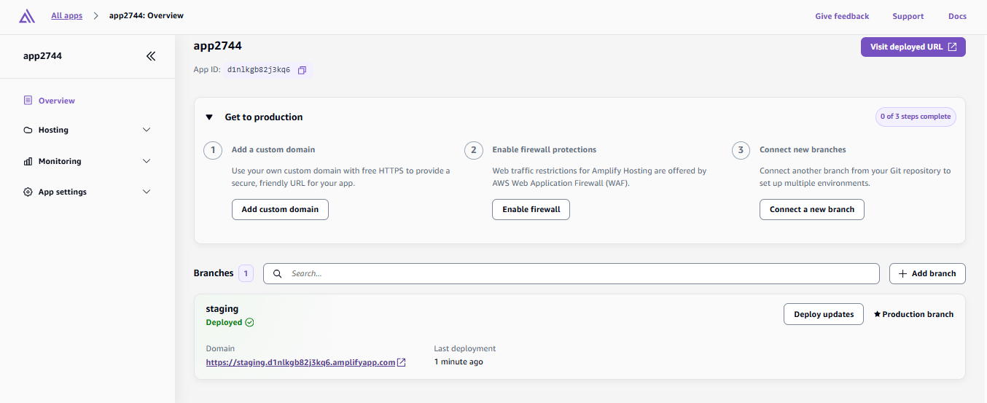

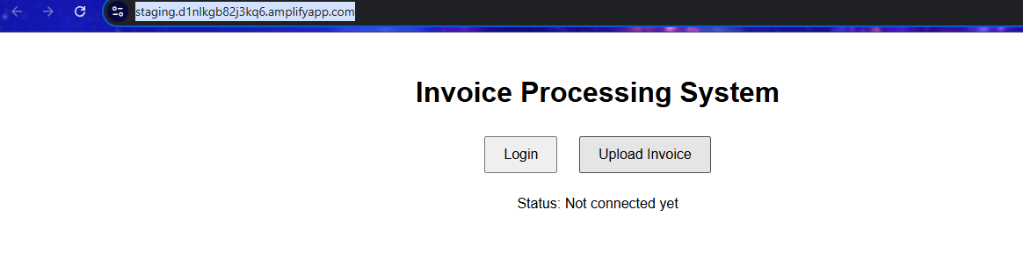
Step 3: Cognito Setup

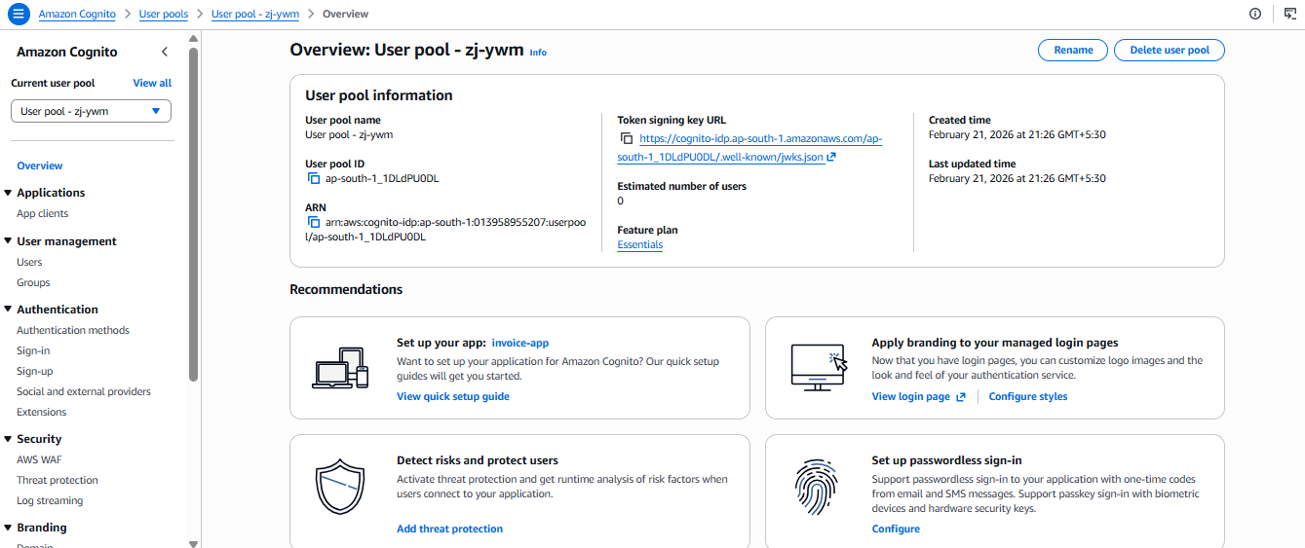

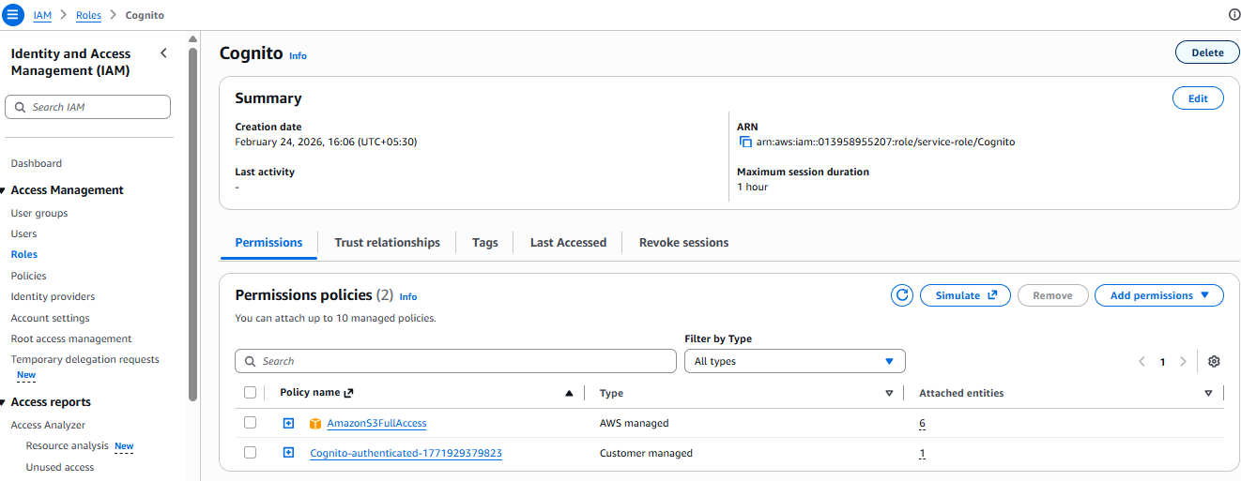\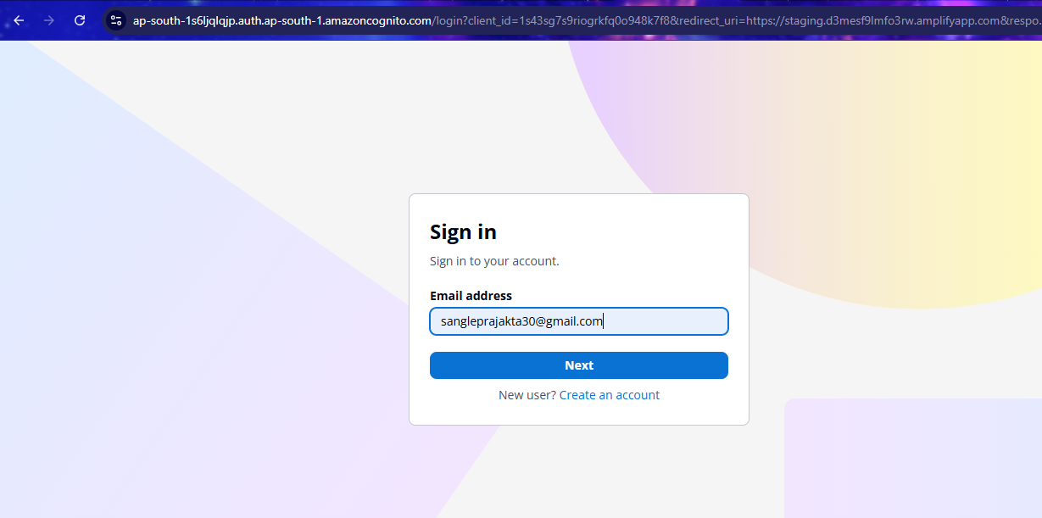

Step 4: S3 bucket creation
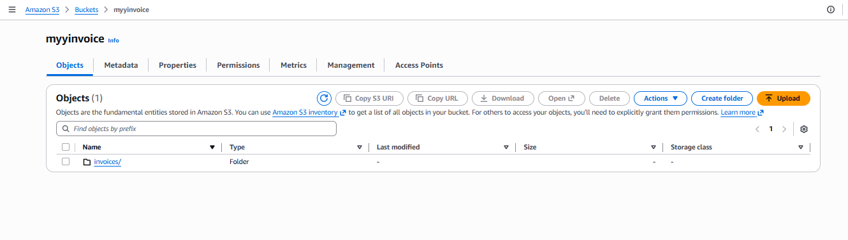

Step 5: Lambda creation and s3 Trigger

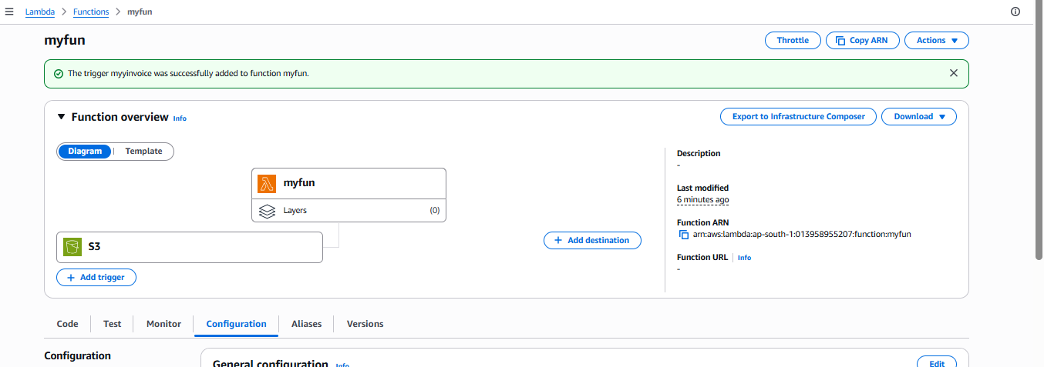
Step 6: Cloudwatch Log
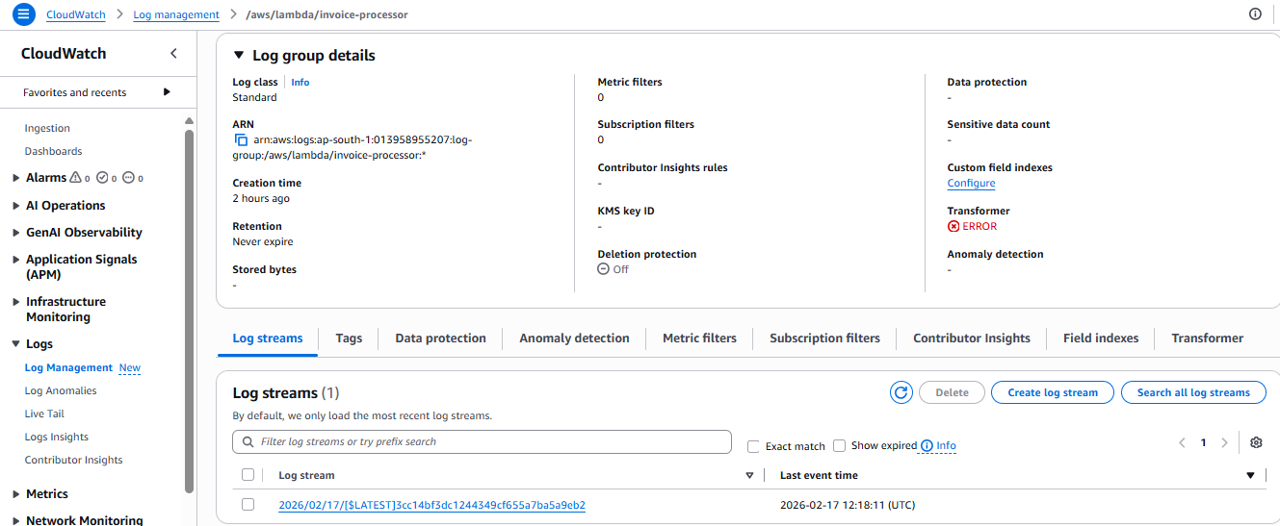
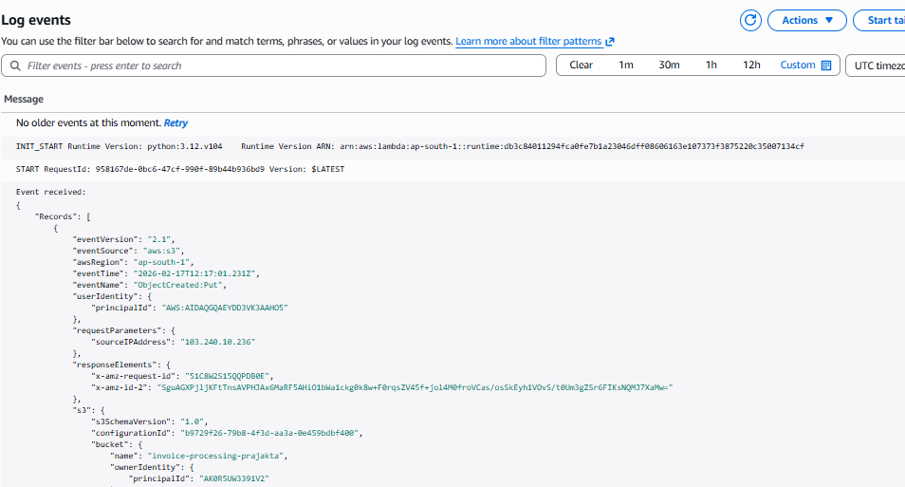

Step 7 Database Creation
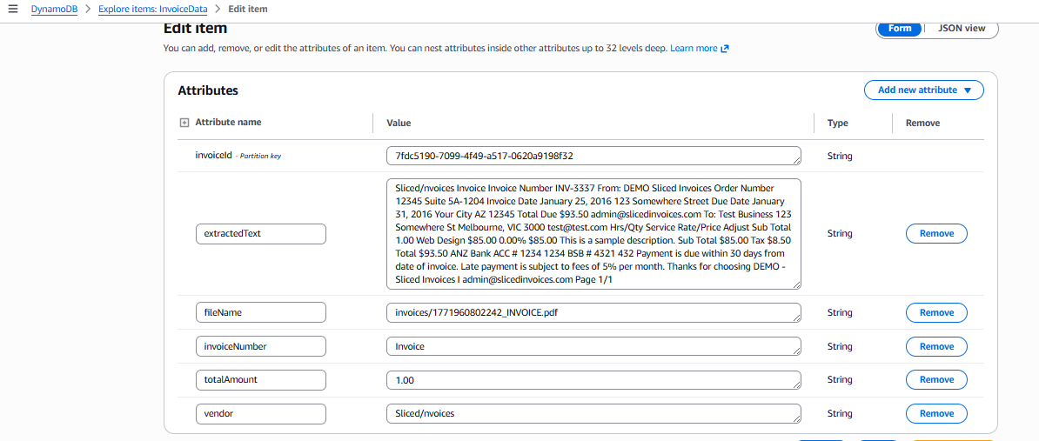

Step 8: Final 