E-Commerce Backend (Microservices)
Step 1: Create your own website and save in your local file with the name index.html
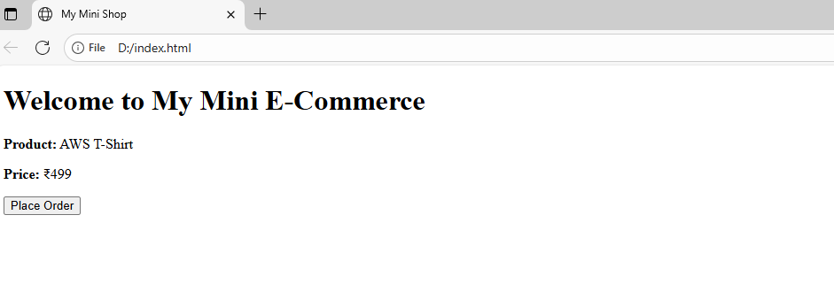
Step 2: Create a S3 bucket
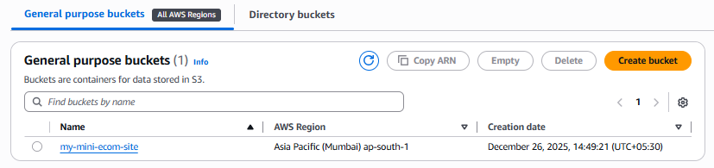
Step 3: Upload index.html in the bucket
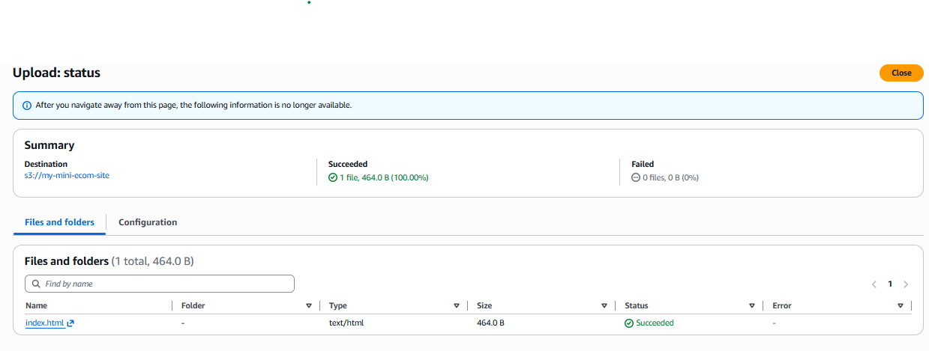

Step 4: Enable the static website hosting
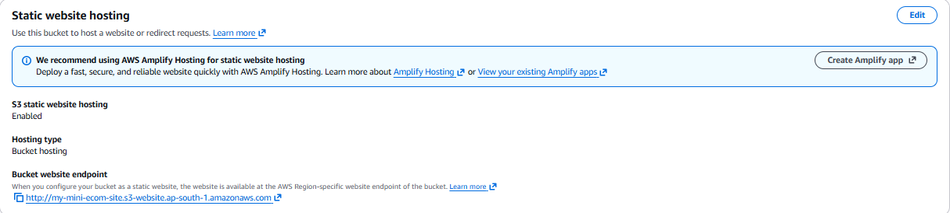
Step 5: Edit the bucket policy to get acces to the website

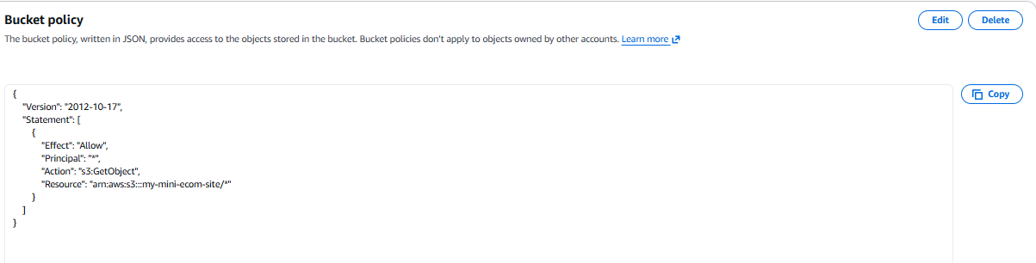
Step 6: Host a website from S3
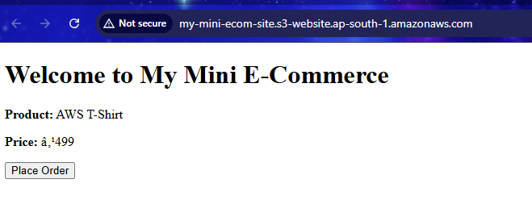

Step 7: Create a EC2 instance
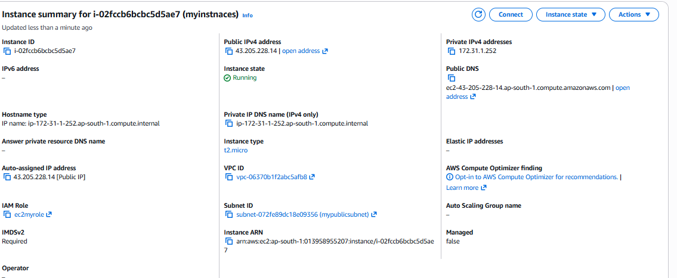
Step 8: Create a IAM role for EC2 and assign permissions policies
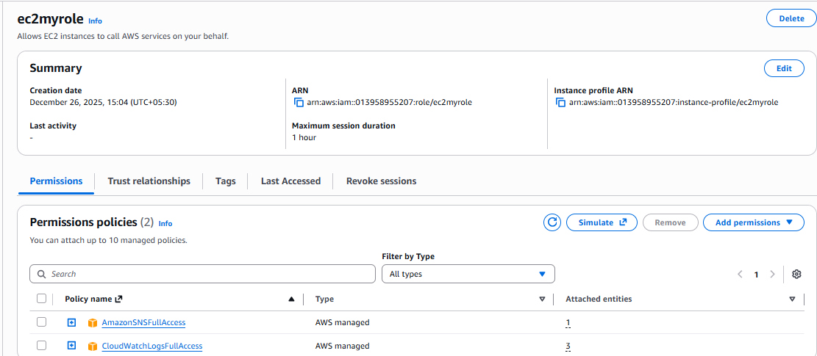
Step 9: Create app.py file and enter a python code for backend
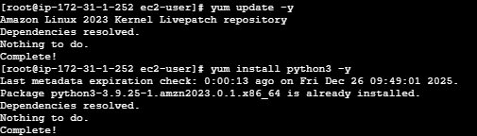

Step 10: Install dependencies if needed and run the python code
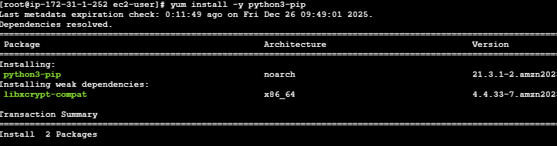
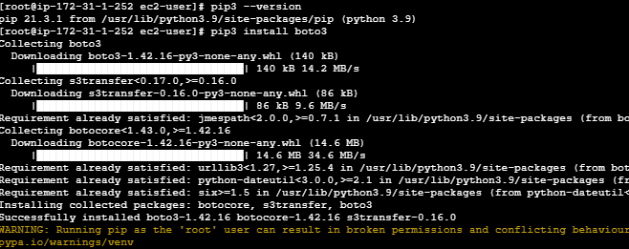
Step 11: Create SNS and attach your email address
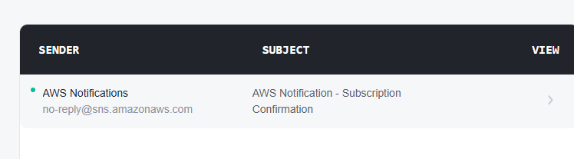

Step 12: Confirm the email
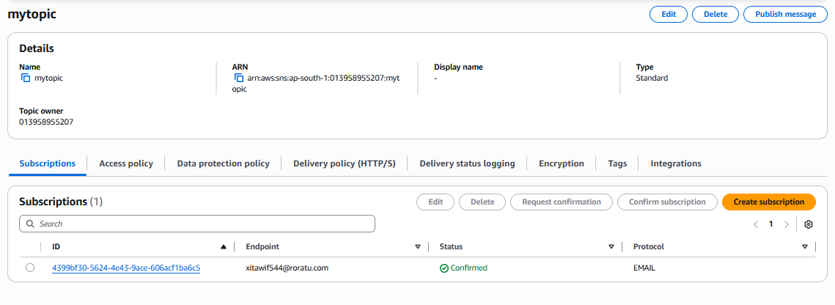
Step 13: Test the website and click place order and receive the email of order placed
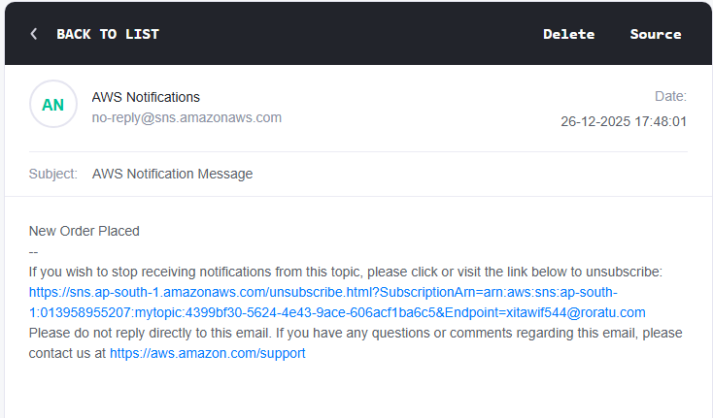
Step 14: Test from curl

