**Flight Search Assignment**

Search Flights between DELHI to MUMBAI on date 10-12-2013

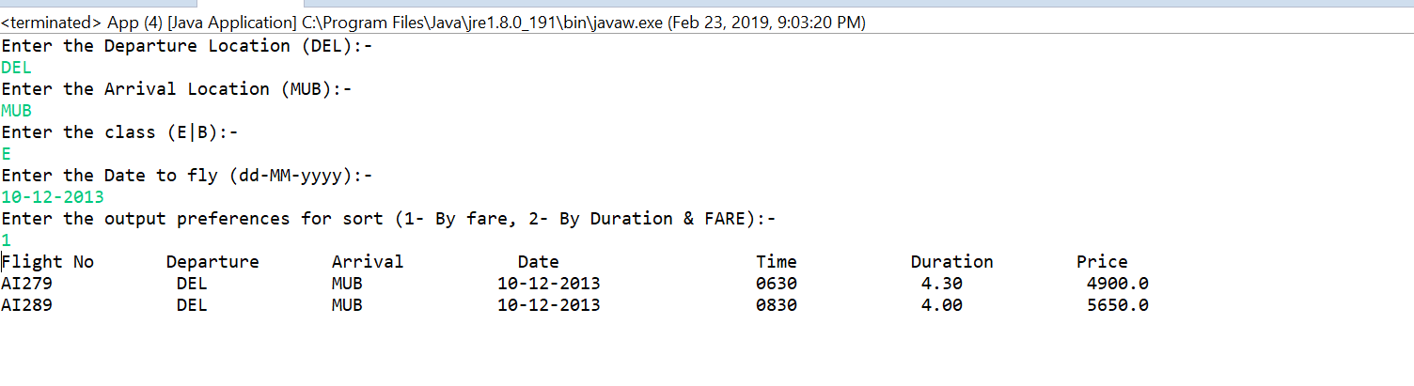

Search flights between DELHI to MUMBAI on date 17-12-2013 and sort by fare & duration

