Exercise 1:

Create a web page with the following using HTML.

* 1. To embed an image map in a web page.
  2. To fix the hot spots.
  3. Show all the related information when the hot spots are clicked

Aim:

To Create a web page with the following using HTML.

* 1. To embed an image map in a web page.
  2. To fix the hot spots.
  3. Show all the related information when the hot spots are clicked

**Algorithm :**

Step 1. Create 4 html pages

Testimgmap.html

Chennai.html

Trichy.html

Kovai.html and download Tamilnadu map.

Step 2. Write the code for Testimgmap.html.

Set the image’s width and height as the picture size in the <img> tag.

**How to set Attributes in Testingmap.html:**

The <map> tag is used to define an image map. An image map is an image with clickable areas.The required name attribute of the <map> element is associated with the [<img>](https://www.w3schools.com/tags/tag_img.asp)'s usemap attribute and creates a relationship between the image and the map.The <map> element contains a number of [<area>](https://www.w3schools.com/tags/tag_area.asp) elements, that defines the clickable areas in the image map. The clickable area for a particular city can be set as rectangle or circle by using shape attribute.

**To fix hotspots:**

Load the Tamilnadu map in paint. The leftmost top point marks the origin of the picture and rightmost bottom –size of the picture. The hotspot can be selected as a rectangular,square or circular area. The approximate pixel position for a city can be selected by hovering over the map. Use shape="rect" or shape="circle". If rectangle give 4 values for ex: coords="34,44,270,350" and for shape="circle" coords="337,300,44" // 3 parameters for cords.

Step 3. Perform mapping using tag. <map>

Step 4: Write the content to be displayed in Chennai.html, Trichy.html, Kovai.html

using various HTML elements.(Pictures, Tables etc)

Step 5. Click the area over Trichy, Chennai and Coimbatore in Tamilnadu map. According to the location the information in respective new html file is displayed.

Step 6: Stop

**Testimgmap.html**

<html>

<body>

<h1>The map and area elements</h1>

<p>Click on the the region of Trichy ,Chennai and Kovai in the map to go to a new page and read more about the topic:</p>

<img src="Tamilnadu-outline.jpg" alt="TNMAP"usemap="#tnmap" width="313" height="379">

<map name="tnmap">

<area shape="rect" coords="232,35,249,47" alt="Chennai" href="Chennai.html">

<area shape="rect" coords="140,197,162,213" alt="Trichy" href="Trichy.html">

<area shape="circle" coords="61,184,25" alt="Coimbatore" href="Kovai.html">

</map>

</body>

</html>

**Chennai.html**

<html>

<p>

Its capital and largest city in Tamilnadu </p>

<p> further …..Descrbie the details of the hotspot use different HTML tag</p>

</html>

**Trichy.html**

<html>

<p>

Trichy is known for Education Hub

</p>

<p> further …..Descrbie the details of the hotspot use different HTML tag</p>

</html>

**Kovai.html**

<html>

<p>

Coimbatore is the second largest city in Tamilnadu. There were ten taluks in the district.

</p>

<p> further …..Describe the details of the hotspot use different HTML tag</p>

</html>

**Image**

Tamilnadu-outline.jpg size:313*379

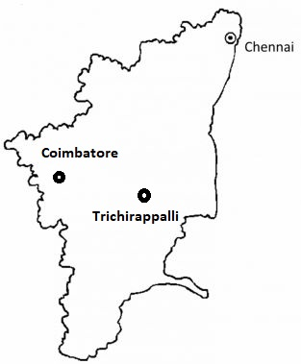

**Output:**

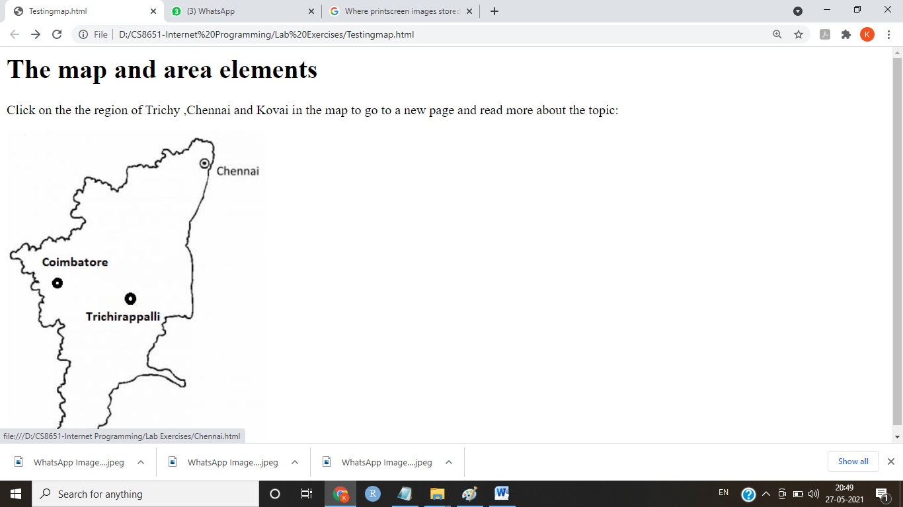

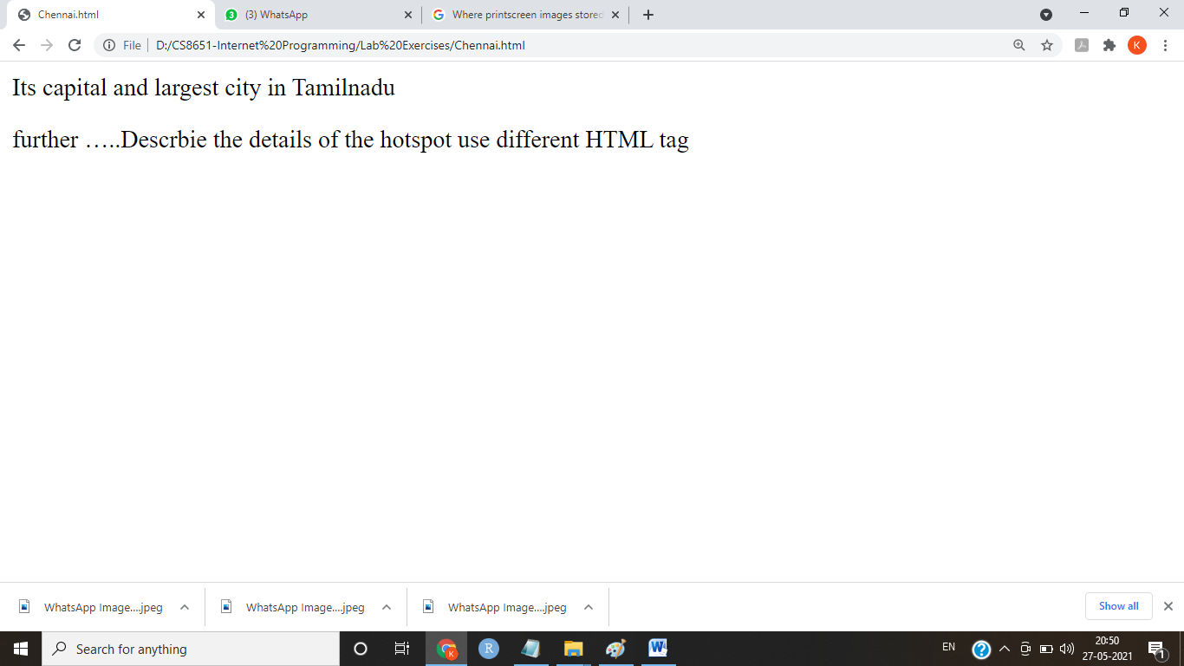

**Result:**

Thus a HTML page is created with an embedded tamilnadu outline image, the hotspots are fixed for the important cities and the relevant information about city is displayed when clicked.