**Exercise 3:**

Validate the Registration, user login, user profile and payment by credit card pages using JavaScript.

**Aim:**

To Create a web page for User registration, user login, user profile and payment by credit card using HTML and to validate those forms using JavaScript.

**Algorithm :**

Step 1. Create 4 html pages

**Reg_Valid_JS.html**

**LoginPage.html**

**Payment.html** for user registration, user login and payment by credit card.

Step 2. To validate form data of user registration and payment, create external java

script file **registration-form-validation.js** and **payment-form-validation.js**.

Step 3. Include validation for login internally within html.

Step 4: Fetch the user data for generating user profile during user registration.

Step 5.Create external style sheet **js-form-validation.css** and link it with **Reg_Valid_JS.html**

**Reg_Valid_JS.html**

<!DOCTYPE html>

<title>JavaScript Form Validation using a sample registration form</title>

<link rel='stylesheet' href='js-form-validation.css' type='text/css' />

<script src="registration-form-validation.js">

</script>

</head>

<body onload="document.registration.userid.focus();">

<h1>Registration Form</h1>

<a href="Login.html">Login</a>

<div id="container">

<form name='registration'>

<ul>

<li><label for="userid">User id:</label></li>

<li><input type="text" name="userid" size="12" /></li>

<li><label for="passid">Password:</label></li>

<li><input type="password" name="passid" size="12" /></li>

<li><label for="username">Name:</label></li>

<li><input type="text" name="username" size="50" /></li>

<li><label for="address">Address:</label></li>

<li><input type="text" name="address" size="50" /></li>

<li><label for="country">Country:</label></li>

<li><select name="country">

<option selected="" value="Default">(Please select a country)</option>

<option value="Australia">Australia</option>

<option value="Canada">Canada</option>

<option value="India">India</option>

<option value="Russia">Russia</option>

<option value="USA">USA</option>

</select></li>

<li><label for="zip">ZIP Code:</label></li>

<li><input type="text" name="zip" /></li>

<li><label for="email">Email:</label></li>

<li><input type="text" name="email" size="50" /></li>

<li><label id="genderlab">Gender:</label></li>

<li><input type="radio" id="mgender" name="gender" value="Male" unchecked/><span>Male</span></li>

<li><input type="radio" id="fgender" name="gender" value="Female" unchecked/><span>Female</span></li>

<li><label>Language:</label></li>

<li><input type="checkbox" name="en" value="English" checked /><span>English</span></li>

<li><input type="checkbox" name="nonen" value="NonEnglish" /><span>Non English</span></li>

<li><label for="desc">About:</label></li>

<li><textarea name="desc" id="desc"></textarea></li>

<li><input type="button" name="submit" value="Submit" onclick="return formValidation();"/></button></li>

<li><input type="button" name="print" value="Print" onclick="return CopyElem();"/></button></li>

</ul>

</form>

</div>

<label>USER PROFILE: </label>

<p><span id='display'></span></p>

</body>

</html>

**js-form-validation.css**

#container {

border: 2px solid;

height:550px;

width:450px;

padding: 5px;

}

h1 {

margin-left: 70px;

}

form li {

list-style: none;

margin-bottom: 5px;

}

form ul li label{

float: left;

clear: left;

width: 100px;

text-align: right;

margin-right: 10px;

font-family:Verdana, Arial, Helvetica, sans-serif;

font-size:14px;

}

form ul li input, select, span {

float: left;

margin-bottom: 10px;

}

form textarea {

float: left;

width: 350px;

height: 150px;

}

[type="submit"] {

clear: left;

margin: 20px 0 0 230px;

font-size:18px

}

p {

margin-left: 70px;

font-weight: bold;

}

a {

margin-left: 500px;

float:left;}

**registration-form-validation.js**

function formValidation()

{

var uid = document.registration.userid;

var passid = document.registration.passid;

var uname = document.registration.username;

var uadd = document.registration.address;

var ucountry = document.registration.country;

var uzip = document.registration.zip;

var uemail = document.registration.email;

var umgender = document.registration.mgender;

var ufgender = document.registration.fgender;

if(userid_validation(uid,5,12))

{

if(passid_validation(passid,7,12))

{

if(allLetter(uname))

{

if(alphanumeric(uadd))

{

if(countryselect(ucountry))

{

if(allnumeric(uzip))

{

if(ValidateEmail(uemail))

{

if(validgender(umgender,ufgender))

{ }}}}}}}}

return false;

}

function userid_validation(uid,mx,my)

{

var uid_len = uid.value.length;

if (uid_len == 0 || uid_len >= my || uid_len < mx)

{

alert("User Id should not be empty / length be between "+mx+" to "+my);

uid.focus();

return false;

}

return true;

}

function passid_validation(passid,mx,my)

{

var passid_len = passid.value.length;

if (passid_len == 0 ||passid_len >= my || passid_len < mx)

{

alert("Password should not be empty / length be between "+mx+" to "+my);

passid.focus();

return false;

}

return true;

}

function allLetter(uname)

{

var letters = /^[A-Za-z]+$/;

if(uname.value.match(letters))

{

return true;

}

else

{

alert('Username must have alphabet characters only');

uname.focus();

return false;

}

}

function alphanumeric(uadd)

{

var letters = /^[0-9a-zA-Z]+$/;

if(uadd.value.match(letters))

{

return true;

}

else

{

alert('User address must have alphanumeric characters only');

uadd.focus();

return false;

}

}

function countryselect(ucountry)

{

if(ucountry.value == "Default")

{

alert('Select your country from the list');

ucountry.focus();

return false;

}

else

{

return true;

}

}

function allnumeric(uzip)

{

var numbers = /^[0-9]+$/;

if(uzip.value.match(numbers))

{

return true;

}

else

{

alert('ZIP code must have numeric characters only');

uzip.focus();

return false;

}

}

function ValidateEmail(uemail)

{

var mailformat = /^\w+([\.-]?\w+)*@\w+([\.-]?\w+)*(\.\w{2,3})+$/;

if(uemail.value.match(mailformat))

{

return true;

}

else

{

alert("You have entered an invalid email address!");

uemail.focus();

return false;

}

}

function validgender(umgender,ufgender)

{

x=0;

if(umgender.checked)

{

x++;

} if(ufgender.checked)

{

x++;

}

if(x==0)

{

alert('Select Male/Female');

umgender.focus();

return false;

}

else

{

alert(uid);

window.location.reload()

return true;}

}

//Print Button

function showInput(params) {

document.getElementById('display').innerHTML =

params;

return true;

}

function CopyElem()

{

var params = '';

var dummy;

for( var i=0; i<document.registration.elements.length; i++ )

{

var fieldType = document.registration.elements[i].type;

var fieldName = document.registration.elements[i].name;

var fieldValue = document.registration.elements[i].value;

var x = document.registration.elements[i].checked;

if(x)

{

if(i==7||i==8||i==9||i==10)

params +=fieldValue+" "+'<br>';

}

if(i==0||i==1||i==12||i==13)

params=params;

else if(i==2||i==3||i==4||i==5||i==6||i==11)

params +=fieldValue+" "+'<br>';

else

dummy=params;

}

showInput(params);

}

**LoginPage.html**

<html>

<head>

<script>

function LoginValidation() {

var x = document.forms["myForm1"]["user"].value;

var y = document.forms["myForm1"]["password"].value;

if ((x == "BRAmbedkar")&&(y=="123")) {

document.getElementById("demo").innerHTML="LOGIN SUCCESSFUL";

}

else

{

document.getElementById("demo").innerHTML="LOGIN FAILED";

}

}

</script>

</head>

<body>

<h3>LOGIN</h3>

<form id="myForm1">

<table>

<tr>

<td>User</td>

<td><input type="text" name="user" /></td>

</tr>

<tr>

<td>password</td>

<td><input type="password"name="password" /></td>

</tr>

</table>

<input type="button" name="login" value="Login" onclick="LoginValidation();"/></button>

</form>

<p id="demo"></p>

<a href="Payment.html">Payment by Credit Card</a>

</body>

</html>

**Payment.html**

<!DOCTYPE html >

<head>

<title> </title>

<script src="payment-form-validation.js">

</script>

</head>

<body onload="document.pay.cardnumber.focus();”>

<h3>MAKE PAYMENT</h3><br/><br/>

<div id="container" style="border:3px solid; width:400px; padding:25px;">

<form name="pay">

<label for="cardlabel">Enter ur Card Number:</label>

<input type="number" name="cardnumber" size="16" /><br/><br/>

<label for="cvv">Enter CVV:</label>

<input type="number" name="cvv" size="3" /><br/><br/>

<label for="otp">Enter OTP:</label>

<input type="text" name="otp" size="8" /><br/><br/>

<label for="Amount">Enter Amount:</label>

<input type="number" name="amount" size="5" /><br/><br/>

<input type="button" name="payment" value="Payment" onclick="return paymentValidation();"/></button>

</form>

</div>

<p id="demo1"></p>

</body>

</html>

**payment-form-validation.js**

function paymentValidation()

{

var cardno = document.pay.cardnumber;

var cvvno = document.pay.cvv;

var otpstr = document.pay.otp;

var amt = document.pay.amount;

if(cardnumber_validation(cardno,16))

{

if(cvv_validation(cvvno,3))

{

if(otp_validation(otpstr,8))

{

if(amt_validation(sum,50000))

{

}

}

}

}

return false;

}

function cardnumber_validation(cardno,16)

{

var cardno_len = cardno.value.length;

if (cardno_len == 0 || cardno_len > 16 || cardno_len < 16)

{

alert("cardno_ should not be empty / length should be 16 ");

cardno.focus();

return false;

}

return true;

}

function cvv_validation(cvvno,3)

{

var cvv_len = cvvno.value.length;

if (cvv_len == 0 ||cvv >3 || cvv < 3)

{

alert("cvv should not be empty / length should be 3");

cvvno.focus();

return false;

}

return true;

}

function otp_validation(otpstr,8)

{

var letters = /^[A-Za-z]+$/;

if(otpstr.value.match(letters))

{

return true;

}

else

{

alert('OTP must have alphabet characters only');

otpstr.focus();

return false;

}

}

function amt_validation(amount,50000)

{

var amnt=amt.value;

if (amnt <= 0 ||amnt >50000 )

{

alert("amount should not be empty / greater than 50000");

sum.focus();

return false;

}

Payment();

return true;

}

function Payment() {

document.getElementById("demo1").innerHTML="PAYMENT SUCCESSFUL";

}

**Output:** 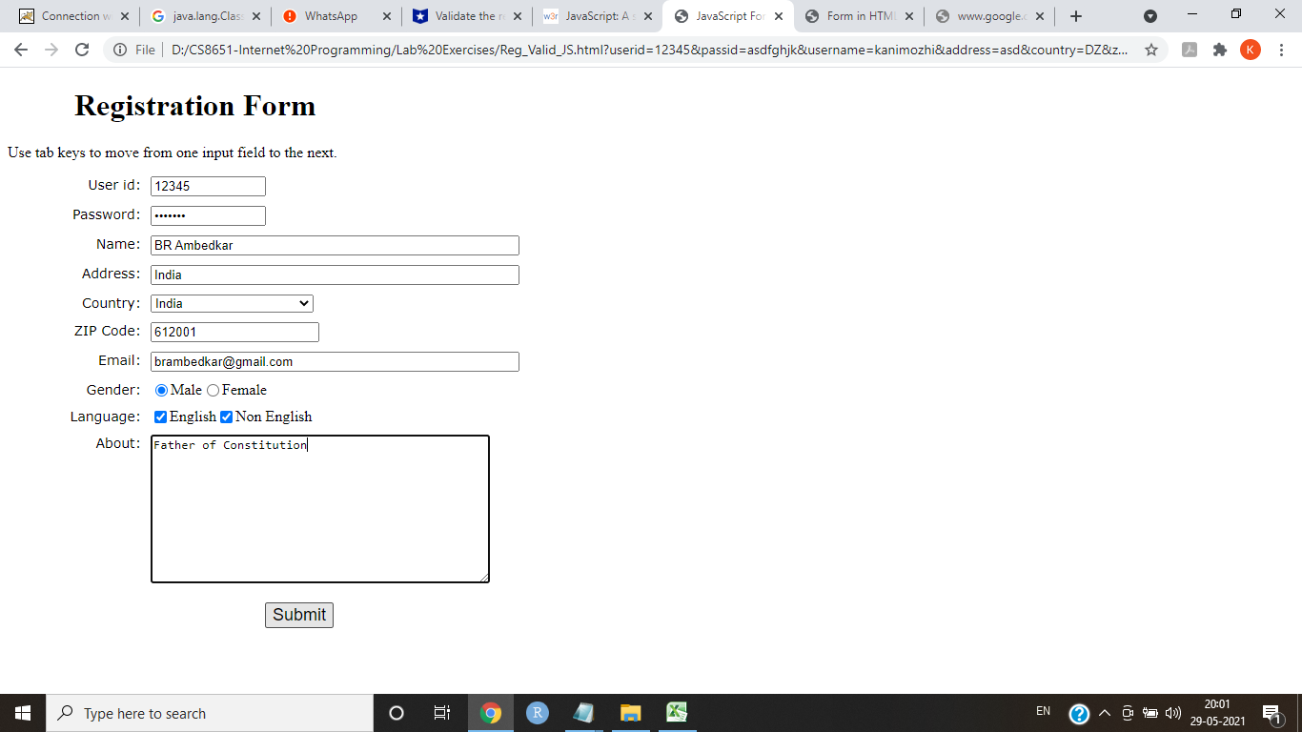 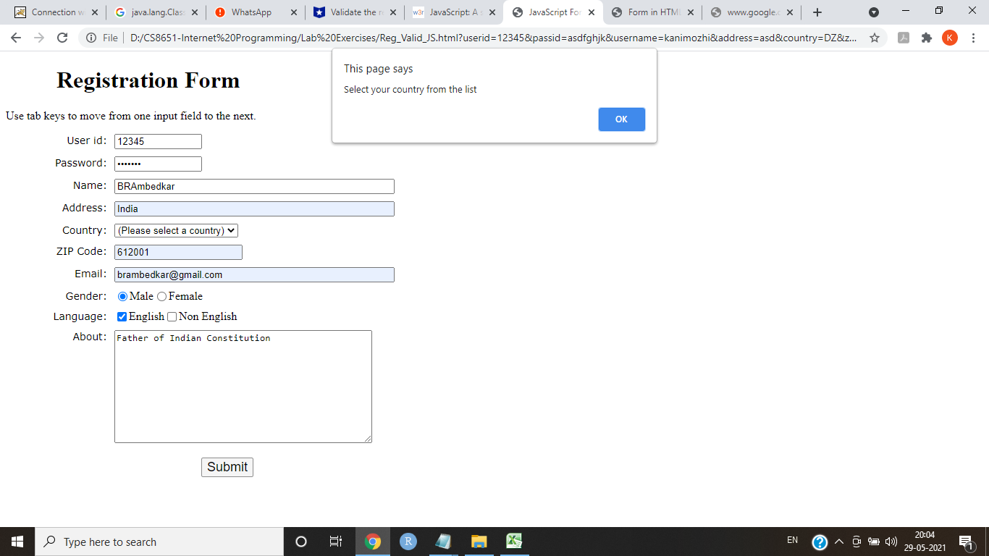 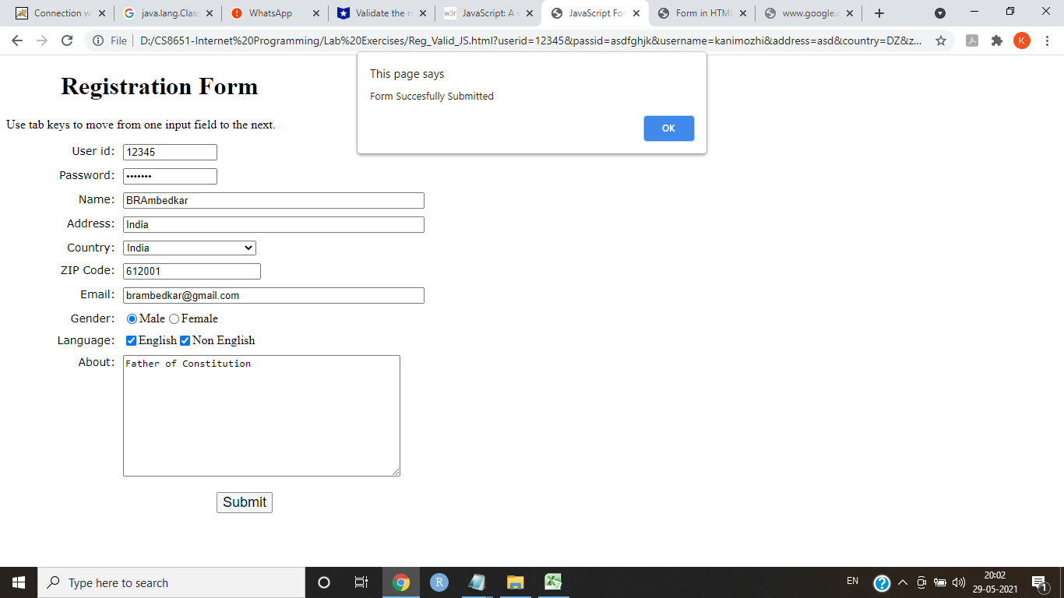 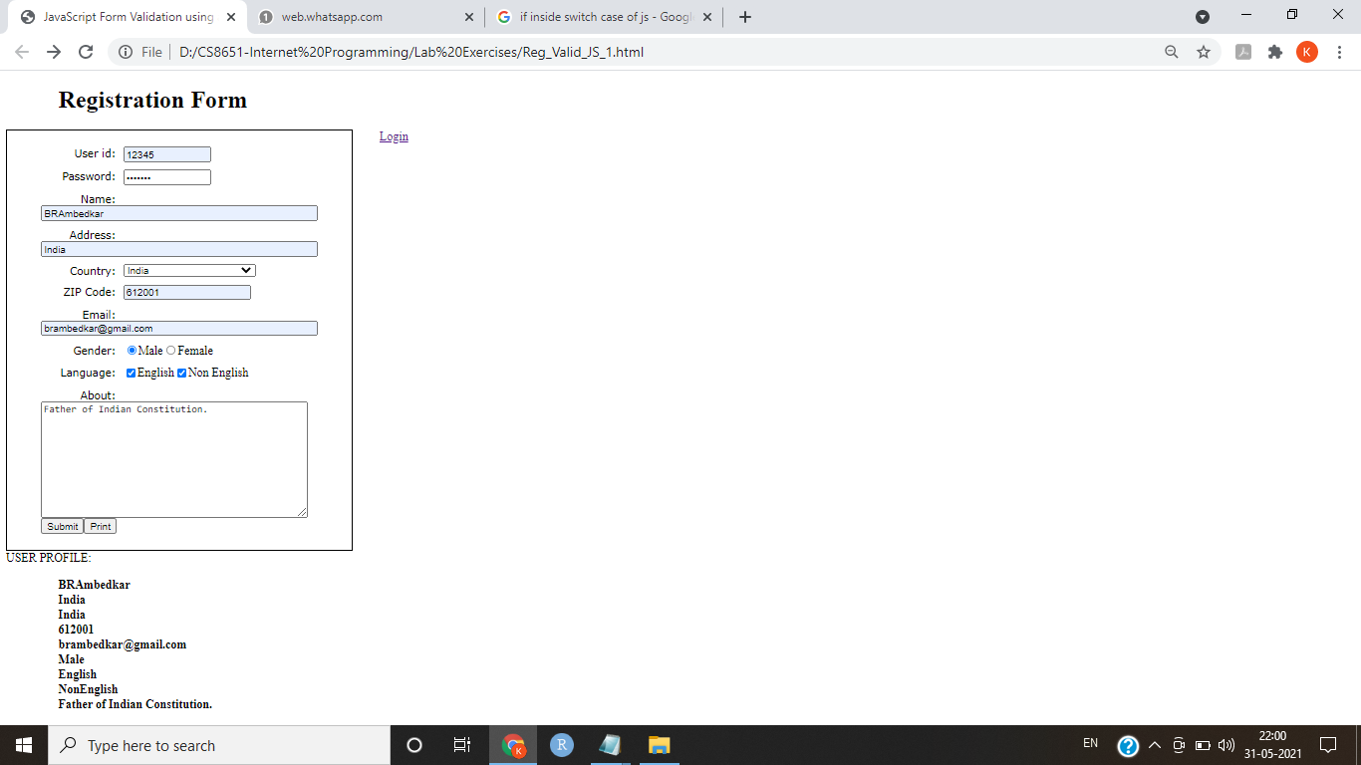 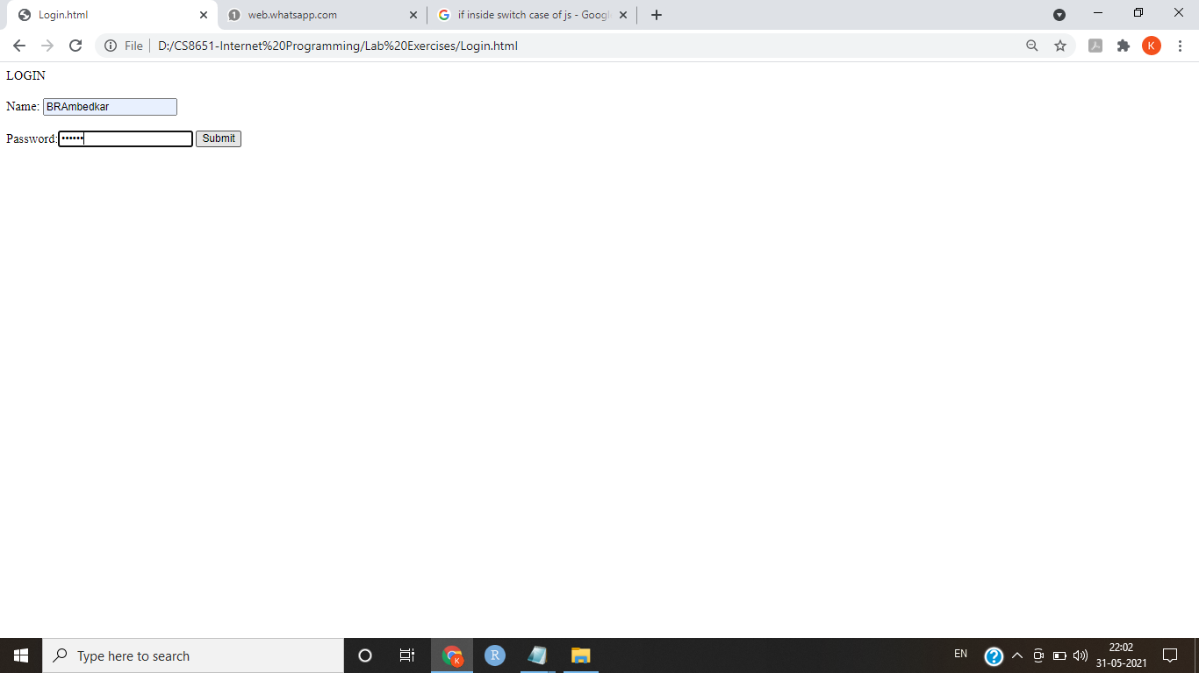 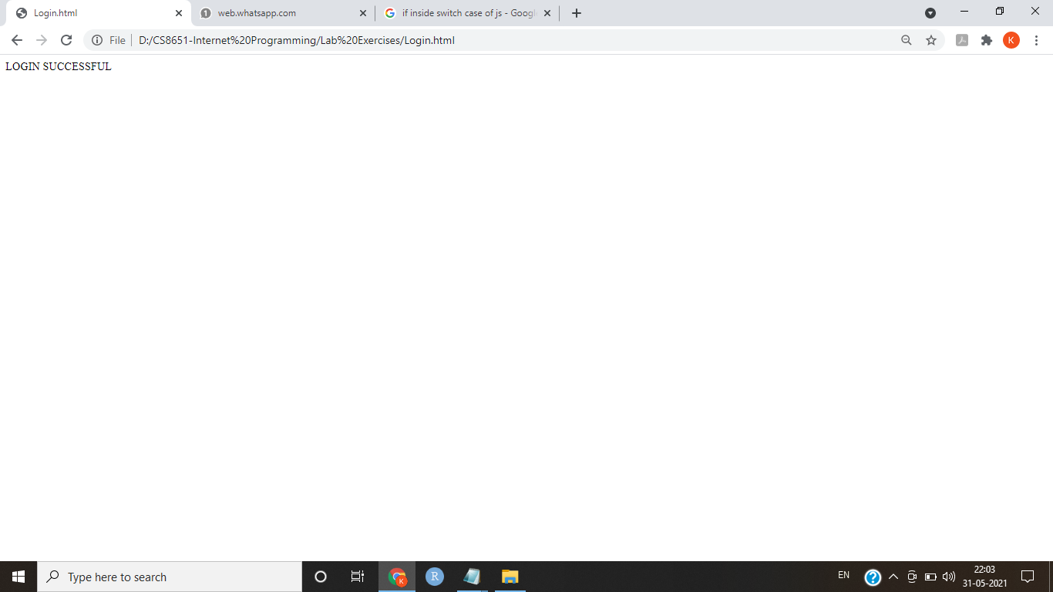

**Result:**

Thus a HTML page is created with an embedded tamilnadu outline image, the hotspots are fixed for the important cities and the relevant information about city is displayed when clicked.