

Machine Learning – Lab 1

学 院 软件学院
专 业 软件工程
姓 名 朱本金
学 号 201430615165
邮 箱 poodarchu@gmail.com
指导教师 吴庆耀
提交日期 2016年11月1日

Data Analysis
DataSet 1： beast-caner dataset， with labels each sample， 1 strands for fine， 2 stands for bad tumor. The dataset has 9 attributes, which need to do dimensionality reduction when visualization.
Dataset 2: the MNIST dataset. To do visualization.
Dataset 3: the students grades dataset, with two times of grades, with lalel pass or fail.
Dataset 4: the microchip dataset, with errors and labels of qualified or not.

Dataset 1 and 2 is used to do Linear regression
Dataset 3 and 4 is used to do Logistic regression

Experiment Process
## Linear regression
- Load the data
- Compute loss function
- Do gradient descent to gain best theta
- Dimensionality reduction and plot
## Logistic regression
- Just familiar with linear regression, but:
- First do non-normalization regression
- Add normalization component and do logistic regression.

Parameter:
In Linear regression, the main parameters I adjust are the
- Learning rate alpha, I finally set to 0.01
- Iteration_times, I set it to 1500
- n_components in PCA set to 2.
In Logistic regression:
- the ones in the above linear regression.
- The normalization parameter lamba, which I try 0, 1 and 100, the I find 1 is the best.

Experimental Results
## Linear Regression
I record the changing trends of Loss function when I was doing gradient descent:
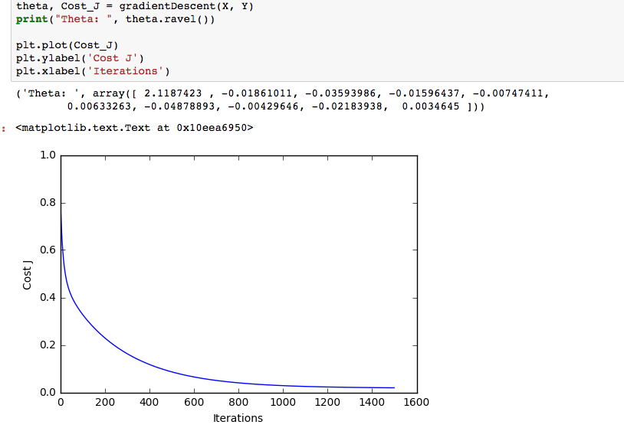
then I use PCA to do dimensionality reduction:
t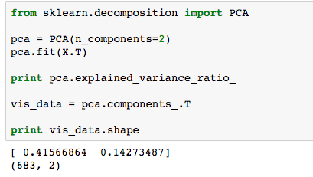
the final result looks like:
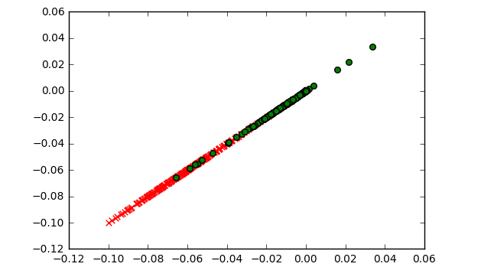
the above is using PCA, then I try TSNE on MNIST dataset:
I choose 20000 out of 70000 samples to speed up computation:
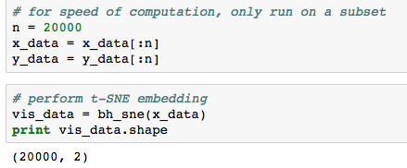
Then I plot the result:

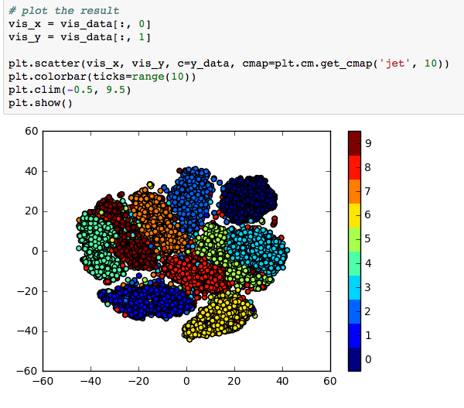

## Logistic regression
first have a glimpse at the data after doing dimensionality reduction:

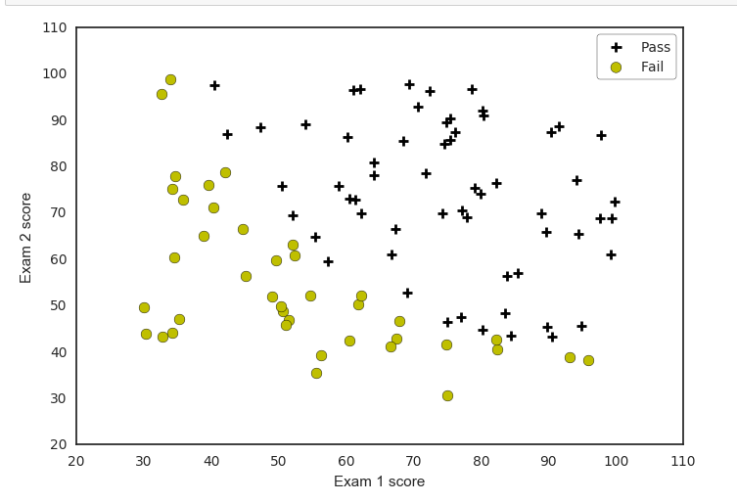
then I define the sigmoid function, the gradient_descent function and loss function, then minimize the Loss function, after several iterations, I got the probably best parametrer.
Then I draw the decision boundary.
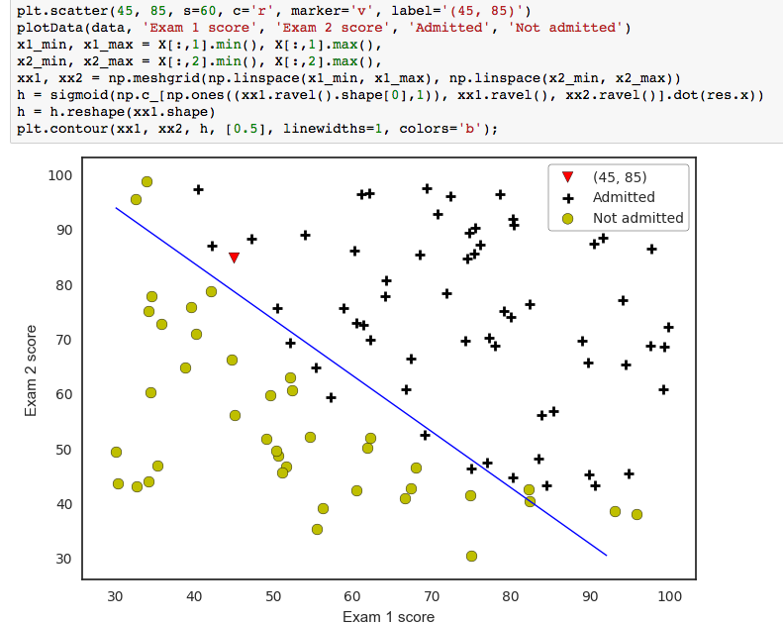

I choose another dataset to try add normalization to the loss function, which looks like:
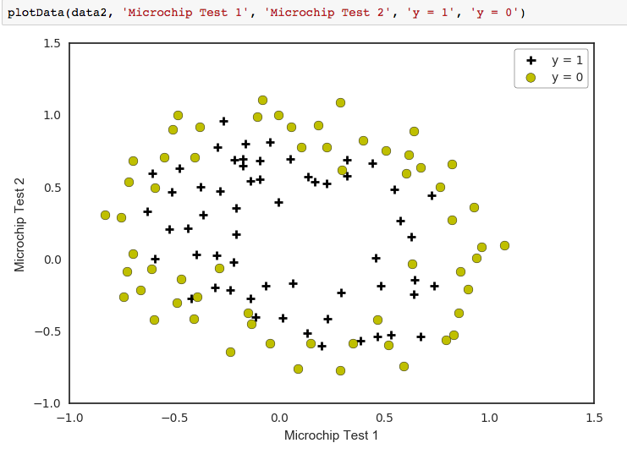
the cost function become:
def costFunctionReg(theta, reg, *args):
m = y.size
h = sigmoid(XX.dot(theta))

J = -1.0*(1.0/m)*(np.log(h).T.dot(y)+np.log(1-h).T.dot(1-y)) + (reg/(2.0*m))*np.sum(np.square(theta[1:]))

if np.isnan(J[0]):
return(np.inf)
return(J[0])
after try normalization lamda on 0, 1, 100, I found 1 is the best:

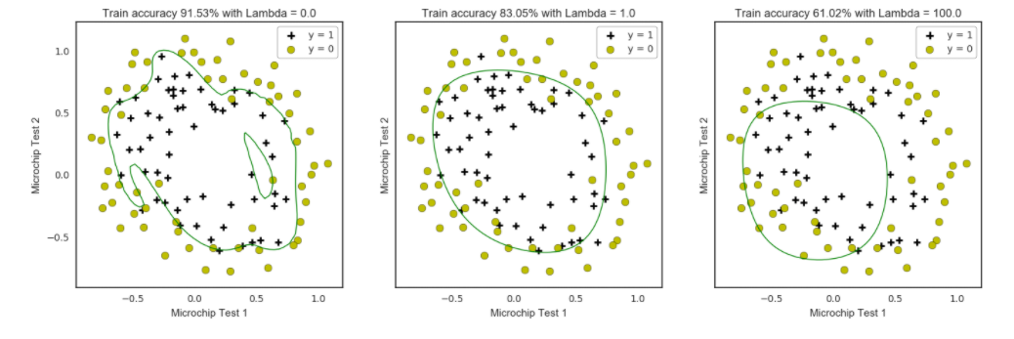

you can tell from above that the middle one is the best.

Discussion and Conclusion
During this lab, I learn how to do data visualization, which is the most gain from this opportunity.
Apart from that, I think deeper when I’m doing parameter tuning.
From the result I think Logistic regression is an esay to learn and use, but still powerful tool to use.

