Liquid Courage  
A 3D Action Adventure game  
Andrew Pugliese  
This is the Unity prototype version of the game. The full game can be downloaded at:  
<http://gameproject.fullsail.com/gpgames/index.php/2015/03/liquid-courage/>

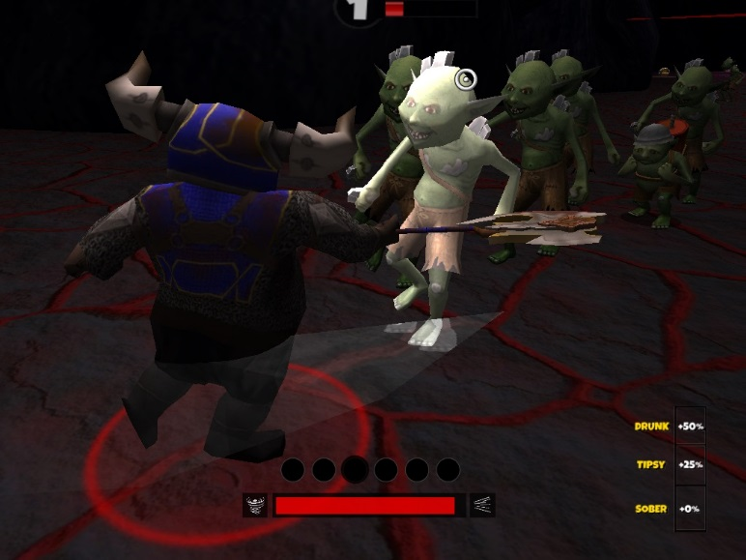

**Controls:***(Controls are for prototype. Full version has documents and tutorial)*

Movement: WASD Keys  
Attack: Left Click  
Dash: Right Click  
Dodge: Space  
E: Open Chests/Doors

**Objective:**

There are 6 levels that each have one of the keys to the boss door. Defeating the enemy spawner at the end of each level will unlock part of the door. As you fight, you will find gold and chests. Gold is used to open chests, which contain powerful flasks of ale that grant you passive and active abilities. After clearing all 6 levels, the boss door will open. You must then defeat the boss to win.

**Focuses of this project:**

This was a 5 month group project, as our final project at school. We had a team 7 and worked under producers, focusing on agile development such as SCRUM. We used Perforce and Hansoft to keep our tasks and overall development organized. We came up with our design over the course of one month, and developed a prototype in Unity in about 2 weeks. The remaining four months we wrote an engine from scratch, with some of its highlights being:

* Stack-based state machine
* Models/Animations to binary exporting tool
* Large scale object manager
* Component architecture
* Dynamic HUD
* Post-process effects
* Multiple AI types
* Cutscenes