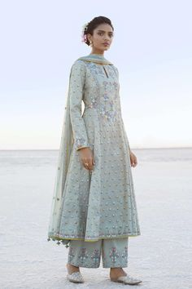

Millia Suit

Inspired by the flowers that bloom in the lush gardens of majestic Rajasthani courtyards, the Millia Suit is beautifully embroidered to perfection with pearls, sequins, zari and zardosi onto delicate fabric. This powder blue suit features a round keyhole

Fashion dress selection of designer dresses

Designer Suits - Buy Millia Suit for Women Online - SS19RR010_Powder Blue - Anita Dongre

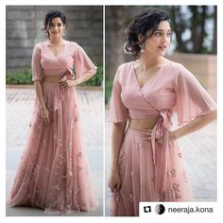

Taavare Clothing

Lovely: wrap-around lehenga choli blouse with bow and bell sleeves. Lehenga and choli blouse in sheer, transparent fabric.

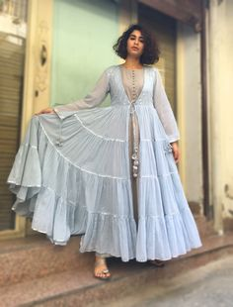

HappyShappy - India’s Own Social Commerce Platform
Anarkali DressPakistani DressesIndian DressesIndian OutfitsIndian AttireIndian Ethnic WearEthnic FashionIndia FashionKurta Designs

HappyShappy - India’s Own Social Commerce Platform

37 Perfect Casual Style Looks To Inspire - Luxe Fashion New Trends

Pattern for grey digital print suit

7 billion others and you: Indianizing the summer

Shrugs for dresses – Lady Dress Designs

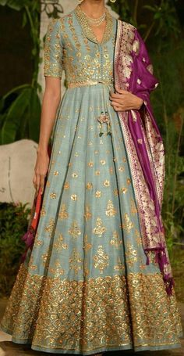

Ideas For Wedding Indian Dress Color Combinations India
Indian GownsIndian AttirePakistani DressesIndian WearIndian OutfitsIndian Designer OutfitsDesigner DressesIndia FashionAsian Fashion

Blouse Neckline these preeti dress available

It should be a selection of dress. The color of the Dresses to Wear to a Wedding ought to fit the fashion and the event.
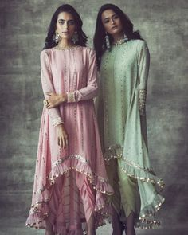

May Brides
Party Wear Indian DressesIndian GownsIndian Wedding OutfitsIndian AttireIndian OutfitsIndian Long FrocksEid DressesDresses OnlinePakistani Dress Design
Looking for mid affordable Gurgaon Budget Lehenga stores? If your budget is anywhere under this lehenga market is perfect for you.

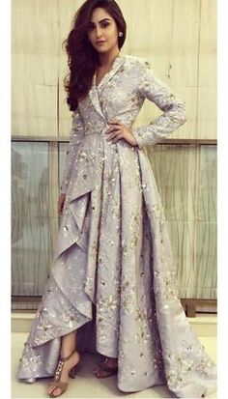

Celebrity Closet – Papa Don't Preach by Shubhika do jacket

Celebrity Closet – Papa Don't Preach by Shubhika do jacket

Jacquard coat gown with thread embellished floral motifs with sequins and bead work paired with a metal sequins , rhinestone belt Composition - Brocade Care Instructions - Dry Clean Only

Cheap High Fashion Women S Clothing

For all your wedding inspirations and ideas, we have a gallery of never ending photos that will keep you busy!
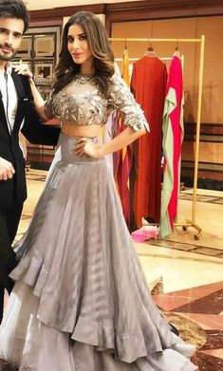

Latest Lehenga Choli Designs for Women Online - Happyshappy!
Lehenga Choli DesignsBridal Lehenga CholiLehenga Designs LatestLehenga Choli OnlineIndian Designer OutfitsDesigner DressesTrajes AnarkaliShararaStylish Dresses
What others are saying

Latest Lehenga Choli Designs for Women Online - Happyshappy!

The latest collection of Lehenga choli designs online on happyshappy! Also available in simple, wedding, bridal, rajasthani styles images, find hairstyle on lehengas cholis ideas and save your favourite once.

A-Line Wedding Dresses Collections Overview 36 Gorgeou…

Beautiful Lehenga-Choli

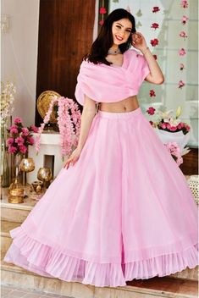

Baby Pink Organza Lehenga
Lehenga CholiBlouse LehengaLehnga DressPink LehengaBridal LehengaLehenga DesignsSaree Blouse DesignsSari DesignIndian Wedding Outfits
Latest Collection of Lehenga Choli Designs in the gallery.
What others are saying

Latest Collection of Lehenga Choli Designs in the gallery.

The Stylish And Elegant Lehenga Choli In Pink Colour Looks Stunning And Gorgeous With Trendy And Fashionable Organza Fabric Looks Extremely Attractive And Can Add Charm To Any Occasion. This Is A Comp.

Baby Pink Organza Lehenga - Source by dresses indian

Trust me when we say this rose pink pleated lehenga trim will bring out the prettiest version of you.
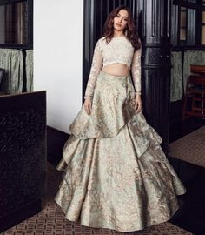

All the glitz & glamour! The beautiful makes a statement & how in this breathtaking royal entry. Outfit: Blouse by & lehenga by Jewellery: Ring by & earrings by Stylist: Photographer: Cinematographer: Hair: Makeup: Art Director: Design: Location courtesy:
Indian Designer OutfitsDesigner DressesIndian DressesIndian OutfitsWestern DressesLehenga DesignsVogueBridal LehengaLehenga Choli

Tamannaah Bhatia Photos plays with intricate floral embroidery

Tamannaah Bhatia Fashion Looks For Wedding Season

Here are 15 wedding trends by actress Tamannaah Bhatia which will inspire you to get celeb fashion and make all the heads turn in the next wedding you attend.

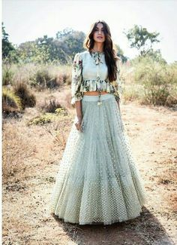

Buy beautiful Designer fully custom made bridal lehenga choli and party wear lehenga choli
Lehenga Choli DesignsBridal Lehenga CholiLehenga Designs SimpleIndian AttireIndian WearIndian DressesIndian OutfitsLehenga StyleLehenga Skirt

Pastel Grey Party Wear Lehenga Choli by Sourgrape's Online - Online shopping for Lehenga Cholis on MyShopPrime -

indian designer wear Check out super cool Peplum Lehenga Styles that you can wear from pre-wedding to your main wedding function. Bonus, some casual ethnic wear peplum lehengas.

Peplum Lehenga Styles have been trending in wedding fashion for a while now. From brides to brides sisters, every girl wants to wear some peplum style lehenga to the wedding functions.

Love this casual ethnic mint blue peplum blouse with tulle lehenga skirt.

Unique

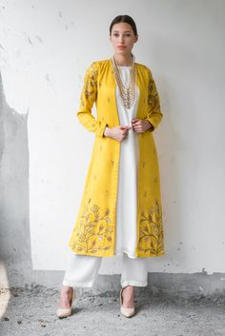

Mustard Long Jacket With Kurta & Palazzo
INDIASPOPUP.COM
Kurta DesignsBlouse DesignsDress DesignsPakistani DressesIndian DressesIndian OutfitsIndian Long DressIndian AttireIndian Wear
Mustard & white satin cotton sequin & zari work ankle-length jacket with kurta & palazzo by Prathyusha Garimella at Aza Fashions

Looking for Unique jacket outfit in yellow and white with straight pants? Browse of latest bridal photos, lehenga & jewelry designs, decor ideas, etc.

Featuring a black chevron long jacket with black kurta and black palazzo. Satin Lining Fabric: Shantoon Closure: Elastic At Waist Care: Dry Clean Only

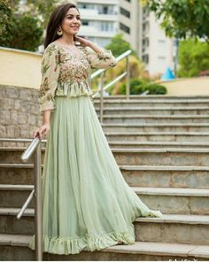

The stunning Ritu Varma looking flawless in Mrunalini Rao . Beautiful pista green color lehenga and peplum top with floret lata design hand embroidery thread work.
Lehenga Choli DesignsIndian Designer OutfitsIndian OutfitsDesigner DressesIndian Gowns DressesPakistani DressesIndian LehengaStylish DressesFashion Dresses
What others are saying

The stunning Ritu Varma looking flawless in Mrunalini Rao . Beautiful pista green color lehenga and peplum top with floret lata design hand embroidery thread work.

Pista green beautiful croptop lehenga is part of Dresses - Fabric Georget lehnga with 3 5 meter flairBanglori blouse with embroidery work all over + printed fabric for sleeves & ruffle pattern ( unstitch )

shaliniboutique - Get gorgeous look by wearing this pastel lehnga

Get your Charming look in this net western wear Bollywood Suit with Heavy embroidered work in sparkling motifs trendy palazzo.

Simplicity is treasured

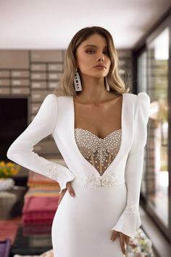

Fashion Evening Gowns Formal Dresses for Girl Glamorous Gowns
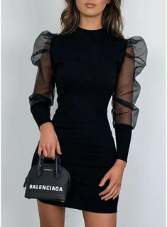

VERYVOGA Solide Lange Mouwen Bodycon Boven de knie Zwart jurkje/Casual/Elegant Jurken - Zwart
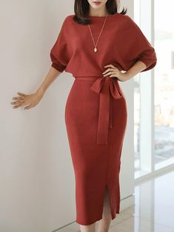
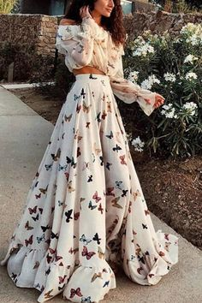

Sexy Off Shoulder Butterflies Floral Printed Maxi Dress
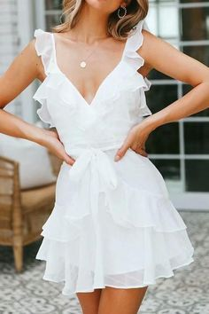

11 Fashion Trends for Summer 2020
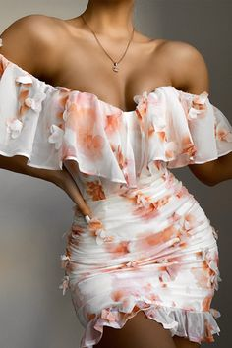

Oriana Dress - Peach Floral
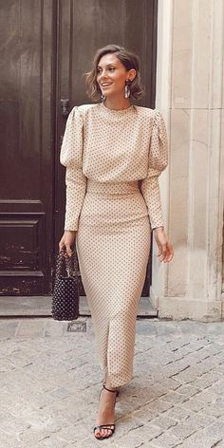

27 Long Mother Of The Bride Dresses
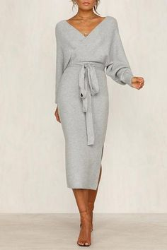

V Neck Backless Sweater Dress
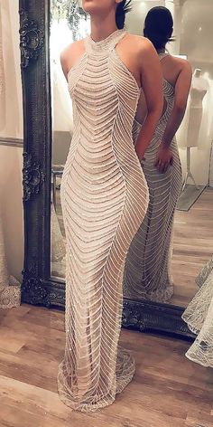

Absolutely Gorgeous Destination Wedding Dresses
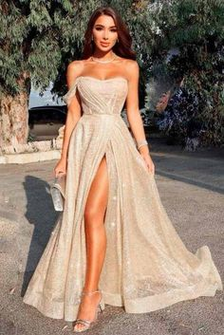
Open

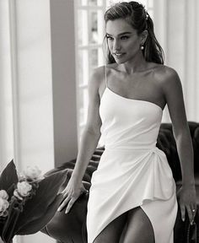

Here Comes the Bride, All Dressed in Alon Livné White
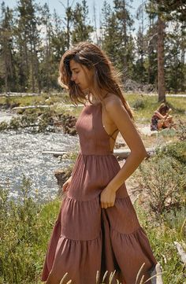

What to Wear: 15 Autumnal Dresses for a Fall Wedding
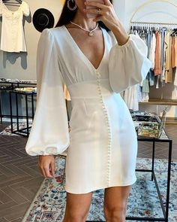
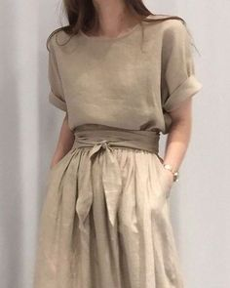
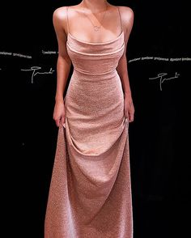
Open
Learn more at susie.laranty.com
72
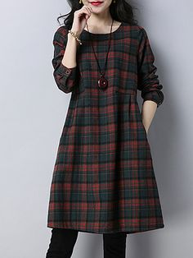

YOINS Khaki Random Leopard Round Neck Patchwork Dress

30+ Winter Date Night Outfits
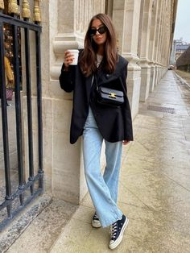

Meet The 8 Must-Know Bag Trends For Fall
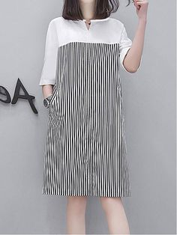

Выкройки трикотажных платьев с запахом
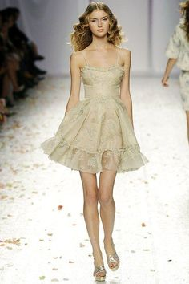

Fashion Evening Gowns Formal Dresses for Girl Glamorous Gowns

VERYVOGA Solide Lange Mouwen Bodycon Boven de knie Zwart jurkje/Casual/Elegant Jurken - Zwart

Sexy Off Shoulder Butterflies Floral Printed Maxi Dress

11 Fashion Trends for Summer 2020

Oriana Dress - Peach Floral

27 Long Mother Of The Bride Dresses

V Neck Backless Sweater Dress

Absolutely Gorgeous Destination Wedding Dresses

60 Most Beautiful Homecoming Dresses

Here Comes the Bride, All Dressed in Alon Livné White

What to Wear: 15 Autumnal Dresses for a Fall Wedding
Open
Learn more at susie.laranty.com
72

YOINS Khaki Random Leopard Round Neck Patchwork Dress
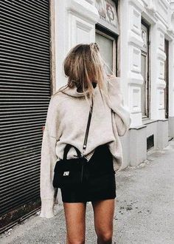

30+ Winter Date Night Outfits

Meet The 8 Must-Know Bag Trends For Fall
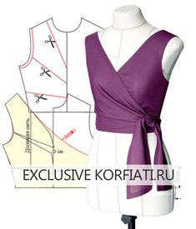

Выкройки трикотажных платьев с запахом

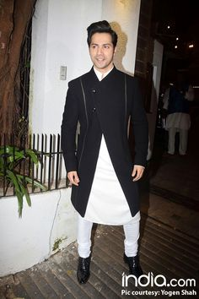

Check out everything Bollywood has been busy with!
Mens Indian WearMens Ethnic WearIndian Groom WearIndian Men FashionMens Fashion SuitsWedding Dresses Men IndianWedding Dress MenWedding SuitsWedding Wear
What others are saying

Deepika Padukone, Shah Rukh Khan, Kareena Kapoor, Saif Ali Khan, Aamir Khan Come Together To Celebrate Diwali – See Pics

Men’s Fashion – How to Nail Office wear – Designer Fashion Tips

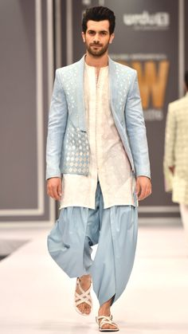

High Fashion Pakistan
Mens Indian WearMens Ethnic WearIndian Men FashionMens Fashion WearHigh FashionIndia Fashion MenPakistan FashionMen's FashionWedding Kurta For Men
High Fashion Pakistan — Deepak and Fahad, Fashion Pakistan Week,. - High Fashion Pakistan — Deepak and Fahad, Fashion Pakistan Week,… -
What others are saying

High Fashion Pakistan is part of Wedding dress men Festive 16 -

61 Best Find the perfect inspiration for your Groom wear images

Classy closed neck semi-formal suit ideas for your wedding. A collection of Royal Sherwani to wear in your brother’s and sister’s wedding.

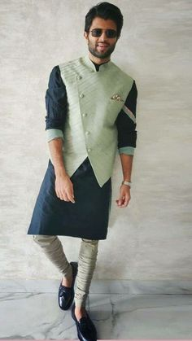

Intricately embroidered bandgala Nehru coat with coordinated peach kurta. Pastel outfit inspiration for Indian groom.
Mens Indian WearMens Ethnic WearIndian Groom WearIndian Men FashionMens Fashion SuitsMens Wedding Wear IndianIndia Fashion MenIndian ManWedding Kurta For Men
What others are saying

various combinations of color and designs for you ethnic wear at Inchstreet.

Wedding Suits Groom look

Are you looking for Custom Clothing & Accessories? Inchstreet is India's custom-made marketplace.

a sweet,roamntic love story of our beloved manan.

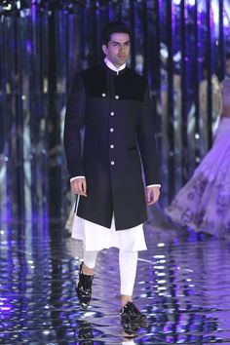

Manish Malhotra at India Couture Week 2017 Call/ WhatsApp for Purchase inqury :
Indian Groom DressWedding Dresses Men IndianWedding Dress MenWedding GroomMens Indian WearMens Ethnic WearIndian Men FashionMen's FashionCouture Week
What others are saying

See Manish Malhotra's complete India Couture Week 2017 show featuring Alia Bhatt and Ranveer Singh on Vogue.

Complete collection: Agami by Neha Agarwal at Lakmé Fashion Week Summer Resort 2018

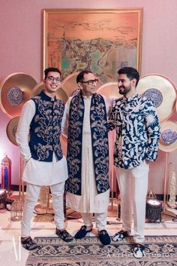

The Most Adorable Groom & Dad Shots We Spotted!
Wedding Kurta For MenWedding Dresses Men IndianWedding Dress MenWedding MenWedding SherwaniMen's Wedding WearWedding Outfits For MenMenswear WeddingWedding Ideas
Family members co-ordinated in matching bridal menswear
What others are saying

11 Families Who Coordinated Their Outfits To Perfection For The Big Day!

You get to see a lot of bride shots with their fathers (most of them super emotional), but how often do you see grooms with their fathers on their wedding? They make an adorable duo too, and one look .

Not Exactly Twinning But they came in the same theme. The Groom His Father & His Little Bro. Who said only girls can work upon there theme. Dont forget to remember your father and brothers.

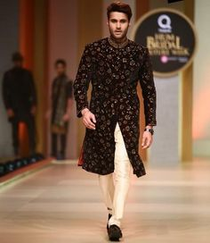

31 Best Pakistani Groom Sherwani Designs for Wedding
Sherwani For Men WeddingWedding Dresses Men IndianGroom Wedding DressPakistani Wedding OutfitsWedding Outfits For GroomWedding SuitsSherwani GroomIndian KurtaMen's Clothing
Wedding Suits black printed wedding sherwani - Need design inspiration for Pakistani wedding sherwani? Check out latest trendy patterns every groom who love Pakistani sherwani should try in wedding.
What others are saying

Clothing: Nandi can close the Sherwani if desired but tends to run hot, so he leave it open normally.

Popping this envy.

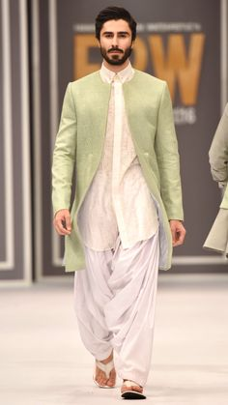

High Fashion Pakistan
Indian Groom DressWedding Dresses Men IndianWedding Outfits For GroomWedding Dress MenMens Indian WearMens Ethnic WearIndian Men FashionHigh FashionMen's Fashion
Intricately embroidered bandgala Nehru coat with coordinated peach kurta. Pastel outfit inspiration for Indian groom.
What others are saying

This combination of contemporary and traditional dress is very easy to pull-off at your brother or sister's wedding. The semi-formal suit style is not going out of fashion anytime soon. A collection of etc. are trending wedding outfit for men in

Deepak and Fahad, Fashion Pakistan Week, Winter/Festive 16

The wedding season is once again approaching soon and gone are the days when only the bride’s wedding outfit and styling used to grab a lot of attention.

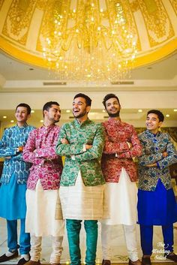

22 Stylish Mehndi Dresses for Men
Wedding Kurta For MenWedding Dresses Men IndianWedding Dress MenWedding MenWedding OutfitsWedding CardSangeet OutfitMehndi OutfitSherwani Groom
Groom Wear - The Dapper Groom!
What others are saying

Indian Wedding Dresses For Men

Our favourite thing about this wedding - the matching outfits the boys side wore during the Sangeet ! Royal weddings seldom come with simplicity.

We know that you boys would be wondering that we write of pieces on brides and on their outfits, jewellery, decor inspiration ideas and all.

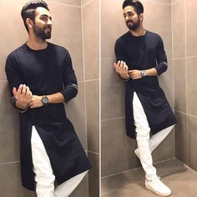

Ayushmann Khurrana Wraps Sriram Raghavan’s Movie With The Stars
Indian Wedding Clothes For MenWedding Kurta For MenWedding Dress MenKurta Pajama MenKurta MenMens Kurta DesignsIndian Men FashionMens Fashion SuitsTraditional Indian Mens Clothing
What others are saying

Yes, Sriram Raghavan’s next movie with Ayushmann Khurrana has been wrapped already and Bareilly Ki Barfi has finished it in a rather unique fashion

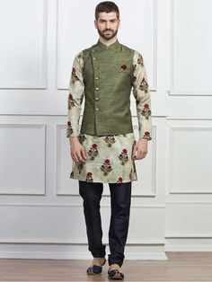

Waistcoat Set for Mens 2020 | G3+ Fashion Mens Waistcoat Sets
Indian Wedding Suits MenWedding Dress MenIndian Wedding OutfitsKurta Pajama MenKurta MenIndian Men FashionMens Fashion SuitsKids Dress WearMen Dress
Waistcoat Set for Men - Let you look smart and dashing in waistcoat set. Buy Online Men's Waistcoat Set for Festive Season in India at Fashion.
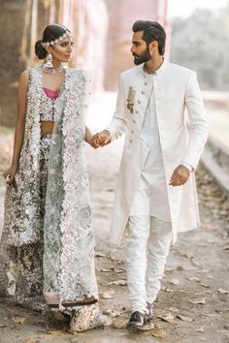

My Pakistani wedding inspirations — lipstick-bullet: “The Jasmine Court” by Elan.
Wedding Dress MenPakistani Wedding DressesIndian Wedding OutfitsPakistani BridalIndian DressesIndian OutfitsBridal DressesIndian Wedding Suits For MenWedding Bride
What others are saying

White/silver elegant detaiked pakistani wedding by elanofficial.

Indian Bridal suits- groom and bride

Pakistani fashion is everything.

ELAN Bridal Dresses Collection Every Brides have many dreams for her big day from celebration to dress up, makeover and even theme of the function .

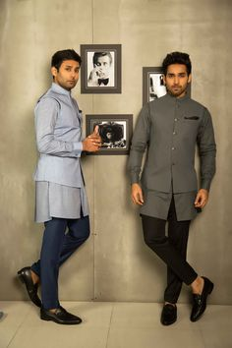

India Fashion Men, Arab Men Fashion, Mens Fashion Wear, Wedding Kurta For Men, Wedding Dresses Men Indian, Wedding Dress Men, Traditional Indian Mens Clothing, Mens Traditional Wear, Punjabi Kurta Pajama Men
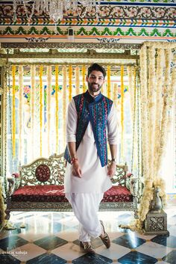

11 Things to Love from this Famous Blogger And Her Model Husband's Wedding!
Mens Indian WearMens Ethnic WearIndian Groom WearIndian Men FashionMens Wedding Wear IndianMens FashionFashion 2020Wedding Dresses Men IndianWedding Dress Men
Groom Wear - The Groom Smaran! Photos Hindu Culture Beige Color Decoration Destination Wedding Designer Groom Wear pictures images vendor credits - Aviraj Saluja Shyamal and Bhumika Makeup by Reema Patil Sabyasachi Couture Pvt Ltd WeddingPlz
What others are saying

Looking for Mehendi groom wear kurta with blue jaipuri jacket?

Ideas for Groom Wear, Decide what to wear - Sherwani or Wedding Suit

You are in the right place about Groom Outfit waistcoat Here we offer you the most beautiful pictures about the Groom Outfit for men you are looking for. Ethnic Jackets and Nehru/Modi jackets to enhance your traditional Indian look in engagement, party or wedding function.

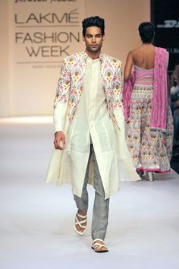

Nargis Fakhri walks the ramp for Ritu Kumar at Lakme Fashion Week 2013
Sherwani For Men WeddingWedding Dress MenIndian Wedding OutfitsIndian Men FashionMens Fashion WearStyle FashionKurta MenMens SherwaniIndian Groom Wear
Model displays Shravan Kumar's collection on day four of the Lakme Fashion Week.

Nargis Fakhri walks the ramp for Ritu Kumar at Lakme Fashion Week 2013

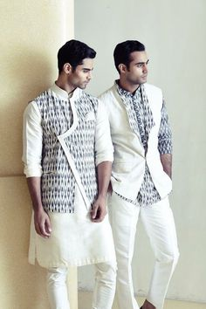

We interview Indian fashion designer Tarun Tahiliani who tells us why Indian fashion is still 10 years behind and the emergence of metrosexual Indian male.
Indian Men FashionMens Fashion WearIndian Fashion DesignersFashion FashionFashion TrendsNew Wedding Dress IndianWedding Dress MenMens Kurta DesignsKurta Design For Men

New wedding dresses indian men tarun tahiliani ideas

indian fashion Casual -- mens fashion & designer clothes

For a day event or groomsmen

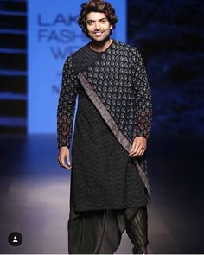

Freshen Up Your Wardrobe with a Touch of Exclusive Styles. Inspired by INCHSTREET.
Mens Indian WearMens Ethnic WearIndian Groom WearIndian Men FashionIndian ManMens FashionEthnic FashionWedding Dresses Men IndianWedding Dress Men

Best Ideas for fashion model men handsome man

Are you looking for Custom Clothing & Accessories? Inchstreet is India's custom-made marketplace. Browse a fantastic range of products and free to use designs.

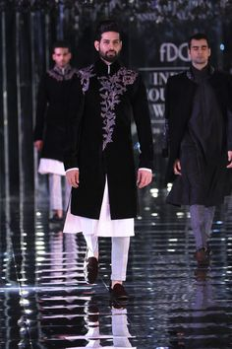

Complete collection: Manish Malhotra at India Couture Week 2017
Sherwani For Men WeddingWedding Dresses Men IndianSherwani GroomWedding Dress MenWedding SuitsBridal DressesKurta Pajama MenBoys KurtaIndian Men Fashion

See Manish Malhotra's complete India Couture Week 2017 show featuring Alia Bhatt and Ranveer Singh on Vogue.

