Source: wikipedia.org

**Moscow, the capital of Russia**

**Moscow** ([/ˈmɒskoʊ/](https://en.wikipedia.org/wiki/Help:IPA/English), [/ˈmɒskaʊ/](https://en.wikipedia.org/wiki/Help:IPA/English);[[10]](https://en.wikipedia.org/wiki/Moscow" \l "cite_note-10)[[11]](https://en.wikipedia.org/wiki/Moscow" \l "cite_note-11) Russian: Москва, [tr.](https://en.wikipedia.org/wiki/Romanization_of_Russian) *Moskva*, IPA: [[mɐˈskva]](https://en.wikipedia.org/wiki/Help:IPA/Russian) ([](https://en.wikipedia.org/wiki/File:Москва.ogg)[listen](https://upload.wikimedia.org/wikipedia/commons/7/71/Москва.ogg))) is the [capital](https://en.wikipedia.org/wiki/Capital_city) and [largest city](https://en.wikipedia.org/wiki/List_of_cities_and_towns_in_Russia_by_population) of [Russia](https://en.wikipedia.org/wiki/Russia). The city stands on the [Moskva River](https://en.wikipedia.org/wiki/Moskva_(river)) in [Central Russia](https://en.wikipedia.org/wiki/Central_Russia), with a population estimated at 12.4 million residents within the city limits,[[12]](https://en.wikipedia.org/wiki/Moscow" \l "cite_note-est.2020-12) while over 17 million residents in the urban area,[[13]](https://en.wikipedia.org/wiki/Moscow" \l "cite_note-Urban-13) and over 20 million residents in the [Moscow Metropolitan Area](https://en.wikipedia.org/wiki/Moscow_metropolitan_area).[[14]](https://en.wikipedia.org/wiki/Moscow" \l "cite_note-Megapolis-14) The city covers an area of 2,511 square kilometres (970 sq mi), while the urban area covers 5,891 square kilometres (2,275 sq mi),[[13]](https://en.wikipedia.org/wiki/Moscow" \l "cite_note-Urban-13) and the metropolitan area covers over 26,000 square kilometres (10,000 sq mi).[[14]](https://en.wikipedia.org/wiki/Moscow" \l "cite_note-Megapolis-14) Moscow is among the [world's largest cities](https://en.wikipedia.org/wiki/List_of_largest_cities), being the [most populous city](https://en.wikipedia.org/wiki/List_of_European_cities_by_population_within_city_limits) entirely within [Europe](https://en.wikipedia.org/wiki/Europe), the [most populous urban area](https://en.wikipedia.org/wiki/List_of_urban_areas_in_Europe) in Europe,[[13]](https://en.wikipedia.org/wiki/Moscow" \l "cite_note-Urban-13) the [most populous metropolitan area](https://en.wikipedia.org/wiki/List_of_metropolitan_areas_in_Europe) in Europe,[[14]](https://en.wikipedia.org/wiki/Moscow" \l "cite_note-Megapolis-14) and also the largest city by land area on the European continent.[[15]](https://en.wikipedia.org/wiki/Moscow" \l "cite_note-Planète_Énergies-15)

Originally established in 1147, Moscow grew to become a prosperous and powerful city that served as the capital of the [Grand Duchy that bears its namesake](https://en.wikipedia.org/wiki/Grand_Duchy_of_Moscow). When the Grand Duchy of Moscow evolved into the [Tsardom of Russia](https://en.wikipedia.org/wiki/Tsardom_of_Russia), Moscow still remained as the political and economic center for most of the Tsardom's history. When the Tsardom was reformed into the [Russian Empire](https://en.wikipedia.org/wiki/Russian_Empire), the capital was moved from Moscow to [Saint Petersburg](https://en.wikipedia.org/wiki/Saint_Petersburg), diminishing the influence of the city. The capital was then moved back to Moscow following the [Russian Revolution](https://en.wikipedia.org/wiki/Russian_Revolution) and the city was brought back as the political centre of the [Russian SFSR](https://en.wikipedia.org/wiki/Russian_Soviet_Federative_Socialist_Republic) and the [Soviet Union](https://en.wikipedia.org/wiki/Soviet_Union). When the Soviet Union dissolved, Moscow remained as the capital city of the contemporary and newly established [Russian Federation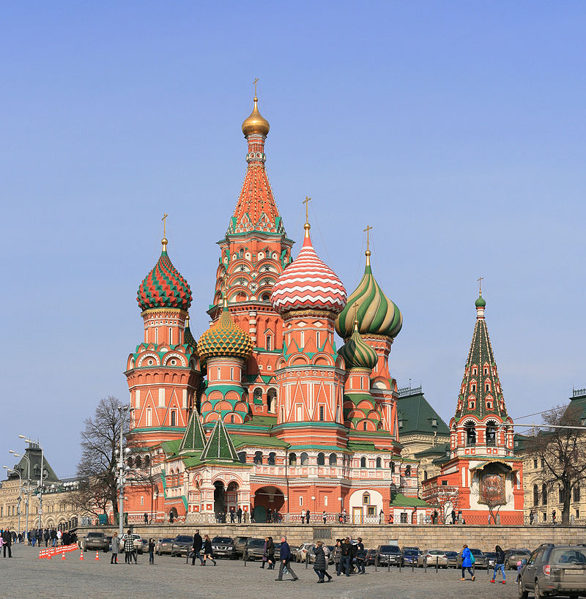](https://en.wikipedia.org/wiki/Russia).

In the 16th and 17th centuries, the three circular defences were built: [Kitay-gorod](https://en.wikipedia.org/wiki/Kitay-gorod) (Китай-город), the White City (Белый город) and the Earthen City (Земляной город). However, in 1547, two fires destroyed much of the town, and in 1571 the [Crimean Tatars](https://en.wikipedia.org/wiki/Crimean_Tatars) [captured Moscow](https://en.wikipedia.org/wiki/Russo-Crimean_Wars), burning everything except the Kremlin.[[38]](https://en.wikipedia.org/wiki/Moscow" \l "cite_note-38) The annals record that only 30,000 of 200,000 inhabitants survived.