Learn to Use this App
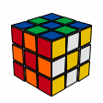

General Introduction
1.Notice: Though this application was originally designed for experienced cube solvers to look up algorithms, anyone who hasn’t even solved the Rubik’s cube for a single time can also use this app to solve their cube by reading this tutorial. Now, let’s get started!!

2.This App uses the CFOP system to solve a Rubik’s, which means ‘Cross; First two Layers; Orientation of Last Layer; Permutation of Last Layer’. Thus, when you are using this app, you’ll take 4 steps to recover your cube.

3.It’s very important for you to understand the cube in a correct way. A Rubik’s cube is not a combination of 6 colors, it is a combination of 26 different pieces that can be divided into 3 different categories: central pieces (with 1 colored face), edge pieces (with 2 colored faces) and corner pieces (with 3 colored faces). Also, no matter how you scramble your cube, the relative position of the central pieces of each face is always the same (e.g. blue central square is always opposite to the green one). You can see that these pieces divide the whole cube into different layers which you can twist. Now you understand what I meant by ’First two Layers’ and ‘Last Layer’:)

4.You’ll encounter many algorithms in this App, and it’s essential for you to understand the notation of these algorithms. You’ll see some confusing marks like F,U,R,L. Remember what I said about layers? These marks refer to different layers. Holding a cube in your hand, the face facing you is the Front face (F).

When you see the mark ‘F’ in the algorithm, it means: twist your front face clockwise for 90degree, just like this

If you see ‘F’ ’, it means: twist your front face counter-clockwise for 90 degree, just like this
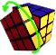
If you see ’F2’, it means: twist your front face for 180 degree, no matter clockwise or counter-clockwise
F = front face
B = back face
L = left face
R = right face
U = up face
D = down face

Step 1: Cross
Now look at your cube, it should be in a great mess, right? Here is the first step of setting it back—Cross.
First of all, choose a color you like and that will be your first layer. Let’s say, blue. Now, find the blue central piece and make a blue cross around it, just like this:
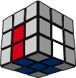.
This is the only step that I can’t give you any algorithm because it’s too flexible. Many may think Cross is too difficult for a beginner. But actually, it’ll become very easy when you get used to the cube and the layers. Try it for yourself, and you’ll soon see how easy it can be!
But, you must pay enough attention here! The edge piece of the cross must be in its proper position
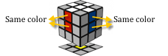

When you can’t make the Cross, just be patient, it’s not as hard as it seems!

Step2: First 2 Layers
Succeeded in the Cross? Congratulations! Now it’s time to go to the second Step.

Now your cube should look exactly like:

And, After F2L, we are going to turn your cube into:
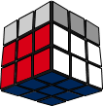
From now on, you can refer to the algorithms in this app. Open the tab ’F2L’ on the bottom bar and you’ll see many algorithms designed for F2L, and the marks of faces should be:
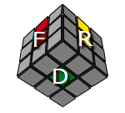
OK, now you can just go ahead, find which algorithm you’ll use, and put back the first 2 layers in their right place.

Having difficulty finding your pattern in the F2L tab? Don’t be panic. Here is something to help you:
1.Don’t be puzzled by colors, it is highly possible that your pattern is exactly like the one on the table, but in different color!
2. Can’t find your pattern on the table? That’s another tricky thing for a beginner. My suggestion is: try to look for a different corner piece (instead of the blue-red-yellow piece as shown), You’ll find a proper algorithm to use!
3. Sometimes, you’ll find that your pattern looks like the one on the table, but it is reversed (mirrored one)! Like
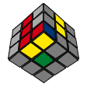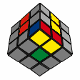
We often call it the Diagonal Mirror of an algorithm. The diagonal mirrored algorithm can be converted from the original one and it’s really simple:
Change all F into R’, R into F’, F’ to R, R’ to F, D to D’, D’ to D, L into B’, L’ into B, B into L’ and L into B’

For example:
The pattern mentioned in the table is
The corresponding algorithm is:
F’ R F R’
If you get:
The converted algorithm is:
R F’ R’ F

See, just like what you do when you place a mirror on the diagonal line!

Step3: Orientation of Last Layer
When you are in this step, you’re done with your first two layers, which means: this is your cube:
In OLL, you ‘ll have to orient all the green colored faces of the last layer to create a green upper face:
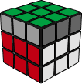

Algorithms will help you do this very quickly. Go to the OLL tab and look up your pattern!

Here, the marks of faces should be:
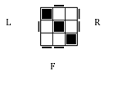
In OLL, there’ll be some new notations:
Notation | Fs | Fs' | Ra | Ra'
 | 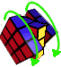 | 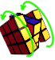 | 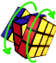 | 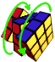
Equals to | F B' | F' B | R L | R' L'
With this, you’ll be able to recognize the algorithms of OLL.

Having completed F2L, I believe you’ll have no difficulty doing OLL. There’s only one thing I want to bring to your attention:
In OLL, you’ll meet another kind of mirror pattern: the Left-Right Mirror:
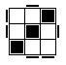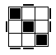
This time, you can change L into R’, R into L’, L’ into R, R’ into L, F’ into F, F into F’, U into U’ ,U’ into U, B into B’, B’ into B
For example:
To solve the above pattern, just convert the original one:
R' F R F' U' Ls D' F D Rs
into
L F' L' F U Ls D F' D' Rs
And everything will work!

Step 4: Permutation of Last Layer
Well done!! There is just one more step to make!!
Now that you have finished the OLL, the only thing you have to do put the pieces of the last layer back into their proper places! Find the ‘improperly-placed’ pieces and think about how to swap their places to make the last layer correct. There’ll be no mirror in PLL because I’ve already listed all possibilities in this App. Use the proper algorithm and everything will be perfect:
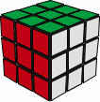
Cheers!!!!!!! You have solved the Rubik’s cube! Now you can show off to your friends and families :-D

