Project : Using AWS Elastic Beanstalk to Set Up RDS and Access It from an EC2 Instance

) 📖 Project Overview
This project demonstrates deploying a Flask web application using AWS Elastic Beanstalk integrated with Amazon RDS (MySQL). It also includes secure database access from a separate EC2 instance, monitoring using CloudWatch, and optional use of Secrets Manager.

🏗️ Architecture Diagram

Flow:
User Request
↓
Elastic Beanstalk
↓
EC2 (Beanstalk Instance)
↓ Flask App
↓
Amazon RDS
↓
Data Response

Manual EC2 (Testing)
↓
Connects to RDS using MySQL / Python script

CloudWatch
↑
Monitors EC2 + Application logs

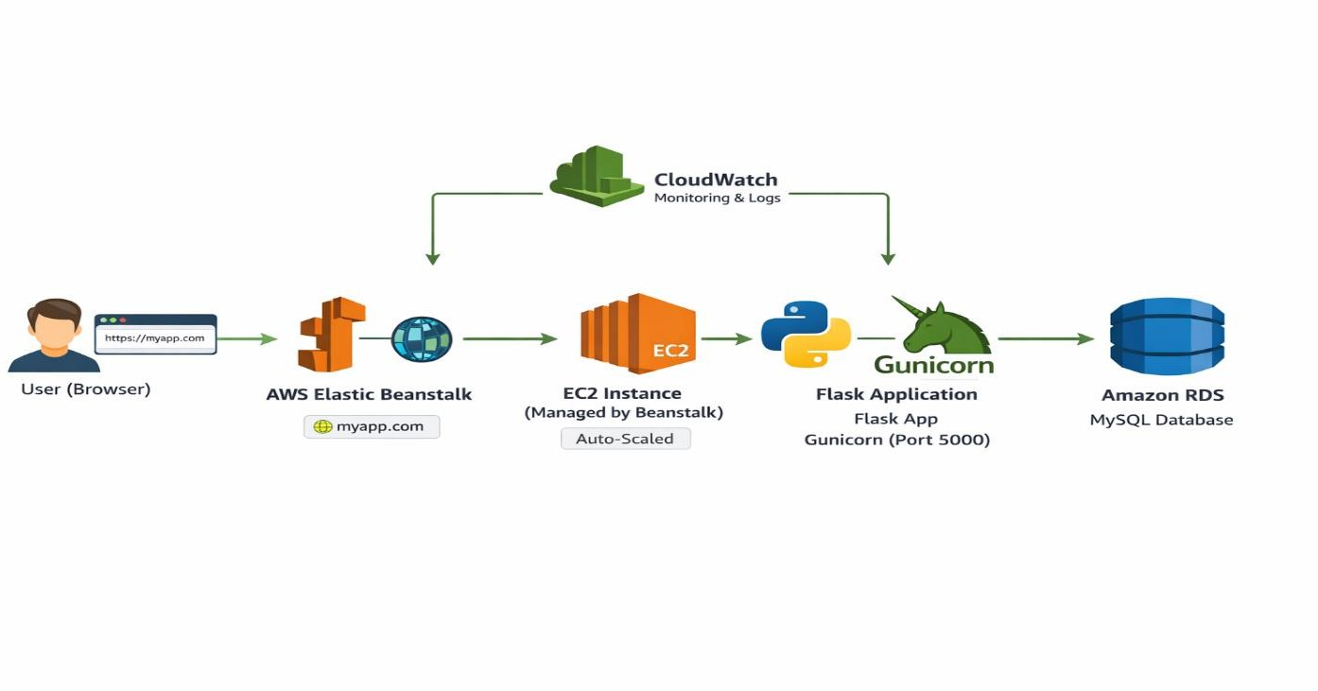

Technologies Used & Purpose

Service | Purpose
AWS Elastic Beanstalk | Application deployment & management
Amazon EC2 (Beanstalk) | Runs Flask app (auto-created by Beanstalk)
Amazon EC2 (Manual) | Used for testing and accessing RDS database
Amazon RDS (MySQL) | Managed relational database to store application data
VPC, Subnets, Security Groups | Network isolation and secure communication between resources
AWS IAM | Manages roles and permissions for secure AWS access
Amazon CloudWatch | Monitoring performance metrics and logs
AWS Secrets Manager (Optional) | Secure storage of database credentials

H•O• Step-by-Step Implementation

Elastic Beanstalk Environment Setup
  - Created a Web Server Environment using Elastic Beanstalk
  - Platform: Python (Flask)

  - Instance Type: t3.micro

Enabled RDS database creation during setup

Ensured both EC2 and RDS are in the same VP

RDS Configuration
  - Engine: MySQL
  - Instance Type: db.t3.micro
  - Database created within same VPC
Security Group Configuration:
  - Allowed port 3306 (MySQL) access only from:
    - Elastic Beanstalk EC2 Security Group
    - Separate EC2 instance (manual)
  - Public access:
    - Disabled (for security)

EC2 Instance Setup (Manual)

Launched a separate EC2 instance in same VPC
  - Connected via SSH:
ssh -i key.pem ubuntu@<EC2-PUBLIC-IP>

Install required tools:
sudo apt update
sudo apt install mysql-client python3-pip -y

Connect to RDS:
mysql -h <RDS-ENDPOINT> -u admin -p

Successfully accessed database from EC2

Test Script for RDS (Read/Write)
Created a Python script (test_db.py) to verify database operations:
import pymysql

connection = pymysql.connect( host="<RDS-ENDPOINT>",
user="admin", password="<PASSWORD>", database="ebdb"
)

cursor = connection.cursor()

# Create table cursor.execute("""
CREATE TABLE IF NOT EXISTS users (
id INT AUTO_INCREMENT PRIMARY KEY, name VARCHAR(50)
) """)

# Insert data
cursor.execute("INSERT INTO users (name) VALUES ('TestUser')") connection.commit()

Run script:

python3 test_db.py

✔ Verified:

  - Insert operation
  - Read operation

CloudWatch Monitoring

Enabled monitoring using Amazon CloudWatch:
Metrics monitored:
  - CPU Utilization
  - Network In / Out
Steps:
  - Navigate to CloudWatch → Metrics → EC2 → Per-Instance
  - Selected instance metrics
  - Viewed real-time graphs

Secrets Manager (Optional)

Stored database credentials securely using AWS Secrets Manager. Example:
import boto3 import json

def get_secret():
client = boto3.client("secretsmanager", region_name="us-east-1") response = client.get_secret_value(SecretId="myrds-secret") return json.loads(response["SecretString"])

✔ Avoids hardcoding credentials in code

🔐 Security Considerations
  - RDS is not publicly accessible
  - Database access restricted via Security Groups
  - IAM roles used for secure AWS access
  - Secrets Manager used for storing sensitive credentials
  - No hardcoded passwords in application

—ˆ• 📸 Screenshots

Include the following screenshots:

- Elastic Beanstalk environment (Running)
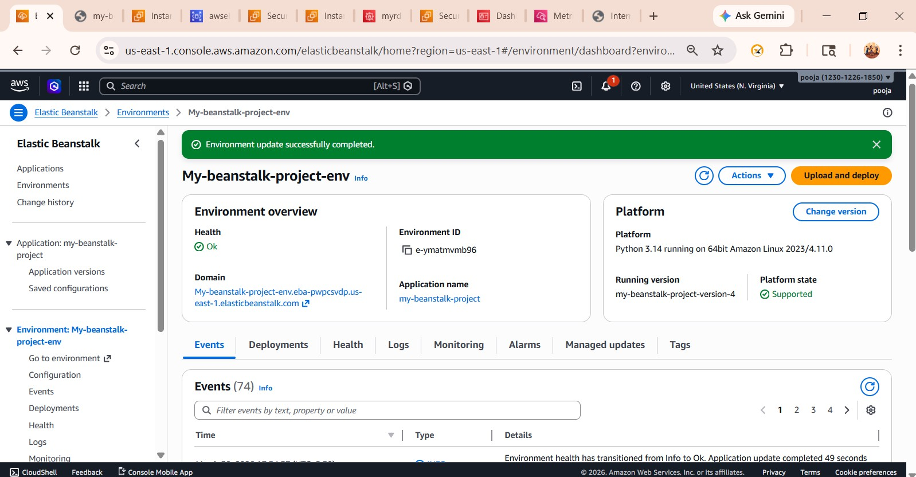

- RDS instance created via Beanstalk

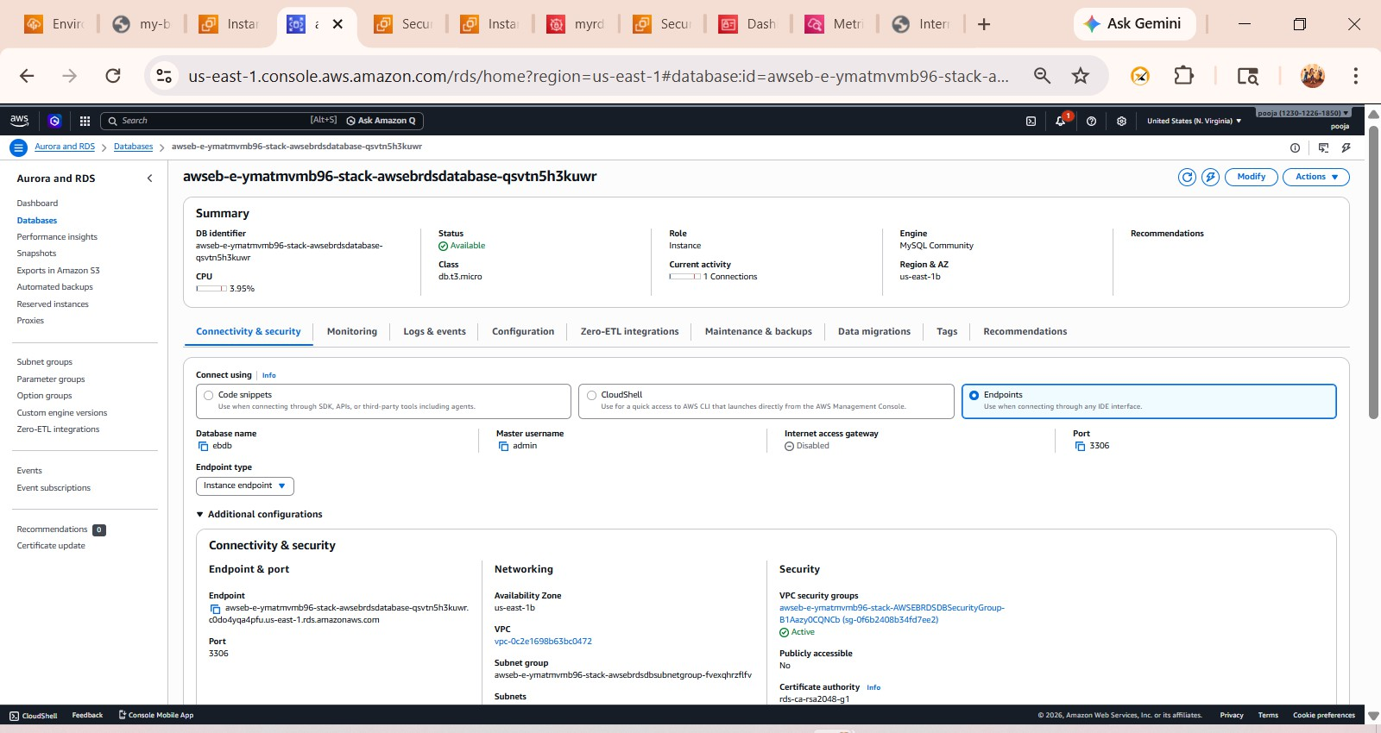

- EC2 instances (Beanstalk + Manual)

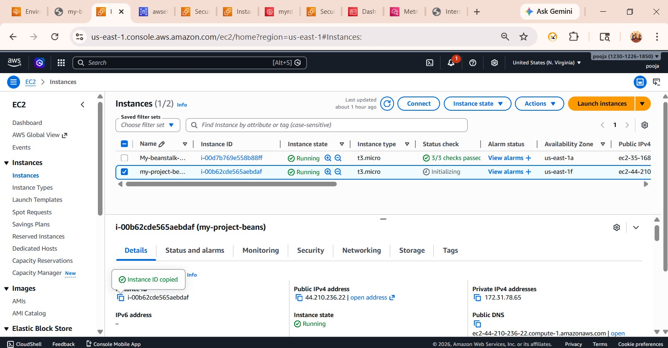

- IAM roles / policies
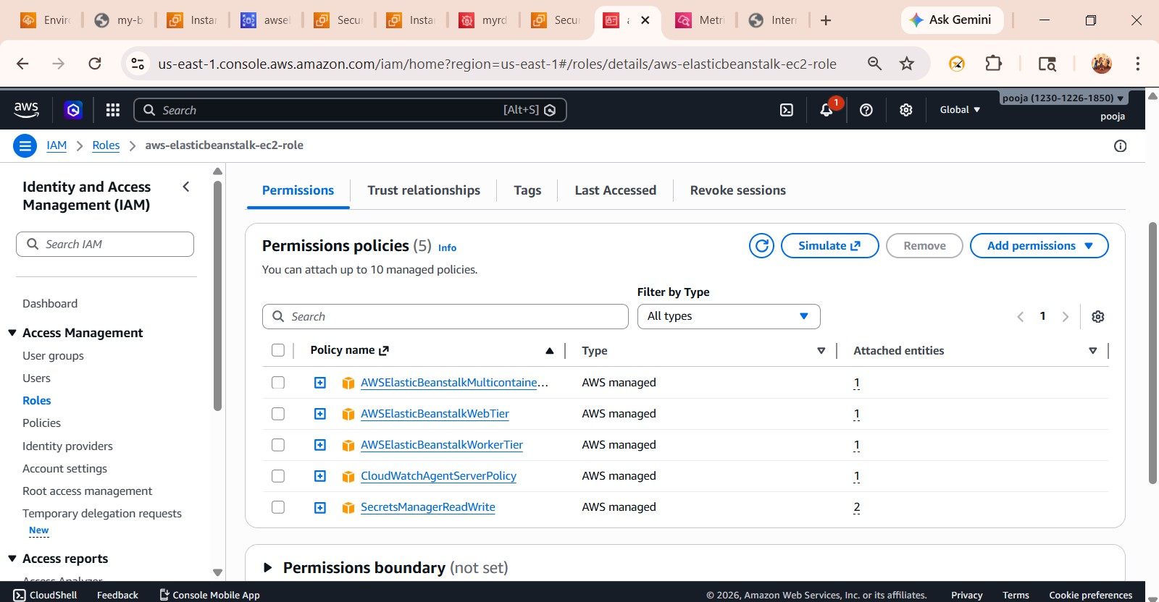

- EC2 to RDS connection (terminal)
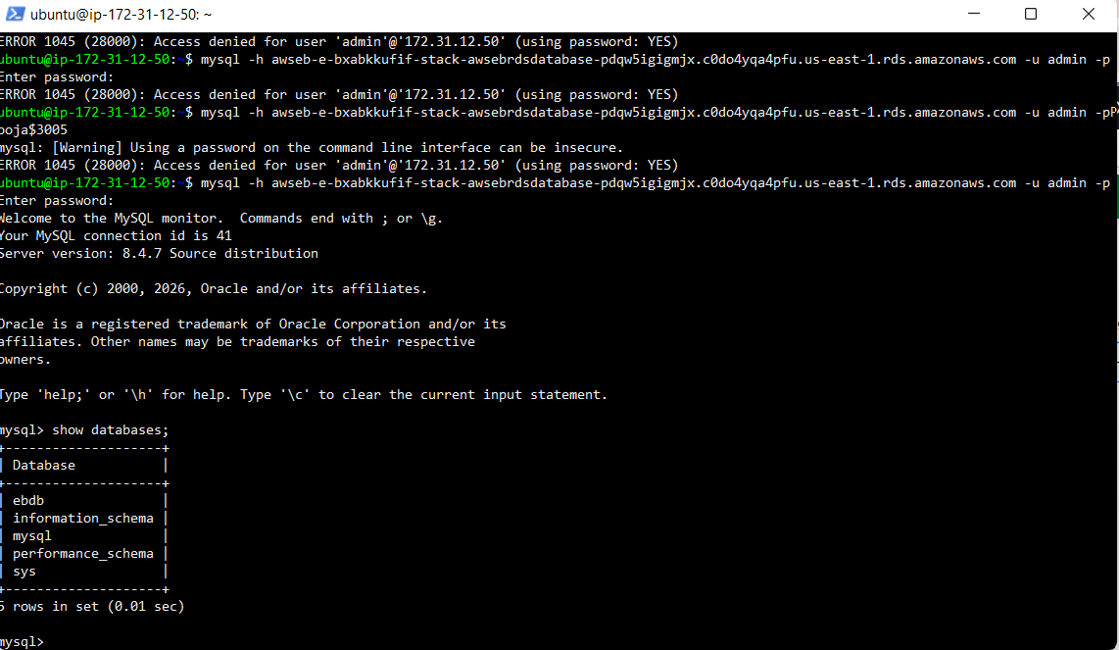

- Test script execution output
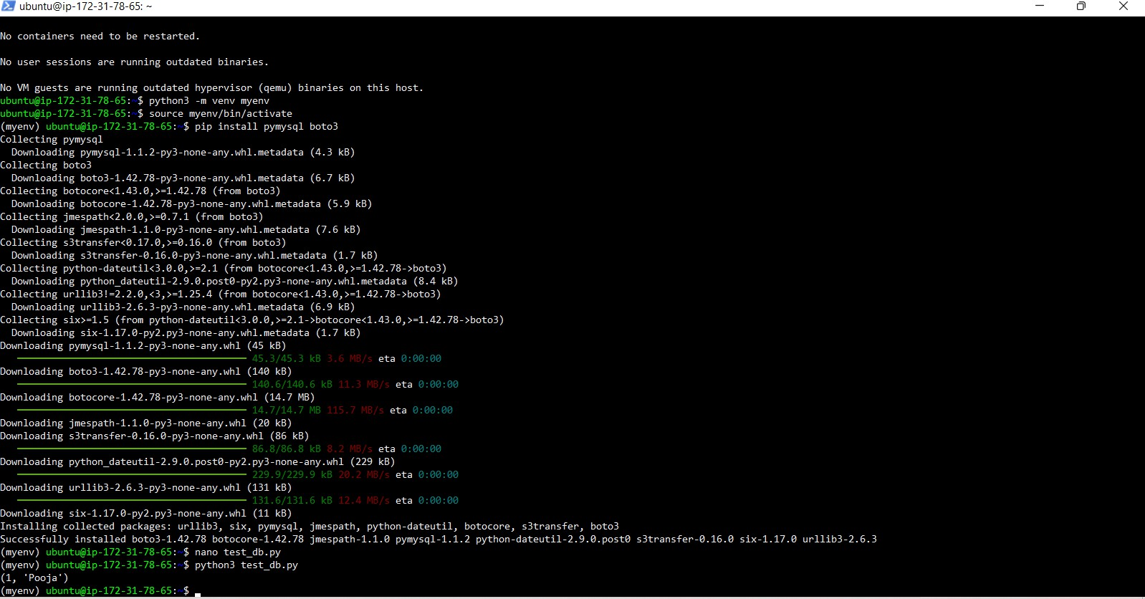

- Flask application output
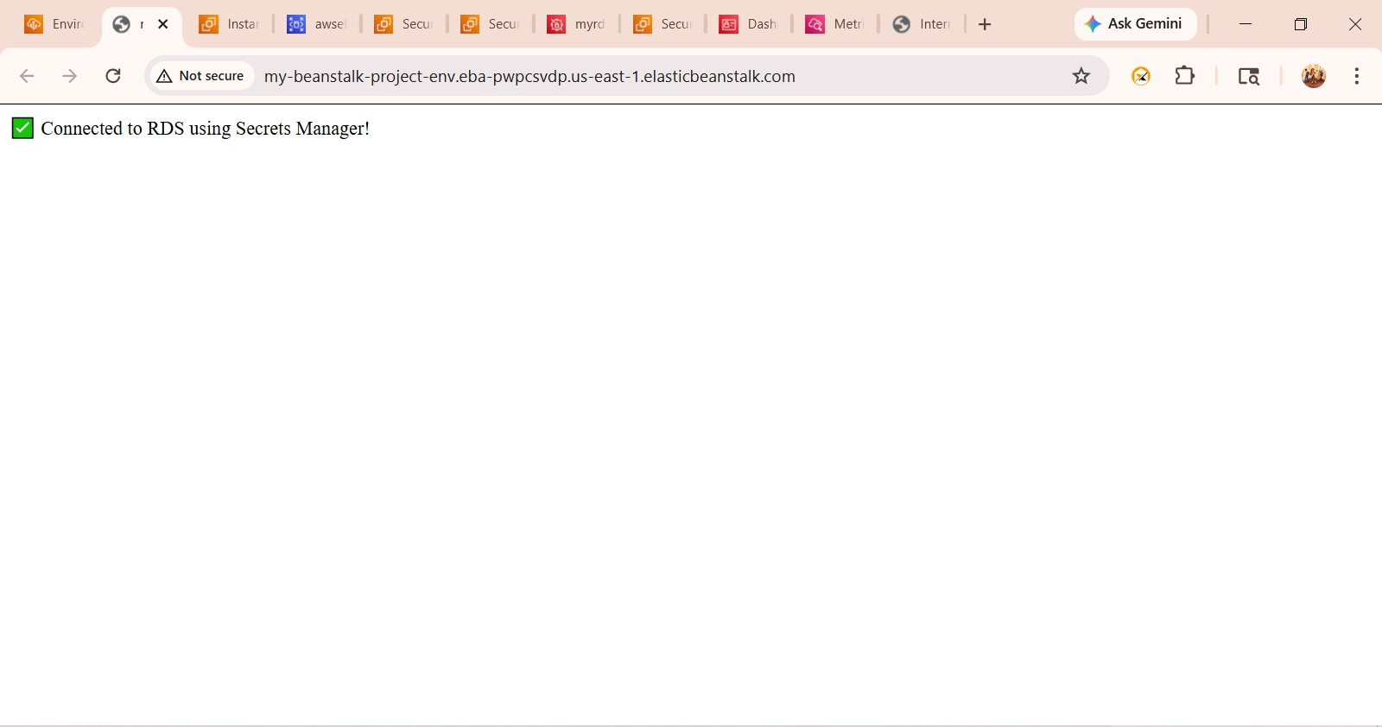

- CloudWatch metrics (CPU)
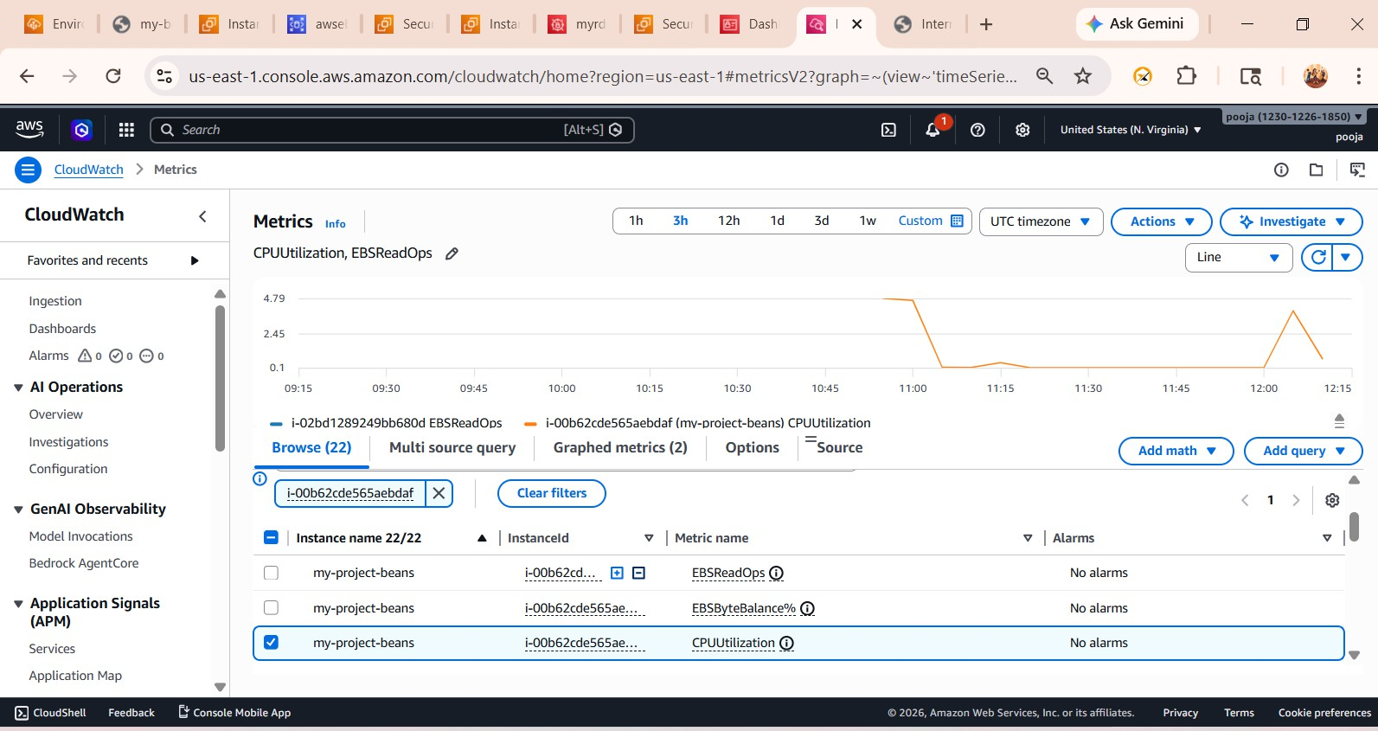

- CloudWatch metrics (Network)

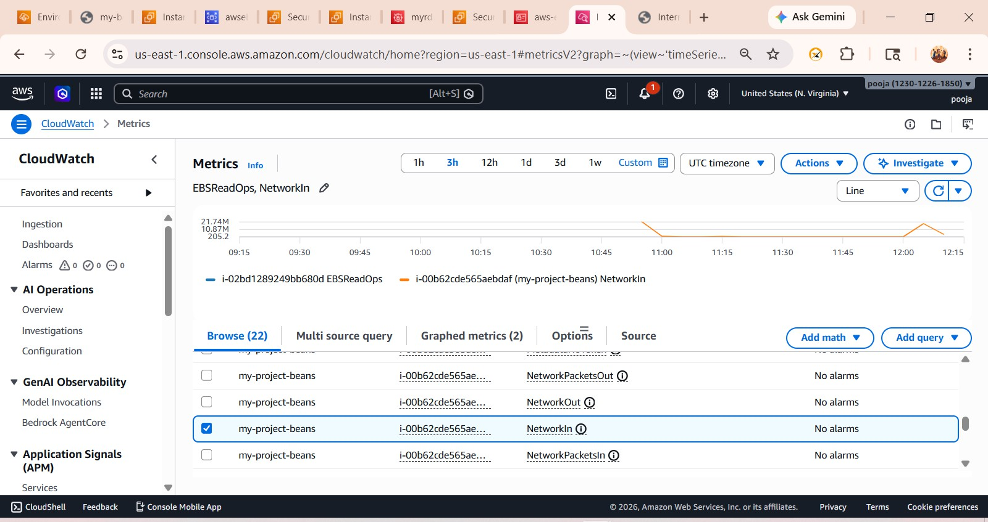

⬛»⬛ Traffic Flow
Client Request
↓
Elastic Beanstalk URL
↓
EC2 Instance (Flask App)
↓
Amazon RDS (MySQL)

⚠️ Challenges & Solutions

Issue | Solution
Unable to connect to RDS | Fixed security group rules
Deployment issues | Corrected project structure
Database connection error | Used correct endpoint
Package installation error | Used virtual environment

●◉✅ Conclusion

  - Successfully deployed a Flask application using Elastic Beanstalk
  - Integrated Amazon RDS securely
  - Validated database connectivity via EC2
  - Implemented monitoring using CloudWatch
  - Followed best practices for security and configuratio

👩‍💻 Author
Pooja Dange
Cloud & DevOps Learner
📧 Email: poojadange1501@gmail.com
🔗 LinkedIn: https://www.linkedin.com/in/pooja-dange-0270072b3
💻 GitHub: (तुझा GitHub link इथे टाक)

