Project: EC2 Instance Launch with Enforced Tagging Policy

📌 Objective
This project demonstrates how to enforce mandatory tagging on EC2 instances using AWS IAM policies to ensure proper cost tracking, governance, and accountability.

🏗️ Architecture Diagram
IAM User (project-user)
│
│ ec2:RunInstances
▼
IAM Policy (Tag Enforcement)
│
▼
Condition Check
(Required Tags + Place = Pune)
│
┌────┴────┐
│ │
YES NO
│ │
▼ ▼
EC2 Instance Request Denied ❌
Launched ✅ (Explicit Deny - IAM)

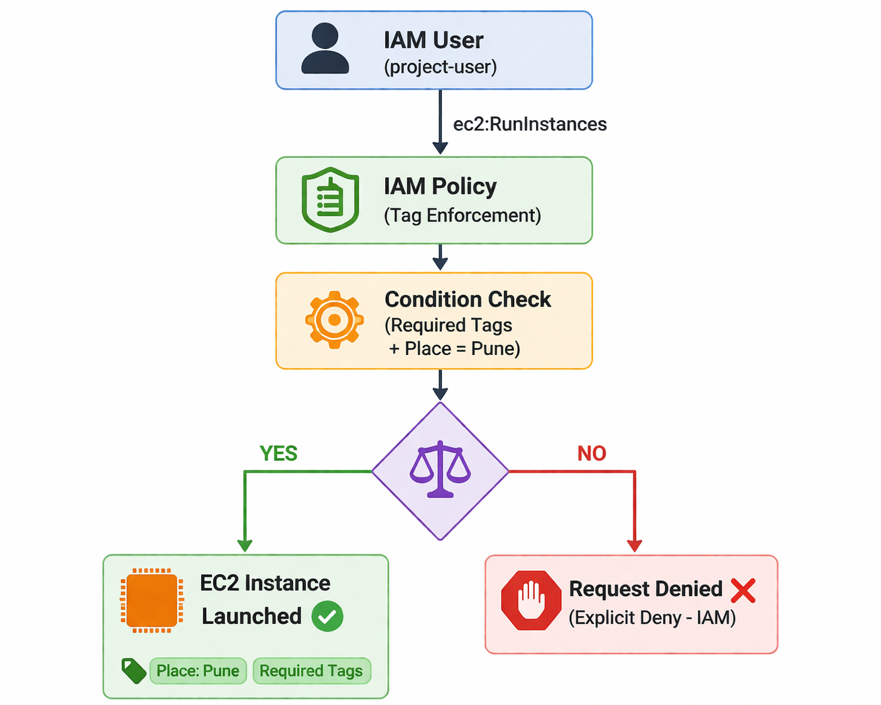

✅ Required Tags
The following tags must be provided during EC2 launch:
Tag Key | Example Value
Name | Pooja
emailID | pooja@example.com
phoneNo | 9846447366
Place | Pune

🔐 Tag Policy Implementation (IAM Policy)
An IAM policy was created to deny EC2 instance creation if required tags are missing or incorrect.

🔧 Policy Logic
- Deny if required tags are missing
- Deny if Place is not equal to Pune

📜 IAM Policy JSON
{
"Version": "2012-10-17",
"Statement": [
{
"Sid": "EnforceMandatoryTagsOnEC2",
"Effect": "Deny",
"Action": "ec2:RunInstances",
"Resource": "arn:aws:ec2:*:*:instance/*",
"Condition": {
"Null": {
"aws:RequestTag/Name": "true",
"aws:RequestTag/emailID": "true",
"aws:RequestTag/phoneNo": "true",
"aws:RequestTag/Place": "true"
}
}
},
{
"Sid": "EnforcePlaceValue",
"Effect": "Deny",
"Action": "ec2:RunInstances",
"Resource": "arn:aws:ec2:*:*:instance/*",
"Condition": {
"StringNotEquals": {
"aws:RequestTag/Place": "Pune"
}
}
}
]
}

🖥️ EC2 Launch Process (With Tags)

Steps:
- Go to AWS Console → EC2 → Launch Instance
- In Name and Tags section, add all required tags:
  - Name = <your-name>
  - emailID = <youre-gmail>
  - phoneNo =<your-phoneNo>
  - Place = Pune
- Select AMI (Amazon Linux)
- Choose instance type (t3.micro)
- Create/select key pair
- Configure security group
- Click Launch Instance

✅ Result:
Instance launched successfully because all required tags were present.

❌ EC2 Launch Without Tags (Failure Case)

Test Scenarios:
- Missing tags
- Incorrect tag value (Place ≠ Pune)

❌ Result:
- Instance launch failed
- Error message:
You are not authorized to perform this operation...
explicit deny in an identity-based policy

📸 Screenshots
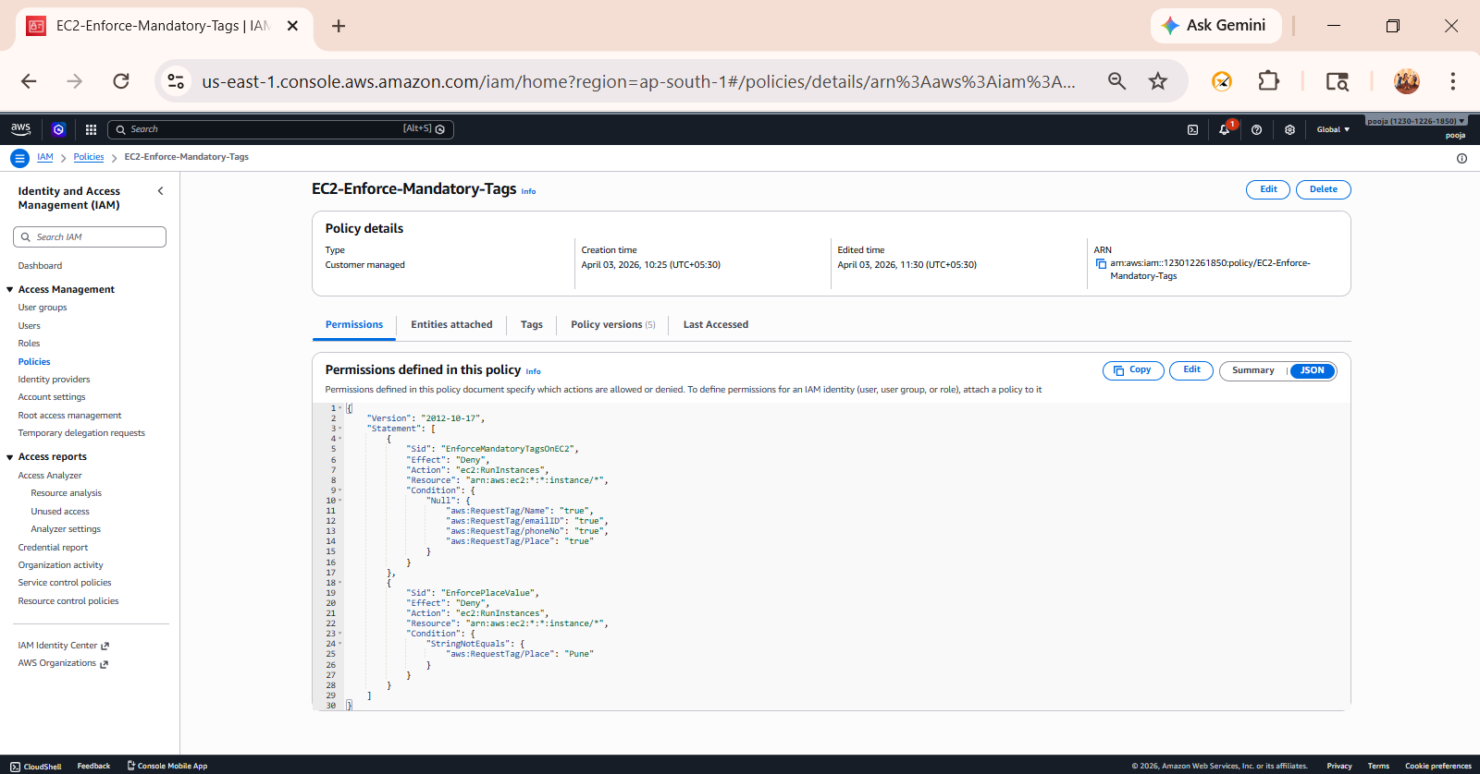
- IAM Policy Creation

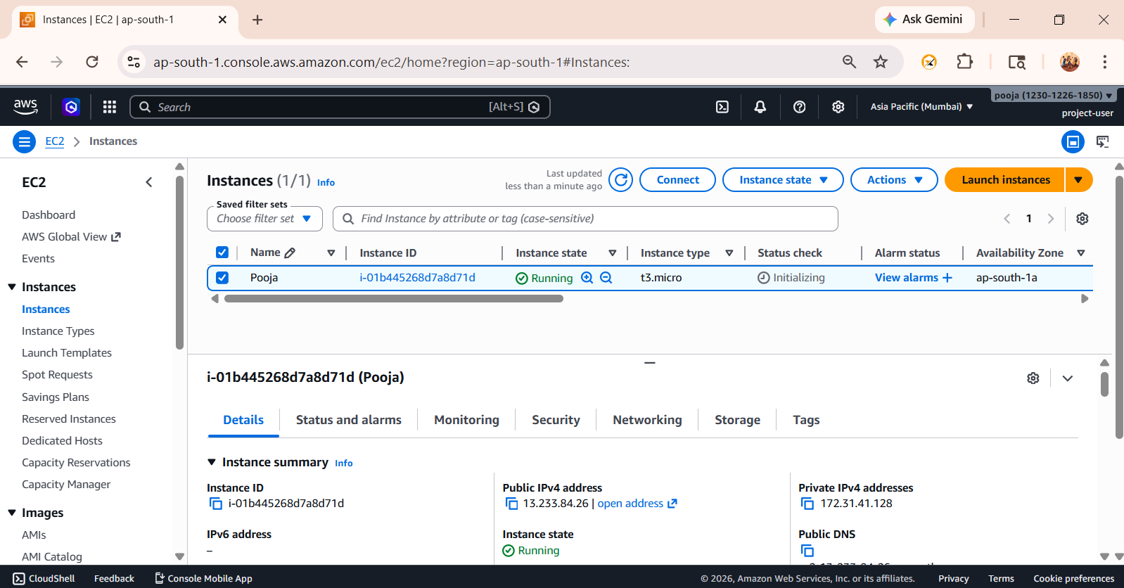
- EC2 Instance Running (State = running)

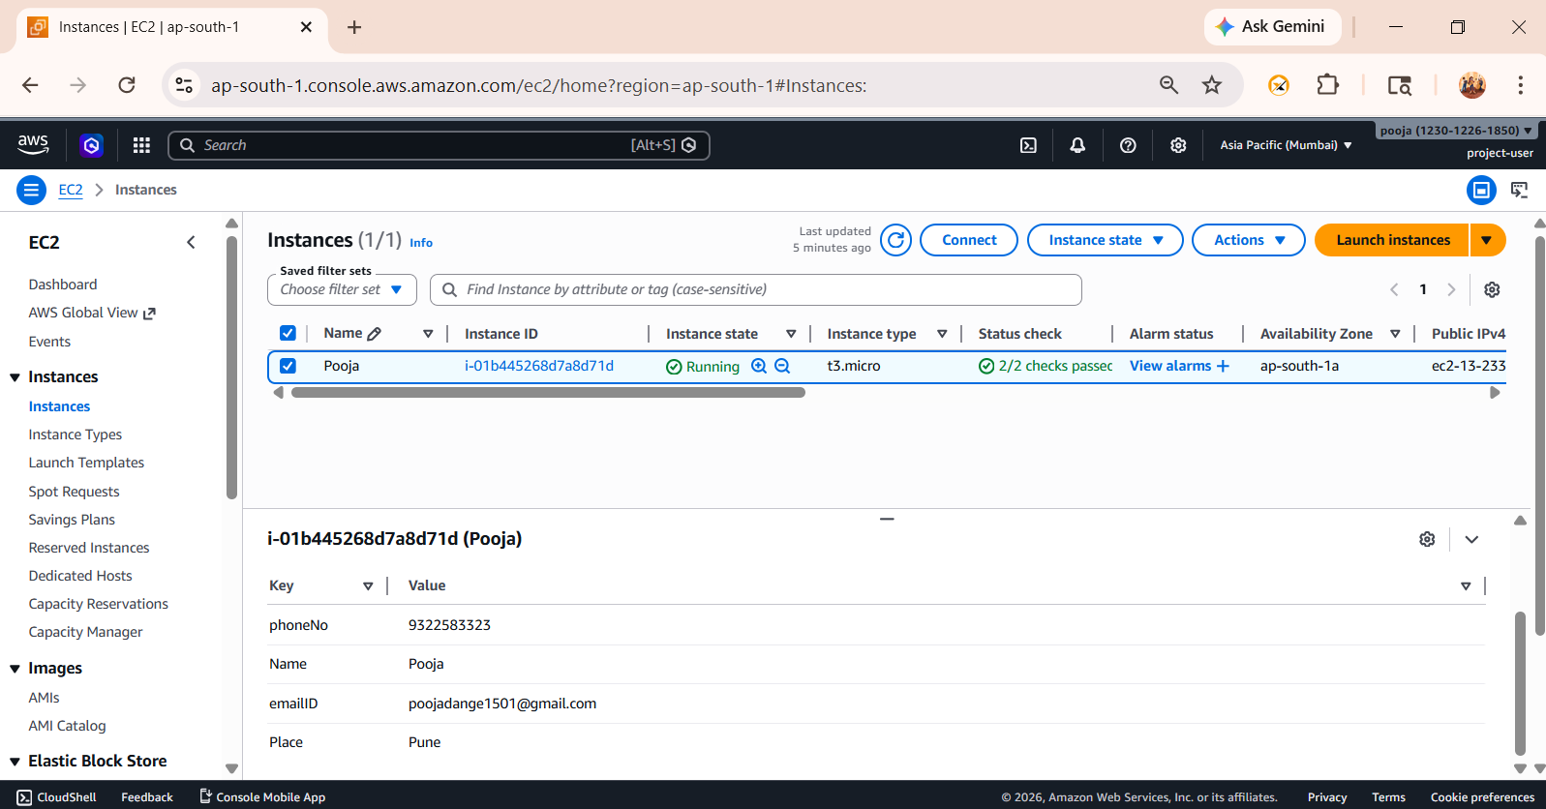
- Tags Tab showing all 4 tags

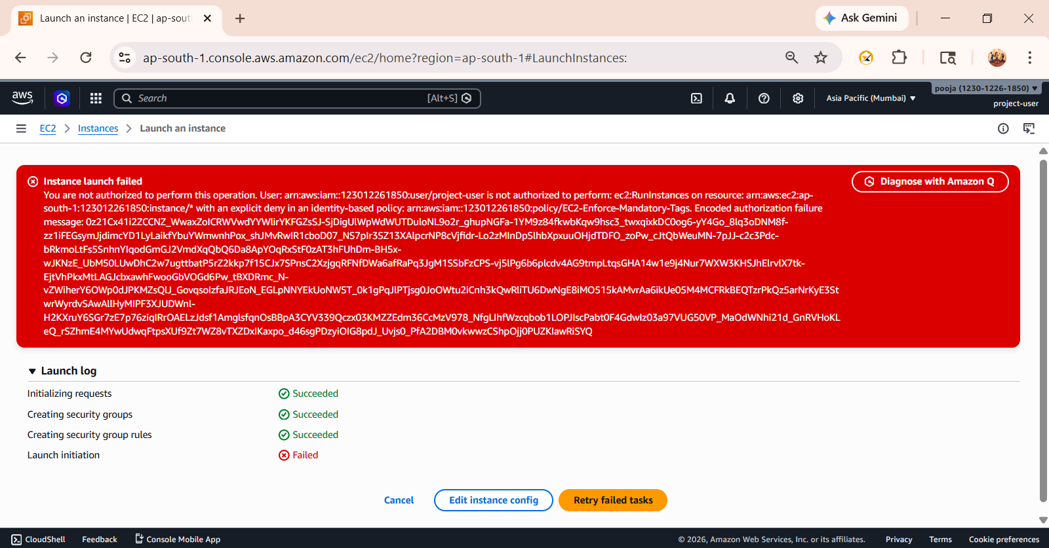
- Error Screenshot (without tags)

🧾 Step-by-Step Guide

🔹 1. How to Apply Tags While Launching EC2 (Console)
- Go to AWS Console → EC2
- Click Launch Instance
- In Name and Tags section:
  - Click Add additional tags
  - Add following:
    - Name = Pooja
    - emailID = poojadange1501@gmail.com
    - phoneNo = 9322583323
    - Place = Pune
- Complete remaining steps (AMI, Instance Type, Key Pair, Security Group)
- Click Launch Instance

3. How to Enforce Tag Policy (IAM Console)
- Go to IAM → Policies
- Click Create Policy
- Select JSON tab
- Paste the IAM policy (given above)
- Click Next → Name policy (e.g., EC2-Enforce-Mandatory-Tags)
- Click Create Policy
- Attach policy to:
  - IAM User

🔍 Observations
- IAM policy successfully enforced tagging
- EC2 instance creation is blocked if tags are missing
- Helps in cost allocation and governance

🎯 Conclusion
This project demonstrates how AWS IAM policies can be used to enforce mandatory tagging on EC2 instances. This ensures better resource management, cost tracking, and organizational compliance.

👩‍💻 Author
Pooja Dange
Cloud & DevOps Learner
📧 Email: poojadange1501@gmail.com
🔗 LinkedIn: https://www.linkedin.com/in/pooja-dange-0270072b3
💻 GitHub: (तुझा GitHub link इथे टाक)

