🚀 Automated Docker CI/CD Pipeline (Jenkins + AWS ECR + Lambda)

📌 Overview
This project demonstrates a complete CI/CD pipeline that automates Docker image build and deployment to Amazon ECR using Jenkins.
An event-driven AWS Lambda function is triggered via EventBridge after every successful image push.

🧠 Architecture

Flow:
Developer (GitHub)
│
▼
Jenkins Pipeline
(Build + Docker Image)
│
▼
Amazon ECR
(Store Docker Image)
│
▼
EventBridge Rule
(Detect Image Push)
│
▼
AWS Lambda
(Trigger Automation)
│
▼
CloudWatch Logs
(Logs / Monitoring)

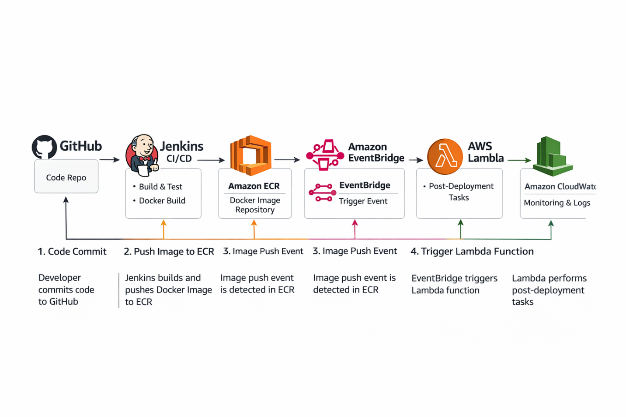

⚙️ Tech Stack
- Docker
- Jenkins
- AWS ECR
- AWS Lambda
- AWS EventBridge
- CloudWatch
- GitHub

🔄 Pipeline Workflow
- Code pushed to GitHub
- Jenkins triggers pipeline
- Docker image is built
- Image is tagged & pushed to ECR
- EventBridge detects push event
- Lambda function executes
- Logs stored in CloudWatch

🐳 Docker Setup

Dockerfile
FROM python:3.9-slim
WORKDIR /app
COPY . .
RUN pip install -r requirements.txt
EXPOSE 5000
CMD ["python", "app.py"]

🐍 Application Code

app.py
from flask import Flask, jsonify

app = Flask(__name__)

@app.route('/')
def home():
return jsonify({
"message": "Hello Pooja 🚀",
"status": "CI/CD Pipeline Working Successfully"
})

@app.route('/health')
def health():
return jsonify({
"status": "healthy"
})

if __name__ == '__main__':
app.run(host='0.0.0.0', port=5000)

requirements.txt
flask

⚙️ Jenkins Pipeline
pipeline {
agent any

environment {
AWS_REGION = 'ap-south-1'
ACCOUNT_ID = '123012261850'
REPO_NAME = 'myapp-repo'
}

stages {

stage('Checkout') {
steps {
checkout scm
}
}

stage('Build Docker Image') {
steps {
sh 'docker build -t pooja-app .'
}
}

stage('Push to ECR') {
steps {
sh '''
aws ecr get-login-password --region $AWS_REGION | docker login --username AWS --password-stdin $ACCOUNT_ID.dkr.ecr.$AWS_REGION.amazonaws.com
docker tag pooja-app $ACCOUNT_ID.dkr.ecr.$AWS_REGION.amazonaws.com/$REPO_NAME:latest
docker push $ACCOUNT_ID.dkr.ecr.$AWS_REGION.amazonaws.com/$REPO_NAME:latest
'''
}
}
}
}

⚡ Lambda Function
import json

def lambda_handler(event, context):
print("Image pushed to ECR")
print(event)
return {
'statusCode': 200,
'body': 'Success'
}

🔔 EventBridge
- Source: aws.ecr
- Type: ECR Image Action
- Action: PUSH
- Target: Lambda

📸 Screenshots
Feature
Jenkins Pipeline
ECR Images
Docker Container
App Output
Lambda
EventBridge
Logs

🚀 Run Locally
docker build -t myapp .
docker run -d -p 8081:5000 myapp

📊 Sample Output
🚀 ECR Image Push Detected!

🎯 Key Highlights
- Automated CI/CD pipeline
- Docker image versioning
- AWS integration
- Event-driven automation

🔮 Future Scope
- SNS Notifications
- DynamoDB Logging
- ECS Deployment

📎 Repository
👉 Add your GitHub link here

