E-COMMERCE ANALYTICS SYSTEM

ID: 148239
Name: Pooja S
GitHub URL: https://github.com/sivasks2004/Hospital_Analytics_System.git

Table Schema:

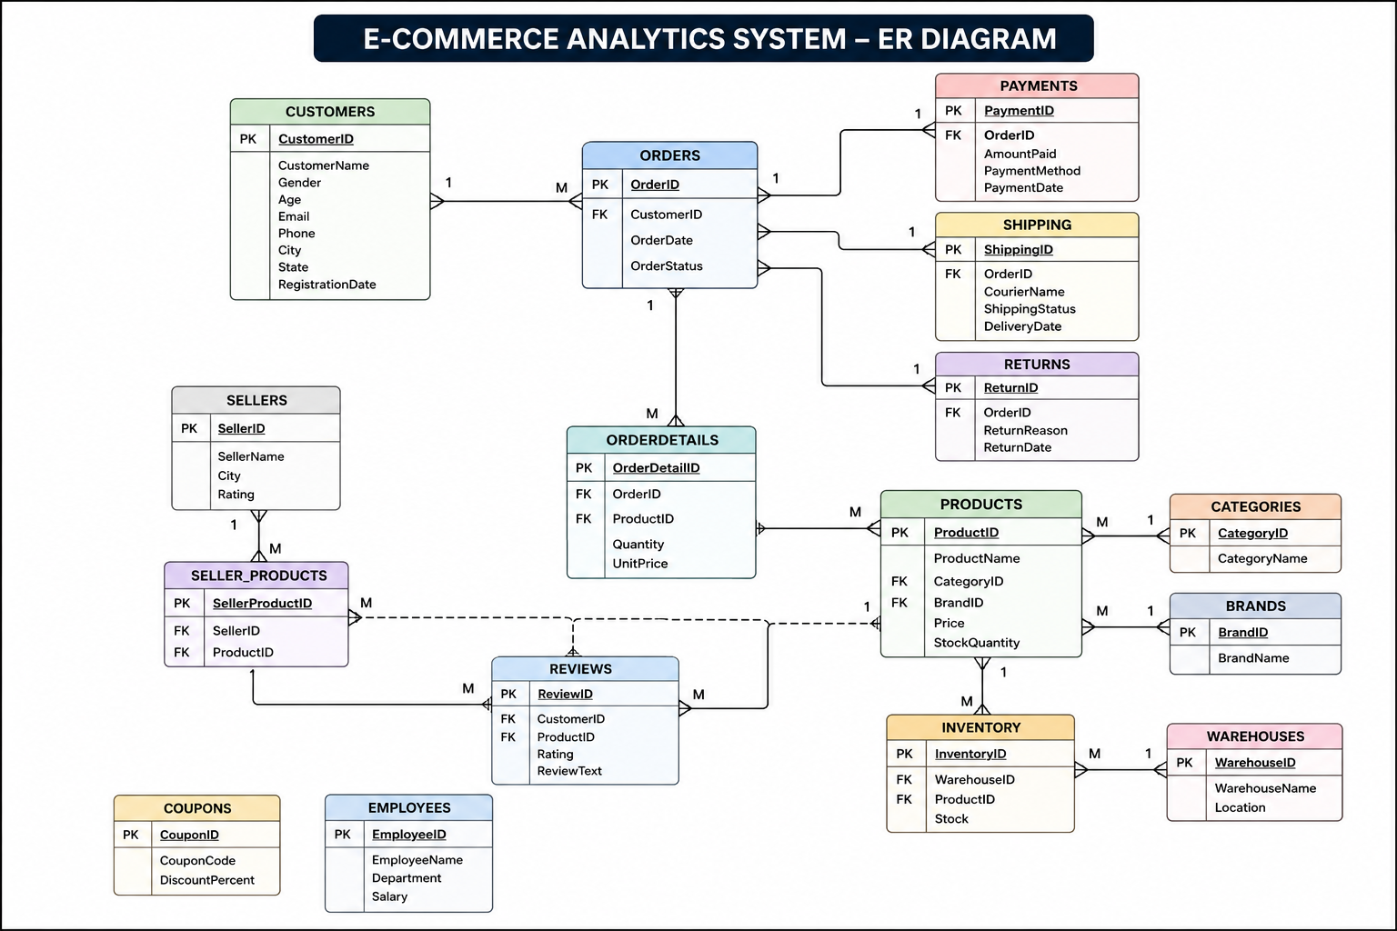

BASIC LEVEL

1. Find customers above age 60.

SELECT *
FROM customers
WHERE Age > 60;

2. Retrieve all orders placed today.

SELECT *
FROM orders
WHERE OrderDate = CURDATE();

3. Find total customers available in each city.

SELECT City, COUNT(*) TotalCustomers
FROM customers
GROUP BY City;

4. Display products with stock quantity below 100.

SELECT *
FROM products
WHERE StockQuantity < 100;

5. Find total orders placed by each customer.

SELECT CustomerID,
COUNT(*) TotalOrders
FROM orders
GROUP BY CustomerID;

6. Retrieve customers who never placed an order.

SELECT *
FROM customers
WHERE CustomerID NOT IN
(
SELECT CustomerID
FROM orders
);

7. Find products priced above ₹50,000.

SELECT *
FROM products
WHERE Price > 50000;

8. Display top 10 highest-priced products.

SELECT *
FROM products
ORDER BY Price DESC
LIMIT 10;

9. Find total inventory stock warehouse-wise.

SELECT WarehouseID,
SUM(Stock) TotalStock
FROM inventory
GROUP BY WarehouseID;

10. Find total revenue generated through payments.

SELECT SUM(AmountPaid) TotalRevenue
FROM payments;

INTERMEDIATE LEVEL

11. Top 5 customers by spending.

SELECT c.CustomerID,
c.CustomerName,
SUM(p.AmountPaid) TotalSpent
FROM customers c
JOIN orders o
ON c.CustomerID=o.CustomerID
JOIN payments p
ON o.OrderID=p.OrderID
GROUP BY c.CustomerID,c.CustomerName
ORDER BY TotalSpent DESC
LIMIT 5;

12. Top 10 products by sales revenue.

SELECT ProductID,
SUM(Quantity*UnitPrice) Revenue
FROM orderdetails
GROUP BY ProductID
ORDER BY Revenue DESC
LIMIT 10;

13. Category generating maximum revenue.

SELECT c.CategoryName,
SUM(od.Quantity*od.UnitPrice) Revenue
FROM categories c
JOIN products p
ON c.CategoryID=p.CategoryID
JOIN orderdetails od
ON p.ProductID=od.ProductID
GROUP BY c.CategoryName
ORDER BY Revenue DESC
LIMIT 1;

14. Most reviewed product.

SELECT ProductID,
COUNT(*) ReviewCount
FROM reviews
GROUP BY ProductID
ORDER BY ReviewCount DESC
LIMIT 1;

15. Customers ordering from multiple categories.

SELECT o.CustomerID
FROM orders o
JOIN orderdetails od
ON o.OrderID=od.OrderID
JOIN products p
ON od.ProductID=p.ProductID
GROUP BY o.CustomerID
HAVING COUNT(DISTINCT p.CategoryID)>1;

16. Top 10 cities generating maximum revenue.

SELECT c.City,
SUM(p.AmountPaid) Revenue
FROM customers c
JOIN orders o
ON c.CustomerID=o.CustomerID
JOIN payments p
ON o.OrderID=p.OrderID
GROUP BY c.City
ORDER BY Revenue DESC
LIMIT 10;

17. Products never sold.

SELECT p.*
FROM products p
LEFT JOIN orderdetails od
ON p.ProductID=od.ProductID
WHERE od.ProductID IS NULL;

18. Most frequently used payment method.

SELECT PaymentMethod,
COUNT(*) UsageCount
FROM payments
GROUP BY PaymentMethod
ORDER BY UsageCount DESC
LIMIT 1;

19. Repeat customers.

SELECT CustomerID,
COUNT(*) OrderCount
FROM orders
GROUP BY CustomerID
HAVING COUNT(*)>1;

20. Monthly sales trend.

SELECT YEAR(PaymentDate),
MONTH(PaymentDate),
SUM(AmountPaid)
FROM payments
GROUP BY YEAR(PaymentDate),
MONTH(PaymentDate);

ADVANCED SQL (STORED PROCEDURE, TRIGGERS)

21. Find the Second Highest Spending Customer

SELECT *
FROM
(
SELECT
c.CustomerID,
c.CustomerName,
SUM(p.AmountPaid) TotalSpent,
DENSE_RANK() OVER(
ORDER BY SUM(p.AmountPaid) DESC
) AS rn
FROM customers c
JOIN orders o
ON c.CustomerID=o.CustomerID
JOIN payments p
ON o.OrderID=p.OrderID
GROUP BY c.CustomerID,c.CustomerName
) x
WHERE rn=2;

22. Product Revenue Ranking

SELECT
ProductID,
SUM(Quantity*UnitPrice) Revenue,
RANK() OVER(
ORDER BY SUM(Quantity*UnitPrice) DESC
) ProductRank
FROM orderdetails
GROUP BY ProductID;

23. Customer Lifetime Value (CLV)

SELECT
c.CustomerID,
c.CustomerName,
SUM(p.AmountPaid) LifetimeValue
FROM customers c
JOIN orders o
ON c.CustomerID=o.CustomerID
JOIN payments p
ON o.OrderID=p.OrderID
GROUP BY c.CustomerID,c.CustomerName
ORDER BY LifetimeValue DESC;

24. Detect Suspicious Payments

SELECT
o.OrderID,
SUM(od.Quantity*od.UnitPrice) OrderValue,
SUM(p.AmountPaid) PaidValue
FROM orders o
JOIN orderdetails od
ON o.OrderID=od.OrderID
JOIN payments p
ON o.OrderID=p.OrderID
GROUP BY o.OrderID
HAVING PaidValue > OrderValue;

25. Top 10 Customers using CTE

WITH CustomerRevenue AS
(
SELECT
c.CustomerID,
c.CustomerName,
SUM(p.AmountPaid) Revenue
FROM customers c
JOIN orders o
ON c.CustomerID=o.CustomerID
JOIN payments p
ON o.OrderID=p.OrderID
GROUP BY c.CustomerID,c.CustomerName
)
SELECT *
FROM CustomerRevenue
ORDER BY Revenue DESC
LIMIT 10;

26. Running Revenue Month-over-Month

SELECT
YEAR(PaymentDate) YearNo,
MONTH(PaymentDate) MonthNo,
SUM(AmountPaid) Revenue,
SUM(SUM(AmountPaid))
OVER(
ORDER BY YEAR(PaymentDate),
MONTH(PaymentDate)
) RunningRevenue
FROM payments
GROUP BY
YEAR(PaymentDate),
MONTH(PaymentDate);

27. Category Revenue Contribution %

SELECT
c.CategoryName,
ROUND(
SUM(od.Quantity*od.UnitPrice)*100/
(
SELECT SUM(Quantity*UnitPrice)
FROM orderdetails
),
2
) ContributionPercent
FROM categories c
JOIN products p
ON c.CategoryID=p.CategoryID
JOIN orderdetails od
ON p.ProductID=od.ProductID
GROUP BY c.CategoryName;

28. Customers Spending Above Average

SELECT *
FROM
(
SELECT
c.CustomerID,
c.CustomerName,
SUM(p.AmountPaid) TotalSpent
FROM customers c
JOIN orders o
ON c.CustomerID=o.CustomerID
JOIN payments p
ON o.OrderID=p.OrderID
GROUP BY c.CustomerID,c.CustomerName
) x
WHERE TotalSpent >
(
SELECT AVG(CustomerSpend)
FROM
(
SELECT
SUM(p.AmountPaid) CustomerSpend
FROM customers c
JOIN orders o
ON c.CustomerID=o.CustomerID
JOIN payments p
ON o.OrderID=p.OrderID
GROUP BY c.CustomerID
) y
);

- Customers Spending Above Their City's Average

SELECT
c.CustomerID,
c.CustomerName,
c.City,
SUM(p.AmountPaid) TotalSpent
FROM customers c
JOIN orders o
ON c.CustomerID = o.CustomerID
JOIN payments p
ON o.OrderID = p.OrderID
GROUP BY
c.CustomerID,
c.CustomerName,
c.City
HAVING SUM(p.AmountPaid) >
(
SELECT AVG(CustomerRevenue)
FROM
(
SELECT
c2.CustomerID,
SUM(p2.AmountPaid) CustomerRevenue
FROM customers c2
JOIN orders o2
ON c2.CustomerID = o2.CustomerID
JOIN payments p2
ON o2.OrderID = p2.OrderID
WHERE c2.City = c.City
GROUP BY c2.CustomerID
) CityCustomers
);

30. Find Customers Who Have Placed Orders

SELECT *
FROM customers c
WHERE EXISTS
(
SELECT 1
FROM orders o
WHERE o.CustomerID=c.CustomerID
);

31. Find Customers Who Never Placed Orders

SELECT *
FROM customers c
WHERE NOT EXISTS
(
SELECT 1
FROM orders o
WHERE o.CustomerID=c.CustomerID
);

- Frequently Purchased Together Products

SELECT
od1.ProductID ProductA,
od2.ProductID ProductB,
COUNT(*) Frequency
FROM orderdetails od1
JOIN orderdetails od2
ON od1.OrderID=od2.OrderID
AND od1.ProductID < od2.ProductID
GROUP BY
od1.ProductID,
od2.ProductID;

Rank Products Within Each Category

SELECT
p.CategoryID,
p.ProductID,
SUM(od.Quantity*od.UnitPrice) Revenue,
RANK() OVER
(
PARTITION BY p.CategoryID
ORDER BY SUM(od.Quantity*od.UnitPrice) DESC
) CategoryRank
FROM products p
JOIN orderdetails od
ON p.ProductID=od.ProductID
GROUP BY
p.CategoryID,
p.ProductID;

34. Month-over-Month Growth %
WITH MonthlySales AS
(
SELECT
YEAR(PaymentDate) AS Yr,
MONTH(PaymentDate) AS Mn,
SUM(AmountPaid) AS Revenue
FROM payments
GROUP BY
YEAR(PaymentDate),
MONTH(PaymentDate)
)
SELECT
Yr,
Mn,
Revenue,
LAG(Revenue) OVER(ORDER BY Yr, Mn) AS PreviousMonthRevenue,
ROUND(
(
Revenue -
LAG(Revenue) OVER(ORDER BY Yr, Mn)
) * 100.0 /
LAG(Revenue) OVER(ORDER BY Yr, Mn),
2
) AS GrowthPercent
FROM MonthlySales;

35. Customer Segmentation
CASE
WHEN Revenue > 100000 THEN 'Platinum'
WHEN Revenue > 50000 THEN 'Gold'
WHEN Revenue > 20000 THEN 'Silver'
ELSE 'Bronze'
END

36. Create Customer Revenue View
CREATE VIEW vw_customer_revenue AS
SELECT
c.CustomerID,
c.CustomerName,
SUM(p.AmountPaid) Revenue
FROM customers c
JOIN orders o
ON c.CustomerID=o.CustomerID
JOIN payments p
ON o.OrderID=p.OrderID
GROUP BY
c.CustomerID,
c.CustomerName;

37. Create Product Sales View
CREATE VIEW vw_product_sales AS
SELECT
p.ProductID,
p.ProductName,
SUM(od.Quantity*od.UnitPrice) Revenue
FROM products p
JOIN orderdetails od
ON p.ProductID=od.ProductID
GROUP BY
p.ProductID,
p.ProductName;

- Get Customer Orders by Customer ID

DROP PROCEDURE IF EXISTS GetCustomerOrders;

DELIMITER //

CREATE PROCEDURE GetCustomerOrders
(
IN p_customerid INT
)
BEGIN

SELECT
OrderID,
CustomerID,
OrderDate,
OrderStatus
FROM orders
WHERE CustomerID = p_customerid;

END //

DELIMITER ;

CALL GetCustomerOrders(101);

39. Monthly Sales Report

DROP PROCEDURE IF EXISTS MonthlySalesReport;

DELIMITER //

CREATE PROCEDURE MonthlySalesReport()
BEGIN

SELECT
YEAR(PaymentDate) AS YearNo,
MONTH(PaymentDate) AS MonthNo,
SUM(AmountPaid) AS Revenue
FROM payments
GROUP BY
YEAR(PaymentDate),
MONTH(PaymentDate)
ORDER BY
YearNo,
MonthNo;

END //

DELIMITER ;

CALL MonthlySalesReport();

40.Top Customer Report

DROP PROCEDURE IF EXISTS TopCustomers;

DELIMITER //

CREATE PROCEDURE TopCustomers()
BEGIN

SELECT
c.CustomerID,
c.CustomerName,
SUM(p.AmountPaid) AS Revenue
FROM customers c
JOIN orders o
ON c.CustomerID = o.CustomerID
JOIN payments p
ON o.OrderID = p.OrderID
GROUP BY
c.CustomerID,
c.CustomerName
ORDER BY Revenue DESC
LIMIT 10;

END //

DELIMITER ;

CALL TopCustomers();

