E-COMMERCE ANALYTICS SYSTEM

ID: 148239

NAME: Pooja S

GitHub URL: https://github.com/pooja-shindhe/E_COMMERCE_ANALYTICS_SYSTEM.git

Table Schema:

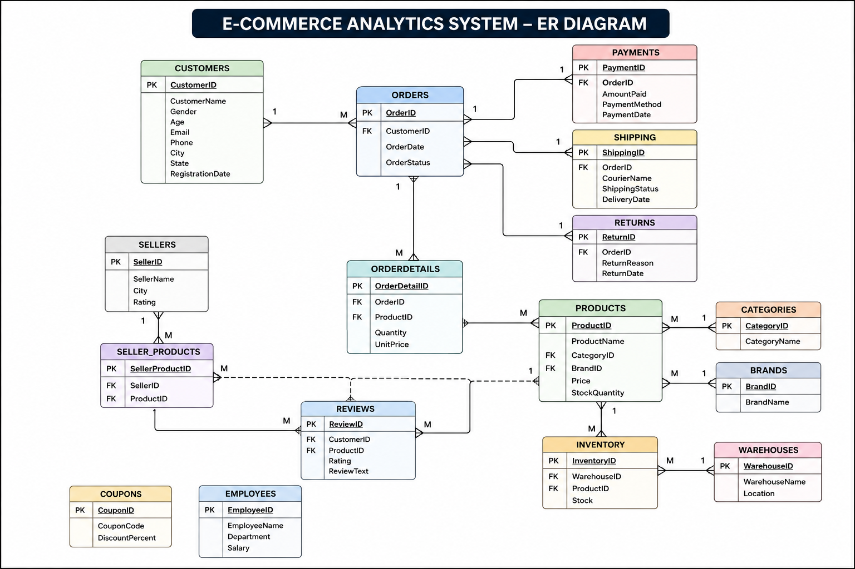

BASIC LEVEL

1. Display all customer details.
SELECT *
FROM customers;

2. Find customers above 60 years of age.
SELECT *
FROM customers
WHERE Age > 60;

3. Find customers whose name starts with 'A'.
SELECT *
FROM customers
WHERE CustomerName LIKE 'A%';

4. Find products priced between ₹10,000 and ₹50,000.
SELECT *
FROM products
WHERE Price BETWEEN 10000 AND 50000;

5. Display orders with status 'Delivered' or 'Shipped'.
SELECT *
FROM orders
WHERE OrderStatus IN ('Delivered','Shipped');

6. Display distinct customer cities.
SELECT DISTINCT City
FROM customers;

7. Display the top 10 highest-priced products.
SELECT *
FROM products
ORDER BY Price DESC
LIMIT 10;

8. Find the total number of customers in each city.
SELECT
City,
COUNT(*) AS TotalCustomers
FROM customers
GROUP BY City;

9. Find the total revenue received.
SELECT
SUM(AmountPaid) AS TotalRevenue
FROM payments;

10. Find the average product price.
SELECT
AVG(Price) AS AveragePrice
FROM products;

11. Find the highest and lowest product prices.
SELECT
MAX(Price) AS HighestPrice,
MIN(Price) AS LowestPrice
FROM products;

12. Find customers registered this year.
SELECT *
FROM customers
WHERE YEAR(RegistrationDate) = YEAR(CURDATE());

13. Find customers who have not placed any orders.
SELECT *
FROM customers
WHERE CustomerID NOT IN
(
SELECT CustomerID
FROM orders
);

14. Find the number of products available in each category.
SELECT
CategoryID,
COUNT(*) AS TotalProducts
FROM products
GROUP BY CategoryID;

15. Find the total available stock across all warehouses.
SELECT
SUM(Stock) AS TotalStock
FROM inventory;

INTERMEDIATE LEVEL

16. Display customer names along with their order details.
SELECT
c.CustomerID,
c.CustomerName,
o.OrderID,
o.OrderDate,
o.OrderStatus
FROM customers c
INNER JOIN orders o
ON c.CustomerID = o.CustomerID;
Concept: INNER JOIN

17. Display product names along with their category names.
SELECT
p.ProductName,
c.CategoryName
FROM products p
INNER JOIN categories c
ON p.CategoryID = c.CategoryID;
Concept: INNER JOIN

18. Display product names along with their brand names.
SELECT
p.ProductName,
b.BrandName
FROM products p
INNER JOIN brands b
ON p.BrandID = b.BrandID;
Concept: INNER JOIN

19. Find the total revenue generated by each customer.
SELECT
c.CustomerID,
c.CustomerName,
SUM(p.AmountPaid) AS TotalRevenue
FROM customers c
INNER JOIN orders o
ON c.CustomerID = o.CustomerID
INNER JOIN payments p
ON o.OrderID = p.OrderID
GROUP BY
c.CustomerID,
c.CustomerName;
Concept: INNER JOIN, GROUP BY, SUM()

20. Find products that have never been sold.
SELECT
p.ProductID,
p.ProductName
FROM products p
LEFT JOIN orderdetails od
ON p.ProductID = od.ProductID
WHERE od.ProductID IS NULL;
Concept: LEFT JOIN, IS NULL

21. Find customers who placed more than one order.
SELECT
CustomerID,
COUNT(OrderID) AS TotalOrders
FROM orders
GROUP BY CustomerID
HAVING COUNT(OrderID) > 1;
Concept: HAVING

22. Find the total sales for each category.
SELECT
c.CategoryName,
SUM(od.Quantity * od.UnitPrice) AS TotalSales
FROM categories c
INNER JOIN products p
ON c.CategoryID = p.CategoryID
INNER JOIN orderdetails od
ON p.ProductID = od.ProductID
GROUP BY c.CategoryName;
Concept: INNER JOIN, GROUP BY

23. Display monthly sales.
SELECT
YEAR(PaymentDate) AS Year,
MONTH(PaymentDate) AS Month,
SUM(AmountPaid) AS Revenue
FROM payments
GROUP BY
YEAR(PaymentDate),
MONTH(PaymentDate)
ORDER BY Year, Month;
Concept: GROUP BY, YEAR(), MONTH()

24. Display customer and employee names.
SELECT CustomerName AS Name
FROM customers
UNION
SELECT EmployeeName
FROM employees;
Concept: UNION

25. Display customer and employee names including duplicates.
SELECT CustomerName AS Name
FROM customers
UNION ALL
SELECT EmployeeName
FROM employees;
Concept: UNION ALL

26. Find customers who have placed at least one order.
SELECT *
FROM customers c
WHERE EXISTS
(
SELECT 1
FROM orders o
WHERE o.CustomerID = c.CustomerID
);
Concept: EXISTS

27. Find customers who have never placed an order.
SELECT *
FROM customers c
WHERE NOT EXISTS
(
SELECT 1
FROM orders o
WHERE o.CustomerID = c.CustomerID
);
Concept: NOT EXISTS

28. Find products frequently purchased together.
SELECT
od1.ProductID AS ProductA,
od2.ProductID AS ProductB,
COUNT(*) AS PurchaseCount
FROM orderdetails od1
INNER JOIN orderdetails od2
ON od1.OrderID = od2.OrderID
AND od1.ProductID < od2.ProductID
GROUP BY
od1.ProductID,
od2.ProductID;
Concept: SELF JOIN

29. Create a view to display customer revenue.
CREATE VIEW vw_customer_revenue AS
SELECT
c.CustomerID,
c.CustomerName,
SUM(p.AmountPaid) AS Revenue
FROM customers c
INNER JOIN orders o
ON c.CustomerID = o.CustomerID
INNER JOIN payments p
ON o.OrderID = p.OrderID
GROUP BY
c.CustomerID,
c.CustomerName;
Concept: VIEW

30. Create a view to display product sales.
CREATE VIEW vw_product_sales AS
SELECT
p.ProductID,
p.ProductName,
SUM(od.Quantity * od.UnitPrice) AS Revenue
FROM products p
INNER JOIN orderdetails od
ON p.ProductID = od.ProductID
GROUP BY
p.ProductID,
p.ProductName;

Concept: VIEW

ADVANCED SQL (STORED PROCEDURE, TRIGGERS)

31. Find Products Costing More Than the Average Price
SELECT *
FROM products
WHERE Price >
(
SELECT AVG(Price)
FROM products
);
Concept: Subquery

32. Find Customers Who Spent More Than the Average Customer Spending
SELECT
c.CustomerID,
c.CustomerName,
SUM(p.AmountPaid) AS TotalSpent
FROM customers c
INNER JOIN orders o
ON c.CustomerID = o.CustomerID
INNER JOIN payments p
ON o.OrderID = p.OrderID
GROUP BY
c.CustomerID,
c.CustomerName
HAVING SUM(p.AmountPaid) >
(
SELECT AVG(CustomerSpend)
FROM
(
SELECT
SUM(AmountPaid) AS CustomerSpend
FROM payments
GROUP BY OrderID
) AS AvgSpend
);
Concept: Nested Subquery

33. Find Top 5 Customers by Revenue Using CTE
WITH CustomerRevenue AS
(
SELECT
c.CustomerID,
c.CustomerName,
SUM(p.AmountPaid) AS Revenue
FROM customers c
INNER JOIN orders o
ON c.CustomerID = o.CustomerID
INNER JOIN payments p
ON o.OrderID = p.OrderID
GROUP BY
c.CustomerID,
c.CustomerName
)
SELECT *
FROM CustomerRevenue
ORDER BY Revenue DESC
LIMIT 5;
Concept: CTE

34. Rank Products Based on Revenue
SELECT
ProductID,
SUM(Quantity * UnitPrice) AS Revenue,
RANK() OVER
(
ORDER BY SUM(Quantity * UnitPrice) DESC
) AS ProductRank
FROM orderdetails
GROUP BY ProductID;
Concept: Window Function, RANK()

35. Find the Second Highest Spending Customer
SELECT *
FROM
(
SELECT
c.CustomerID,
c.CustomerName,
SUM(p.AmountPaid) AS TotalSpent,
DENSE_RANK() OVER
(
ORDER BY SUM(p.AmountPaid) DESC
) AS RankNo
FROM customers c
INNER JOIN orders o
ON c.CustomerID = o.CustomerID
INNER JOIN payments p
ON o.OrderID = p.OrderID
GROUP BY
c.CustomerID,
c.CustomerName
) x
WHERE RankNo = 2;
Concept: DENSE_RANK()

36. Display Running Revenue Month-wise
SELECT
YEAR(PaymentDate) AS YearNo,
MONTH(PaymentDate) AS MonthNo,
SUM(AmountPaid) AS Revenue,
SUM(SUM(AmountPaid))
OVER
(
ORDER BY YEAR(PaymentDate),
MONTH(PaymentDate)
) AS RunningRevenue
FROM payments
GROUP BY
YEAR(PaymentDate),
MONTH(PaymentDate);
Concept: SUM() OVER()

37. Rank Products Within Each Category
SELECT
p.CategoryID,
p.ProductID,
SUM(od.Quantity * od.UnitPrice) AS Revenue,
RANK() OVER
(
PARTITION BY p.CategoryID
ORDER BY SUM(od.Quantity * od.UnitPrice) DESC
) AS CategoryRank
FROM products p
INNER JOIN orderdetails od
ON p.ProductID = od.ProductID
GROUP BY
p.CategoryID,
p.ProductID;
Concept: PARTITION BY

38. Display Month-over-Month Sales Growth
WITH MonthlySales AS
(
SELECT
YEAR(PaymentDate) AS Yr,
MONTH(PaymentDate) AS Mn,
SUM(AmountPaid) AS Revenue
FROM payments
GROUP BY
YEAR(PaymentDate),
MONTH(PaymentDate)
)
SELECT
Yr,
Mn,
Revenue,
LAG(Revenue)
OVER
(
ORDER BY Yr,Mn
) PreviousRevenue
FROM MonthlySales;
Concept: LAG()

39. Categorize Customers Based on Revenue
SELECT
CustomerID,
CustomerName,
Revenue,
CASE
WHEN Revenue > 100000 THEN 'Platinum'
WHEN Revenue > 50000 THEN 'Gold'
WHEN Revenue > 20000 THEN 'Silver'
ELSE 'Bronze'
END AS CustomerCategory
FROM
(
SELECT
c.CustomerID,
c.CustomerName,
SUM(p.AmountPaid) AS Revenue
FROM customers c
INNER JOIN orders o
ON c.CustomerID = o.CustomerID
INNER JOIN payments p
ON o.OrderID = p.OrderID
GROUP BY
c.CustomerID,
c.CustomerName
) x;
Concept: CASE

40. Create Stored Procedure to Get Customer Orders
DROP PROCEDURE IF EXISTS GetCustomerOrders;
DELIMITER //
CREATE PROCEDURE GetCustomerOrders
(
IN p_customerid INT
)
BEGIN
SELECT *
FROM orders
WHERE CustomerID = p_customerid;
END //
DELIMITER ;
CALL GetCustomerOrders(101);
Concept: Stored Procedure (Input Parameter)

41. Create Stored Procedure to Display Monthly Sales
DROP PROCEDURE IF EXISTS MonthlySalesReport;
DELIMITER //
CREATE PROCEDURE MonthlySalesReport()
BEGIN
SELECT
YEAR(PaymentDate) YearNo,
MONTH(PaymentDate) MonthNo,
SUM(AmountPaid) Revenue
FROM payments
GROUP BY
YEAR(PaymentDate),
MONTH(PaymentDate);
END //
DELIMITER ;
CALL MonthlySalesReport();
Concept: Stored Procedure

42. Create Stored Procedure to Display Top 10 Customers
DROP PROCEDURE IF EXISTS TopCustomers;
DELIMITER //
CREATE PROCEDURE TopCustomers()
BEGIN
SELECT
c.CustomerID,
c.CustomerName,
SUM(p.AmountPaid) Revenue
FROM customers c
INNER JOIN orders o
ON c.CustomerID=o.CustomerID
INNER JOIN payments p
ON o.OrderID=p.OrderID
GROUP BY
c.CustomerID,
c.CustomerName
ORDER BY Revenue DESC
LIMIT 10;
END //
DELIMITER ;
CALL TopCustomers();
Concept: Stored Procedure

43. Create BEFORE INSERT Trigger to Validate Payment
DELIMITER //
CREATE TRIGGER ValidatePayment
BEFORE INSERT
ON payments
FOR EACH ROW
BEGIN
IF NEW.AmountPaid <=0 THEN
SIGNAL SQLSTATE '45000'
SET MESSAGE_TEXT='Payment amount must be greater than zero';
END IF;
END //
DELIMITER ;
Concept: BEFORE INSERT Trigger

44. Create AFTER INSERT Trigger to Update Inventory
DELIMITER //
CREATE TRIGGER UpdateInventory
AFTER INSERT
ON orderdetails
FOR EACH ROW
BEGIN
UPDATE inventory
SET Stock = Stock - NEW.Quantity
WHERE ProductID = NEW.ProductID;
END //
DELIMITER ;
Concept: AFTER INSERT Trigger

45. Create BEFORE DELETE Trigger to Prevent Customer Deletion
DELIMITER //
CREATE TRIGGER PreventCustomerDelete
BEFORE DELETE
ON customers
FOR EACH ROW
BEGIN
IF EXISTS
(
SELECT 1
FROM orders
WHERE CustomerID=OLD.CustomerID
)
THEN
SIGNAL SQLSTATE '45000'
SET MESSAGE_TEXT='Customer has orders. Deletion not allowed.';
END IF;
END //
DELIMITER ;
Concept: BEFORE DELETE Trigger

