**Exercise 2: E-commerce Platform Search Function**

**Scenario:**

You are working on the search functionality of an e-commerce platform. The search needs to be optimized for fast performance.

**Steps:**

1. **Understand Asymptotic Notation:**
   * Explain Big O notation and how it helps in analyzing algorithms.

**Big O Notation** describes the upper bound of an algorithm’s running time or space as the input size grows.

* + Describe the best, average, and worst-case scenarios for search operations.

| **Scenario** | **Linear Search** | **Binary Search** |
| --- | --- | --- |
| Best Case | O(1) (first match) | O(1) (middle match) |
| Average Case | O(n/2) ≈ O(n) | O(log n) |
| Worst Case | O(n) | O(log n) |

**Linear Search** checks each element one by one.

**Binary Search** repeatedly divides the search interval in half — requires sorted data.

1. **Setup:**
   * Create a class **Product** with attributes for searching, such as **productId, productName**, and **category**.

**Product Class:**

package com.searchFunction;

public class Product {

int productId;

String productName;

String category;

public Product(int productId, String productName, String category) {

this.productId = productId;

this.productName = productName;

this.category = category;

}

*@Override*

public String toString() {

return productId + ": " + productName + " [" + category + "]";

}

}

1. **Implementation:**
   * Implement linear search and binary search algorithms.
   * Store products in an array for linear search and a sorted array for binary search.

**ProductSearch Class:**

package com.searchFunction;

import java.util.Arrays;

import java.util.Comparator;

public class ProductSearch {

// Linear Search by productName within a specific category

public static Product linearSearch(Product[] products, String name, String category) {

for (Product product : products) {

if (product.category.equalsIgnoreCase(category) &&

product.productName.equalsIgnoreCase(name)) {

return product;

}

}

return null;

}

// Binary Search by productName in sorted array (filtered by category beforehand)

public static Product binarySearch(Product[] sortedProducts, String name) {

int left = 0, right = sortedProducts.length - 1;

while (left <= right) {

int mid = (left + right) / 2;

int compare = sortedProducts[mid].productName.compareToIgnoreCase(name);

if (compare == 0) return sortedProducts[mid];

else if (compare < 0) left = mid + 1;

else right = mid - 1;

}

return null;

}

}

1. **Analysis:**
   * Compare the time complexity of linear and binary search algorithms.

**SearchTest Class:**

package com.searchFunction;

import java.util.*;

public class SearchTest {

public static void main(String[] args) {

Product[] allProducts = {

new Product(101, "Laptop", "Electronics"),

new Product(102, "Headphones", "Electronics"),

new Product(103, "Notebook", "Stationery"),

new Product(104, "Pencil", "Stationery"),

new Product(105, "Smartphone", "Electronics"),

new Product(106, "Charger", "Electronics")

};

String targetName = "Smartphone";

String targetCategory = "Electronics";

// LINEAR SEARCH

long startLinear = System.*nanoTime*();

Product resultLinear = ProductSearch.*linearSearch*(allProducts, targetName, targetCategory);

long endLinear = System.*nanoTime*();

System.***out***.println("Linear Search Result: " + resultLinear);

System.***out***.println("Linear Search Time: " + (endLinear - startLinear) + " ns");

// BINARY SEARCH

Product[] filteredCategory = Arrays.*stream*(allProducts)

.filter(p -> p.category.equalsIgnoreCase(targetCategory))

.toArray(Product[]::new);

Arrays.*sort*(filteredCategory, Comparator.*comparing*(p -> p.productName.toLowerCase()));

long startBinary = System.*nanoTime*();

Product resultBinary = ProductSearch.*binarySearch*(filteredCategory, targetName);

long endBinary = System.*nanoTime*();

System.***out***.println("Binary Search Result: " + resultBinary);

System.***out***.println("Binary Search Time: " + (endBinary - startBinary) + " ns");

}

}

Output Screenshot:

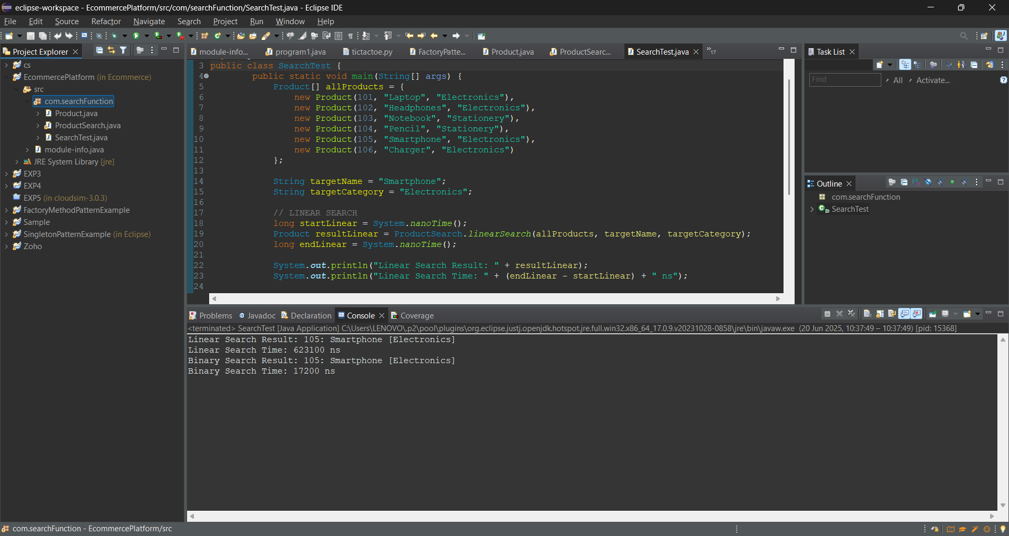

* + Discuss which algorithm is more suitable for your platform and why.

**Linear Search** is simple and does not require sorting. Ideal for small or unsorted datasets.

**Binary Search** is much faster on **pre-sorted** or **category-filtered** data.

For an e-commerce platform, where **categories are already defined**, and **products can be sorted**, **Binary Search is highly efficient** and should be preferred.

**Exercise 7: Financial Forecasting**

**Scenario:**

You are developing a financial forecasting tool that predicts future values based on past data.

**Steps:**

1. **Understand Recursive Algorithms:**
   * Explain the concept of recursion and how it can simplify certain problems.

Recursion is when a method **calls itself** to solve a smaller subproblem of the original problem.  
It works well when a problem can be broken down into similar sub-problems.

**Example Problem**:  
Forecast a future investment value where each year’s value is based on a constant growth rate.

**Mathematically**:

FV(n) = FV(n - 1) * (1 + r)

FV(0) = initialValue

1. **Setup:**
   * Create a method to calculate the future value using a recursive approach.

**FinancialForecast Class:**

package com.forcasting;

import java.util.HashMap;

public class FinancialForecast {

// Memoized recursive method

public static double forecastFutureValue(double initial, double rate, int year, HashMap<Integer, Double> memo) {

if (year == 0) return initial;

// Check if result already exists

if (memo.containsKey(year)) {

return memo.get(year);

}

// Calculate recursively

double previous = *forecastFutureValue*(initial, rate, year - 1, memo);

double current = previous * (1 + rate);

memo.put(year, current); // Store the result)

return current;

}

}

1. **Implementation:**
   * Implement a recursive algorithm to predict future values based on past growth rates.

**ForecastTest Class:**

1. package com.forcasting;
2. import java.util.HashMap;
3. public class ForecastTest {
4. public static void main(String[] args) {
5. double initialValue = 10000; // ₹10,000
6. double growthRate = 0.08; // 8% per year
7. int years = 15; // Forecast for 15 years
8. // Display initial parameters
9. System.***out***.println("----- Financial Forecasting Tool -----");
10. System.***out***.printf("Initial Investment: ₹%.2f\n", initialValue);
11. System.***out***.printf("Annual Growth Rate: %.2f%%\n", growthRate * 100);
12. System.***out***.printf("Forecast Period: %d years\n", years);
13. HashMap<Integer, Double> memo = new HashMap<>();
14. double futureValue = FinancialForecast.*forecastFutureValue*(initialValue, growthRate, years, memo);
15. // Display result
16. System.***out***.printf("Forecasted Future Value: ₹%.2f\n", futureValue);
17. }
18. }

**Output Screenshot:**

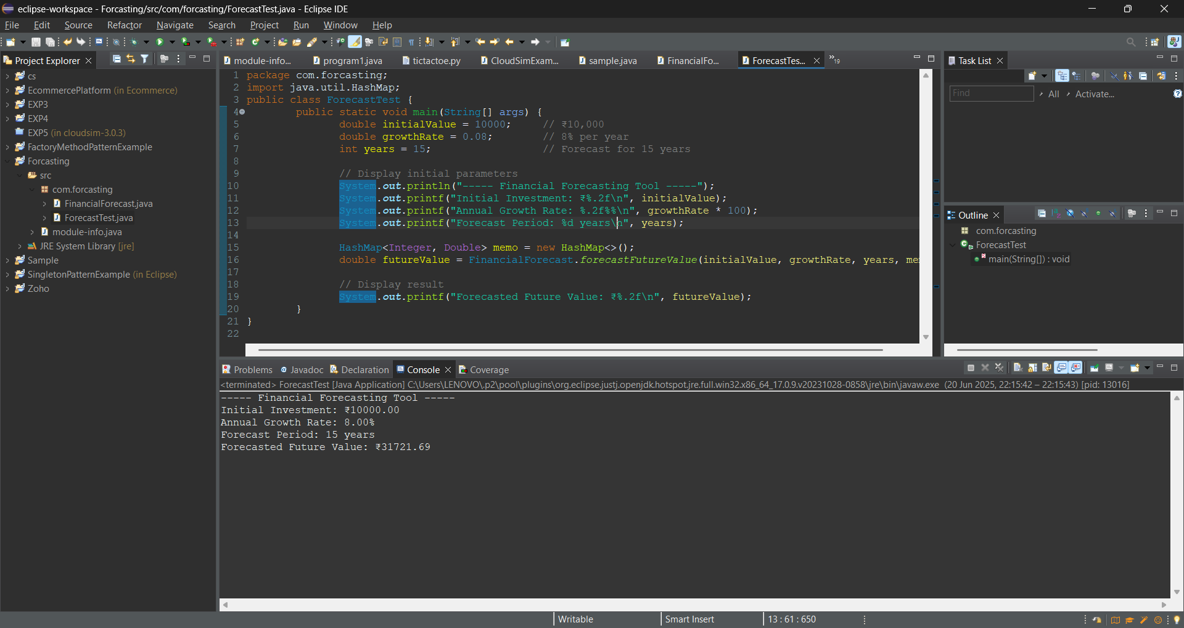

**4.Analysis:**

* + Discuss the time complexity of your recursive algorithm.

**Time Complexity of Recursive Algorithm**

The method:

forecastFutureValue(initial, rate, year, memo)

calls itself recursively for each year from **n** down to **0**. Without memoization, it would recompute values multiple times, leading to inefficiency.

**With Memoization** (using **HashMap**):

* + Each year’s value is computed only once.
  + Average **O(1)** for **get()** and **put().**

**Time Complexity:** **O(n)**  
 **Space Complexity:** **O(n)**

* + Explain how to optimize the recursive solution to avoid excessive computation.

### Optimization: Avoiding Excessive Computation

Using **memoization** avoids redundant calculations by caching already-computed results.

if (memo.containsKey(year)) {

return memo.get(year);

}

This ensures each value is computed only once.

Speeds up execution for large year values.