JUnit Basic Testing Exercises

# Exercise 1: Setting Up JUnit

**Scenario:**

You need to set up JUnit in your Java project to start writing unit tests. **Steps:**

1. Create a new Java project in your IDE (e.g., IntelliJ IDEA, Eclipse).

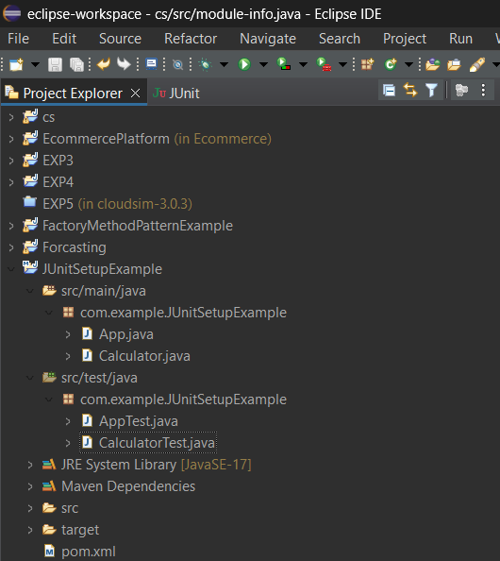

1. Add JUnit dependency to your project. If you are using Maven, add the following to your pom.xml:

<dependency>

<groupId>junit</groupId>

<artifactId>junit</artifactId>

<version>4.13.2</version>

<scope>test</scope>

</dependency>

**Pom.xml:**

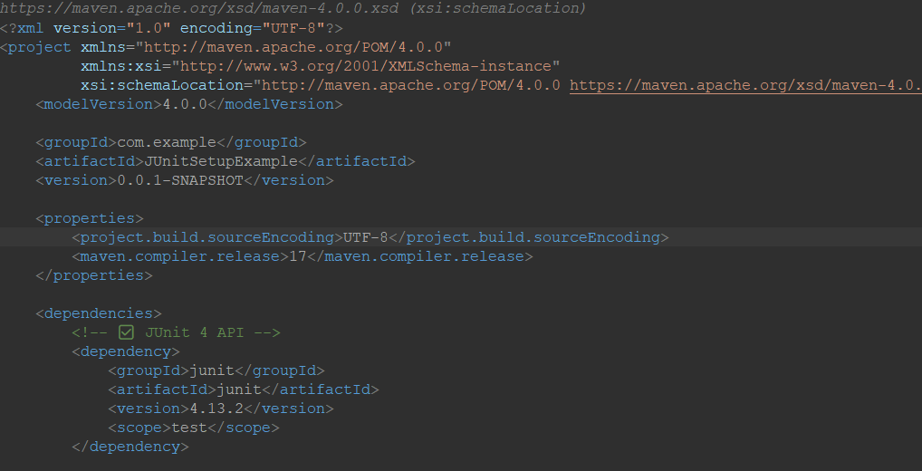

1. Create a new test class in your project.

**Class: Calculator**

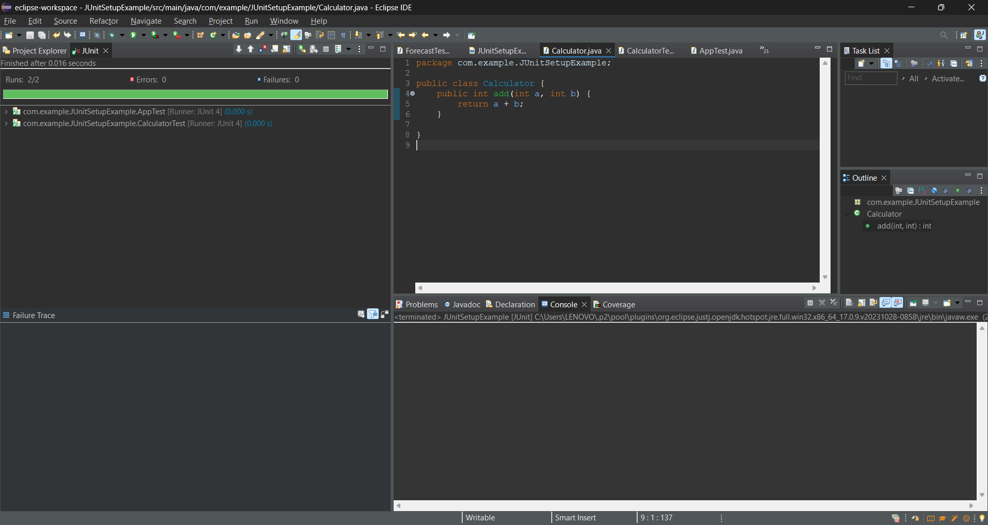

**Test Class: CalculatorTest**

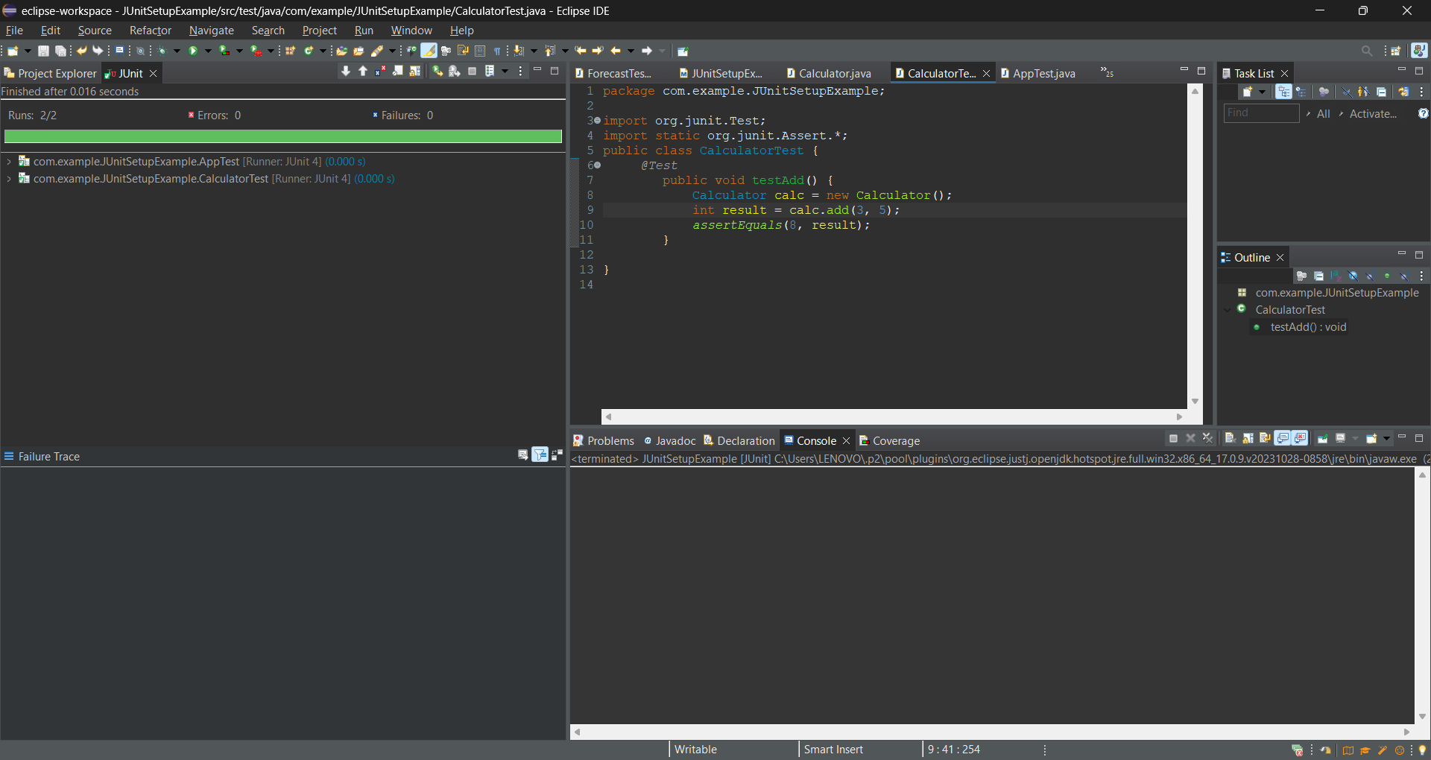

**Output Screenshots:**

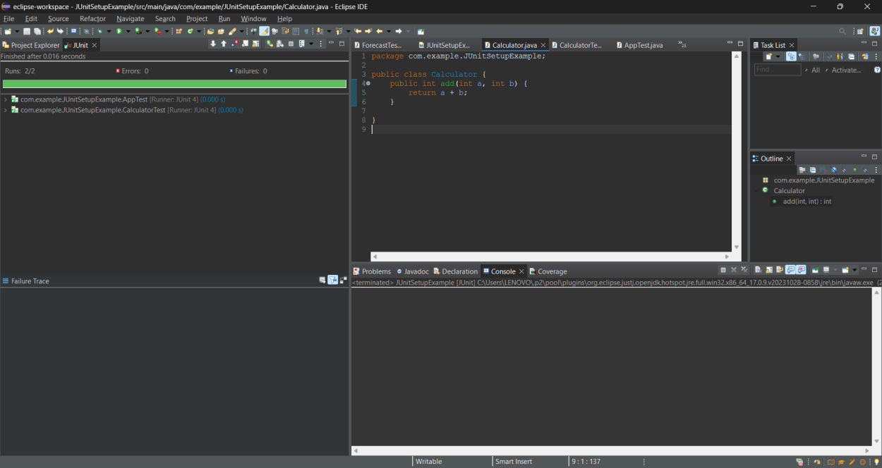



# Exercise 3: Assertions in JUnit

**Scenario:**

You need to use different assertions in JUnit to validate your test results. **Steps:**

1.Write tests using various JUnit assertions.

**Code:**

public class AssertionsTest { @Test

public void testAssertions() {

// Assert equals assertEquals(5, 2 + 3);

// Assert true assertTrue(5 > 3);

// Assert false assertFalse(5 < 3);

// Assert null assertNull(null);

// Assert not null assertNotNull(new Object());

}

}

**Test class: AssertionsTest**

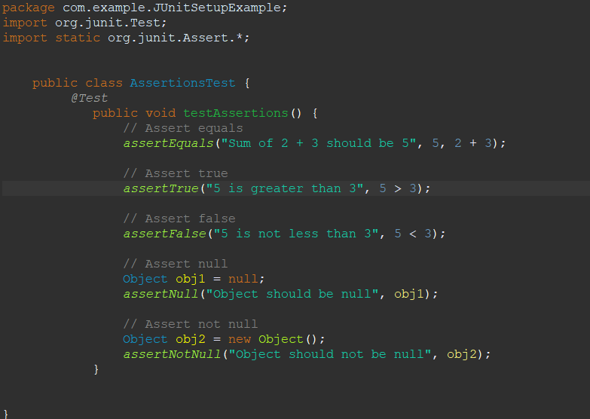

2.Test the code by run the class as :

Run as> JUnit Test

**Output Screenshots:**

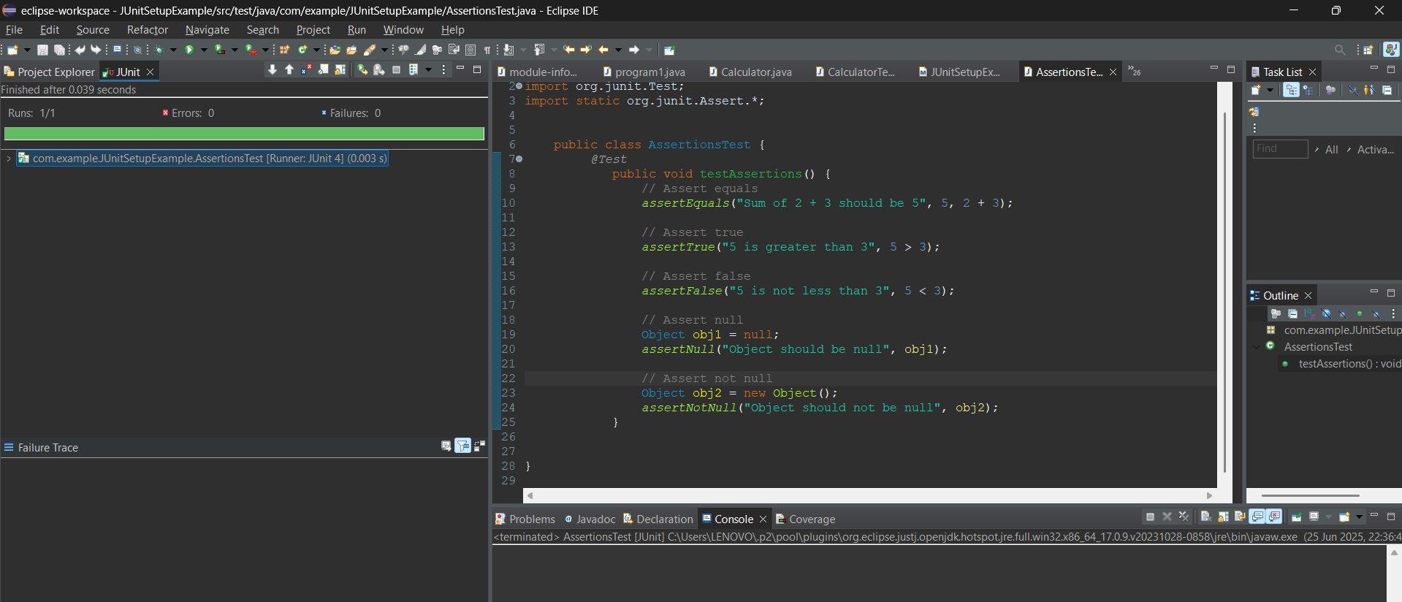

# Exercise 4: Arrange-Act-Assert (AAA) Pattern, Test Fixtures, Setup and Teardown Methods in JUnit

**Scenario:**

You need to organize your tests using the Arrange-Act-Assert (AAA) pattern and use setup and teardown methods.

**Steps:**

1. Write tests using the AAA pattern.
2. Use @Before and @After annotations for setup and teardown methods.
3. Run as JUnit Test to get the result for the class.

**Calculator Class:**

package com.example.JUnitSetupExample;

public class Calculator {

public int add(int a, int b) {

return a + b;

}

public int subtract(int a, int b) {

return a - b;

}

}

**CalculatorTest class:**

package com.example.JUnitSetupExample;

import org.junit.After;

import org.junit.Before;

import org.junit.Test;

import static org.junit.Assert.*;

public class CalculatorTest {

private Calculator calculator;

// Setup method (runs before each test)

@Before

public void setUp() {

System.out.println("Setting up...");

calculator = new Calculator(); // Arrange

}

// Teardown method (runs after each test)

@After

public void tearDown() {

System.out.println("Cleaning up...");

calculator = null;

}

@Test

public void testAddition() {

// Arrange (done in setUp)

// Act

int result = calculator.add(10, 5);

// Assert

assertEquals(15, result);

}

@Test

public void testSubtraction() {

// Arrange (done in setUp)

// Act

int result = calculator.subtract(10, 5);

// Assert

assertEquals(5, result);

}

}

**Output Screenshot:**

