**Exercise 1: Control Structures**

**Scenario 1:** The bank wants to apply a discount to loan interest rates for customers above 60 years old.

* + **Question:** Write a PL/SQL block that loops through all customers, checks their age, and if they are above 60, apply a 1% discount to their current loan interest rates.

**Scenario 2:** A customer can be promoted to VIP status based on their balance.

* + **Question:** Write a PL/SQL block that iterates through all customers and sets a flag IsVIP to TRUE for those with a balance over $10,000.

**Scenario 3:** The bank wants to send reminders to customers whose loans are due within the next 30 days.

* + **Question:** Write a PL/SQL block that fetches all loans due in the next 30 days and prints a reminder message for each customer.

**Objective:**

This document demonstrates how PL/SQL control structures such as loops and conditional logic can be used to solve real-world banking problems. The three scenarios simulate customer segmentation, loan discounting, and automated notifications.

**CODE:**

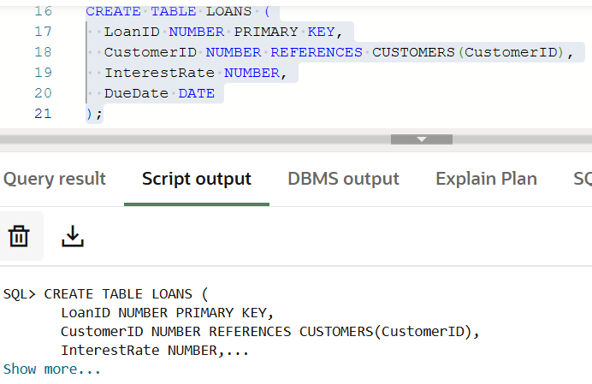**Create CUSTOMERS Table and LOAN table**

CREATE TABLE CUSTOMERS (

CustomerID NUMBER PRIMARY KEY,

Name VARCHAR2(100),

Age NUMBER,

Balance NUMBER,

IsVIP VARCHAR2(5)

);

CREATE TABLE LOANS (

LoanID NUMBER PRIMARY KEY,

CustomerID NUMBER REFERENCES CUSTOMERS(CustomerID),

InterestRate NUMBER,

DueDate DATE

);

**INSERTION OF DATA:**

INSERT INTO CUSTOMERS VALUES (1, 'Anika', 66, 14000, 'FALSE');

INSERT INTO CUSTOMERS VALUES (2, 'Harsh', 52, 9500, 'FALSE');

INSERT INTO CUSTOMERS VALUES (3, 'Zoya', 72, 16000, 'FALSE');

INSERT INTO CUSTOMERS VALUES (4, 'Kabir', 58, 10500, 'FALSE');

INSERT INTO LOANS VALUES (201, 1, 10, SYSDATE + 8);

INSERT INTO LOANS VALUES (202, 2, 12, SYSDATE + 45);

INSERT INTO LOANS VALUES (203, 3, 11, SYSDATE + 6);

INSERT INTO LOANS VALUES (204, 4, 13, SYSDATE + 20);

COMMIT;

**Scenario 1: Interest Rate Discount for Senior Citizens**

The bank wants to offer a 1% interest rate discount on all loans for customers who are above 60 years old.

BEGIN

FOR rec IN (SELECT CustomerID FROM CUSTOMERS WHERE Age > 60) LOOP

UPDATE LOANS

SET InterestRate = InterestRate - 1

WHERE CustomerID = rec.CustomerID;

END LOOP;

COMMIT;

DBMS_OUTPUT.PUT_LINE('1% discount applied to eligible senior customers.');

END;

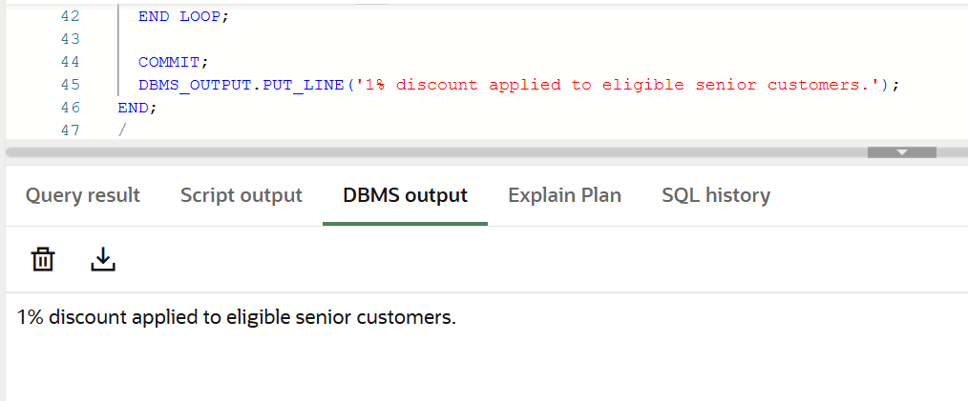**OUTPUT:**

**SCENARIO 2**: **Promote Customers to VIP Status Based on Balance**

Set IsVIP = 'TRUE' for all customers whose **balance > 10,000**.

**CODE:**

BEGIN

FOR rec IN (SELECT CustomerID FROM CUSTOMERS WHERE Balance > 10000) LOOP

UPDATE CUSTOMERS

SET IsVIP = 'TRUE'

WHERE CustomerID = rec.CustomerID;

END LOOP;

COMMIT;

DBMS_OUTPUT.PUT_LINE(' Customers with balance > 10,000 promoted to VIP.');

END;

/

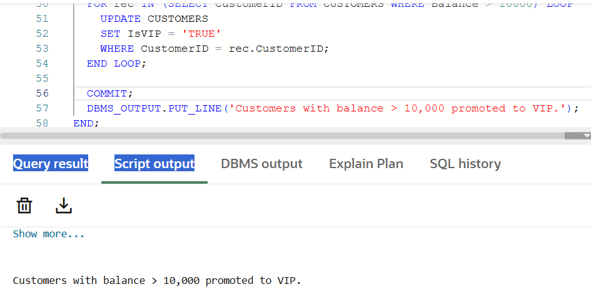**OUTPUT:**

**SCENARIO 3: Send Reminders for Loans Due Within 30 Days**

**CODE:**

BEGIN

FOR rec IN (

SELECT l.LoanID, c.Name, l.DueDate

FROM LOANS l

JOIN CUSTOMERS c ON l.CustomerID = c.CustomerID

WHERE l.DueDate <= SYSDATE + 30

) LOOP

DBMS_OUTPUT.PUT_LINE(' Reminder: Loan ' || rec.LoanID || ' for customer ' || rec.Name ||

' is due on ' || TO_CHAR(rec.DueDate, 'DD-MON-YYYY'));

END LOOP;

END;

/

**OUTPUT:**

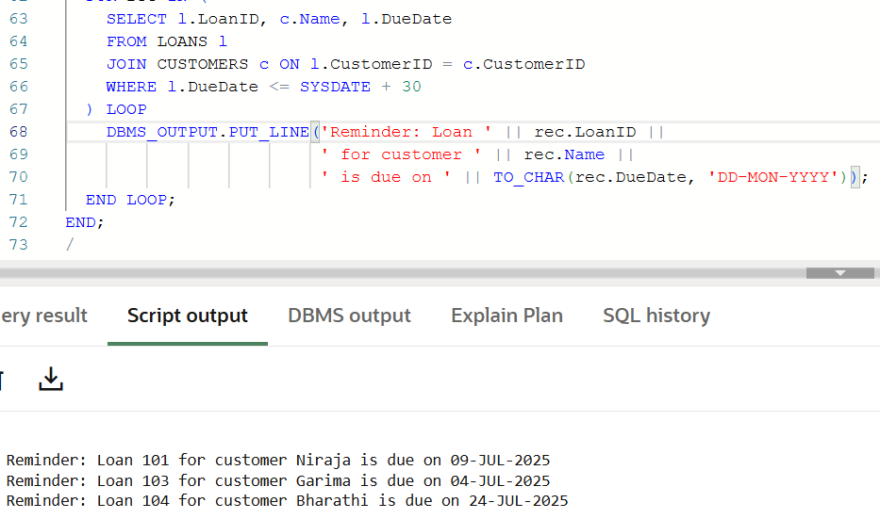

**Exercise 3: Stored Procedures**

**Scenario 1:** The bank needs to process monthly interest for all savings accounts.

* + **Question:** Write a stored procedure **ProcessMonthlyInterest** that calculates and updates the balance of all savings accounts by applying an interest rate of 1% to the current balance.

**Objective:**

The objective of this exercise is to design and implement stored procedures in PL/SQL to handle core banking operations. These include interest calculation for savings accounts, performance-based bonus updates for employees, and secure fund transfers between customer accounts. This helps in automating financial processes efficiently and accurately.

**Creation of Tables :**

CREATE TABLE ACCOUNTS (

AccountID NUMBER PRIMARY KEY,

CustomerName VARCHAR2(100),

Balance NUMBER,

AccountType VARCHAR2(20)

);

CREATE TABLE EMPLOYEES (

EmployeeID NUMBER PRIMARY KEY,

Name VARCHAR2(100),

Department VARCHAR2(50),

Salary NUMBER

);

**INSERTION OF DATA:**

INSERT INTO ACCOUNTS VALUES (101, 'Karthik Raj', 13500, 'Savings');

INSERT INTO ACCOUNTS VALUES (102, 'Divya Lakshmi', 9200, 'Current');

INSERT INTO ACCOUNTS VALUES (103, 'Arun Prasad', 15800, 'Savings');

INSERT INTO ACCOUNTS VALUES (104, 'Meena Kumari', 11200, 'Current');

INSERT INTO EMPLOYEES VALUES (201, 'Sundar Vel', 'Finance', 61000);

INSERT INTO EMPLOYEES VALUES (202, 'Revathi Elango', 'IT', 78000);

INSERT INTO EMPLOYEES VALUES (203, 'Prakash Mani', 'HR', 55000);

INSERT INTO EMPLOYEES VALUES (204, 'Lakshmi Narayan','Operations', 63000);

**Scenario 1: Process Monthly Interest (1% for Savings Accounts)**

CREATE OR REPLACE PROCEDURE ProcessMonthlyInterest IS

BEGIN

UPDATE ACCOUNTS

SET Balance = Balance + (Balance * 0.01)

WHERE AccountType = 'SAVINGS';

COMMIT;

DBMS_OUTPUT.PUT_LINE('Monthly interest of 1% applied to all savings accounts.');

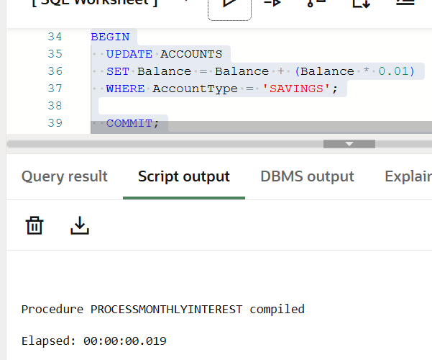END;

**Scenario 2: Update Employee Bonus:**

**CODE:**

CREATE OR REPLACE PROCEDURE UpdateEmployeeBonus (

p_department IN VARCHAR2,

p_bonus_percent IN NUMBER

) IS

BEGIN

UPDATE EMPLOYEES

SET Salary = Salary + (Salary * p_bonus_percent / 100)

WHERE Department = p_department;

COMMIT;

DBMS_OUTPUT.PUT_LINE(' Bonus applied to ' || p_department || ' department.');

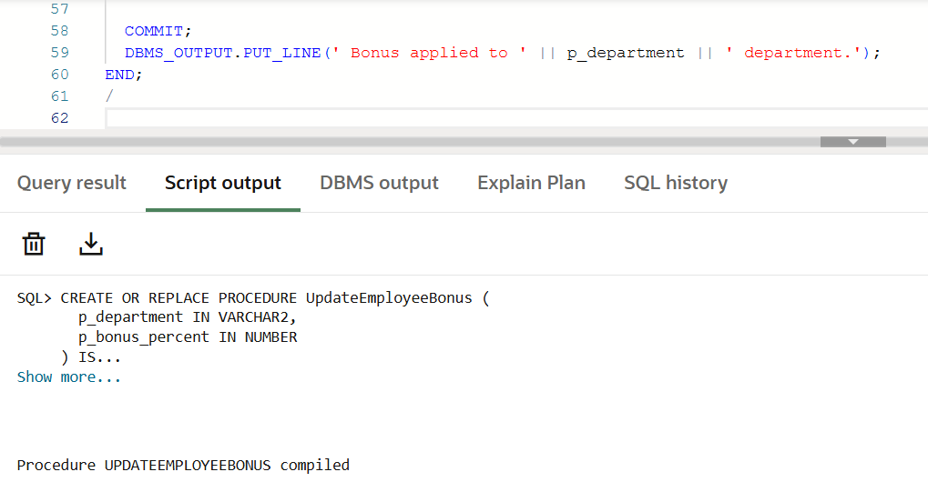END;

**Scenario 3: Transfer Funds Between Accounts**

**CODE:**

CREATE OR REPLACE PROCEDURE TransferFunds (

p_from_account IN NUMBER,

p_to_account IN NUMBER,

p_amount IN NUMBER

) IS

v_balance NUMBER;

BEGIN

-- Get balance of sender

SELECT Balance INTO v_balance

FROM ACCOUNTS

WHERE AccountID = p_from_account;

-- Check if sufficient balance

IF v_balance < p_amount THEN

DBMS_OUTPUT.PUT_LINE('Insufficient funds. Transfer failed.');

ELSE

-- Deduct from sender

UPDATE ACCOUNTS

SET Balance = Balance - p_amount

WHERE AccountID = p_from_account;

-- Add to receiver

UPDATE ACCOUNTS

SET Balance = Balance + p_amount

WHERE AccountID = p_to_account;

COMMIT;

DBMS_OUTPUT.PUT_LINE(' ₹' || p_amount || ' transferred from Account ' || p_from_account || ' to Account ' || p_to_account);

END IF;

END;

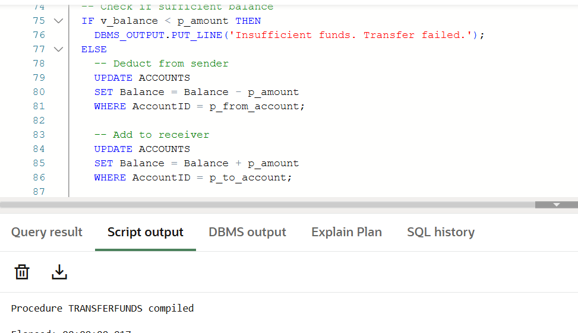**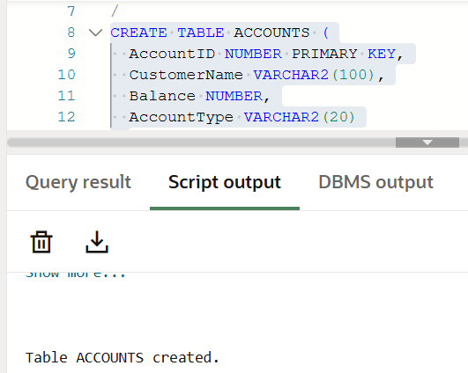OUTPUT:**

