**Heat waves Analysis and its Impact on Human Health**

Nausheen Gandhi, Janhvi Mahangade, Pooja Sonawane, Sanjay Shitole, Sonali Bodekar

Affiliation-Usha Mittal Institute Of Technology,SNDTWU.

Location:-Mumbai, India.

Email- [*nausheen.official12@gmail.com*](mailto:nausheen.official12@gmail.com) *,* [*janhvimmahangade@gmail.com*](mailto:janhvimmahangade@gmail.com), [*pooja.sonawane.st@gmail.com*](mailto:pooja.sonawane.st@gmail.com), [*Sanjay.Shitole@umit.sndt.ac.in*](mailto:Sanjay.Shitole@umit.sndt.ac.in), [*sonali.bk86@gmail.com*](mailto:sonali.bk86@gmail.com)

**Abstract**

Summers of current year clearly give indication of the fact that the world is heading towards a worsening crisis of climate change that is being accelerated through global warming, Urban heat Inland effects, and ozone depletion. Due to increasing temperatures, health issues such as heat strokes and sunburns will become serious problem for humankind. As 2024 sets new records for heat, there is a probability that we’ll be facing more extensive heat in future causing worst situation for humans and environment. Analysis shows that there is alarming call to identify the heat pattern and know various key terms related to it and finding a way to mitigate its impact and solutions for this. In this project we have done the extensive analysis through interactive “Power BI” dashboard that will help user to monitor the weather situation and know them better to get it acuteness. The dashboard will help the user to prepare for and how to respond in such extreme heat events. Additionally, based on the analysis, we have provided practical suggestions and strategies such as Diet Plan, Clothing, Do’s and Don’ts for minimizing the effects of heat waves. We have focused on pregnant women as they are among the vulnerable populations affected most by the effects of heat waves.

Keyword *Heat Wave, Heat Index, Power BI Dashboard, Pregnant women.*

Introduction

A heatwave is generally defined as the absolute prolongation of very high temperature for at least five consecutive days, causing serious effects on multifaceted domains. The extreme weather event is increasing and intensifying due to heat waves.

India ranks among the countries most affected by heatwaves, particularly in recent years. Extreme heatwaves have brought dangerous conditions into much of the regions, especially in northern, central, and western areas of the country [1]. 37 cities have experienced over 45°C temperature with the risk of heat strokes and other heat-related illnesses remaining very high. There have been cases of over 16,000 heat strokes and 60 heat-related deaths since March 2024 [2]. India faced severe heat waves in 2020 and 2021, exacerbated by the COVID-19 pandemic. In 2022, delayed monsoons and reduced rainfall caused water shortages, crop damage, and food insecurity. The heat also led to widespread health issues, such as heatstroke, dehydration, and strain on electrical grids due to high cooling demands, impacting millions. In 2023 around 2,500+ people died due to heat waves.2024 records as the hottest year so far in human history. India experienced overall 733 deaths and over 40,000 heatstroke in 2024 ,46 deaths and over 19,000 heatstroke cases in just May 2024 [3].

In 2024, the heatwave in Mumbai took temperatures to nearly about 39.7°C with high humidity and threatened people with serious health risks across the region. The group most vulnerable to heatstroke, dehydration, and exhaustion included outdoor workers, the elderly, and children. Thus, the city's infrastructures struggled with power cuts and water scarcity, along with other discomforts that worsened the situation [4]. It underlined the pressing need for greater climate resilience measures for public health safety against rising temperatures.

As heatwaves majorly affect human health leading to heat-related diseases, dehydration, and aggravating existing medical conditions [5]. Heat waves can significantly affect pregnant women, posing great risk to both the mother and the developing baby [6]. Pregnant women are especially vulnerable to extreme heat due to physical, mental and hormonal changes in body due to pregnancy, such as increased body temperature, pain and discomfort. This can lead to various types of health complication to both mother and baby. Prolonged heat stress in late pregnancy can reduce placenta size, leading to fetal growth issues, small-for-gestational-age babies, preterm birth, or stillbirth [7]. Understanding the roots of heat waves, driven by climate change and urbanization, is crucial. Swift action to reduce emissions and improve infrastructure is needed to protect human health, productivity, and quality of life from escalating risks. Proactive measures are vital to safeguard lives and mitigate future impacts.

To address increasing heatwaves, we have developed a dashboard. It provides easy access to examine historical data on heatwaves as well as providing precautions which user can filter according to their age groups. Through providing data-driven insights and tailored recommendations, the dashboard aims to empower informed decision-making, ensuring more effective protection against health impacts of extreme heat in those specific age groups.

**Methodology**

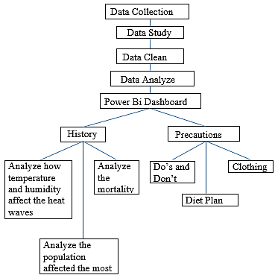

1.Flowchart represents the methodology followed in this study

**Data Collection**: Data collected from UMIT(Mumbai) and Raj bhavan (Delhi) weather station.

**Data Study**: We studied the data and researched about which parameters affect the heat waves.

We found that majorly temperature and humidity are the main factors.

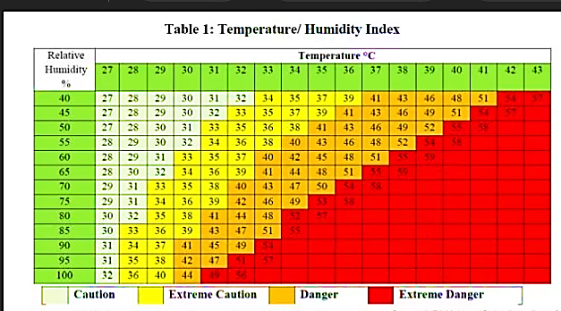

2. Relation between temperature, humidity and heat index

image from: [8]

By using pandas (python library) and y-data profiling a HTML report was generated.

**Parameters are:**

Humidity, Dew point, Heat Index, Temperature, wet bulbs, wind speed and wind chill.

**Data Cleaning:** Filter the data by using python lib(pandas).

**Data Analyze:** Analyze the weather data by using python library (matplotlib and seaborn).

**Created a Power BI Dashboard**

**First page:**

1) Multi Graph- User can select the date and accordingly the relation between temperature, humidity and heat index will be shown.

2)Pie chart- Gives the information of mortality rate (2013-2022).

3)Funnel- Shows the population affected by heat waves.

**Second page**

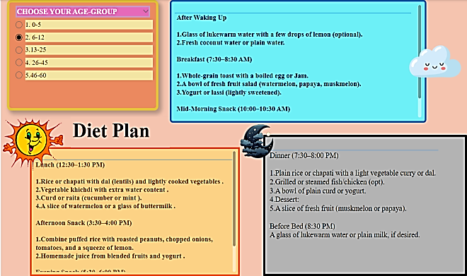

3. According to the age group, the user will get the Diet Plan from morning till night.

**Third page**



4. According to the age group, the user will get the clothing patterns (what needs to be worn) during heat waves condition.

**Fourth page**

Dos and Don’ts for vulnerable populations (infants, outdoor workers, pregnant women**.**

**Fifth page**

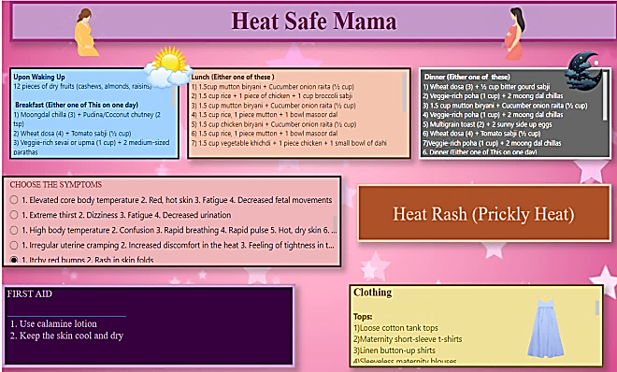

5. Diet Plan, Clothing, First aid for heat related diseases for pregnant women

**Results:**

Relation between temperature, humidity and heat index

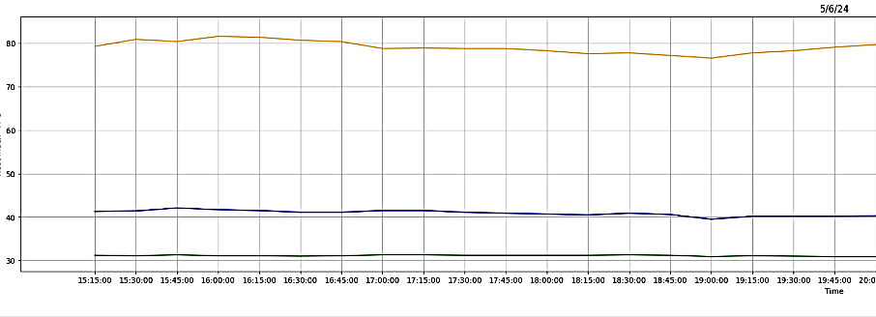

6**.** Graph analysis of temperature, humidity and heat index

Green –Temperature (°C), Blue-Heat index(°C), Orange -Humidity (%)

**Outcome**: As shown in the graph, temperature and humidity significantly impact heat waves. Even when the temperature is lower, high humidity can increase the heat index, making it feel much hotter than the actual temperature.

**Comparing the Heat Index of Delhi and Mumbai**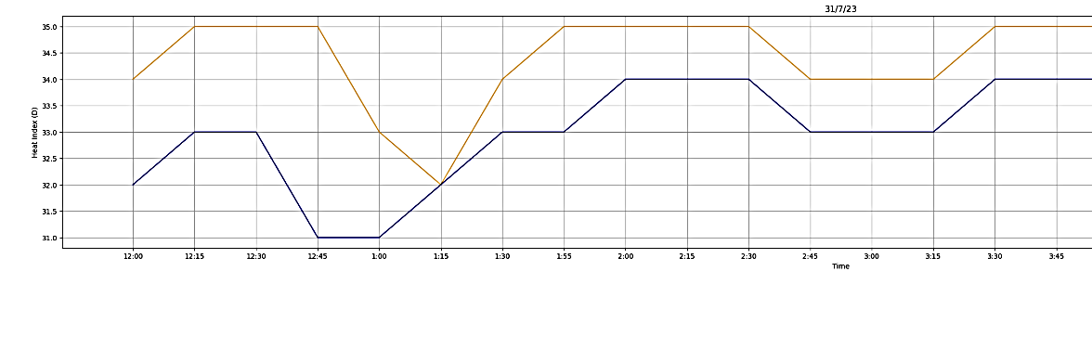

7.Comparing the heat Index of Delhi and Mumbai

Blue -Heat index of Raj bhavan (Delhi), Yellow -Heat index of UMIT(Mumbai)

**Comparing the humidity of Delhi and Mumbai**

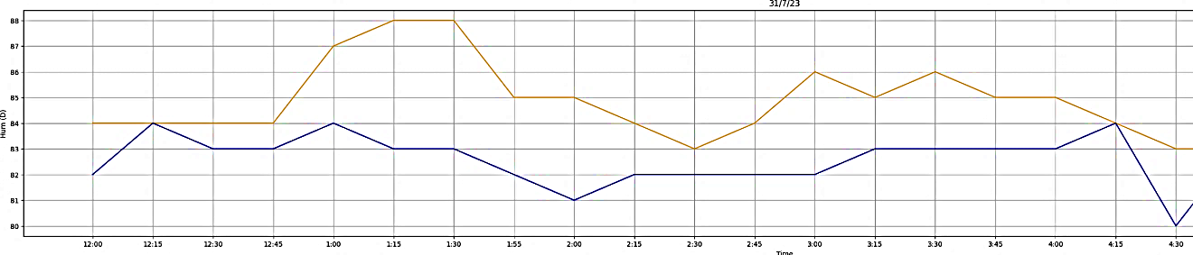

8.Comparing the humidity of Delhi and Mumbai

Blue-Humidity of Raj bhavan (Delhi), Yellow -Humidity of UMIT(Mumbai)

**Outcome**: As we can see in graph, that the heat index of Mumbai is more than Delhi in July due to more humid climate of Mumbai, henceforth the people feel hotter compared to the ones who stays in Delhi.

**Result from the first page of our dashboard**

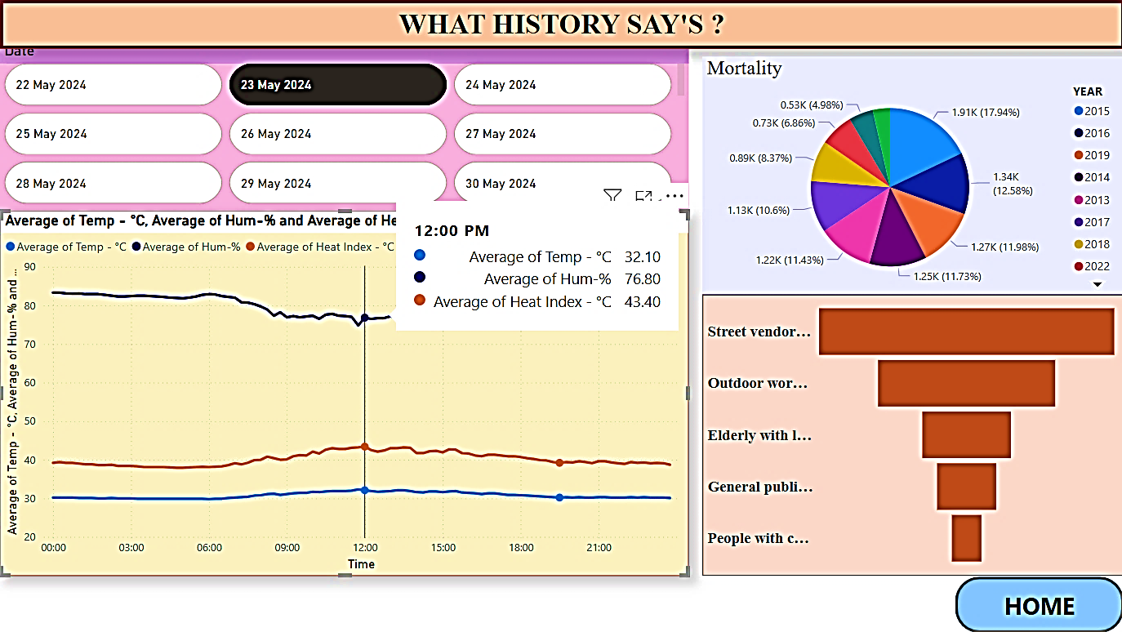

9. First page of Dashboard

**Outcome:** 2015 heat wave was more severe due to its early timing, prolonged duration, lack of preparedness, and delayed monsoon.

Through the funnel, we found out that Street vendors, Construction side workers and Homeless people are affected the most by heat waves.

**Discussion**

We find that majorly temperature and humidity increase heat index ultimately, giving rise to heat waves. Mumbai tends to feel considerably hotter than Delhi, even at similar temperatures, primarily due to high humidity levels, coastal climatic influence, minimal temperature fluctuations and the Urban Heat Island Effect. Although Delhi experiences higher absolute temperatures during summer, the dry heat feels less suffocating compared to Mumbai’s humid environment. Hence, it’s reflected in the city’s higher mortality rate, especially during heat waves and periods of extreme weather.

Our research shows that specific groups such as Young Children, Elderly people, People living in poverty, Outdoor workers and Pregnant women are particularly vulnerable to the harmful effects of heat waves.

**Conclusion**

Our project highlights the importance of studying heat waves and their impact on human health, using weather station data to analyze temperatures, wind speeds, humidity, and the heat index. Our Power BI dashboard provides historical weather data, peak temperature timings, and mortality analysis during heat waves, highlighting their severity. It includes precautions, diet plans, and clothing tips to help users prepare. A dedicated page for pregnant women offers tailored advice on diet, clothing, and first aid for heat-related issues.

**Future Work**

We aim to enhance the heat wave dashboard with real-time weather data, live updates, heat wave alerts, and location-based notifications. The focus will be on vulnerable groups like outdoor workers and pregnant women, offering personalized advice based on age, health, activity, and location. Multilingual support will also be added to overcome language barriers.

# **References**

|  |  |
| --- | --- |
| [1] | Srivastava, Akhil and Mohapatra, M and Kumar, Naresh, "Hot weather hazard analysis over India," *Scientific reports,* vol. 12, p. 19768, 2022. |
| [2] | P. C. Pandey, 13 August 2024. [Online]. Available: https://www.climatescorecard.org/2024/08/climate-change-and-extreme-heat-in-india/#:~:text=Temperatures%20in%2037%20cities%20exceeded%2045%C2%BAC%20and%20above%2C,strokes%20and%2060%20heat-related%20deaths%20since%20March%202024.. |
| [3] | G. Mudur, 03 June 2024. [Online]. Available: https://www.telegraphindia.com/india/heatwave-singes-90-per-cent-of-country-19000-heat-stroke-cases-46-deaths-recorded/cid/2024251. |
| [4] | "The Current Heatwaves in India 2024: An Alarming Climate Change," 29 May 2024. [Online]. Available: https://www.aqi.in/blog/en-in/current-heatwaves-in-india-2024-an-alarming-climate-change/#:~:text=As%20of%20May%202024%2C%20the%20country%20is%20experiencing,also%20leading%20to%20significant%20socio-economic%20and%20environmental%20challenges. |
| [5] | P. Kumar, "Analysis of heat stress and heat wave in the four metropolitan cities of India in recent period," *Science of The Total Environment,* vol. 818, p. 151788, 2022. |
| [6] | "Extreme heat at work can double stillbirth risk, India study finds," 22 March 2024. [Online]. Available: https://www.bbc.com/news/world-asia-india-68575943. |
| [7] | W. Cowell, "Ambient temperature, heat stress and fetal growth: a review of placenta-mediated mechanisms," *Molecular and Cellular Endocrinology,* vol. 576, p. 112000, 2023. |
| [8] | Gupta, Anil and Barwal, Anjali and Madan, Aditi and Sood, Atisha, Health Adaptation and Resilience to Climate Change and Related Disasters: A Compendium of Case Studies, 2021. |