Introduction To Linux

Q1)
Create a directory "exercise" inside your home directory and create nested(dir1/dir2/dir3) directory structure inside "excerise" with single command.

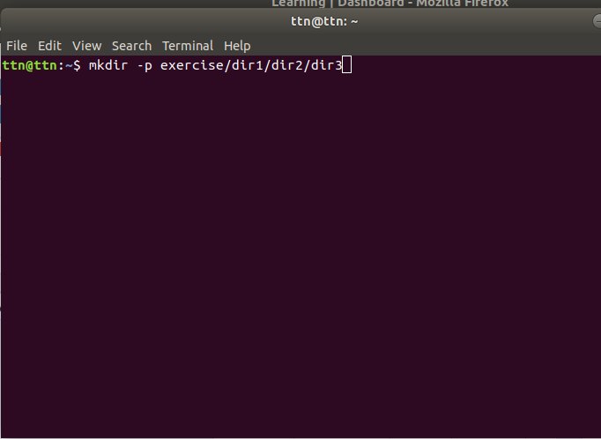

Q2)
Create two empty files inside dir2 directory: emptyFile1,emptyFile2 in single command
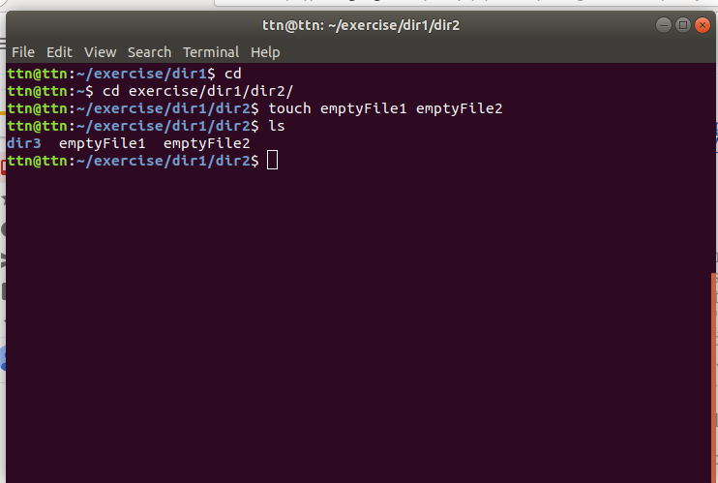

Q3)
Create one file file1.txt containing text "hello world" and save it.
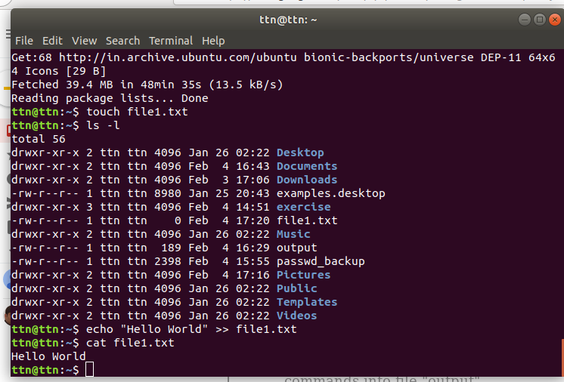

Q4)
Find a "passwd" file using find command inside /etc. copy this files as passwd_copy and then rename this file as passwd_backup.

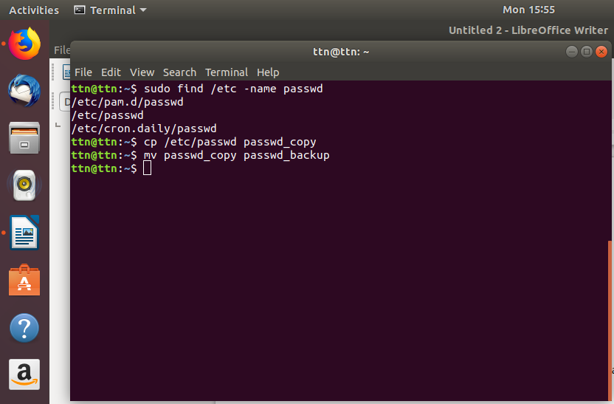

Q 5) Try reading passwd_backup file in multiple tools :less,more,cat,string,etc.

less passwd_backup
more passwd_backup
cat passwd_backup
strings passwd_backup

Q 6)
Find out the number of line in passwd_backup containing "/bin/false".
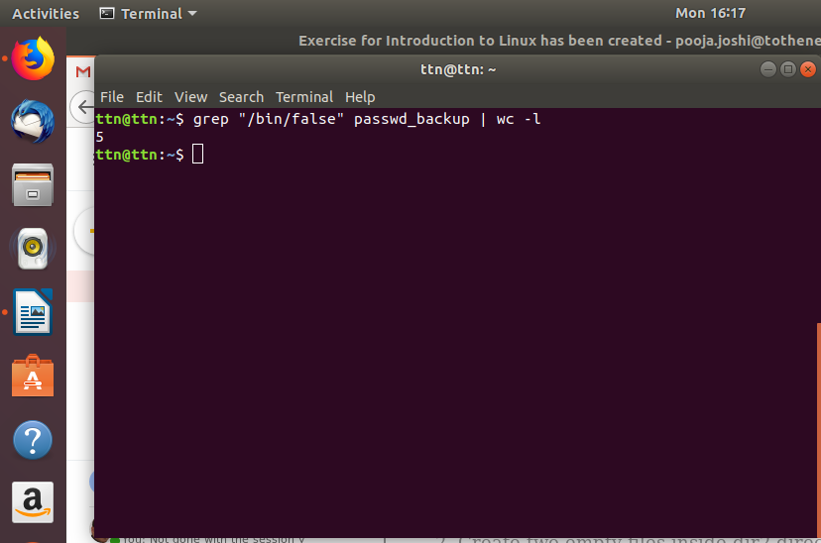

Q 7)
Get the first 5 lines of a file “passwd_backup” and Redirect the output of the above commands into file "output".
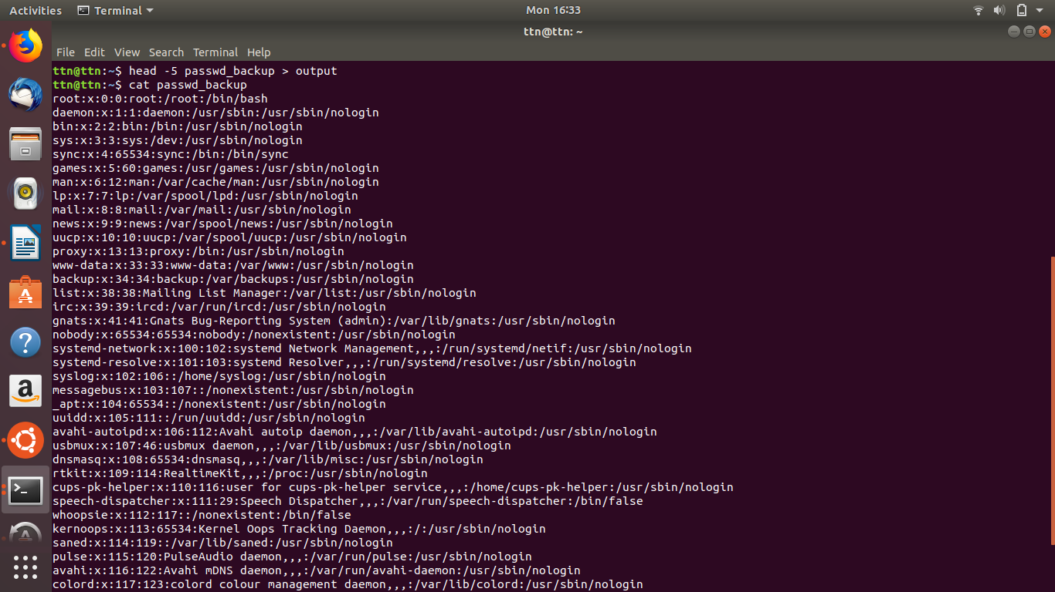
Q 8)Create a "test" user,create its password and find out its uid and gid.

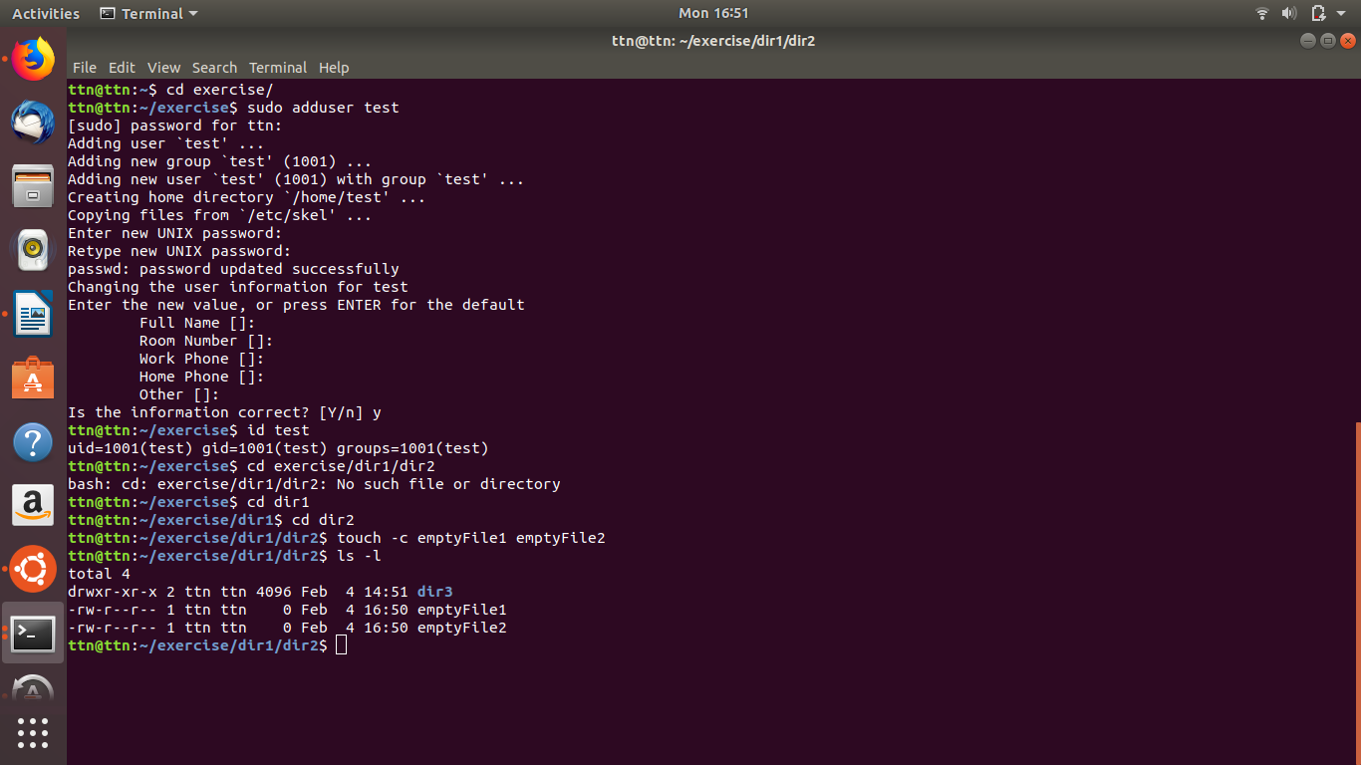

Q 9)
Change the timestamp of emptyFile1,emptyFile2 which are exist in dir2

Q 10)
Login as test user and edit the "output" file created above. Since the permission wont allow you to save the changes. Configure such that test user can edit it.

Q 11)Create alias with your name so that it creates a file as "/tmp/aliastesting".

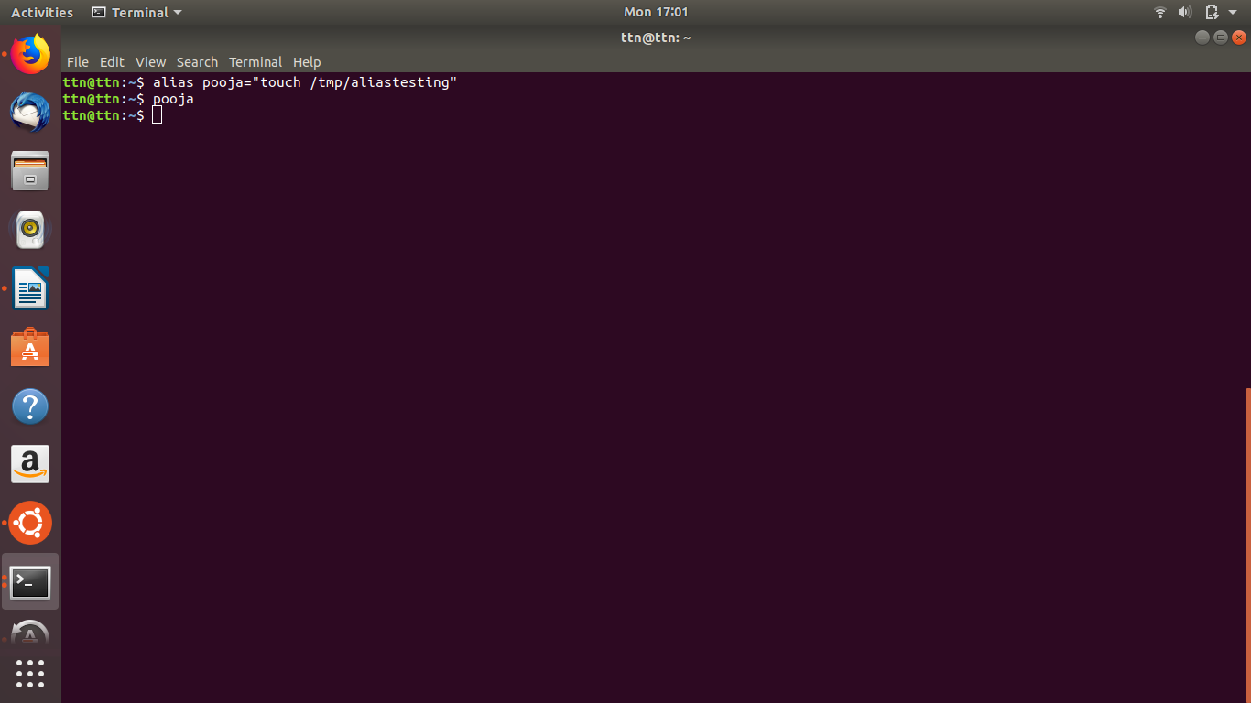

Q 12)
Edit ~/.bashrc file such that when you change to "test" user it should clear the screen and print "Welcome".
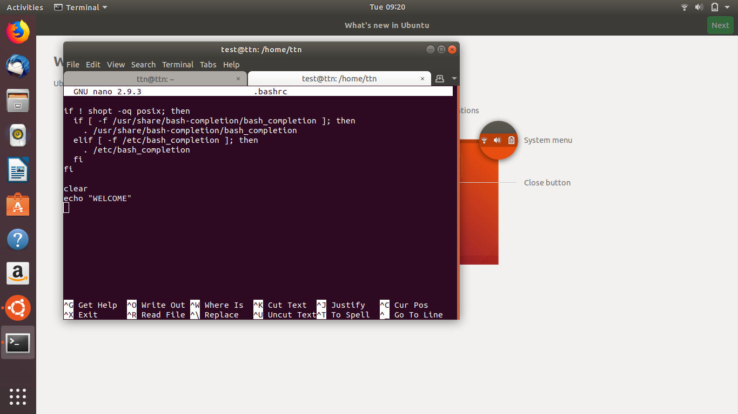

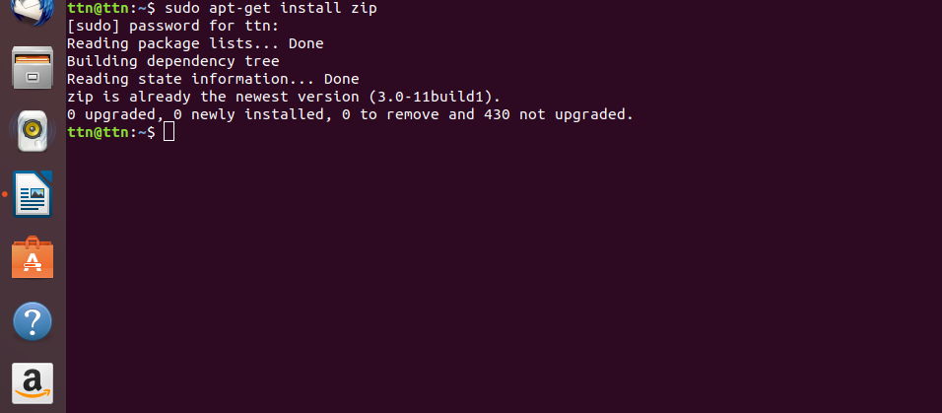
Q 13) Install “zip” package.

Q 14)
Compress "output" and "passwd_backup" files into a tar ball. List the files present inside the tar created.

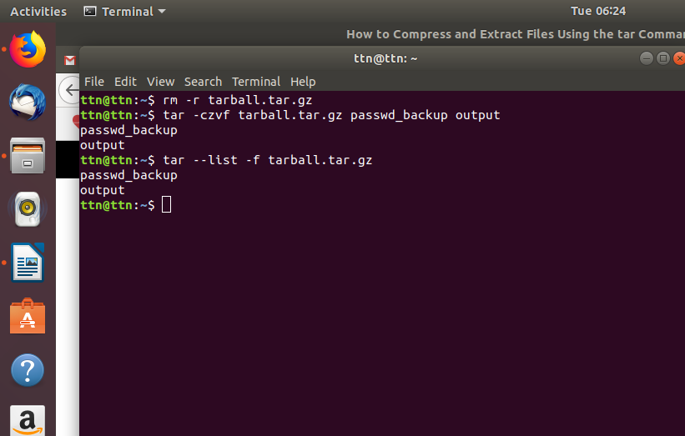

Q 15)
scp this file to test user

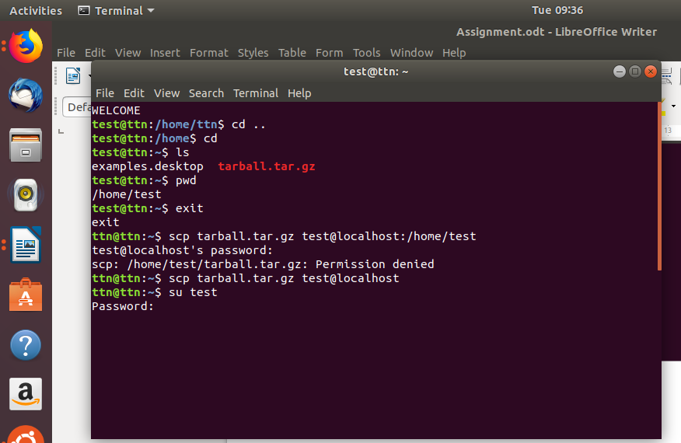

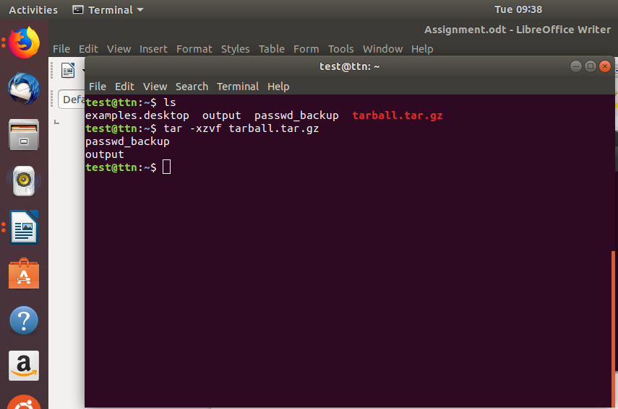

Q 16) unzip the tar ball by logging into the remote server.

Q 17) download any image from web and move to desktop.

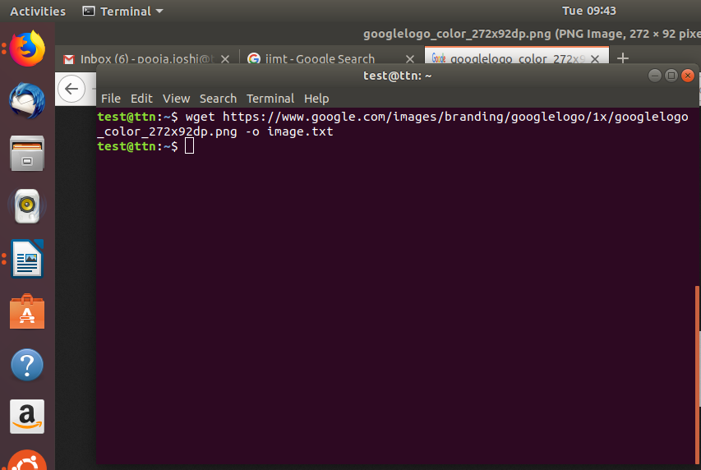

Q 18) How to get help of commands usages.

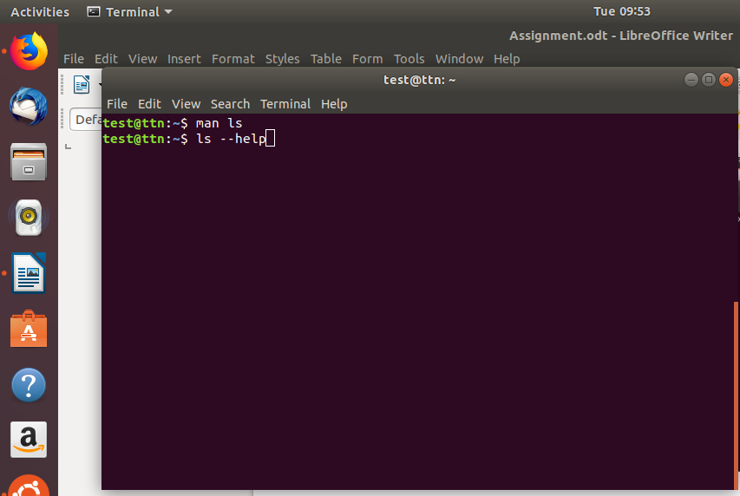

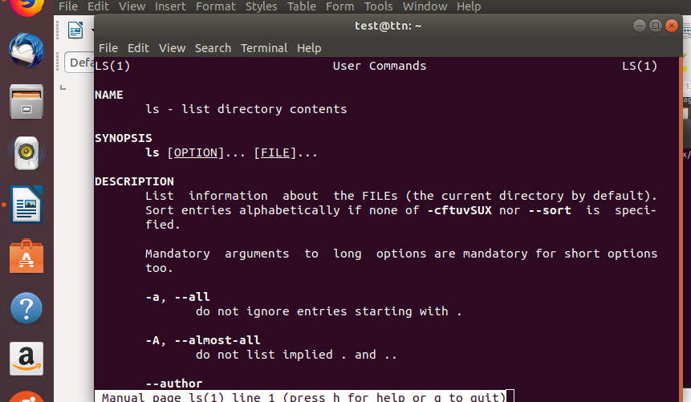

Q 19)Create a symlink of /etc/services into tmp/ports-info

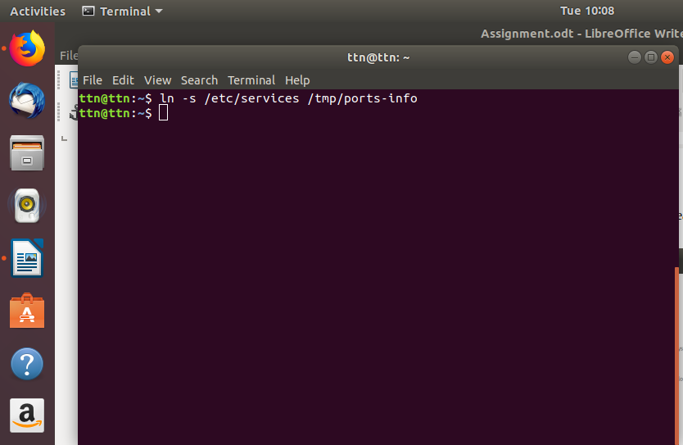

Q 20)
To find the location of “xyz ” command “which “ and “whereis” is used-

