Netflix Review Data Analysis and NLP Report

Project Overview
This project performs data cleaning, translation, sentiment analysis, and NLP-based insights on Netflix user reviews using Python. The goal is to understand user sentiment, highlight top-rated shows, and extract meaningful entities (like movie names, people, or organizations) from text reviews.
The entire workflow transforms raw text data into actionable insights through a combination of data preprocessing, translation, machine learning, and visualization techniques.
- Data Cleaning Process
Steps Performed:
- Remove duplicates to ensure unique entries.
- Handle missing values:
  - Missing Rating filled with the mean rating.
  - Missing ReviewText filled with "No Review".
- Standardize text:
  - Trim spaces from UserName and MovieTitle.
  - Convert movie titles to title case (e.g., “money heist” → “Money Heist”).
  - Replace spaces in usernames with underscores.
- Fix invalid ratings:
Ratings capped between 1 and 5.
- Convert dates to datetime format and remove invalid ones.
- Filter abnormal reviews:
Remove purely numeric or very short reviews.
- Clean special characters from reviews using Regular Expressions.

import pandas as pd
import re
from deep_translator import GoogleTranslator
from textblob import TextBlob
from collections import Counter
import matplotlib.pyplot as plt
import numpy as np
import spacy
import nltk

# Load CSV file
df = pd.read_csv("net.csv", sep=None, engine="python")

#before cleaning
print(df)

# -------------------- Cleaning Steps --------------------

# 1. Remove duplicate rows (if any)
df = df.drop_duplicates()

# 2. Handle missing values
df["Rating"] = df["Rating"].fillna(df["Rating"].mean()) # Fill missing ratings
df["ReviewText"] = df["ReviewText"].fillna("No Review") # Fill missing text reviews

# 3. Standardize column text
df["UserName"] = df["UserName"].str.strip()
df["MovieTitle"] = df["MovieTitle"].str.strip()

# 4. Fix ratings outside valid range (1–5)
df.loc[df["Rating"] > 5, "Rating"] = 5
df.loc[df["Rating"] < 1, "Rating"] = 1

# 5. Convert Date column to datetime format (month/day/year)
df["Date"] = pd.to_datetime(df["Date"], format="%m/%d/%Y", errors="coerce")

# 6. Remove rows with invalid dates
df = df.dropna(subset=["Date"])

# 7. Clean abnormal reviews (remove purely numeric or too short reviews)
df = df[~df["ReviewText"].str.isnumeric()] # removes reviews like "3333"
df = df[df["ReviewText"].str.len() > 5] # removes too short reviews

# 8. Capitalize movie titles properly
df["MovieTitle"] = df["MovieTitle"].str.title()

# 9. Standardize usernames (replace spaces with "_")
df["UserName"] = df["UserName"].str.replace(" ", "_")

# 10. Cleaned version (keep for analysis)
def clean_text(text):
return re.sub(r"[^\w\s]", "", str(text)) # works for all languages

df["ReviewText_Cleaned"] = df["ReviewText"].apply(clean_text).str.strip()

# --------------------------------------------------------

print("\nAfter Cleaning:")
print(df)
# Save cleaned file back to Excel
df.to_csv("netflix_reviews_cleaned.csv", index=False)
Output Load CSV file :
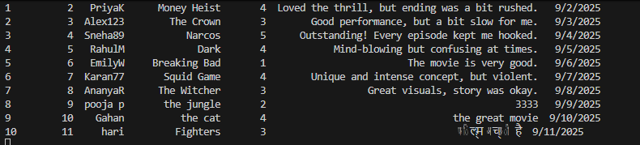
Cleaning Data Output :
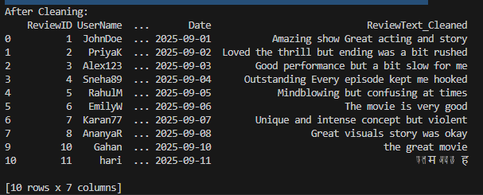

Language Translation
Some reviews may be written in different languages.
Using the Deep Translator (GoogleTranslator) library, all text reviews are automatically translated into English.
A new column ReviewText_English is created to store the translated text.
#--------------translate-----------

# 11. Translate reviews into English
def translate_to_english(text):
try:
return GoogleTranslator(source="auto", target="en").translate(text)
except Exception:
return text # fallback

df["ReviewText_English"] = df["ReviewText"].apply(translate_to_english)

# --------------------------------------------------------

print("\nAfter Cleaning + Translation:")
print(df[["UserName", "MovieTitle", "Rating", "ReviewText", "ReviewText_English"]])

#save after translate the review
df.to_csv("netflix_reviews_translate.csv", index=False)
Translation output :
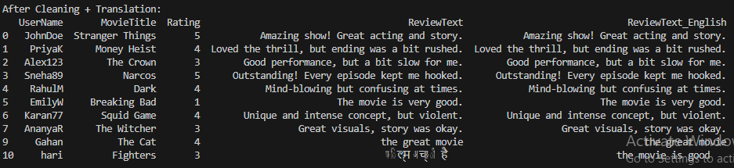

Sentiment Analysis
Sentiment analysis determines whether a review is Positive, Negative, or Neutral using the TextBlob library.
Polarity Value | Interpretation
> 0 | Positive
< 0 | Negative
= 0 | Neutral
Results are stored in the column Sentiment_reviewtext.
#-------------Sentiment Analysis--------------

def get_sentiment(text):
analysis = TextBlob(text).sentiment.polarity
if analysis > 0:
return "Positive"
elif analysis < 0:
return "Negative"
else:
return "Neutral"
df["Sentiment_reviewtext"] = df["ReviewText_English"].apply(get_sentiment)
print("\nAfter Cleaning + Translation + Sentiment_reviewtext:")
print(df[["UserName", "MovieTitle", "Rating", "ReviewText",
"ReviewText_English", "Sentiment_reviewtext"]])

# Save final version with sentiment
df.to_csv("sentiment_analysis.csv", index=False)
Sentiment Analysis Output:
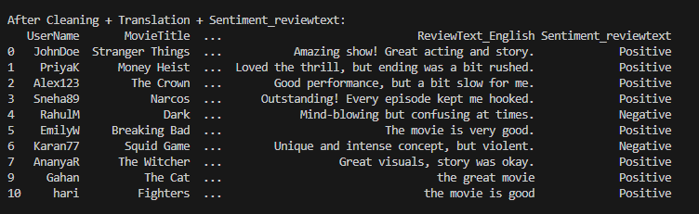

Keyword Extraction
To identify commonly used terms, all English-translated reviews are merged and tokenized.
The Counter class from Python’s collections module is used to find the Top 20 most frequent words across reviews.
These keywords help understand recurring themes and user opinions.
#-----------Keyword Extraction (Most frequent words or phrases in reviews)-------

all_words = " ".join(df["ReviewText_English"]).lower().split()
common_words = Counter(all_words).most_common(20)
print(common_words)
Keyword Extraction Output:

Top 5 Highest Rated Movies
Using the Pandas groupby() function:
- Average rating per movie is calculated.
- Top 5 highest-rated movies are displayed in a bar chart using Matplotlib.
#---------------- top 5 movies rating---------------
import matplotlib.pyplot as plt

# Group by movie and calculate average rating
avg_ratings = df.groupby("MovieTitle")["Rating"].mean()

# Sort movies by rating descending and take top 5
top5_movies = avg_ratings.sort_values(ascending=False).head(5)
print("Top 5 Highest Rated Movies:")
print(top5_movies)

# Bar chart for top 5 movies
plt.figure(figsize=(10,6))
top5_movies.plot(kind='bar', color='orange')
plt.title("Top 5 Highest Rated Movies")
plt.ylabel("Average Rating")
plt.xlabel("Movie Title")
plt.ylim(0, 5) # Ratings range 1-5
plt.xticks(rotation=45, ha='right')
plt.tight_layout()
plt.show()

Top 5 Highest Rating Output:
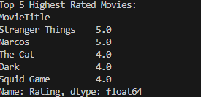
Top 5 Highest Rating Bar chart :
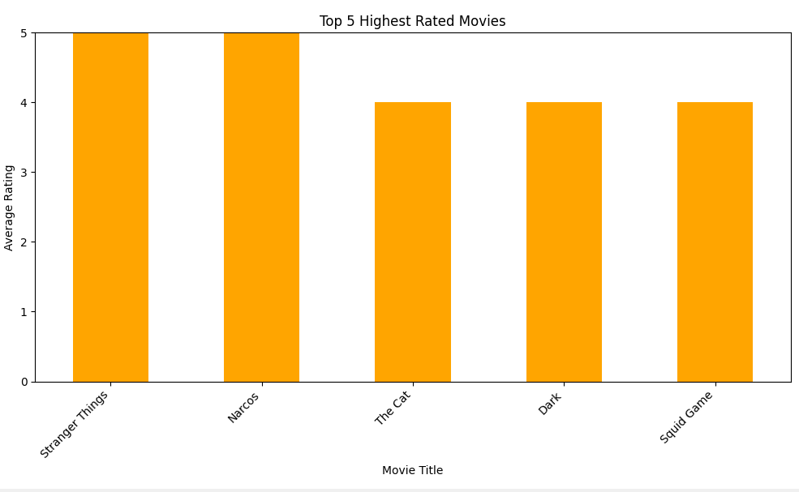

Rating vs Sentiment Consistency Check
To compare numerical ratings with text sentiment, a new column RatingVsSentiment_Analysis is created.
Rating | Expected Sentiment | Result
4–5 | Positive | Consistent
1–2 | Negative | Consistent
3 | Neutral | Neutral or Mismatch
If the rating and sentiment disagree (e.g., rating = 5 but sentiment = Negative), it’s marked as Mismatch.
This helps detect inconsistent or misleading reviews.
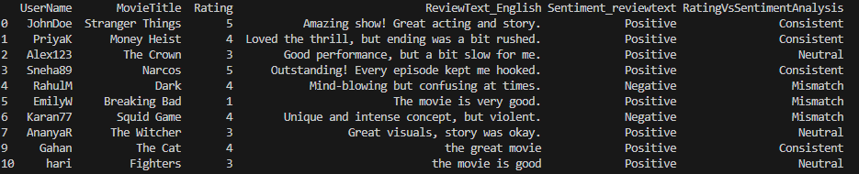

Named Entity Recognition (NER)
NER (Named Entity Recognition) is an NLP (Natural Language Processing) technique that automatically finds and classifies important information (entities) in text. Using SpaCy’s en_core_web_sm model, entities are extracted from the translated reviews.
Extracted entities include:
WORK_OF_ART: Movie or series names
ORG: Organizations
PERSON: Actor or creator names
A new column Entities is added to store these recognized names.
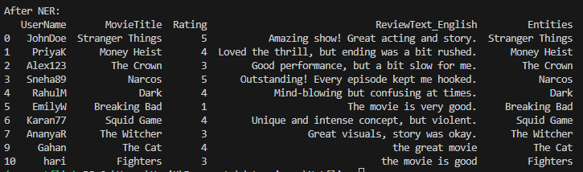

Conclusion
This project demonstrates an end-to-end data analysis pipeline integrating:
- Data Cleaning
- Language Translation
- Sentiment Analysis
- Keyword Extraction
- NER
- Visualization
It provides valuable insights into audience perception of Netflix content and can be scaled to handle larger datasets for automated brand or product review analysis.

Final Data in Excel :
ReviewID | UserName | MovieTitle | Rating | ReviewText | Date
1 | JohnDoe | Stranger Things | 5 | Amazing show! Great acting and story. | 9/1/2025
2 | PriyaK | Money Heist | 4 | Loved the thrill, but ending was a bit rushed. | 9/2/2025
3 | Alex123 | The Crown | 3 | Good performance, but a bit slow for me. | 9/3/2025
4 | Sneha89 | Narcos | 5 | Outstanding! Every episode kept me hooked. | 9/4/2025
5 | RahulM | Dark | 4 | Mind-blowing but confusing at times. | 9/5/2025
6 | EmilyW | Breaking Bad | 1 | The movie is very good. | 9/6/2025
7 | Karan77 | Squid Game | 4 | Unique and intense concept, but violent. | 9/7/2025
8 | AnanyaR | The Witcher | 3 | Great visuals, story was okay. | 9/8/2025
10 | Gahan | The Cat | 4 | the great movie | 9/10/2025
11 | hari | Fighters | 3 | फिल्म अच्छी है | 9/11/2025

ReviewText_Cleaned | ReviewText_English | Sentiment_reviewtext
Amazing show Great acting and story | Amazing show! Great acting and story. | Positive
Loved the thrill but ending was a bit rushed | Loved the thrill, but ending was a bit rushed. | Positive
Good performance but a bit slow for me | Good performance, but a bit slow for me. | Positive
Outstanding Every episode kept me hooked | Outstanding! Every episode kept me hooked. | Positive
Mindblowing but confusing at times | Mind-blowing but confusing at times. | Negative
The movie is very good | The movie is very good. | Positive
Unique and intense concept but violent | Unique and intense concept, but violent. | Negative
Great visuals story was okay | Great visuals, story was okay. | Positive
the great movie | the great movie | Positive
फलम अचछ ह | the movie is good | Positive

RatingVsSentimentAnalysis | Entities
Consistent | Stranger Things
Consistent | Money Heist
Neutral | The Crown
Consistent | Narcos
Mismatch | Dark
Mismatch | Breaking Bad
Mismatch | Squid Game
Neutral | The Witcher
Consistent | The Cat
Neutral | Fighters

