NEURAL NETWORK & DEEP LEARNING
ASSIGNMENT 8

Pooja Bhavani Avuthu
Student ID: 700746936
Git hub Link: https://github.com/pooja0079/ICP-8

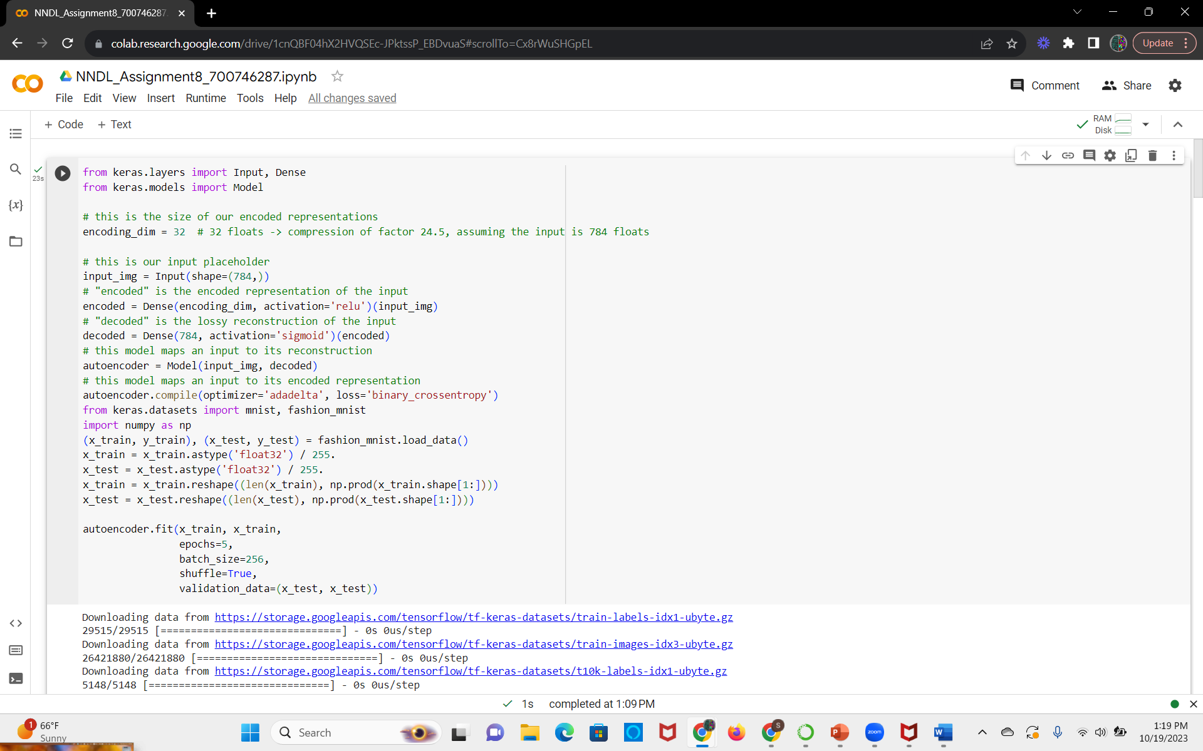
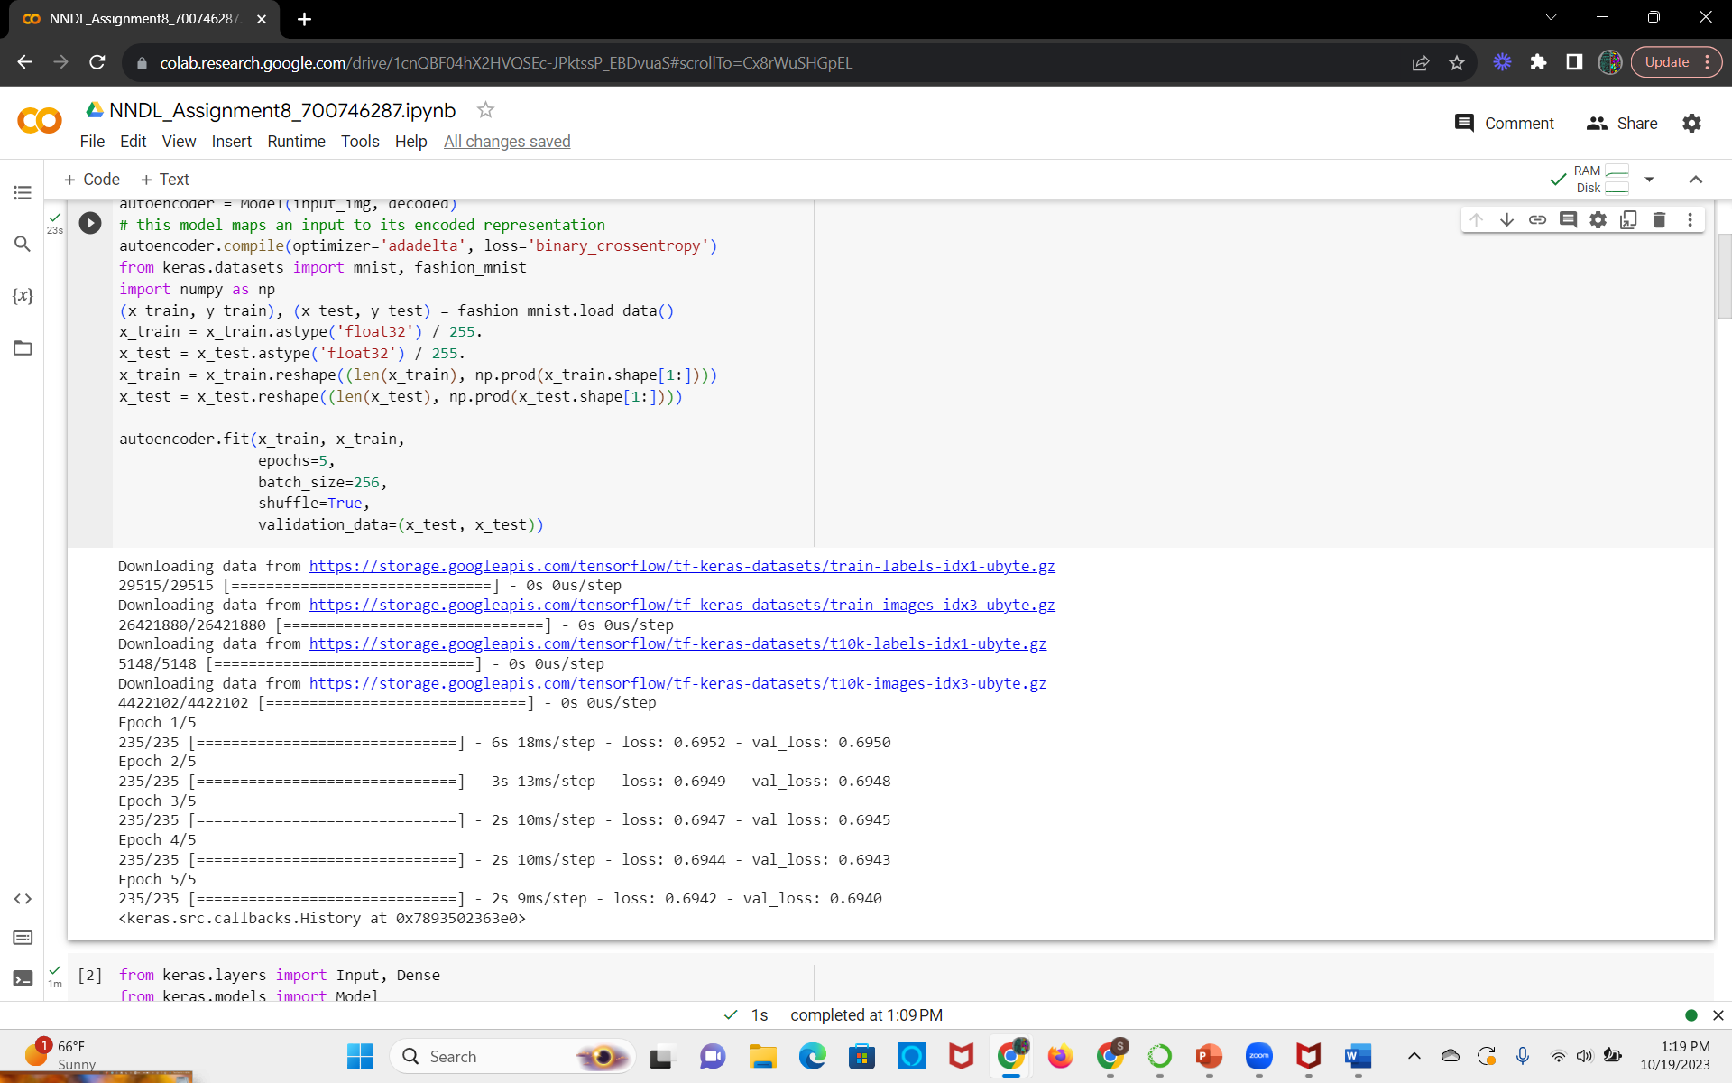

Here we added a new hidden layer to the encoder and the decoder
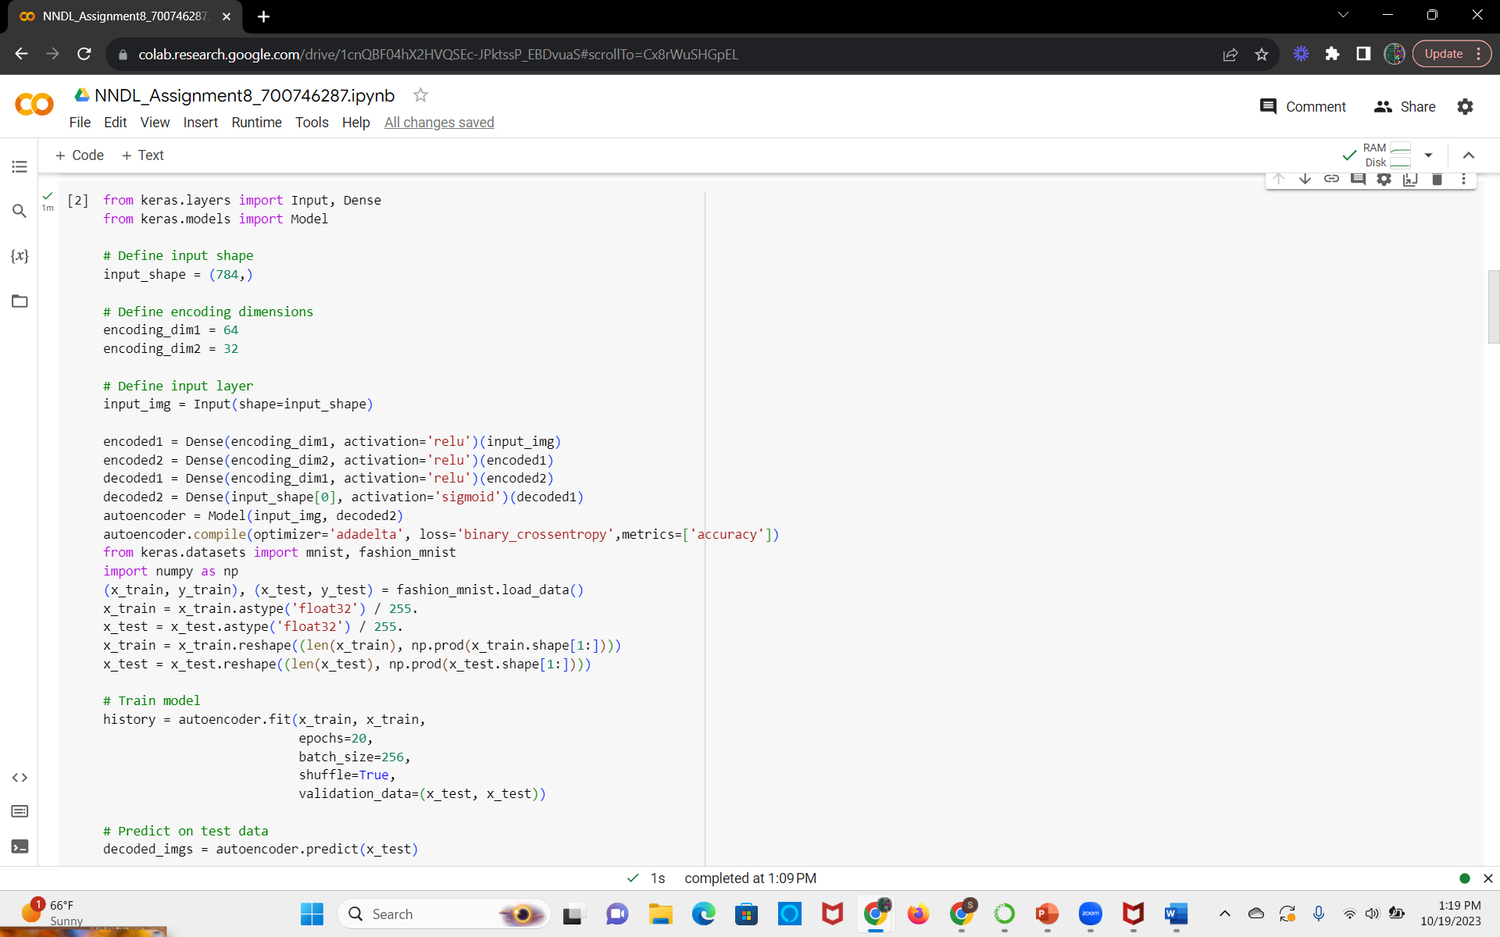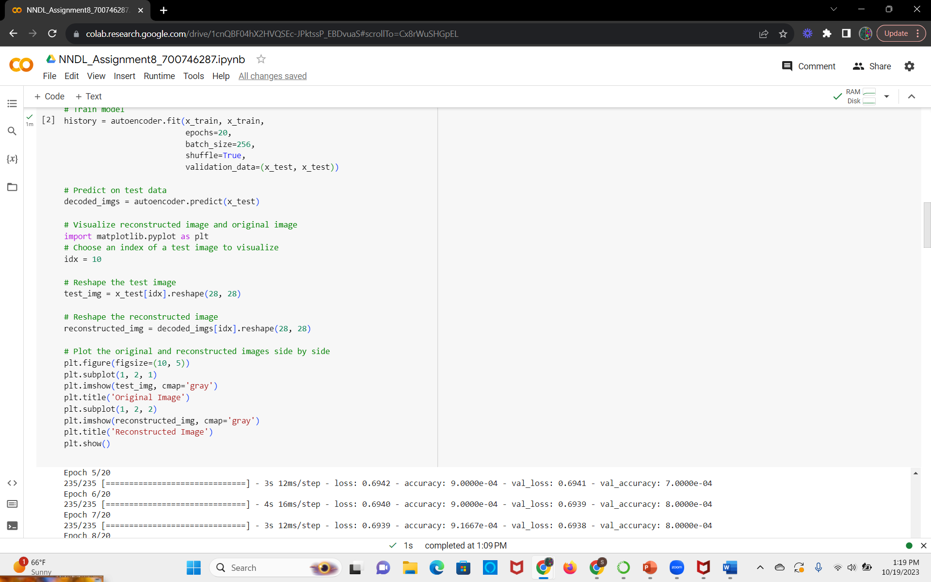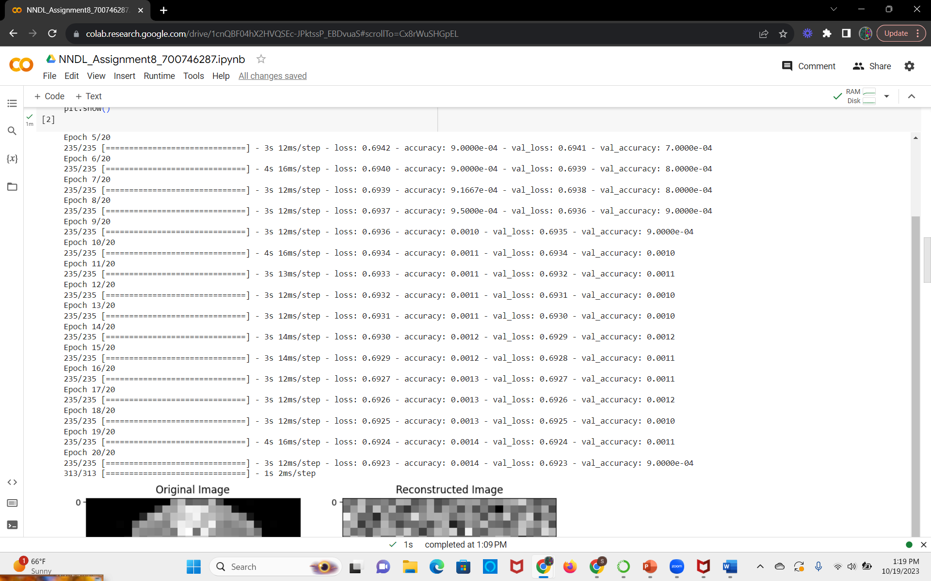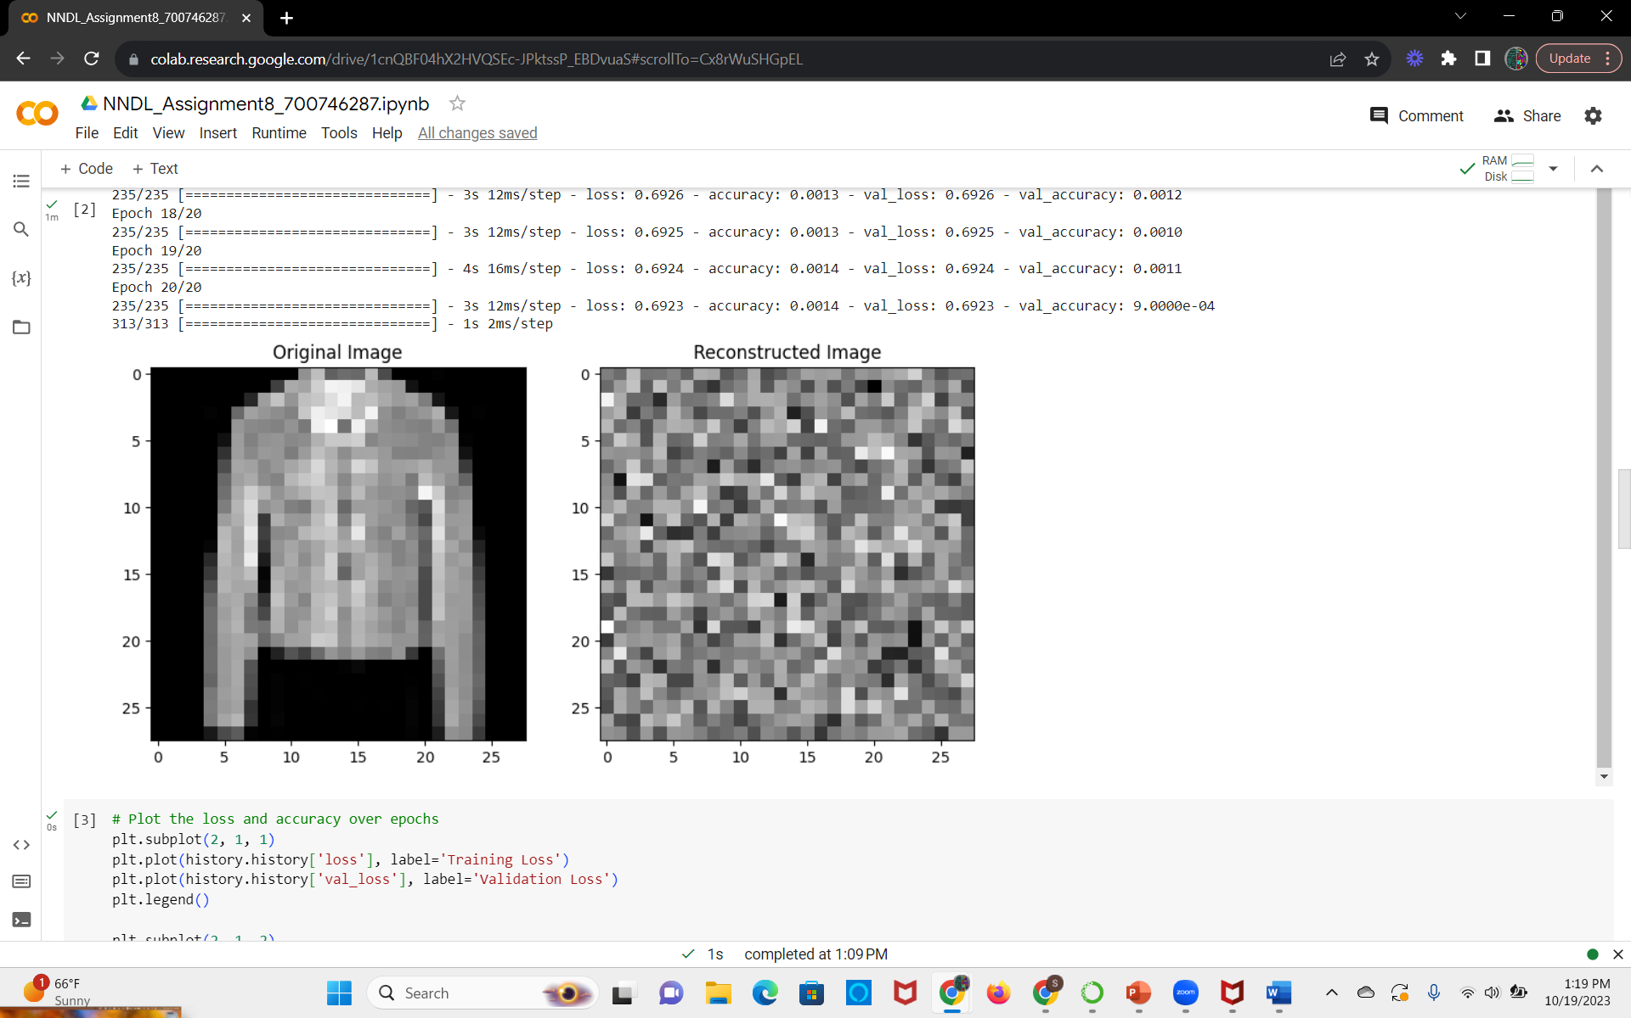
We are calculating the loss and accuracy of the model using the history object where in the compile metrics are set to accuracy

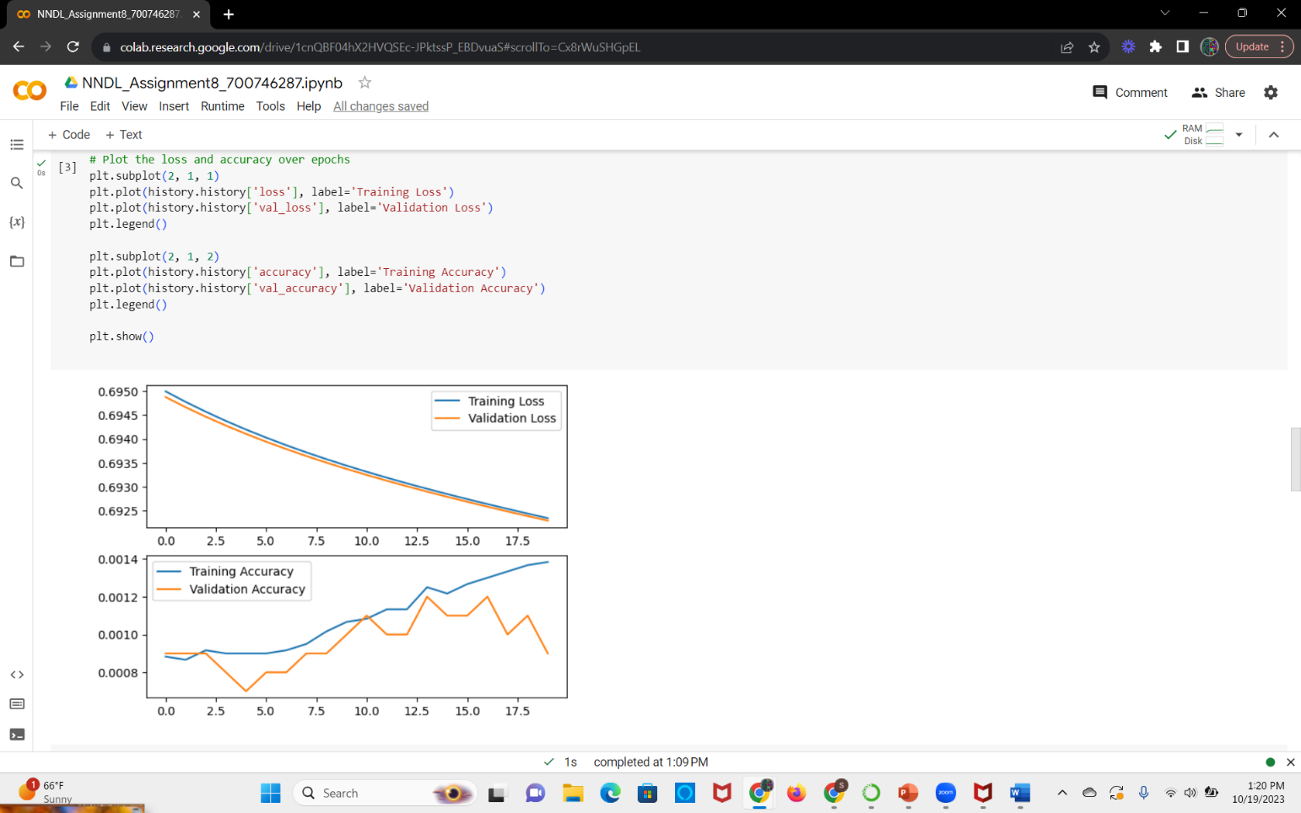
For the denoisening autoencoder we are adding the noise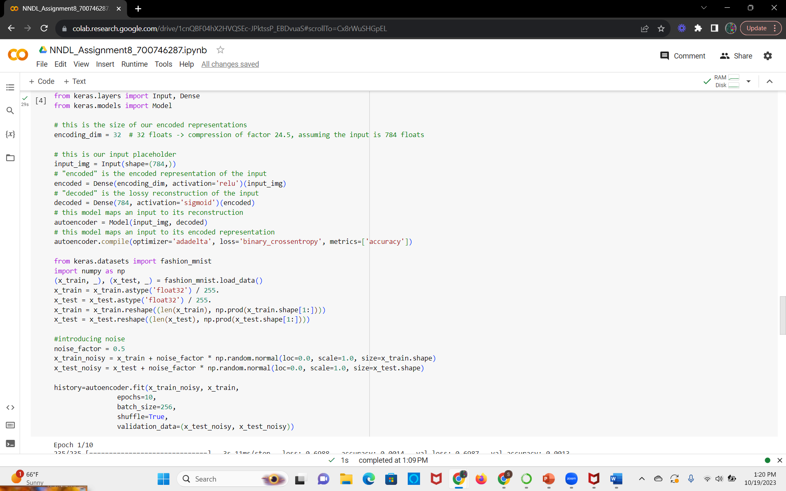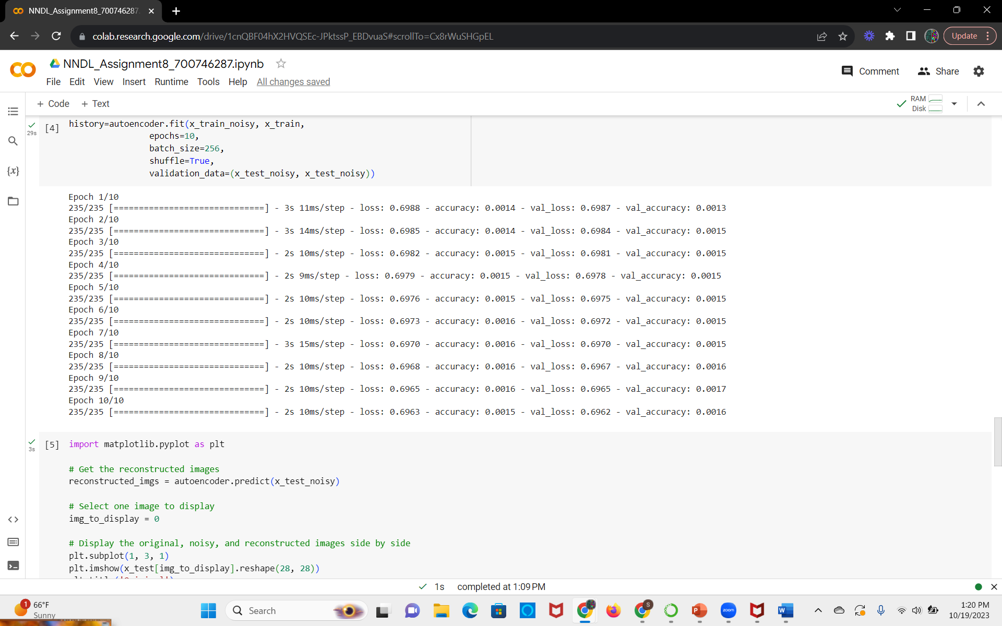

We are plotting the original image and the reconstructed image using the matplotlib library
