# CS5720 Neural Networks & Deep Learning ICP-4

**NAME: Pooja Bhavani Avuthu**

**STUDENT ID:700746936**

***Git hub Link***: https://github.com/pooja0079/ICP4

# Data Manipulation

* 1. Read the provided CSV file ‘data.csv’.
  2. https://drive.google.com/drive/folders/1h8C3mLsso-R-sIOLsvoYwPLzy2fJ4IOF?usp=sharing
  3. Show the basic statistical description about the data.

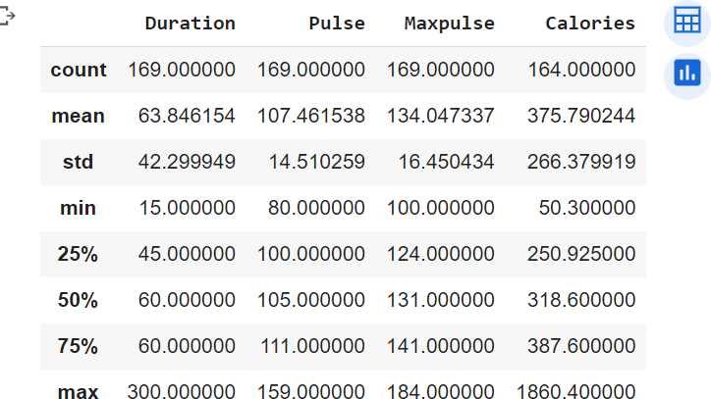

* 1. Check if the data has null values.



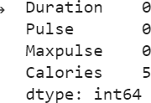

i. Replace the null values with the mean

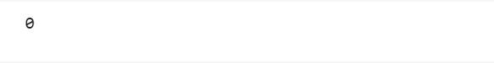

* 1. Select at least two columns and aggregate the data using: min, max, count,mean.

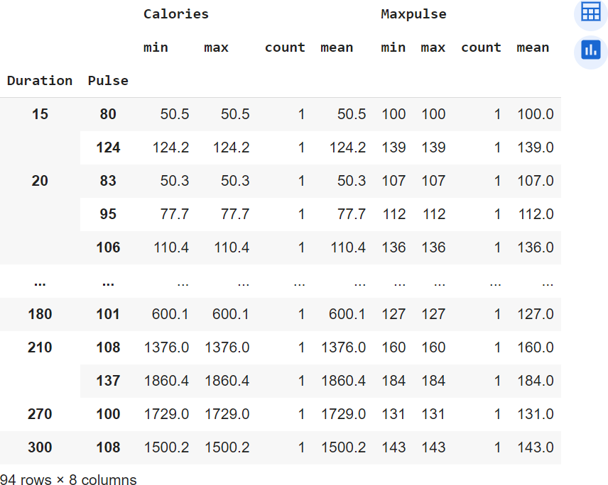

* 1. Filter the dataframe to select the rows with calories values between 500 and1000.



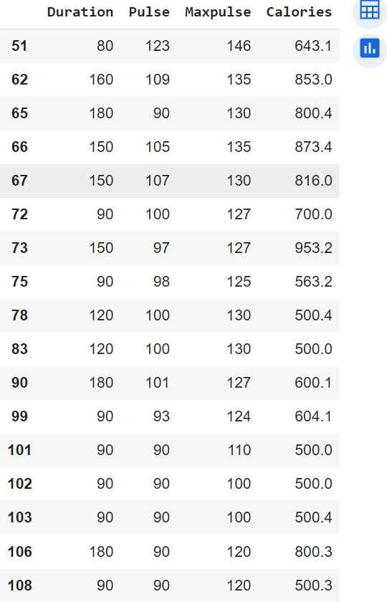

* 1. Filter the dataframe to select the rows with calories values > 500 and pulse <100.



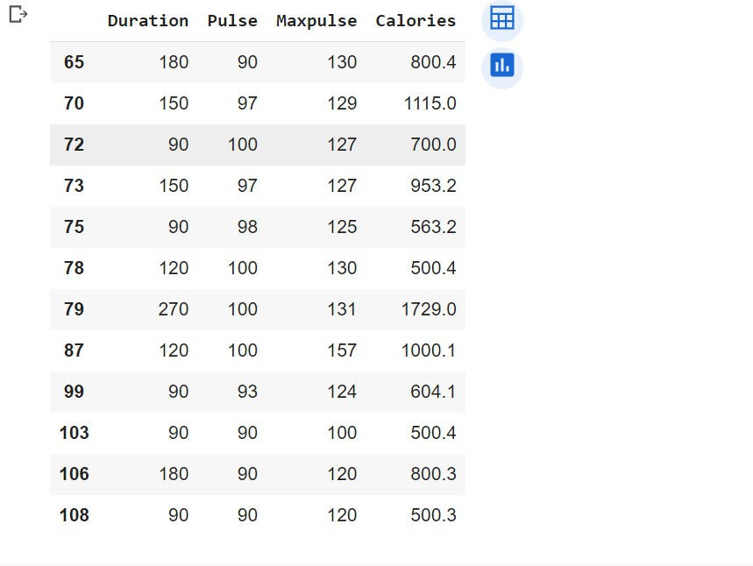

* 1. 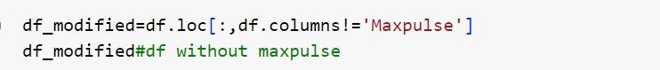Create a new “df_modified” dataframe that contains all the columns from df exceptfor “Maxpulse”.

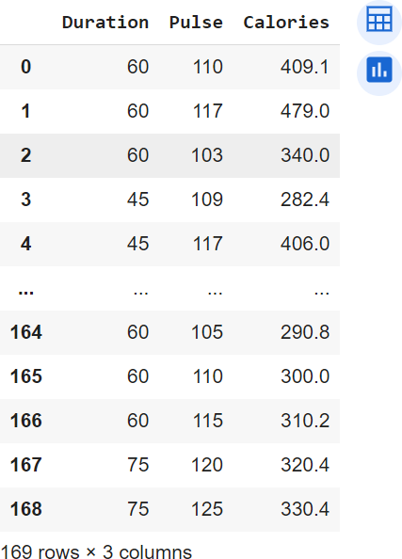

* 1. Delete the “Maxpulse” column from the main df dataframe



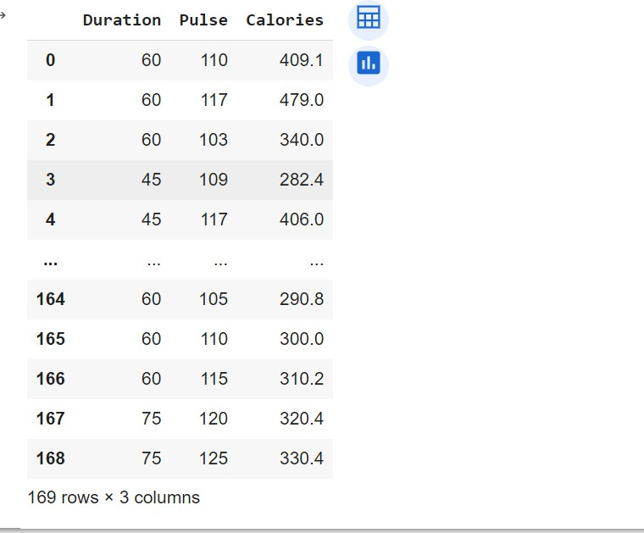

* 1. Convert the datatype of Calories column to int datatype.



* 1. Using pandas create a scatter plot for the two columns (Duration andCalories).



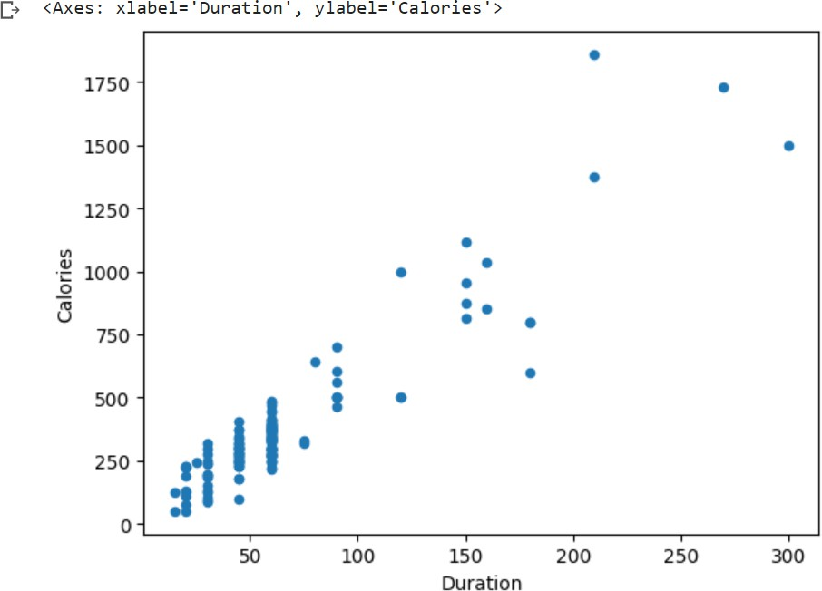

# Linear Regression

1. Import the given “Salary_Data.csv”

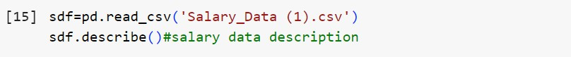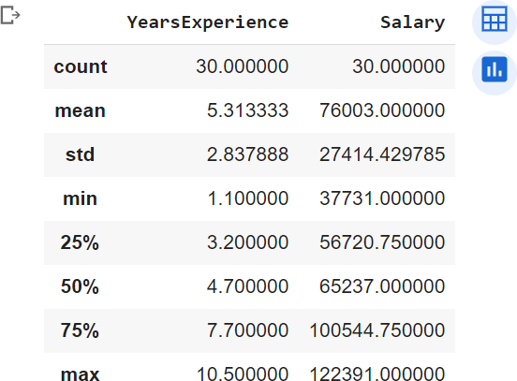

1. Split the data in train_test partitions, such that 1/3 of the data is reserved as test subset.



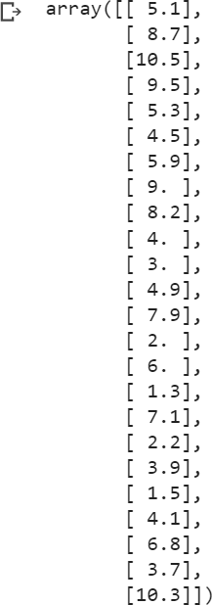

1. Train and predict the model.

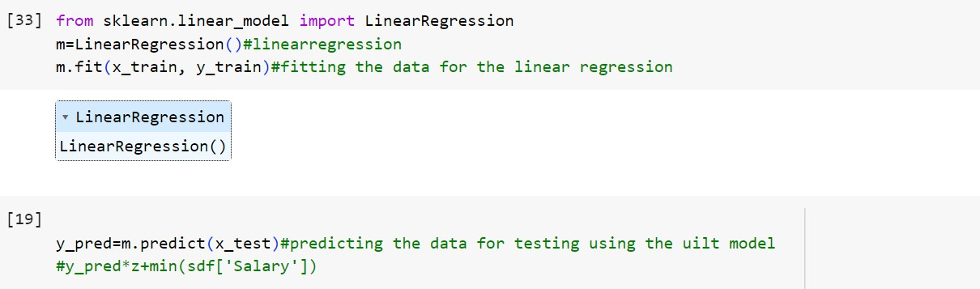

1. Calculate the mean_squared error

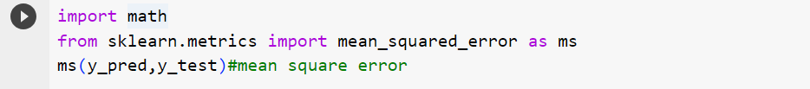

1. Visualize both train and test data using scatter plot.

