**Addressbook**

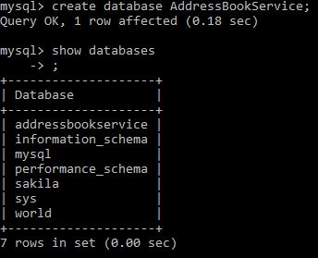

**UC1: Ability to create a Address Book Service DB**

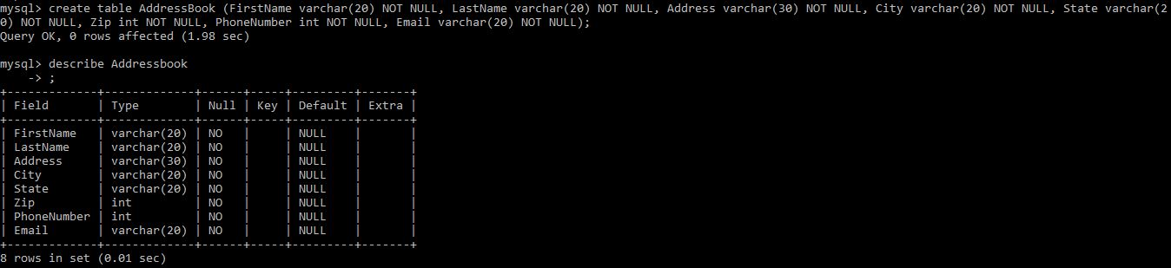

**UC2-Ability to create a Address Book Table with first and last names, address, city, state, zip, phone number and email as its attributes**

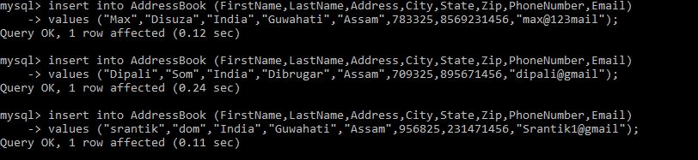

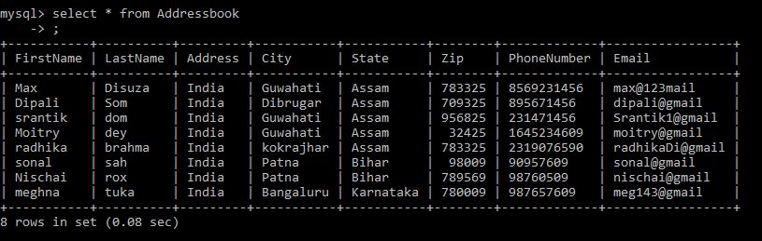

**UC3-Ability to insert new Contacts to Address Book**

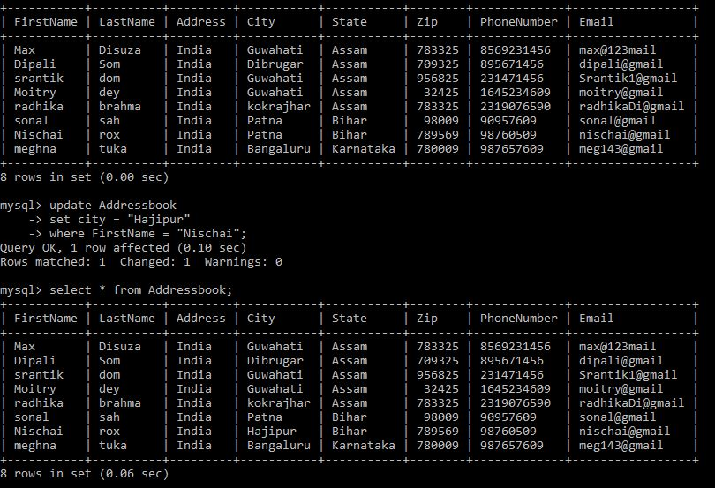

**UC4-Ability to edit existing contact person using their name**

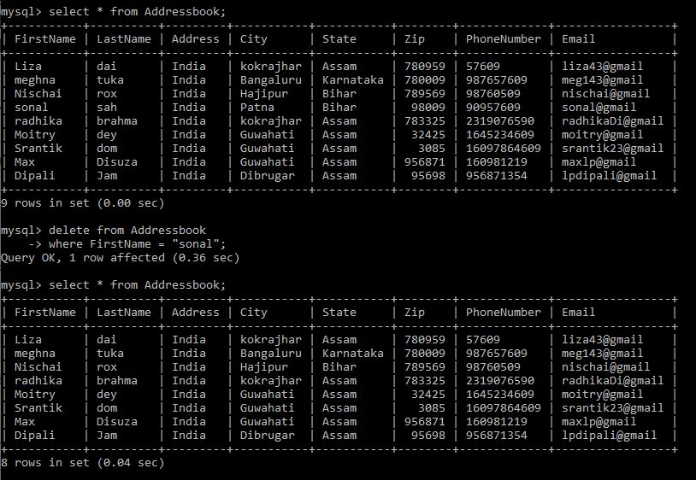

**UC5-Ability to delete a person using person's name**

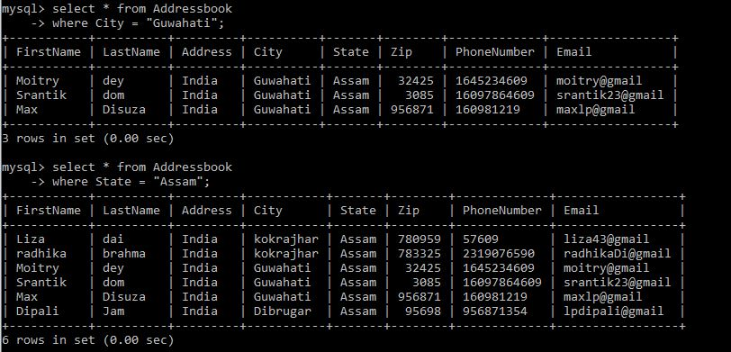

**UC6-Ability to Retrieve Person belonging to a City or State from the Address Book**

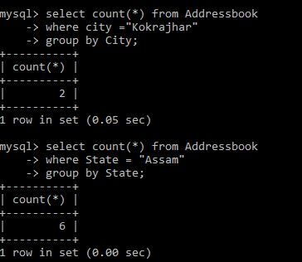

**UC7-Ability to understand the size of address book by City and State**

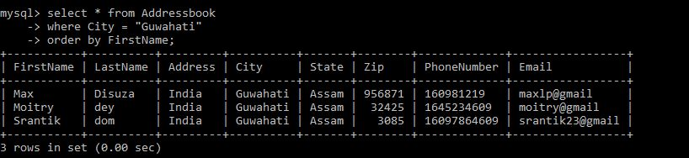

**UC8-Ability to retrieve entries sorted alphabetically by Person’s name for a given city**

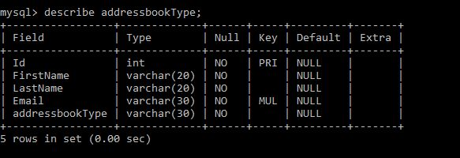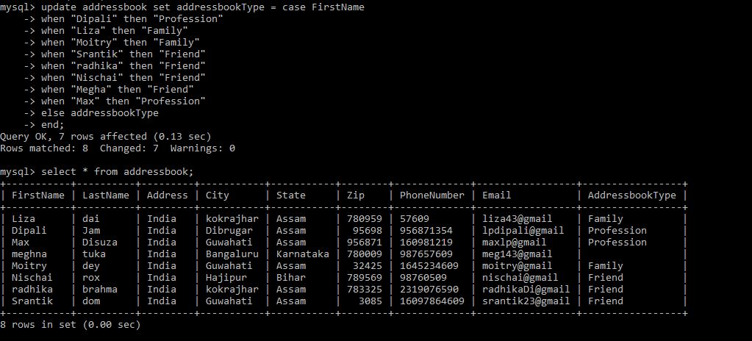

**UC9-Ability to identify each Address Book with name and Type.**

**&**

**UC11- Ability to add person to both Friend and Family**

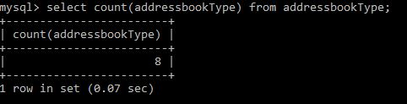

**UC10-** **Ability to get number of contact persons i.e. count by type**

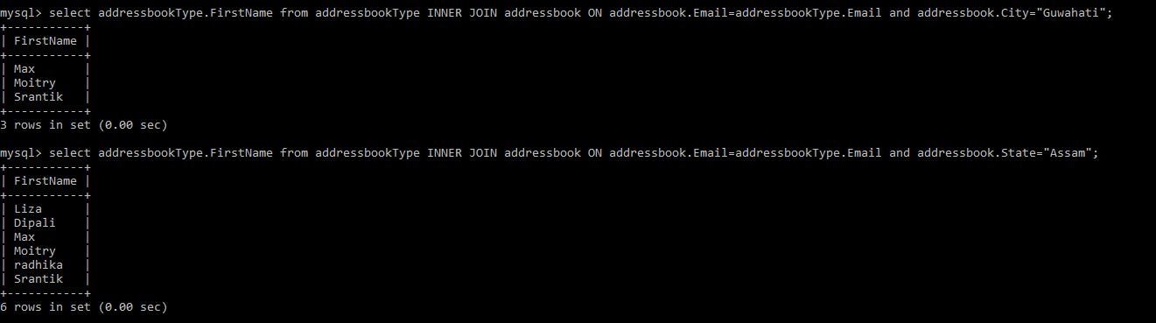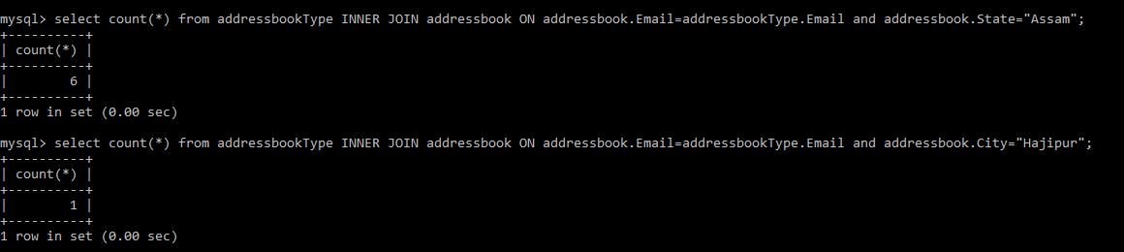

**UC13-** **Ensure all retrieve queries done especially in UC 6, UC 7, UC 8 and UC 10 are working with new table structure**

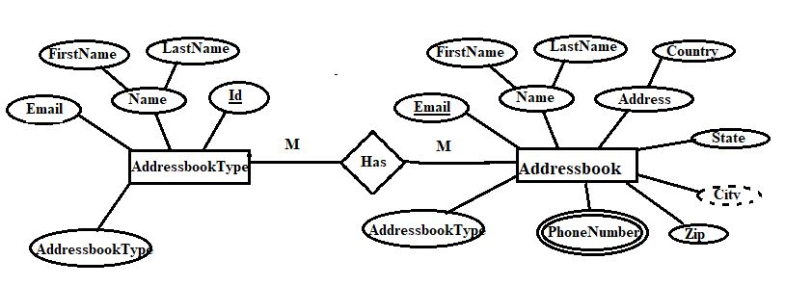

**UC12-Draw the ER Diagram for Address Book Service DB**