**EMPLOYEE PAYROLL**

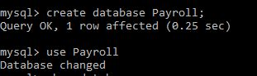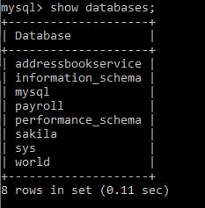

**UC1-Ability to create a payroll service database.**

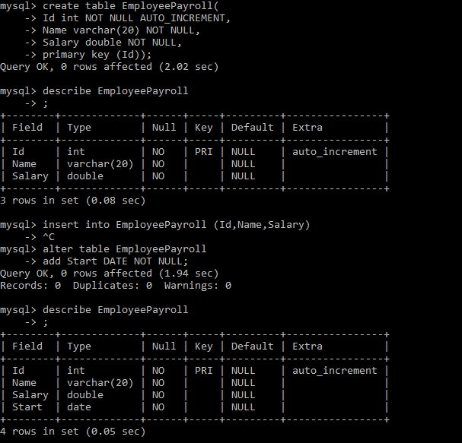

**UC2-Ability to create a employee payroll table in the payroll service database to manage employee payrolls**

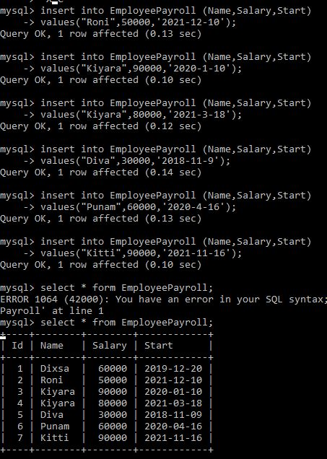

**UC3-Ability to create employee payroll data in the payroll service database.**

**&**

**UC4-Ability to retrieve all the employee payroll data that is added to payroll service database.**

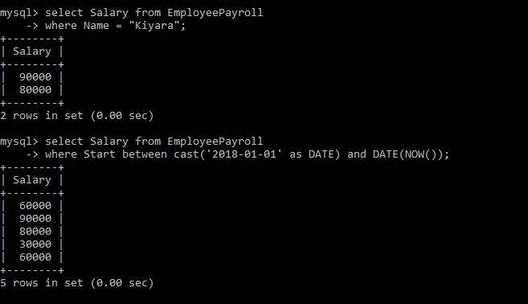

**UC5-Ability to retrieve salary data for a particular employee as well as all employees who have joined in a particular data range from the payroll service database**

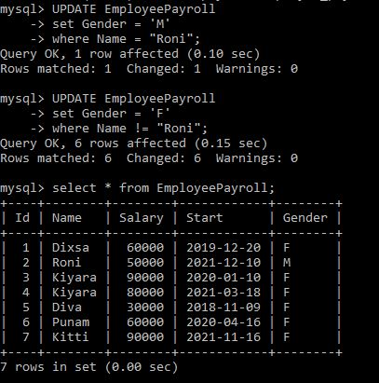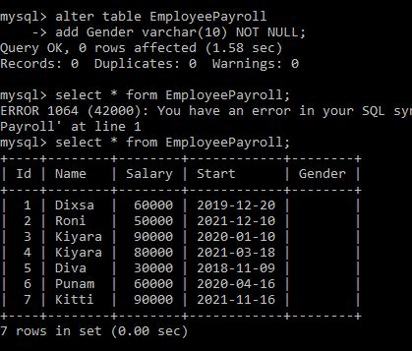

**UC6-Ability to add Gender to Employee Payroll Table and Update the Rows to reflect the correct Employee Gender**

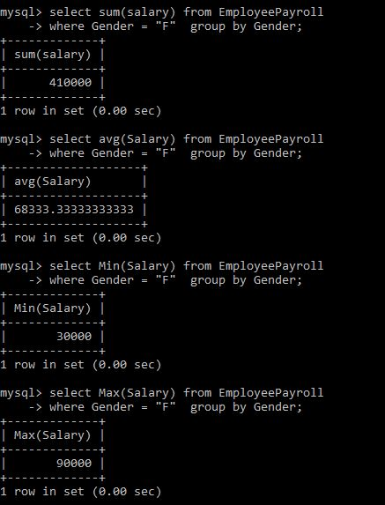

**UC7-Ability to find sum, average, min, max and number of male and female employees**