Log of Test Case :AmazonSearchProductTestCase
:::::::::::::::::::::::::::::Amazon Home Page:::::::::::::::::::::::::::::
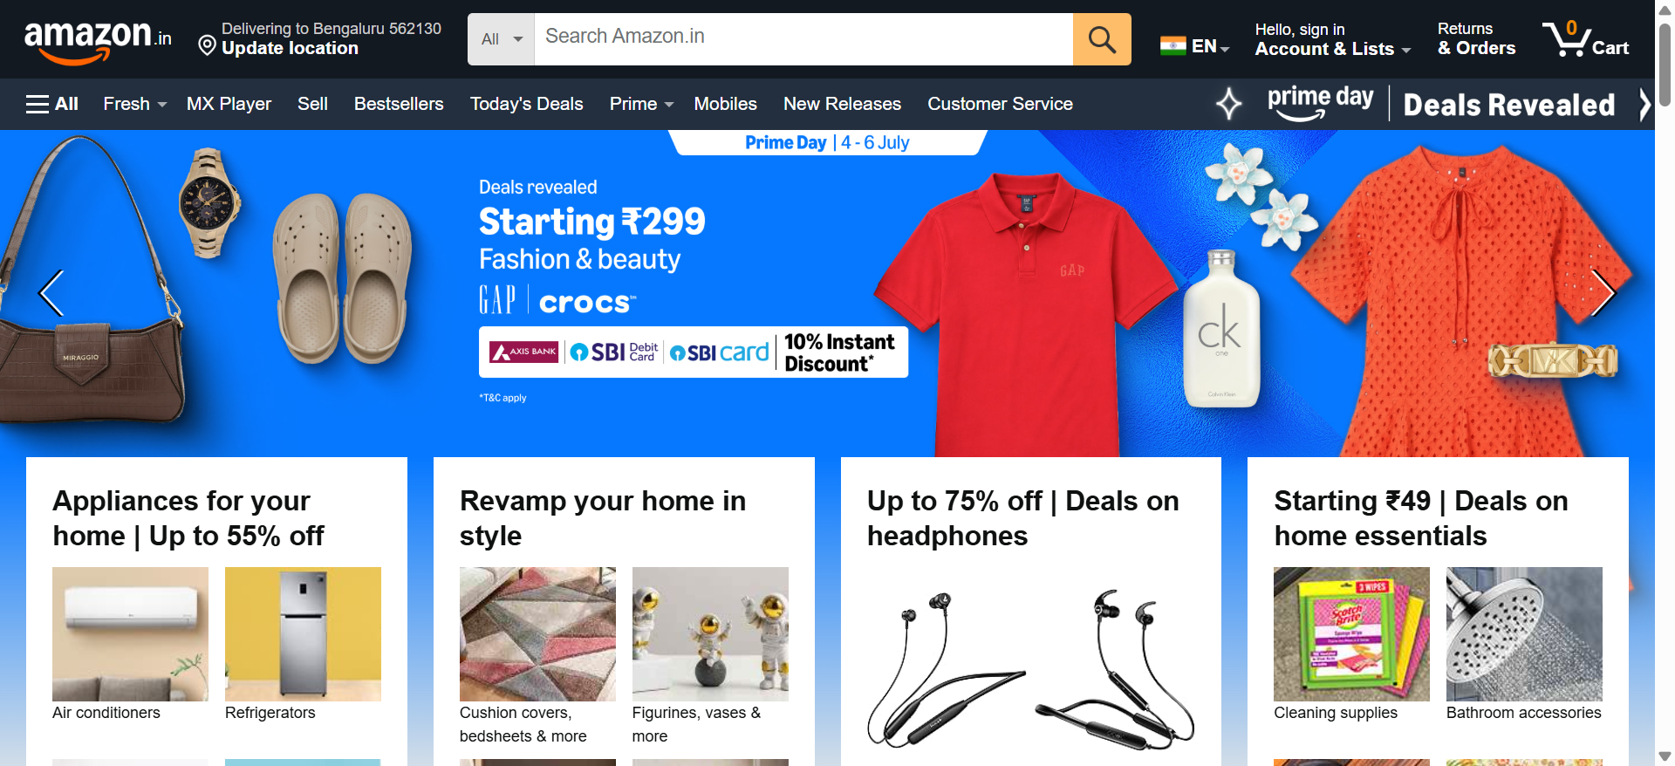
:::::::::::::::::::::::::::::Online Shopping site in India: Shop Online for Mobiles, Books, Watches, Shoes and More - Amazon.in:::::::::::::::::::::::::::::
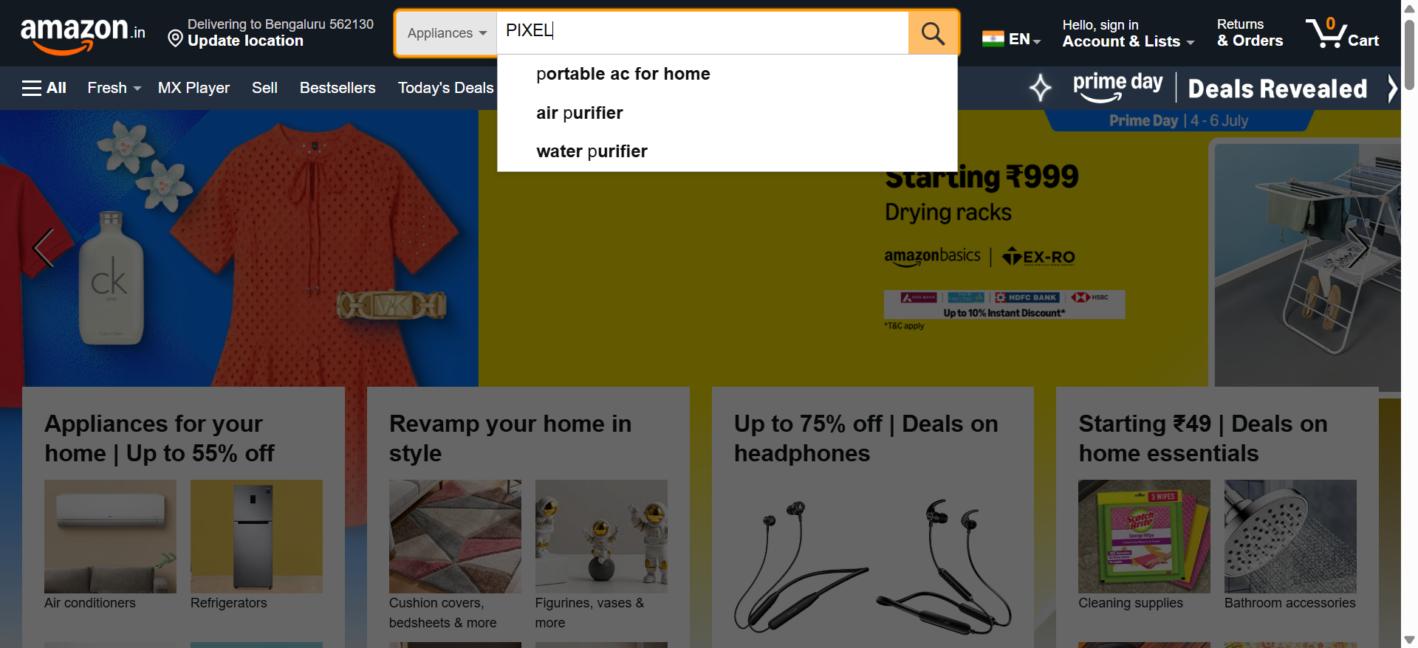
:::::::::::::::::::::::::::::Online Shopping site in India: Shop Online for Mobiles, Books, Watches, Shoes and More - Amazon.in:::::::::::::::::::::::::::::
