Log of Test Case :AmazonSearchTestCase1
:::::::::::::::::::::::::::::Amazon Home Page:::::::::::::::::::::::::::::
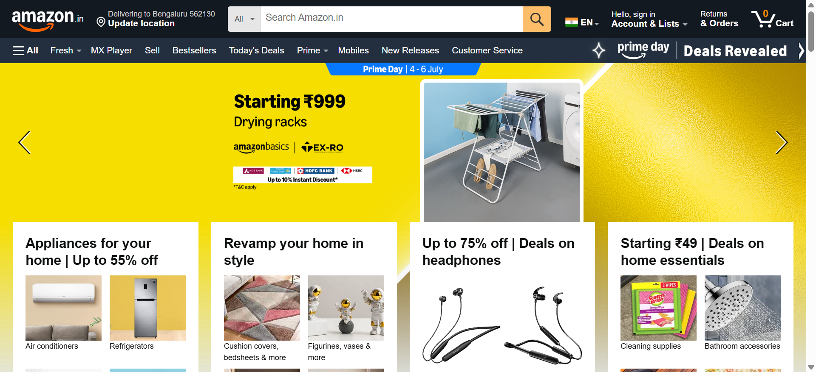
:::::::::::::::::::::::::::::Online Shopping site in India: Shop Online for Mobiles, Books, Watches, Shoes and More - Amazon.in:::::::::::::::::::::::::::::
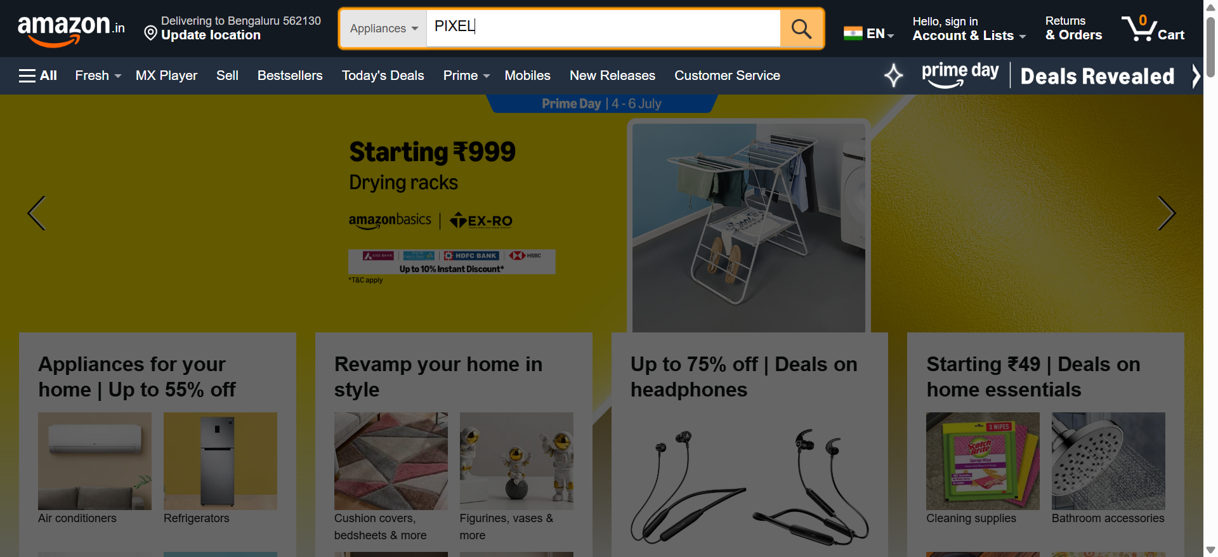
:::::::::::::::::::::::::::::Amazon.in : PIXEL:::::::::::::::::::::::::::::
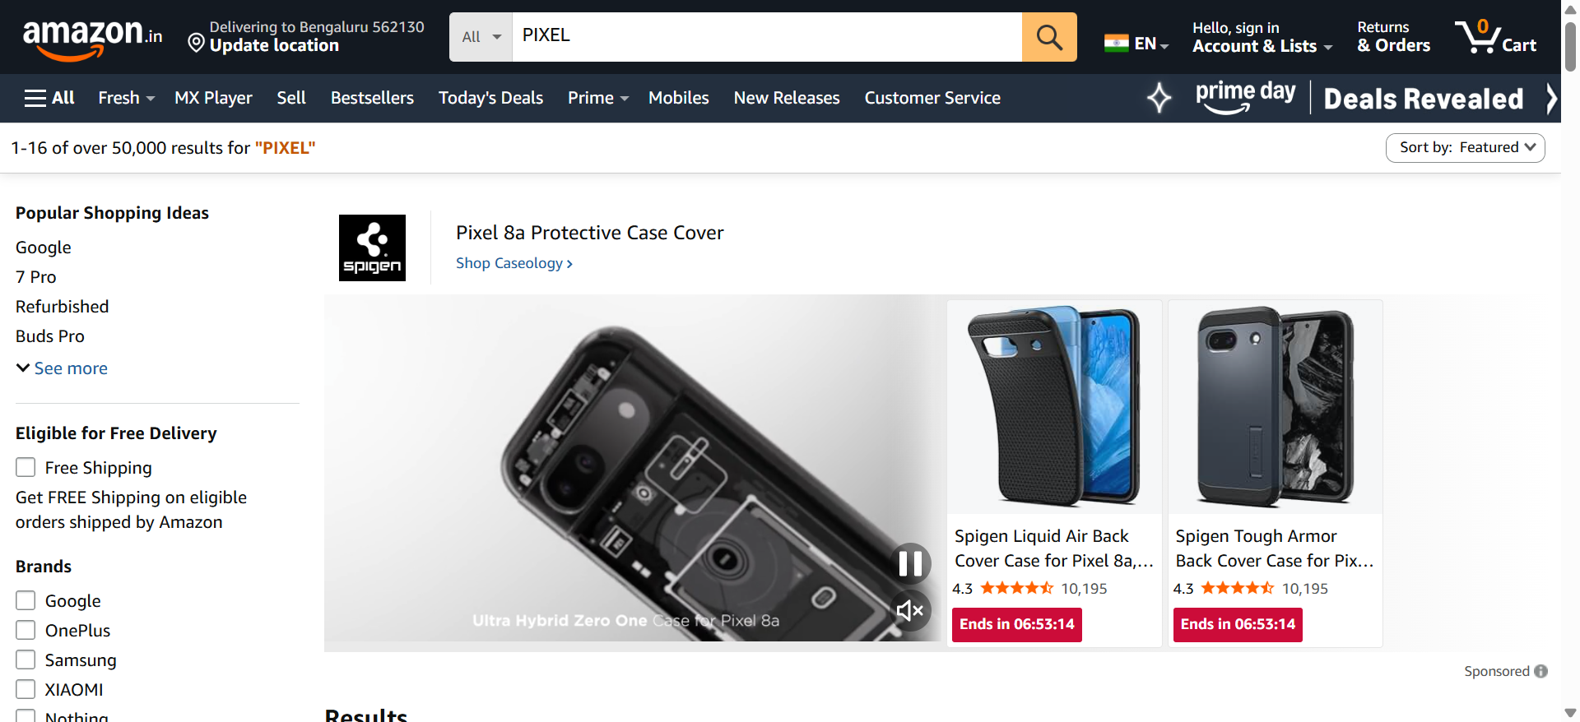
:::::::::::::::::::::::::::::Amazon.in : PIXEL:::::::::::::::::::::::::::::
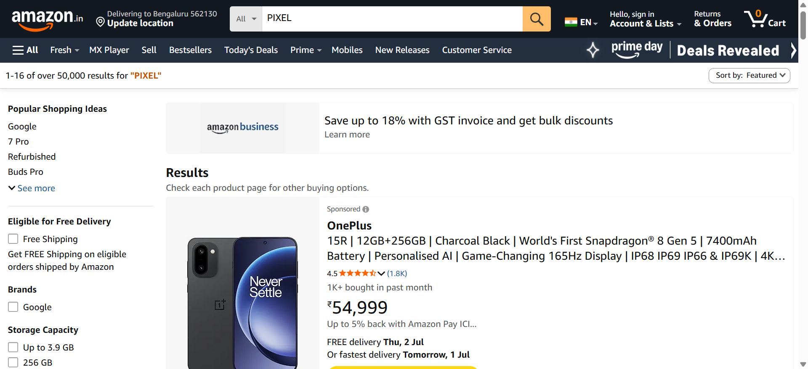
:::::::::::::::::::::::::::::Amazon.in : PIXEL:::::::::::::::::::::::::::::
