Log of Test Case :DragandDropTestWithFrame
:::::::::::::::::::::::::::::Pre Drag Drop Operation:::::::::::::::::::::::::::::
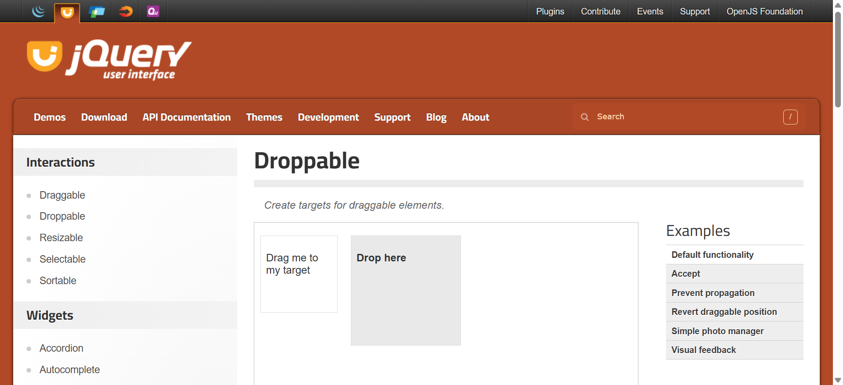
:::::::::::::::::::::::::::::Post Drag Drop Operation:::::::::::::::::::::::::::::
