**AIM:** Sort a given set of N integer elements using **Selection Sort** technique and compute its time taken. Run the program for different values of N and record the time taken to sort.

Plot a graph of the time taken versus N  using MS Excel.  The program should allow both manual entry of the array elements and also reading of array elements using random number generator.  Note: In the record book students should

- Handwrite  the Algorithm

- Handwrite the Program

- Pasting of the printout of the Output and Graph or Handwriting of the Output and Graph.

Note: N value should be in the range

**ALGORITHM :** sel_sort(a[0….n-1]

**//**Sorts a given array by selection sort

**//**Input : An array a[0….n-1] of orderable elements

//Output : Array a[0….n-1] sorted in ascending order

**for** i🡨0 to n-2 **do**

       small_pos🡨i

**for** j🡨i+1 to n-1 **do**

**if** a[j]<a[small_pos]

             small_pos🡨j

**end if**

**end for**

    swap a[i] and a[small_pos]

**end for**

**Program:**

#include<stdio.h>

#include<time.h>

#include<stdlib.h> /* To recognise exit function when compiling with gcc*/

void selsort(int n,int a[]);

void main()

{

   int a[15000],n,i,j,ch,temp;

   clock_t start,end;

   while(1)

   {

 printf("\n1:For manual entry of N value and array elements");

 printf("\n2:To display time taken for sorting number of elements N in the range 500 to 14500");

 printf("\n3:To exit");

     printf("\nEnter your choice:");

     scanf("%d", &ch);

     switch(ch)

     {

       case 1:  printf("\nEnter the number of elements: ");

scanf("%d",&n);

printf("\nEnter array elements: ");

for(i=0;i<n;i++)

{

  scanf("%d",&a[i]);

}

start=clock();

selsort(n,a);

end=clock();

printf("\nSorted array is: ");

for(i=0;i<n;i++)

printf("%d\t",a[i]);

printf("\n Time taken to sort %d numbers is %f Secs",n, (((double)(end-start))/CLOCKS_PER_SEC));

break;

     case 2:

      n=500;

      while(n<=14500) {

      for(i=0;i<n;i++)

  {

    //a[i]=random(1000);

    a[i]=n-i;

  }

      start=clock();

      selsort(n,a);

          //Dummy loop to create delay

  for(j=0;j<500000;j++){ temp=38/600;}

              end=clock();

printf("\n Time taken to sort %d numbers is %f Secs",n, (((double)(end-start))/CLOCKS_PER_SEC));

            n=n+1000;

  }

      break;

   case 3: exit(0);

   }

   getchar();

    }

}

void selsort(int n,int a[])

{

     int i,j,t,small,pos;

     for(i=0;i<n-1;i++)

      {

       pos=i;

       small=a[i];

       for(j=i+1;j<n;j++)

       {

  if(a[j]<small)

  {

    small=a[j];

    pos=j;

  }

       }

       t=a[i];

       a[i]=a[pos];

       a[pos]=t;

    }

}

OUTPUT:-

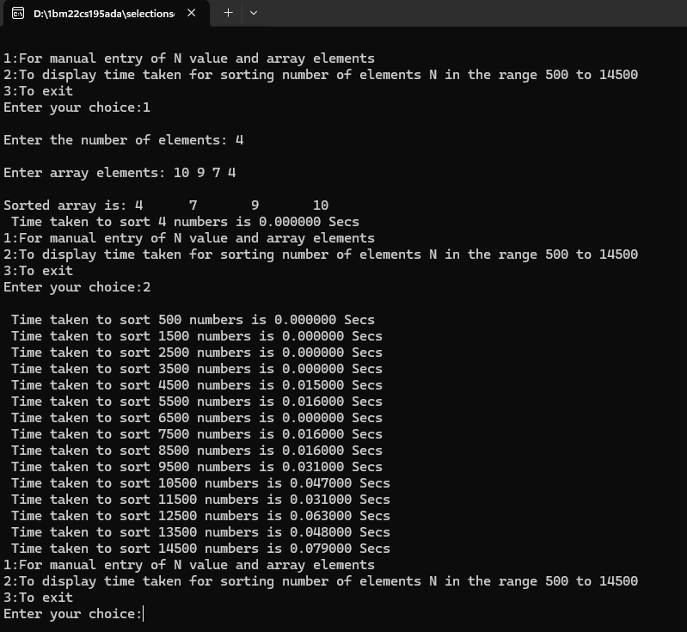

Graph Output:-

