LAB-10

From a given vertex in a weighted connected graph, find shortest paths to other vertices using

Dijkstra’s algorithm.

Algorithm:-

dijkstras(c[1….n,1….n],src)

//To compute shortest distance from given source node to all nodes of a weighted undirected graph

//Input: An nXn cost matrix c[1…n,1….n] with source node src

//Output: The length dist[j] of a shortest path from src to j

for j←1 to n do

dist[j]←c[src,[j]

end for

for j←1 to n do

vis[j]←0

end for

dist[src]←0

vis[src]←1

count←1

while count!=n do

min←9999

for j←1 to n do

if dist[j]&lt;min and vis[j]!=1

min←dist[j]

u←j

end if

end for

vis[u]←1

count←count+1

for j←1 to n do

if min+c[u,j]&lt;dist[j] and vis[j]!=1

dist[j]←min+c[u,j]

end if

end for

end while

write ‘shortest distance is’

for j←1 to n do

write src,j,dist[j]

end for

code:-

#include <stdio.h>

#include <stdlib.h>

#define MAX_NODES 100

#define INF 9999

void dijkstra(int n, int src, int cost[MAX_NODES][MAX_NODES]);

int main() {

int n;

int cost[MAX_NODES][MAX_NODES];

int src;

printf("Enter the number of nodes: ");

scanf("%d", &n);

printf("Enter the cost adjacency matrix (use -1 for infinity):\n");

for (int i = 0; i < n; i++) {

for (int j = 0; j < n; j++) {

scanf("%d", &cost[i][j]);

if (cost[i][j] == -1 && i != j) {

cost[i][j] = INF;

}

}

}

printf("Enter the source node: ");

scanf("%d", &src);

dijkstra(n, src, cost);

return 0;

}

void dijkstra(int n, int src, int cost[MAX_NODES][MAX_NODES]) {

int dist[MAX_NODES];

int vis[MAX_NODES];

for (int j = 0; j < n; j++) {

dist[j] = cost[src][j];

vis[j] = 0;

}

dist[src] = 0;

vis[src] = 1;

int count = 1;

while (count != n) {

int min = INF;

int u = -1;

for (int j = 0; j < n; j++) {

if (!vis[j] && dist[j] < min) {

min = dist[j];

u = j;

}

}

if (u == -1) break;

vis[u] = 1;

count++;

for (int j = 0; j < n; j++) {

if (!vis[j] && cost[u][j] != INF && dist[u] + cost[u][j] < dist[j]) {

dist[j] = dist[u] + cost[u][j];

}

}

}

printf("Shortest distances from source node %d:\n", src);

for (int j = 0; j < n; j++) {

if (dist[j] == INF) {

printf("To %d: Infinity\n", j);

} else {

printf("To %d: %d\n", j, dist[j]);

}

}

}  
output:-

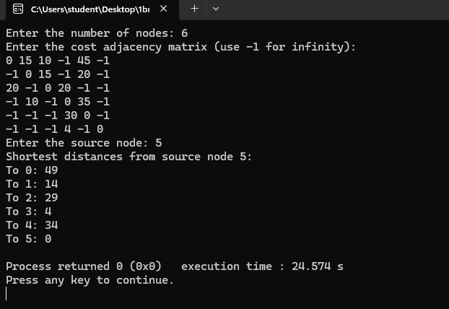

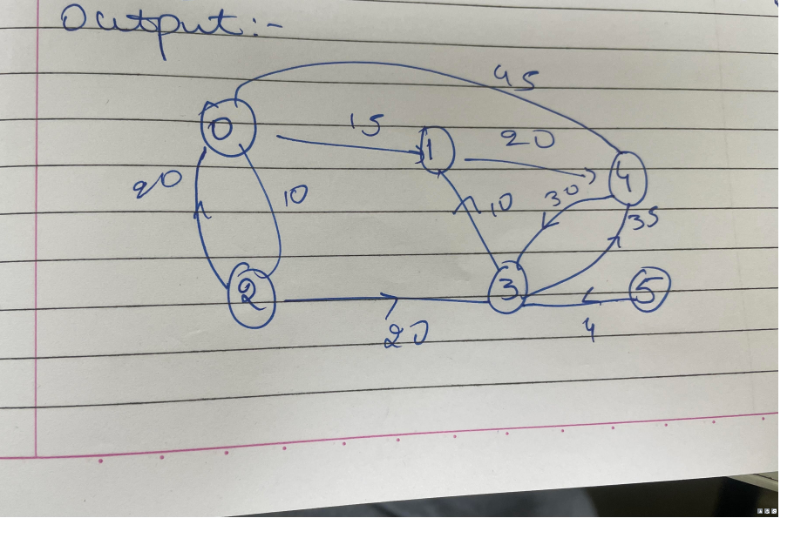

Find Minimum Cost Spanning Tree of a given undirected graph using Kruskals algorithm.  
Algorithm:

kruskals(c[1…n,1…n])

//To compute the minimum spanning tree of a given weighted undirected graph using Kruskal’s

// algorithm

//Input: An nXn cost matrix c[1…n,1….n]

//Output: minimum cost of spanning tree of given undirected graph

ne←0

mincost←0

for i←1 to n do

parent[i]←0

end for

while ne!=n-1 do

min←9999

for i←1 to n do

for j←1 to n do

if c[i,j]&lt;min

min←c[i,j]

u←i

a←i

v←j

b←j

end if

end for

end for

while parent[u]!=0 do

u←parent[u]

end while

while parent[v]!=0 do

v←parent[v]

end while

if u!= v

write a,b,min

parent[v]←u

ne←ne+1

mincost←mincost+min

end if

c[a,b]←9999

c[b,a]←9999

end while

write mincost

return

Code:-

#include <stdio.h>

#include <stdbool.h>

#define MAX 100

struct Edge {

int u, v, weight;

};

int compare(const void *a, const void *b) {

struct Edge *a1 = (struct Edge *)a;

struct Edge *b1 = (struct Edge *)b;

return a1->weight - b1->weight;

}

int find(int parent[], int i) {

if (parent[i] == 0)

return i;

return find(parent, parent[i]);

}

void unionSets(int parent[], int u, int v) {

parent[v] = u;

}

void kruskals(int cost_matrix[][MAX], int n) {

struct Edge edges[MAX * MAX];

int edge_count = 0;

int parent[MAX] = {0};

for (int i = 1; i <= n; i++) {

for (int j = 1; j <= n; j++) {

if (cost_matrix[i][j] != 9999) {

edges[edge_count].u = i;

edges[edge_count].v = j;

edges[edge_count].weight = cost_matrix[i][j];

edge_count++;

}

}

}

qsort(edges, edge_count, sizeof(edges[0]), compare);

int mincost = 0;

int ne = 0;

printf("Edges in the Minimum Cost Spanning Tree:\n");

for (int i = 0; i < edge_count; i++) {

int u = find(parent, edges[i].u);

int v = find(parent, edges[i].v);

if (u != v) {

printf("%d - %d : %d\n", edges[i].u, edges[i].v, edges[i].weight);

unionSets(parent, u, v);

mincost += edges[i].weight;

ne++;

}

if (ne == n - 1)

break;

}

printf("Minimum Cost of Spanning Tree: %d\n", mincost);

}

int main() {

int n;

printf("Enter the number of vertices: ");

scanf("%d", &n);

int cost_matrix[MAX][MAX];

printf("Enter the cost matrix (n x n):\n");

for (int i = 1; i <= n; i++) {

for (int j = 1; j <= n; j++) {

scanf("%d", &cost_matrix[i][j]);

if (cost_matrix[i][j] == 0)

cost_matrix[i][j] = 9999;

}

}

kruskals(cost_matrix, n);

return 0;

}  
output:-  
