Lab 7

Johnson Trotter program

CODE:-

#include <stdio.h>

#include <stdlib.h>

#include <stdbool.h>

void printPermutation(int \*perm, int size) {

for (int i = 0; i < size; i++) {

printf("%d ", perm[i]);

}

printf("\n");

}

int findLargestMobile(int \*perm, int \*dir, int size) {

int largestMobileIndex = -1;

int largestMobileValue = -1;

for (int i = 0; i < size; i++) {

int nextIndex = i + dir[i];

if (nextIndex >= 0 && nextIndex < size && perm[i] > perm[nextIndex] && perm[i] > largestMobileValue) {

largestMobileValue = perm[i];

largestMobileIndex = i;

}

}

return largestMobileIndex;

}

void swap(int \*a, int \*b) {

int temp = \*a;

\*a = \*b;

\*b = temp;

}

void generatePermutations(int n) {

int \*perm = (int \*)malloc(n \* sizeof(int));

int \*dir = (int \*)malloc(n \* sizeof(int));

for (int i = 0; i < n; i++) {

perm[i] = i + 1;

dir[i] = -1; // Initialize all directions to left (-1)

}

printPermutation(perm, n);

while (true) {

int largestMobileIndex = findLargestMobile(perm, dir, n);

if (largestMobileIndex == -1) {

break; // No more mobile integers

}

int nextIndex = largestMobileIndex + dir[largestMobileIndex];

swap(&perm[largestMobileIndex], &perm[nextIndex]);

swap(&dir[largestMobileIndex], &dir[nextIndex]);

for (int i = 0; i < n; i++) {

if (perm[i] > perm[nextIndex]) {

dir[i] = -dir[i]; // Reverse the direction

}

}

printPermutation(perm, n);

}

free(perm);

free(dir);

}

int main() {

int n;

printf("Enter the number of elements: ");

scanf("%d", &n);

generatePermutations(n);

return 0;

}  
OUTPUT:-

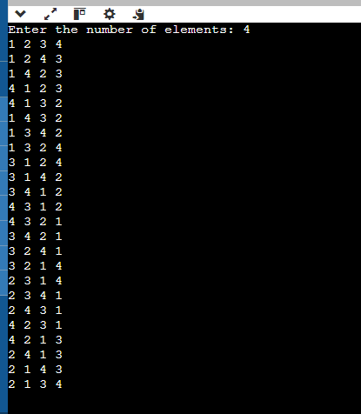

Substring matching program in main Text program brute force technique

CODE:-

#include <stdio.h>

#include <string.h>

int substringMatch(char \*text, char \*pattern) {

int textLength = strlen(text);

int patternLength = strlen(pattern);

for (int i = 0; i <= textLength - patternLength; i++) {

int j;

for (j = 0; j < patternLength; j++) {

if (text[i + j] != pattern[j])

break;

}

if (j == patternLength)

return i;

}

return -1;

}

int main() {

char text[100], pattern[100];

printf("Enter the main text: ");

fgets(text, sizeof(text), stdin);

text[strcspn(text, "\n")] = '\0';

printf("Enter the pattern to search: ");

fgets(pattern, sizeof(pattern), stdin);

pattern[strcspn(pattern, "\n")] = '\0';

int index = substringMatch(text, pattern);

if (index != -1)

printf("Pattern found at index: %d\n", index);

else

printf("Pattern not found in the text.\n");

return 0;

}  
OUTPUT:-

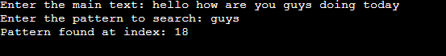

LEETCODE

To find the Kth largest integer in the given array

code:-

int compare(const void \*a, const void \*b) {

const char \*str1 = \*(const char \*\*)a;

const char \*str2 = \*(const char \*\*)b;

int len1 = strlen(str1);

int len2 = strlen(str2);

if (len1 != len2) {

return len2 - len1;

}

return strcmp(str2, str1);

}

char\* kthLargestNumber(char \*\*nums, int numsSize, int k) {

qsort(nums, numsSize, sizeof(char\*), compare);

return nums[k - 1];

}  
Ouput:-

