LAB-8

1.A given set of N integer elements using Heap Sort technique and compute its time taken.

Code:-

#include<stdio.h>

#include<time.h>

#include<stdlib.h>

void swap(int* a, int* b)

{

int temp = *a;

*a = *b;

*b = temp;

}

void heapify(int arr[], int N, int i)

{

int largest = i;

int left = 2 * i + 1;

int right = 2 * i + 2;

if (left < N && arr[left] > arr[largest])

largest = left;

if (right < N && arr[right] > arr[largest])

largest = right;

if (largest != i) {

swap(&arr[i], &arr[largest]);

heapify(arr, N, largest);

}

}

void heapSort(int arr[], int N)

{

for (int i = N / 2 - 1; i >= 0; i--)

heapify(arr, N, i);

for (int i = N - 1; i >= 0; i--) {

swap(&arr[0], &arr[i]);

heapify(arr, i, 0);

}

}

void main(){

int a[100000],n,i,j,ch,temp;

clock_t start,end;

while(1){

printf("\n1:For manual entry of N value and array elements");

printf("\n2:To display time taken for sorting number of elements N in the range 500 to 14500");

printf("\n3:To exit");

printf("\nEnter your choice:");

scanf("%d", &ch);

switch(ch){

case 1:

printf("\nEnter the number of elements: ");

scanf("%d",&n);

printf("\nEnter array elements: ");

for(i=0;i<n;i++){

scanf("%d",&a[i]);

}

start=clock();

heapSort(a,n);

end=clock();

printf("\nSorted array is: ");

for(i=0;i<n;i++)

printf("%d\t",a[i]);

printf("\n Time taken to sort %d numbers is %f Secs",n, (((double)(end-start))/CLOCKS_PER_SEC));

break;

case 2:

n=7500;

while(n<=15500) {

for(i=0;i<n;i++){

a[i]=n-i;

}

start=clock();

heapSort(a,n);

for(j=0;j<500000;j++){

temp=38/600;

}

end=clock();

printf("\n Time taken to sort %d numbers is %f Secs",n, (((double)(end-start))/CLOCKS_PER_SEC));

n=n+1000;

}

break;

case 3:

exit(0);

}

getchar();

}

}

Output

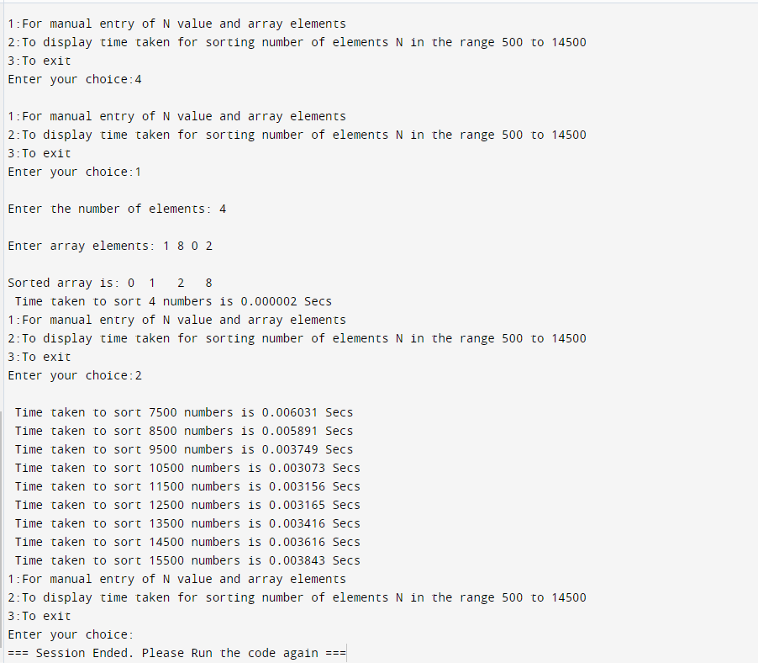

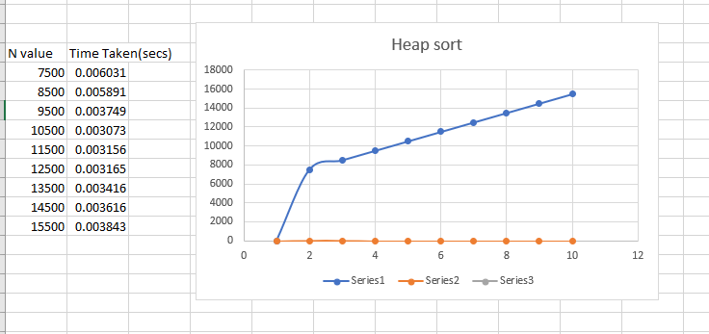

2.Implement All Pair Shortest paths problem using Floyd’s algorithm

Code:-

#include <stdio.h>  
#include <limits.h>  
int INF = 1e5;  
void printSolution(int v, int dist[v][v]) {  
    printf("The following matrix shows the shortest distances between every pair of vertices (-1 = infinity):\n");  
    for (int i = 0; i < v; i++) {  
        for (int j = 0; j < v; j++) {  
            if (dist[i][j] == INF)  
                printf("-1 ");  
            else  
                printf("%d ", dist[i][j]);  
        }  
        printf("\n");  
    }  
}  
void floydWarshall(int v, int graph[v][v]) {  
    int dist[v][v], i, j, k;  
    for (i = 0; i < v; i++)  
        for (j = 0; j < v; j++)  
            dist[i][j] = graph[i][j];    for (k = 0; k < v; k++) {  
               for (i = 0; i < v; i++) {            for (j = 0; j < v; j++)

{    if (dist[i][k] + dist[k][j] < dist[i][j])  
                    dist[i][j] = dist[i][k] + dist[k][j];  
            }  
        }  
    }  
    printSolution(v, dist);  
}  
  
  
  
int main() {  
    int v;  
    printf("Enter no. of vertices: ");  
    scanf("%d", &v);  
    int graph[v][v];/* = { {0, 5, INF, 10}, {INF, 0, 3, INF}, {INF, INF, 0, 1}, {INF, INF, INF, 0} }; */  
    printf("Enter weighted adjacency matrix (Enter -1 for inf): \n");  
    for(int i = 0; i < v; i++){  
        for(int j = 0; j < v; j++){  
            scanf("%d", &graph[i][j]);  
            if (graph[i][j] == -1) graph[i][j] = INF;  
        }  
    }  
    floydWarshall(v, graph);  
    return 0;}

Output:-

