Lab:-9

Perform Knapsack problem using Dynamic programming technique using n=4 objects with associated weights and profits .  
Display the table values and the objects selected in the knapsack to get maximum profit.

Code:-

#include <stdio.h>  
  
#define MAX_OBJECTS 100  
  
// Function to calculate maximum of two integers  
int max(int a, int b) {  
    return (a > b) ? a : b;  
}  
  
// Function to solve 0/1 Knapsack problem using Dynamic Programming  
void knapsack(int n, int W, int weights[], int profits[]) {  
    int i, w;  
    int K[MAX_OBJECTS + 1][W + 1]; // DP table to store results  
  
    // Build DP table K[][] in bottom-up manner  
    for (i = 0; i <= n; i++) {  
        for (w = 0; w <= W; w++) {  
            if (i == 0 || w == 0)  
                K[i][w] = 0;  
            else if (weights[i - 1] <= w)  
                K[i][w] = max(profits[i - 1] + K[i - 1][w - weights[i - 1]], K[i - 1][w]);  
            else  
                K[i][w] = K[i - 1][w];  
        }  
    }  
  
    // Print DP table with indices  
    printf("DP Table:\n");  
    printf("\t");  
    for (w = 0; w <= W; w++) {  
        printf("%d\t", w);  
    }  
    printf("\n");  
    for (i = 0; i <= n; i++) {  
        printf("%d\t", i);  
        for (w = 0; w <= W; w++) {  
            printf("%d\t", K[i][w]);  
        }  
        printf("\n");  
    }  
  
    // Maximum profit will be at K[n][W]  
    int maxProfit = K[n][W];  
    printf("Maximum profit: %d\n", maxProfit);  
  
    // To find the selected items  
    printf("Objects selected in the knapsack:\n");  
    int res = maxProfit;  
    w = W;  
    for (i = n; i > 0 && res > 0; i--) {  
        if (res == K[i - 1][w])  
            continue;  
        else {  
            printf("Object %d (weight = %d, profit = %d)\n", i, weights[i - 1], profits[i - 1]);  
            // Move to the previous item considering its weight  
            res -= profits[i - 1];  
            w -= weights[i - 1];  
        }  
    }  
}  
  
int main() {  
    int n, W;  
    int weights[MAX_OBJECTS], profits[MAX_OBJECTS];  
    int i;  
  
    // Input number of objects  
    printf("Enter number of objects (max %d): ", MAX_OBJECTS);  
    scanf("%d", &n);  
  
    if (n <= 0 || n > MAX_OBJECTS) {  
        printf("Invalid number of objects\n");  
        return 1;  
    }  
  
    // Input weights of objects  
    printf("Enter the weights of the objects:\n");  
    for (i = 0; i < n; i++) {  
        scanf("%d", &weights[i]);  
    }  
  
    // Input profits of objects  
    printf("Enter the profits of the objects:\n");  
    for (i = 0; i < n; i++) {  
        scanf("%d", &profits[i]);  
    }  
  
    // Input knapsack capacity  
    printf("Enter the capacity of the knapsack: ");  
    scanf("%d", &W);  
  
    if (W <= 0) {  
        printf("Invalid knapsack capacity\n");  
        return 1;  
    }  
  
    knapsack(n, W, weights, profits);  
  
    return 0;  
}

Output:-

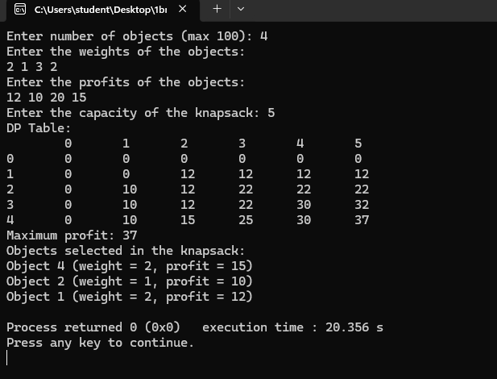

Pfa of the Prims algorithm pseudo code please try to convert this into C program and find the MST of a Given graph with cost adjacency matrix as input.

Algorithm :-

Algorithm Prims(n,cost)

Purpose: To compute the Minimum Spanning Tree

//Input: n number of vertices in the graph

Cost : Cost adjacency matrix with values &gt;0

//Output : d- shortest distance from source to all other nodes.

p- Shortest path from source to destination

s- gives the information nodes that are so far visited and the nodes that are not visted.

Step 1: [ Obtain a source vertex which has the least edge going out of it]

Min← 9999; Source←0

For i&lt;-0 to n-1

For j&lt;- 0 to n-1

If(cost[i,j]!=0 &amp;&amp; cost[i,j]&lt;min)

Min=cost[i][j]

Source=i

End if.

Step 2: [Initialization]

For i&lt;-0 to n-1 do

S[i]=0, d[i]=cost[Source,i]

P[i]=source

End for

Step 3: {Add Source to s]

S[source]=1

Step 4: [Find the Minimum spanning tree if exists ]

Sum&lt;-0; k&lt;-0

For i&lt;-1 to n-1 do

// find u and d[u] such that d[u] is minimum and u Є v-s

Min←9999

U=-1

For j &lt;- 0 to n-1 do

If(s[j]=0 and d[j] &lt;=min)

Min&lt;-d[j]

U&lt;-j

End if

End for

//Select an edge with the least cost

T[K][0]&lt;- U T[K][1]&lt;-P[U] K&lt;-K+1

//Add the cost associated with the edge to get total cost of MST.

Sum&lt;-sum + cost[u][p[u]]

//Add u to s

S[u]&lt;- 1

//Find the new vertex u and distance which gives the shortest path and destination.

For every v Є v –s do

If(cost[u][v] &lt; d[v])

D[v]=cost[u][v]

P[v]=u

End if

End for

End for // Outer for Loop

Step 5: [Check for the existence of spanning tree]

If(sum &gt;=9999)

Write “spanning tree does not exist”

Else

Write “Spanning tree exists and MST is”

For i&lt;-0 to n-2 do

Write T[i][0], T[i][1]

End for

Write “The cost of Spanning tree is MST is”, sum

End if

Code:-

#include <stdio.h>

#include <string.h>

#include <limits.h>

#define MAX_VERTICES 100

#define INF INT_MAX

int minKey(int n, int d[], int s[]) {

int min = INF, min_index;

for (int v = 0; v < n; v++) {

if (s[v] == 0 && d[v] < min) {

min = d[v];

min_index = v;

}

}

return min_index;

}

int printMST(int n, int p[], int cost[MAX_VERTICES][MAX_VERTICES]) {

int total_cost = 0;

printf("Edge Weight\n");

for (int i = 1; i < n; i++) {

printf("%d - %d %d \n", p[i], i, cost[i][p[i]]);

total_cost += cost[i][p[i]];

}

return total_cost;

}

int parseCost(int n, int cost[MAX_VERTICES][MAX_VERTICES]) {

char input[10];

for (int i = 0; i < n; i++) {

for (int j = 0; j < n; j++) {

scanf("%s", input);

if (strcmp(input, "inf") == 0) {

cost[i][j] = INF;

} else {

sscanf(input, "%d", &cost[i][j]);

if (cost[i][j] == 0 && i != j) {

cost[i][j] = INF;

}

}

}

}

}

void primMST(int n, int cost[MAX_VERTICES][MAX_VERTICES]) {

int p[MAX_VERTICES];

int d[MAX_VERTICES];

int s[MAX_VERTICES];

for (int i = 0; i < n; i++) {

d[i] = INF;

s[i] = 0;

}

d[0] = 0;

p[0] = -1;

for (int count = 0; count < n - 1; count++) {

int u = minKey(n, d, s);

s[u] = 1;

for (int v = 0; v < n; v++) {

if (cost[u][v] && s[v] == 0 && cost[u][v] < d[v]) {

p[v] = u;

d[v] = cost[u][v];

}

}

}

int total_cost = printMST(n, p, cost);

printf("Total cost of Minimum Spanning Tree (MST): %d\n", total_cost);

}

int main() {

int n;

int cost[MAX_VERTICES][MAX_VERTICES];

printf("Enter number of vertices (max %d): ", MAX_VERTICES);

scanf("%d", &n);

printf("Enter the cost adjacency matrix (use 'inf' for infinity):\n");

parseCost(n, cost);

printf("Minimum Spanning Tree (MST) using Prim's algorithm:\n");

primMST(n, cost);

return 0;

}

Output:-

