LAB 1

Tic Tac Toe

Code:-

import random

def initialize_board():

return [[' ' for _ in range(3)] for _ in range(3)]

def display_board(board):

for row in board:

print('|'.join(row))

print('-' * 5)

def check_winner(board):

for row in board:

if row[0] == row[1] == row[2] != ' ':

return row[0]

for col in range(3):

if board[0][col] == board[1][col] == board[2][col] != ' ':

return board[0][col]

if board[0][0] == board[1][1] == board[2][2] != ' ':

return board[0][0]

if board[0][2] == board[1][1] == board[2][0] != ' ':

return board[0][2]

return None

def available_moves(board):

return [(i, j) for i in range(3) for j in range(3) if board[i][j] == ' ']

def check_two_in_a_row(board, player):

for row in range(3):

if board[row].count(player) == 2 and board[row].count(' ') == 1:

return row, board[row].index(' ')

for col in range(3):

if [board[row][col] for row in range(3)].count(player) == 2:

empty_index = [row for row in range(3) if board[row][col] == ' ']

if empty_index:

return empty_index[0], col

if [board[i][i] for i in range(3)].count(player) == 2:

empty_index = [i for i in range(3) if board[i][i] == ' ']

if empty_index:

return empty_index[0], empty_index[0]

if [board[i][2 - i] for i in range(3)].count(player) == 2:

empty_index = [i for i in range(3) if board[i][2 - i] == ' ']

if empty_index:

return empty_index[0], 2 - empty_index[0]

return None

def make_move(board, player, move):

board[move[0]][move[1]] = player

def computer_move(board):

move = check_two_in_a_row(board, 'O')

if move:

make_move(board, 'O', move)

return

move = check_two_in_a_row(board, 'X')

if move:

make_move(board, 'O', move)

return

moves = available_moves(board)

if moves:

move = random.choice(moves)

make_move(board, 'O', move)

def user_move(board):

while True:

try:

row = int(input("Enter row (0-2): "))

col = int(input("Enter column (0-2): "))

if board[row][col] == ' ':

make_move(board, 'X', (row, col))

return

else:

print("That spot is already taken. Try again.")

except (ValueError, IndexError):

print("Invalid input. Please enter numbers between 0 and 2.")

def play_game():

board = initialize_board()

players = ['X', 'O']

current_player = 0

for _ in range(9):

display_board(board)

if current_player == 0:

user_move(board)

else:

computer_move(board)

winner = check_winner(board)

if winner:

display_board(board)

print(f"Player {winner} wins!")

return

current_player = 1 - current_player

display_board(board)

print("It's a draw!")

play_game()

Output:-

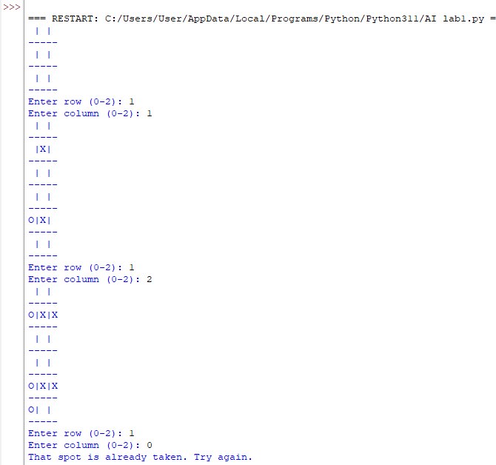  
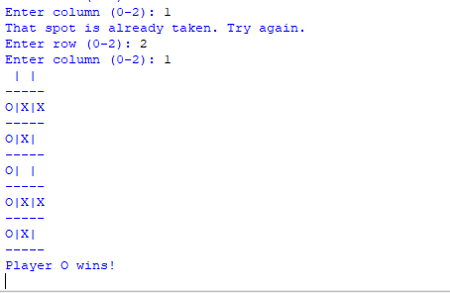  
Observation book:

