Lab2:-

Vacuum Cleaner

Code:-

class VacuumCleaner:  
    def __init__(self, grid):  
        self.grid = grid  
        self.position = (0, 0)  
  
    def clean(self):  
        x, y = self.position  
        if self.grid[x][y] == 1:  
            print(f"Cleaning position {self.position}")  
            self.grid[x][y] = 0  
        else:  
            print(f"Position {self.position} is already clean")  
  
    def move(self, direction):  
        x, y = self.position  
        if direction == 'up' and x > 0:  
            self.position = (x - 1, y)  
        elif direction == 'down' and x < len(self.grid) - 1:  
            self.position = (x + 1, y)  
        elif direction == 'left' and y > 0:  
            self.position = (x, y - 1)  
        elif direction == 'right' and y < len(self.grid[0]) - 1:  
            self.position = (x, y + 1)  
        else:  
            print("Move not possible")  
  
    def run(self):  
        rows = len(self.grid)  
        cols = len(self.grid[0])  
         
         
        for i in range(rows):  
            for j in range(cols):  
                self.position = (i, j)    
                self.clean()    
  
        print("Final grid state:")  
        for row in self.grid:  
            print(row)  
  
def get_dirty_coordinates(rows, cols, num_dirty_cells):  
    dirty_cells = set()  
    while len(dirty_cells) < num_dirty_cells:  
        try:  
            coords = input(f"Enter coordinates for dirty cell {len(dirty_cells) + 1} (format: row,col): ")  
            x, y = map(int, coords.split(','))  
            if 0 <= x < rows and 0 <= y < cols:  
                dirty_cells.add((x, y))  
            else:  
                print("Coordinates are out of bounds. Try again.")  
        except ValueError:  
            print("Invalid input. Please enter coordinates in the format: row,col")  
    return dirty_cells  
  
rows = int(input("Enter the number of rows: "))  
cols = int(input("Enter the number of columns: "))  
num_dirty_cells = int(input("Enter the number of dirty cells: "))  
  
if num_dirty_cells > rows * cols:  
    print("Number of dirty cells exceeds total cells in the grid. Adjusting to maximum.")  
    num_dirty_cells = rows * cols  
  
initial_grid = [[0 for _ in range(cols)] for _ in range(rows)]  
dirty_coordinates = get_dirty_coordinates(rows, cols, num_dirty_cells)  
  
for x, y in dirty_coordinates:  
    initial_grid[x][y] = 1  
  
vacuum = VacuumCleaner(initial_grid)  
print("Initial grid state:")  
for row in initial_grid:  
    print(row)  
  
vacuum.run()

Output:-

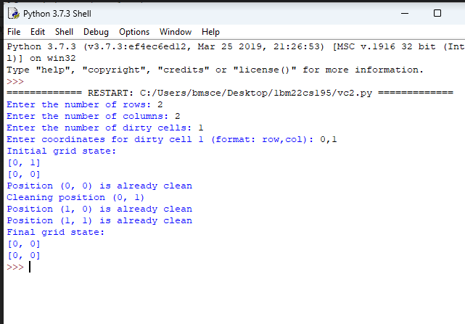

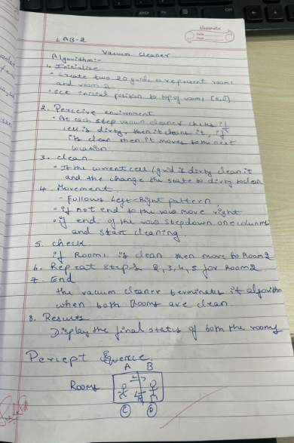

Observation Book:-



