Lab 3:-

8-Puzzel Game

Code:-

Using Depth First Search (DFS)

class SlidingPuzzle:

def __init__(self, board, empty_pos, path=[]):

self.board = board

self.empty_pos = empty_pos

self.path = path

def is_solved(self):

return self.board == [1, 2, 3, 4, 5, 6, 7, 8, 0]

def get_moves(self):

x, y = self.empty_pos

possible_moves = []

for dx, dy in [(-1, 0), (1, 0), (0, -1), (0, 1)]:

nx, ny = x + dx, y + dy

if 0 <= nx < 3 and 0 <= ny < 3:

new_board = self.board[:]

new_board[x * 3 + y], new_board[nx * 3 + ny] = new_board[nx * 3 + ny], new_board[x * 3 + y]

possible_moves.append((new_board, (nx, ny)))

return possible_moves

def depth_first_search(initial_puzzle):

stack, visited = [initial_puzzle], set()

while stack:

current_puzzle = stack.pop()

if current_puzzle.is_solved():

return current_puzzle.path

visited.add(tuple(current_puzzle.board))

for new_board, new_empty_pos in current_puzzle.get_moves():

new_state = SlidingPuzzle(new_board, new_empty_pos, current_puzzle.path + [new_board])

if tuple(new_board) not in visited:

stack.append(new_state)

return None

def display_board(board):

for i in range(0, 9, 3):

print(board[i:i + 3])

print()

def main():

initial_board = [1, 2, 3, 4, 0, 5, 7, 8, 6]

empty_pos = initial_board.index(0)

initial_puzzle = SlidingPuzzle(initial_board, (empty_pos // 3, empty_pos % 3))

print("Initial state:")

display_board(initial_board)

solution = depth_first_search(initial_puzzle)

if solution:

print("Solution found:")

for step in solution:

display_board(step)

else:

print("No solution found.")

if __name__ == "__main__":

main()  
Output:-

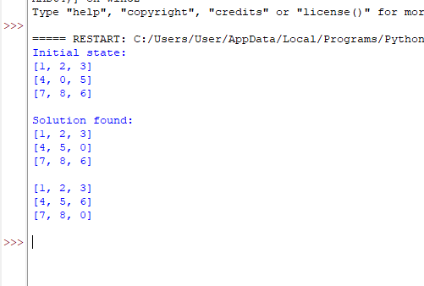

Code:-

Using Manhattan Distance

class SlidingPuzzleSolver:

def __init__(self, initial_state):

self.initial_state = initial_state

self.goal_state = [[1, 2, 3], [4, 5, 6], [7, 8, 0]]

def manhattan_distance(self, state):

distance = 0

for i in range(3):

for j in range(3):

if state[i][j] != 0:

goal_i = (state[i][j] - 1) // 3

goal_j = (state[i][j] - 1) % 3

distance += abs(i - goal_i) + abs(j - goal_j)

return distance

def get_neighbors(self, state):

i, j = next((i, j) for i in range(3) for j in range(3) if state[i][j] == 0)

moves = [(i - 1, j), (i + 1, j), (i, j - 1), (i, j + 1)]

return [self.swap(state, i, j, x, y) for x, y in moves if 0 <= x < 3 and 0 <= y < 3]

def swap(self, state, i1, j1, i2, j2):

new_state = [row[:] for row in state]

new_state[i1][j1], new_state[i2][j2] = new_state[i2][j2], new_state[i1][j1]

return new_state

def dfs_with_manhattan(self, state, visited=set()):

if state == self.goal_state:

return [state]

visited.add(str(state))

neighbors = sorted(self.get_neighbors(state), key=lambda x: self.manhattan_distance(x))

for neighbor in neighbors:

if str(neighbor) not in visited:

path = self.dfs_with_manhattan(neighbor, visited)

if path:

return [state] + path

return None

def solve(self):

solution = self.dfs_with_manhattan(self.initial_state)

return solution

initial_state = [[int(x) for x in input(f"Enter row {i + 1}: ").split()] for i in range(3)]

solver = SlidingPuzzleSolver(initial_state)

solution = solver.solve()

if solution:

print("Solution found:")

for state in solution:

print(*state, sep='\n', end='\n\n')

else:

print("No solution found.")

Output:-

