Lab9

Implementation of unification in FLO  
code:-

def is_variable(term):

"""

Check if a term is a variable.

Variables are typically single lowercase letters.

"""

return isinstance(term, str) and term.islower()

def unify(expr1, expr2, subst={}):

"""

Unify two expressions expr1 and expr2 under the given substitution subst.

"""

if subst is None:

return None # Failure case

if expr1 == expr2:

return subst # Expressions are identical

if is_variable(expr1):

return unify_variable(expr1, expr2, subst)

if is_variable(expr2):

return unify_variable(expr2, expr1, subst)

if isinstance(expr1, tuple) and isinstance(expr2, tuple):

if len(expr1) != len(expr2):

return None # Different arity

# Recursively unify each component

for arg1, arg2 in zip(expr1, expr2):

subst = unify(arg1, arg2, subst)

if subst is None:

return None # Failure

return subst

return None # No unification possible

def unify_variable(var, term, subst):

"""

Unify a variable with a term, updating the substitution.

"""

if var in subst:

return unify(subst[var], term, subst) # Apply substitution to var

if term in subst:

return unify(var, subst[term], subst) # Apply substitution to term

if occurs_check(var, term, subst):

return None # Circular substitution detected

# Add var -> term to the substitution

subst = subst.copy()

subst[var] = term

return subst

def occurs_check(var, term, subst):

"""

Check if var occurs in term (directly or indirectly) to prevent circular substitutions.

"""

if var == term:

return True

if isinstance(term, tuple):

return any(occurs_check(var, t, subst) for t in term)

if term in subst:

return occurs_check(var, subst[term], subst)

return False

def parse_input(expr):

"""

Parse user input into a structured format (nested tuples for functions and terms).

Example: "f(X, g(y))" -> ('f', 'X', ('g', 'y'))

"""

expr = expr.strip()

if '(' not in expr:

return expr # Simple variable or constant

func_name = expr[:expr.index('(')].strip()

args = expr[expr.index('(') + 1:expr.rindex(')')].split(',')

args = [parse_input(arg.strip()) for arg in args]

return (func_name, *args)

def format_output(expr):

"""

Convert the nested tuple representation back into a string for output.

Example: ('f', 'X', ('g', 'y')) -> "f(X, g(y))"

"""

if isinstance(expr, str):

return expr

return f"{expr[0]}({', '.join(format_output(arg) for arg in expr[1:])})"

# Main Program

if __name__ == "__main__":

print("Enter the first term:")

expr1 = parse_input(input().strip())

print("Enter the second term:")

expr2 = parse_input(input().strip())

print("Unifying......")

result = unify(expr1, expr2)

if result is None:

print("Unification failed")

else:

print("Unification succeeded with substitution:")

for var, term in result.items():

print(f"{var} -> {format_output(term)}")

Output:-

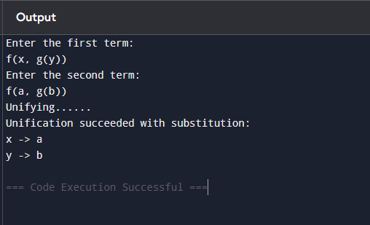

Observation book

