
SHRI G. S. INSTITUTE OF TECHNOLOGY & SCIENCE, INDORE
Department of Computer Engineering | Computer Graphics Project
PROJECT REPORT
SGSITS Virtual Campus
An Interactive Map-Based 360 Degree College Tour and Computer Graphics Navigation System
Submitted by | Submitted to
Ojasv Agrawal | Dr. Puja Gupta

Academic Session 2026-27
Live Project: https://mp-darshan-360.vercel.app/
Repository: https://github.com/ojasvagr123/mp-darshan-360

Project Summary
PROJECT OVERVIEW SGSITS Virtual Campus is a full-stack interactive college-tour application. A public spectator can explore institute landmarks from a campus image map or a sliding place directory, follow an animated route, open a 360 degree panorama, read place information, browse photographs and listen to an audio guide. A single college administrator manages tour stops by clicking the campus map and uploading content.
Field | Details
Project Name | SGSITS Virtual Campus
Domain | Education, campus navigation, multimedia guide
Problem Statement | Interactive College Tour Guide
Public User | Spectator / visitor / prospective student
Privileged User | College administrator only
Frontend | React, Vite, HTML Canvas
Backend | Node.js, Express.js, Prisma ORM
Database | SQLite locally; Supabase PostgreSQL in production
Deployment | Vercel frontend, Render backend, Supabase database
Submitted By | Ojasv Agrawal
Submitted To | Dr. Puja Gupta

Abstract
College campuses can be difficult to understand for prospective students, parents, guests and new learners who cannot physically visit beforehand. Conventional maps provide positions but do not communicate what a place looks like, why it matters, or how it connects to other locations. This project transforms the original MP tourism concept into SGSITS Virtual Campus, an institute-specific multimedia tour built around an image map of Shri G. S. Institute of Technology & Science, Indore.
The application supports two user modes. The spectator requires no account and can select a place directly from the campus map or from a searchable sliding directory. The administrator signs in through a protected account, clicks an exact map point, enters descriptions and accessibility details, and uploads a panorama and gallery images. The frontend displays the published stop through 360 view, about, gallery, audio guide and CG navigation tabs.
Computer Graphics is integrated into the application rather than presented as an isolated demonstration. Normalized image coordinates provide viewport mapping; the DDA algorithm rasterizes a route from the Main Gate; a quadratic Bezier curve controls animated movement; translation and rotation orient the direction marker; and requestAnimationFrame continuously redraws the Canvas. The result is a deployable full-stack project that connects graphics theory with a useful campus-discovery problem.

Table of Contents
- Problem Statement
- Proposed Solution
- Objectives
- Scope of the Project
- Technology Stack
- System Architecture
- User Roles and Main Flow
- Major Application Modules
- Database Design
- API Design
- Backend Processing Logic
- Computer Graphics Implementation
- Frontend UI/UX and Application Screens
- Local Setup Guide
- Deployment Architecture
- Testing and Validation
- Security Considerations
- Limitations
- Future Scope
- Conclusion
- References

1. Problem Statement
The revised project problem is to design an Interactive College Tour Guide for SGSITS Indore. A visitor should be able to understand important campus locations without requiring physical presence, specialist software or a user account. The system must combine a recognizable college map, location descriptions, panoramic imagery, narration and navigation graphics in a single web interface.
A plain digital map is insufficient because it shows only position. The project therefore connects spatial selection with multimedia explanation. It also provides an administrator-controlled publishing workflow so institute content is curated rather than crowd-sourced.

2. Proposed Solution
SGSITS Virtual Campus uses the supplied campus raster map as the primary coordinate surface. The administrator clicks a point and the browser converts the click into normalized mapX and mapY percentages. These percentages stay aligned when the map is resized. The administrator then publishes a place name, campus zone, category, visitor description, history, audio script, visiting note, accessibility information, panorama and optional gallery photographs.
A spectator can search the place directory or click a numbered marker. Selection opens a detailed tour stop and animates a route from the Main Gate. No spectator authentication is required. This separation keeps public exploration simple while restricting content modification to the college administrator.

3. Objectives
- Create an institute-specific virtual tour for SGSITS Indore.
- Allow visitors to choose a place from either the map or a sliding directory.
- Provide an interactive 360 degree panorama with drag and zoom controls.
- Give the college administrator a secure map-point publishing workflow.
- Store responsive normalized campus coordinates instead of fixed screen pixels.
- Demonstrate DDA rasterization, Bezier animation and 2D transformations in a practical navigation task.
- Provide gallery, history, accessibility and browser-based audio narration.
- Deploy the complete system using Vercel, Render and Supabase.

4. Scope of the Project
In Scope | Out of Scope / Future Work
Public campus exploration without login | Indoor floor-by-floor navigation
Single college administrator authentication | Multiple departmental editor roles
Map-based stop creation and selection | GPS-based turn-by-turn mobile navigation
Panorama and gallery upload | Dedicated object storage and CDN pipeline
Browser speech synthesis narration | Professionally recorded multilingual audio
Canvas-based CG route demonstration | Full WebGL digital-twin reconstruction

5. Technology Stack
Layer | Technology | Purpose
Frontend | React 19 + Vite | Single-page responsive user interface
Graphics | HTML Canvas | DDA route pixels and animated direction marker
Media | CSS background transforms | Interactive panorama drag and zoom
Backend | Node.js + Express | REST APIs, authentication and uploads
Validation | Zod + Multer | Structured fields and image upload checks
ORM | Prisma 6 | Database models and PostgreSQL/SQLite access
Local DB | SQLite | Simple offline development database
Cloud DB | Supabase PostgreSQL | Persistent production data
Security | JWT + bcrypt | Admin session and password hashing
Hosting | Vercel + Render | Frontend and backend deployment

6. System Architecture
The system follows a three-tier web architecture. The Vercel-hosted React client requests public tour data and submits administrator actions to the Render-hosted Express API. The API validates JWT authorization and uploaded fields, then reads or writes through Prisma to Supabase PostgreSQL. Local development uses the same application models with an explicit SQLite schema.
Component | Responsibility
React frontend | Campus map, directory, detail tabs, panorama, narration and admin modal
Canvas graphics layer | Responsive route rasterization and animated movement
Express API | Public reads, admin login, protected publishing and media handling
Prisma ORM | Typed database access with separate local and production schemas
Supabase PostgreSQL | Cloud persistence for administrator, places and media
Vercel | Static frontend hosting and VITE_API_URL configuration
Render | Backend runtime, database migration and seed workflow

DEPLOYMENT FLOW Vercel frontend -> Render REST API -> Supabase PostgreSQL

7. User Roles and Main Flow

7.1 Spectator
- Open the public website without creating an account.
- Choose a campus landmark from the image map or sliding directory.
- Follow the animated route from the Main Gate to the selected marker.
- Use 360 View, About, Gallery, Audio Guide and CG Navigation tabs.
- Search another campus place and continue the virtual visit.

7.2 College Administrator
- Sign in with the protected administrator account.
- Open Add stop and click the exact location on the campus map.
- Enter place, zone, category, visitor description, history and access details.
- Upload an equirectangular panorama and optional gallery photographs.
- Publish the stop; the API saves normalized coordinates and media.
- Confirm that the new numbered marker appears for public spectators.

8. Major Application Modules
Module | Functionality
Landing page | SGSITS identity, project introduction and direct tour actions
Campus directory | Searchable sliding list of buildings, landmarks and facilities
Campus image map | Numbered responsive markers and direct place selection
Administrator login | Single role-restricted JWT authentication flow
Admin map studio | Click-to-pin publishing form with panorama and gallery upload
360 panorama | Pointer drag and wheel zoom over uploaded equirectangular imagery
Place information | Description, history, campus zone, hours and accessibility
Audio guide | Browser SpeechSynthesis narration from administrator script
CG navigation | DDA route, Bezier motion, transforms and viewport mapping

9. Database Design
The inherited database contains User, Place, PlaceMedia and Comment models. The revised application actively uses User, Place and PlaceMedia. Comment is retained for schema compatibility but is not exposed in the spectator interface.
Model | Important Fields | Purpose
User | id, name, email, passwordHash, role | Stores the single ADMIN identity and hashed credentials
Place | title, district, category, story, history, mapX, mapY, panoramaDataUrl | Stores a campus stop and its normalized map point
PlaceMedia | type, caption, dataUrl, mimeType, sizeBytes, placeId | Stores optional gallery images linked to a stop
Comment | body, placeId, userId, createdAt | Legacy-compatible model; not used by public tour flow

MEDIA STORAGE NOTE Panoramas and gallery images are stored as data URLs for a compact college demonstration. Production scale should move binary assets to Supabase Storage or another object-storage service.

10. API Design
Method | Endpoint | Purpose / Access
GET | /api/health | Backend health check - public
POST | /api/auth/login | Administrator login and JWT issue
GET | /api/me | Current authenticated administrator
GET | /api/places | List campus stops - public
GET | /api/places/:id | Fetch one tour stop - public
GET | /api/places/:id/guide | Structured multimedia guide - public
POST | /api/places | Publish stop and images - ADMIN only

11. Backend Processing Logic
The backend validates login fields, campus-stop metadata and file uploads. requireAuth verifies the JWT and loads the database user, while requireAdmin rejects every non-ADMIN account. The public endpoints return sanitized user and place data. The upload route converts image buffers to data URLs, creates PlaceMedia records, and stores the selected map point.
CORS normalizes trailing slashes in CLIENT_URL and supports comma-separated allowed origins. Production Prisma uses PostgreSQL by default; local commands explicitly select schema.sqlite.prisma. The Render build workflow installs backend dependencies, generates the PostgreSQL client, pushes the schema and runs an idempotent seed.
mapX = ((pointerX - mapLeft) / mapWidth) * 100
mapY = ((pointerY - mapTop) / mapHeight) * 100
screenX = (mapX / 100) * currentMapWidth
screenY = (mapY / 100) * currentMapHeight

12. Computer Graphics Implementation
The CG Navigation tab explains and displays the graphics pipeline using the actual selected campus stop. The algorithms are visible in the application and directly connected to navigation behavior.
CG Concept | Implementation in SGSITS Virtual Campus
Viewport mapping | Normalized campus percentages are mapped to the current responsive image dimensions.
DDA line drawing | Discrete gold pixels are plotted from the Main Gate to the chosen map point.
Quadratic Bezier curve | The navigation arrow follows a smooth curved path using parameter t.
Translation | Canvas context is translated to the arrow's current animated point.
Rotation | The arrow is rotated using atan2 so it faces the route direction.
Animation loop | requestAnimationFrame clears and redraws the Canvas continuously.
Image transformation | Panorama background position and scale change during drag and wheel input.

12.1 DDA Route Rasterization
For start point (x1, y1) and destination (x2, y2), the algorithm computes dx and dy. The number of steps equals max(abs(dx), abs(dy)). It then increments x and y by dx/steps and dy/steps. Every few calculated points are drawn as small gold rectangles, producing a dotted route that retains the character of raster graphics.

12.2 Bezier Navigation Animation
B(t) = (1 - t)^2 P0 + 2(1 - t)t P1 + t^2 P2
0 <= t <= 1
P0 = Main Gate, P1 = raised control point, P2 = selected stop
The time parameter repeats approximately every 2.6 seconds. Translation positions the arrow at B(t), and rotation aligns it with the direction between origin and destination.

13. Frontend UI/UX and Application Screens
The frontend adopts the SGSITS website identity: navy and gold colors, institute emblem, formal serif headings and clear administrative controls. The screenshots below document the implemented solution rather than the earlier MP tourism design.
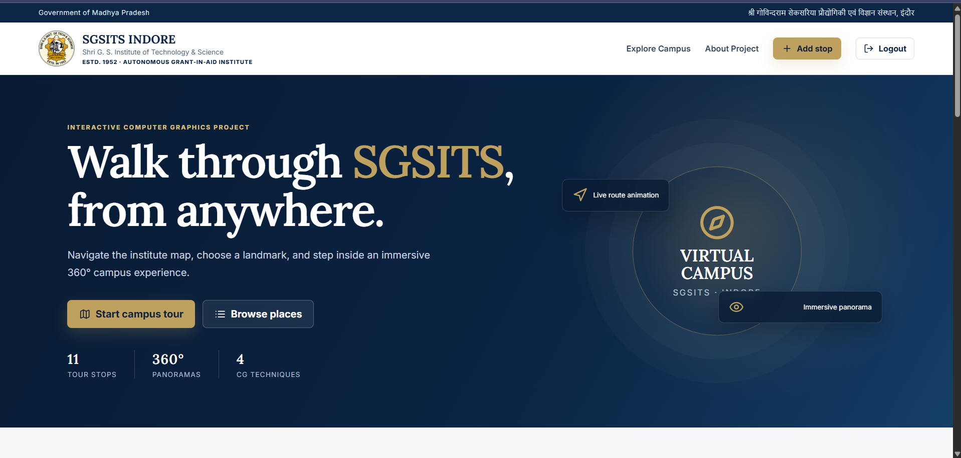
Figure 1. SGSITS Virtual Campus landing page with institute branding, tour actions and CG feature indicators.

13.1 Administrator Authentication
The public spectator experience does not require login. The restricted modal exists only for the college administrator and clearly explains that the account is used to publish campus stops.
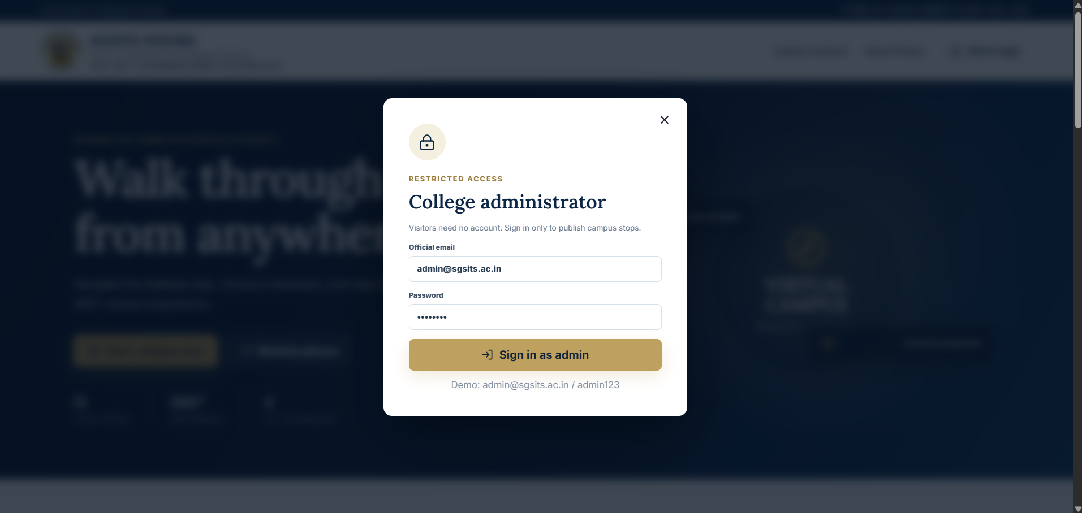
Figure 2. Restricted administrator login modal for protected campus-content management.

13.2 Admin Map Studio
The publishing interface combines map selection and content entry. A red draft marker records the clicked normalized coordinate. Existing numbered points remain visible to help the administrator position a new landmark relative to current tour stops.
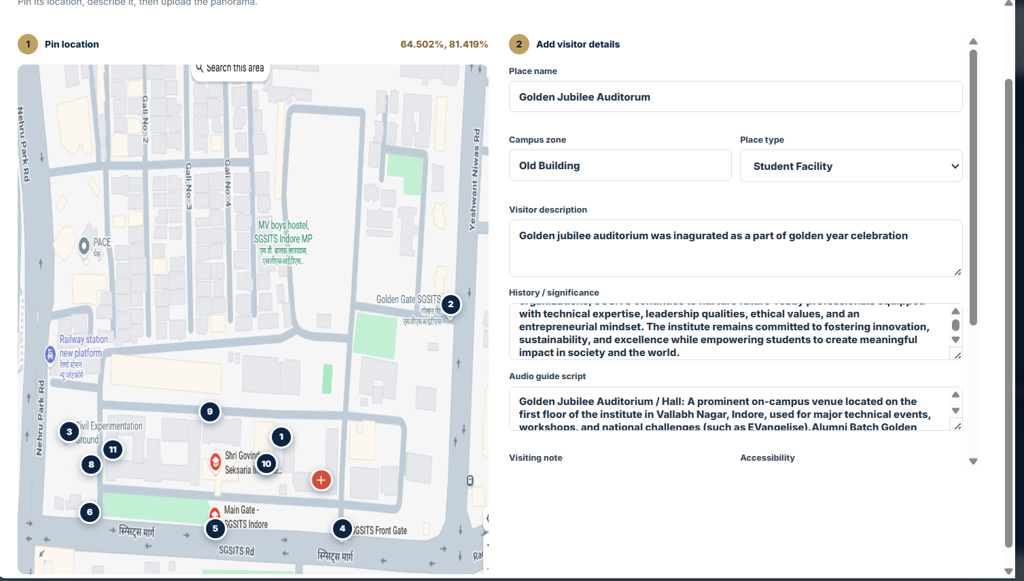
Figure 3. Administrator selecting a location and entering place, zone, category and narrative details.

The lower portion of the same workflow captures visiting information, accessibility, the required panorama and optional gallery photographs. Publishing sends one multipart request to the protected backend endpoint.
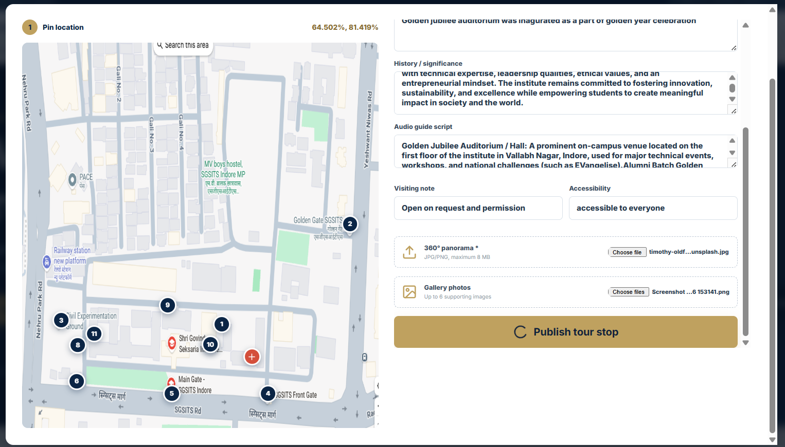
Figure 4. Panorama/gallery upload and Publish tour stop action in the admin workflow.

13.3 Multimedia Tour Stop
Each selected location opens a detail workspace with consistent tabs. The panorama viewer supports pointer dragging and wheel zoom. The screenshot uses a demonstration equirectangular panorama; campus-specific panorama images can be uploaded by the administrator using the same workflow.
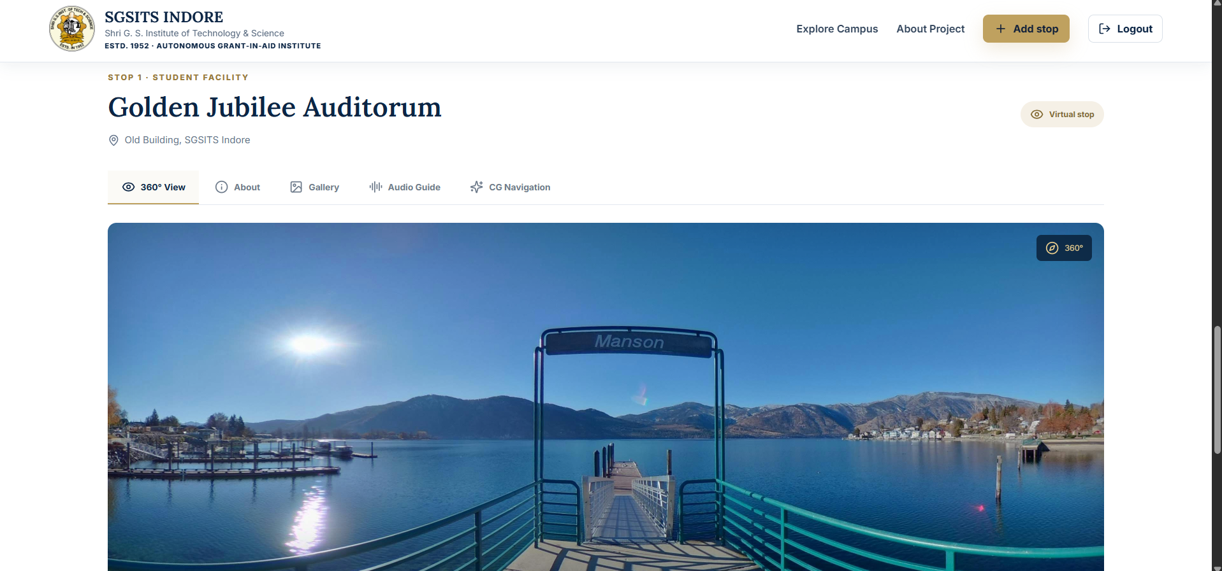
Figure 5. Interactive 360 degree tour-stop view with draggable panoramic media.

13.4 Accessible Audio Narration
The Audio Guide tab uses the browser SpeechSynthesis interface. The administrator's script is narrated with play and stop controls, providing hands-free access to place information without storing a separate audio file.
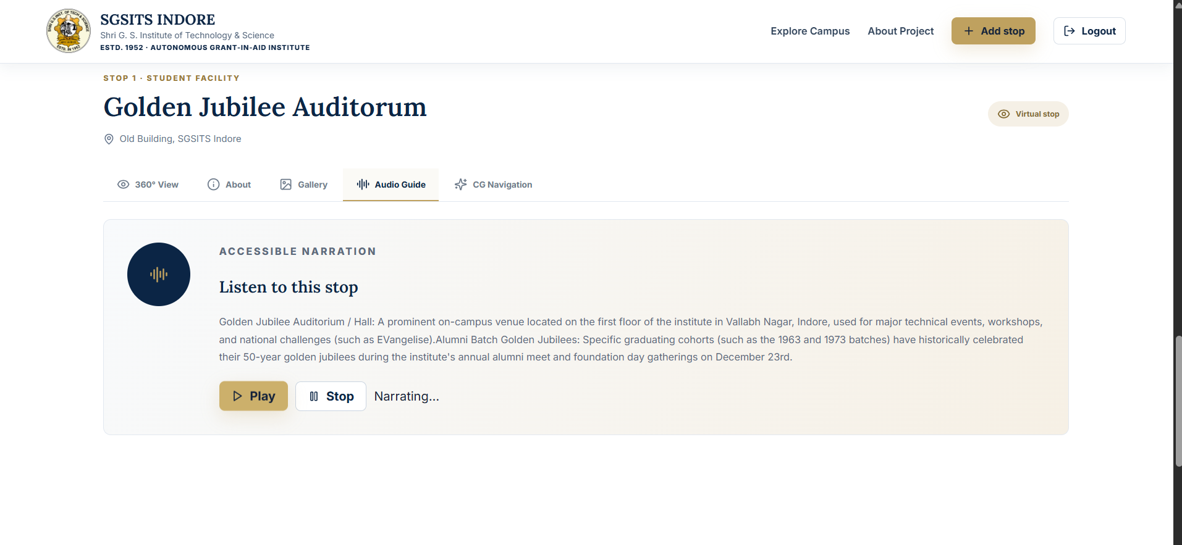
Figure 6. Audio Guide tab narrating the published campus-stop script.

13.5 CG Navigation View
The CG view overlays the campus raster map with numbered points and the gold DDA route. An animated direction marker moves from the Main Gate to the currently selected location. This screen provides direct evidence of the assignment-specific graphics implementation.
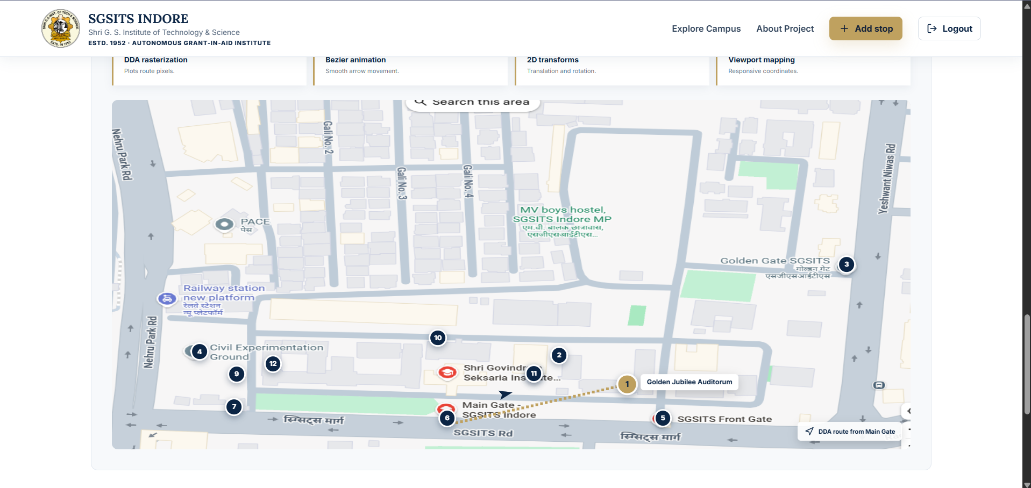
Figure 7. CG Navigation tab showing normalized markers and the DDA route from the Main Gate.

14. Local Setup Guide
Run the following commands from the repository root in PowerShell or a terminal with Node.js installed.
npm install
npm run install:all
npm run db:generate
npm run db:init
npm run db:seed
npm run dev
Service | Local URL / Credential
Frontend | http://localhost:5173
Backend health | http://localhost:4000/api/health
Admin email | admin@sgsits.ac.in
Demo password | admin123

SECURITY NOTE The demo credentials and local JWT secret must be changed before a real institutional production launch.

15. Deployment Architecture
Service | Used For | Important Configuration
Supabase | PostgreSQL database | DATABASE_URL in Render; use a PostgreSQL connection string
Render | Express API | Build: npm run render:build; Start: npm start; set CLIENT_URL
Vercel | React/Vite frontend | Set VITE_API_URL to the Render URL ending in /api

15.1 Production Environment Variables
Render: DATABASE_URL=<Supabase PostgreSQL URL>
Render: JWT_SECRET=<long random value>
Render: CLIENT_URL=https://mp-darshan-360.vercel.app
Vercel: VITE_API_URL=https://mp-darshan-360.onrender.com/api
The backend normalizes a trailing slash in CLIENT_URL to prevent browser CORS mismatch. For multiple Vercel preview origins, CLIENT_URL accepts a comma-separated list.

16. Testing and Validation
- Frontend production build completes successfully with Vite.
- PostgreSQL and SQLite Prisma schemas validate independently.
- Health endpoint returns SGSITS Virtual Campus API status.
- Public places endpoint returns seeded campus stops without authentication.
- Admin login returns a JWT and ADMIN role for valid credentials.
- Unauthenticated place publishing returns HTTP 401.
- CORS preflight returns the exact deployed Vercel origin.
- Map markers remain aligned at multiple viewport sizes.
- Panorama supports drag and zoom interactions.
- Audio guide starts and stops narration.
- DDA route and Bezier direction marker animate for selected stops.
- Admin upload validates an image panorama and required descriptive fields.

17. Security Considerations
- Administrator passwords are hashed with bcrypt.
- JWT protects campus-stop publishing and administrator identity endpoints.
- requireAdmin enforces the ADMIN role after authentication.
- Public visitors receive read-only access and require no session.
- DATABASE_URL and JWT_SECRET remain backend environment variables.
- VITE_API_URL is intentionally public because it is embedded in the browser bundle.
- Multer limits uploaded files and Zod validates structured form values.
- CORS accepts only configured frontend origins.

18. Limitations
- Panorama and gallery images stored as data URLs increase database size.
- The viewer is a lightweight image-space panorama rather than a WebGL sphere.
- Routes are visual CG demonstrations and do not follow exact walkable corridors.
- The supplied map is a raster screenshot, so clarity is limited at extreme zoom.
- There is one administrator account and no departmental approval workflow.
- Render's free service may sleep and delay the first API request.
- The demonstration panorama should be replaced by actual campus photography for final presentation.

19. Future Scope
- Capture verified equirectangular panoramas for every major SGSITS landmark.
- Move images to Supabase Storage with CDN delivery and database URLs.
- Create graph-based routes that follow campus roads and pedestrian paths.
- Add indoor floor plans and room-level navigation.
- Support Hindi and English recorded narration.
- Add multiple editor roles with review, draft and publish states.
- Introduce WebGL or Three.js panorama rendering and device-orientation controls.
- Provide accessibility-first routes and keyboard navigation.
- Add QR codes at physical campus points to open the corresponding virtual stop.

20. Conclusion
SGSITS Virtual Campus successfully redefines the original MP tourism project as an institution-focused tour application. It provides a simple public spectator experience and a controlled administrator publishing workflow. Visitors can select campus places from either a map or directory and learn through panorama, text, gallery, narration and route graphics.
The project is especially suitable for a Computer Graphics submission because viewport mapping, DDA rasterization, Bezier motion, translation, rotation and continuous Canvas rendering are visible parts of a useful navigation system. At the same time, the full-stack architecture demonstrates frontend development, protected APIs, database design, file uploads and multi-service cloud deployment.

21. References
- Project repository: https://github.com/ojasvagr123/mp-darshan-360
- Live frontend: https://mp-darshan-360.vercel.app/
- React documentation: https://react.dev/
- Vite documentation: https://vite.dev/
- MDN Canvas API: https://developer.mozilla.org/docs/Web/API/Canvas_API
- Express documentation: https://expressjs.com/
- Prisma documentation: https://www.prisma.io/docs/
- Supabase documentation: https://supabase.com/docs
- Render documentation: https://render.com/docs
- Vercel documentation: https://vercel.com/docs

