**Operating System Concepts**

**SunBeam Institute of Information & Technology, Hinjwadi, Pune & Karad.**

****Sunbeam Infotech www.sunbeaminfo.com

Introduction

**Mr. Sachin Gajanan Pawar.** 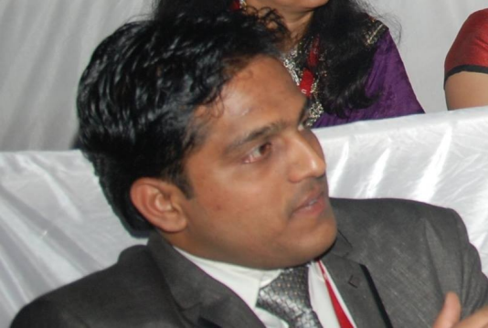

**Lead Technical @SunBeam.**

**# Educational Qualification:**

1. B.Sc. Electronics.

2. M.Sc.Tech (Industrial Maths & Computer

Applications).

**# Work Experience:**

1. 7 Yrs of teaching experience in SunBeam

Pune & Karad, for PreCAT & CDAC

Courses.

2. 3+ Yrs of Industry Experience of Software

Development.

**# Skills:**

1. C Programming Language

2. C++ Programming Language

3. Data Structures

4. Operating System Concepts

Sunbeam Infotech www.sunbeaminfo.com

Operating System Concepts

**\* Introduction:**

- Why there is need of an OS?

- What is an OS?

- Functions of an OS

**\* Computer Fundamentals:**

- Major Components: Processor, Memory Devices & IO Devices. - Memory Technologies and its characteristics

- IO Techniques

Sunbeam Infotech www.sunbeaminfo.com

Operating System Concepts

**\* UNIX System Architecture Design**

- Major subsystem of an UNIX system: File subsystem & Process Control subsystem.

- System Calls & its catagories

- Dual Mode Operation

**\* Process Management**

- What is Process & PCB?

- States of the process

- CPU scheduling & CPU scheduling algorithms

- Inter Process Communication: Shared Memory Model & Message Passing Model

Sunbeam Infotech www.sunbeaminfo.com

Operating System Concepts

**\* Process Management**

- Process Synchronization/Co-ordination

- Deadlocks & deadlock handling methods

**\* Memory Management**

- Swapping

- Memory Allocation Methods

- Internal Fragmentation & External Fragmentation - Segmentation

- Paging

- Virtual Memory Management

Sunbeam Infotech www.sunbeaminfo.com

Operating System Concepts

**\* File Management**

- What is file?

- What is filesystem & filesystem structure? - Disk space allocation methods

- Disk scheduling algorithms

Sunbeam Infotech www.sunbeaminfo.com

Operating System Concepts

**Q. Why there is a need of an OS?**

- Computer is a machine/hardware does different tasks efficiently & accurately.

- Basic functions of computer:

1. Data Storage

2. Data Processing

3. Data Movement

4. Control

- As any user cannot communicates/interacts directly with computer hardware to do different tasks, and hence there is need of some interface between user and hardware.

Sunbeam Infotech www.sunbeaminfo.com

Operating System Concepts

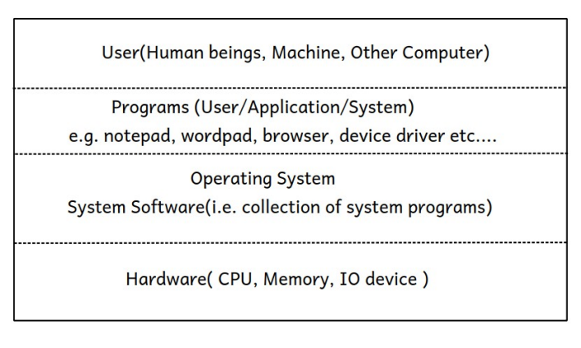Sunbeam Infotech www.sunbeaminfo.com

Operating System Concepts

**Q. What is an Operating System?**

- An OS is a **system software** (i.e. collection of system programs) which acts as an interface between user and hardware.

- An OS also acts as an interface between programs and hardware.

- An OS allocates resources like main memory, CPU time, i/o devices access etc... to all running programs, hence it is also called as a **resource allocator.**

- An OS controls an execution of all programs and it also controls hardware devices which are connected to the computer system and hence it is also called as a **control program.**

****Sunbeam Infotech www.sunbeaminfo.com

Operating System Concepts

**Q. What is an Operating System?**

- An OS manages limited available resources among all running programs, hence it is also called as a **resource manager.**

- From End User: An OS is a software (i.e. collection of programs) comes either in CD/DVD, has following main components:

**1. Kernel:** It is a core program/part of an OS which runs continuosly into the main memory does basic minimal functionalities of it.

e.g. Linux: vmlinuz, Windows: ntoskrnl.exe

**2. Utility Softwares:** e.g. disk manager, windows firewall, anti-virus software etc...

**3. Application Softwares:** e.g. google chrome, shell, notepad, msoffice etc...

Sunbeam Infotech www.sunbeaminfo.com

Operating System Concepts

**# Functions of an OS:**

**Basic minimal functionalities/Kernel functionalities:** 1. Process Management

2. Memory Management

3. Hardware Abstraction

4. CPU Scheduling

5. File & IO Management

**Extra utility functionalities/optional:**

6. Protection & Security

7. User Interfacing

8. Networking

Sunbeam Infotech www.sunbeaminfo.com

Operating System Concepts

**# Computer Fundamentals:**

- Computer is a hardware mainly contains:

**1. Processor**

**2. Memory Devices**

**3. IO Devices**

- There are two basic/fundamental **structural** and **functional units** of computer hardware system:

1. Memory cell

2. Gates

- As the data stoarage can be acheived by memory cell, data processing, data movement and control functions can be achieved by using gates, hence memory cell & gates are referred as functional units, wheras computer is a digital device made up of collection of millions of memory cells & gates, and hence memory cell & gates are referred as structural units as well.

Sunbeam Infotech www.sunbeaminfo.com

Operating System Concepts

**# Computer Fundamentals:**

**1. Memory cell:** memory has the capacity to store one value at a time in it either 0 OR 1.



**2. Gates:** gate a basic digital device (flip-flop gates) can be used for performing arithmetic & logic operations as well as for control.

Sunbeam Infotech www.sunbeaminfo.com

Operating System Concepts

**# Processor:**

- Processor contains: ALU(Arithmetic Logic Unit), CU(Control Unit), Registers.

- Processor is also called as **CPU(Central Processing Unit).**

****Sunbeam Infotech www.sunbeaminfo.com

Operating System Concepts

- Computer system mainly contains Processor, Main Memory, Hard Disk Drive, Keyboard & Monitor.

- In a Computer system each and every device has got its own dedicated processor which controls operations of that device specifically, and there exists one processor which controls all the operations and devices in a computer system centrally by co ordinating with dedicated processors.

For Example: Hard Disk Drive has **disk controller** which controls all disk operations, whereas processor in a block diagram controls all operations

- All components in a computer are connected via conducting wires through which transfer of data, addresses and control signals takes place, these conducting wires are referred as **buses.**

****Sunbeam Infotech www.sunbeaminfo.com

Operating System Concepts

- Three types of buses are there:

**1. Data Bus:** transfers data

**2. Address Bus:** transferes addresses

**3. Control Bus:** transferes control signals

- Major components of computer system ( i.e. components which are onto the motherboard like CPU, Cache Memory, Main Memory etc...) are connected via a bus referred as a **system bus**.

- As data which is sent by one component can be recieved by any other component connected to the bus, hence it is a **shared communication pathway.**

- Control signals sent by the CPU to other devices referred as commands. **1. TEST:** to check the status of any device

**2. WRITE**

**3. READ**

**4. CONTROL**

****Sunbeam Infotech www.sunbeaminfo.com