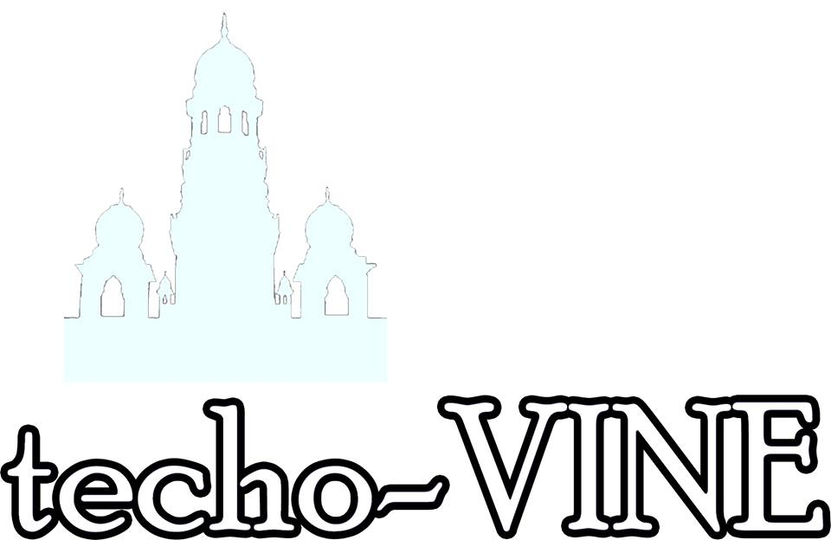

**Roll no. Seat no.**

**Pooja Ahuja 502 472**

**Falguni Sonawala 554 522**

**Japa Swadia 555 523**

**ACKNOWLEDGEMENT**

Our heartfelt gratitude to Viral Sir for his valuable guidance and suggestions which helped us in developing this application.

We would also like to thank our parents for their constant support and encouragement.

**TABLE OF CONTENTS**

* 1. **INTRODUCTION**
  2. **PROJECT PROFILE**
* **Title**
* **Objective**
* **Scope**
* **Technology Base**
  1. **TOOLS AND TECHNOLOGIES**

**D. DESCRIPTION**

**E. DIAGRAMS**

* **Entity Relationship Diagram**
* **Data Flow Diagram**

**F. MODULES**

**G. FUTURE SCOPE**

**INTRODUCTION**

*techo-Vine* is a social networking site meant to enhance communication and interaction among the students and faculty of Techo. Through a combination of unique features and a user friendly interface techo-Vine can do wonders for a small community and keep all its members connected 24x7. It might not hold the stature of the likes of Facebook or Twitter, albeit it is an ideal social networking site for each and every Techoite.

**PROJECT PROFILE**

Title: techo-Vine

(Social Networking Site for Techoites)

Objective: Our purpose is to facilitate the students and teachers of Techo with an effective medium of communication using which they can post important details about the on-going activities in the college as well as receive essential news from others. They can also maintain a profile and update it which includes status and profile picture updates.

Scope: The project, up to its current implementation, enables the user to maintain a personal profile and edit its details whenever he/she wants to. The user can share some important news through the Broadcast feature and it can also be limited to a smaller group. Other features that are provided include an Admin controlled Techo page, Search Friends and view their profiles.

Platform: Frontend implemented with .Net Framework using C# and Backend through SQL Server.

**TOOLS AND TECHNOLOGIES**

**.NET FRAMEWORK**

The .Net framework is a revolutionary platform that helps you to write the following types of applications:

* Windows applications
* Web applications
* Web services

The .Net framework applications are multi-platform applications. The framework has been designed in such a way that it can be used from any of the following languages: C#, C++, Visual Basic, Jscript, COBOL, etc. All these languages can access the framework as well as communicate with each other.

**C#**

C# is a modern, general-purpose, object-oriented programming language developed by Microsoft and approved by Ecma and ISO. C# was developed by Anders Hejlsberg and his team during the development of .Net Framework.

C# is designed for Common Language Infrastructure (CLI), which consists of the executable code and runtime environment that allows use of various high-level languages to be used on different computer platforms and architectures.

**MICROSOFT SQL SERVER**

Microsoft SQL Server is a [relational database management system](http://en.wikipedia.org/wiki/Relational_database_management_system) developed by [Microsoft](http://en.wikipedia.org/wiki/Microsoft). As a database, it is a software product whose primary function is to store and retrieve data as requested by other software applications, be it those on the same computer or those running on another computer across a network (including the Internet). There are at least a dozen different editions of Microsoft SQL Server aimed at different audiences and for workloads ranging from small single-machine applications to large Internet-facing applications with many concurrent users. Its primary [query languages](http://en.wikipedia.org/wiki/Query_language) are [T-SQL](http://en.wikipedia.org/wiki/Transact-SQL) and [ANSI SQL](http://en.wikipedia.org/wiki/SQL).

**DESCRIPTION**

Human beings are social creatures, and therefore, are dedicated to creating and participating in “social networks” in order to express and share their ideas. With the rise of the internet, people have started satisfying this natural necessity in online communities such as internet forums. The evolution of these social forums resulted in today’s global social networking.

Today, everyone has heard of the most popular social network– Facebook – but there are many more social networks than solely Mark Zuckerberg’s po­pular website. Some of these are designed for sharing information, some can help you find a new job, some are used for sharing videos, music or pictures, and some are uniting members of a particular interest. “ techo-Vine” is a similar endeavor aimed at bringing together each and every Techoite with the help of the following features:

* Broadcast your posts

Post important news or information that you intend to share with other Techoites. The post can be limited to a small number of people, for e.g. only department, only faculty etc.

* The Notice Board

The posts are displayed on an attractive notice board which is the main art of any user’s home page.

* Get an insight

Access the details of your friends by viewing their profiles.

* Update or Edit

Manage your profiles the way you want- update your profile picture or change your status. You can also view your posts and edit them if required.

* Easy Search option

Search your friends with ease through the Search Friends option which directs you to the links of their profiles.

* My Techo

This feature is an admin based page through which users can share their memories of Techo through posts and pictures. These are first reviewed by the admin and then uploaded on the My Techo page

Data Flow Diagram

**Context Level**

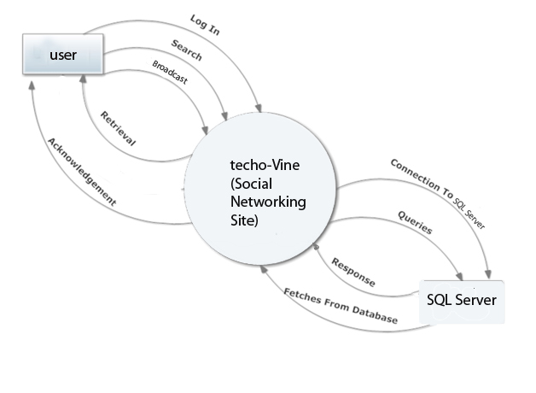

**Level 1**

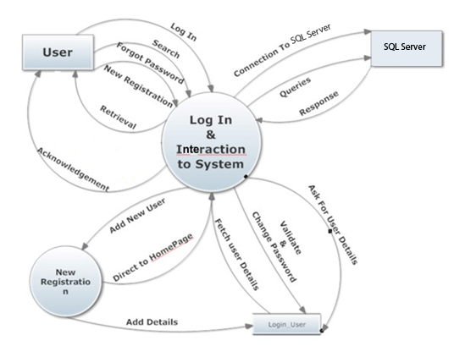

**Level 2**

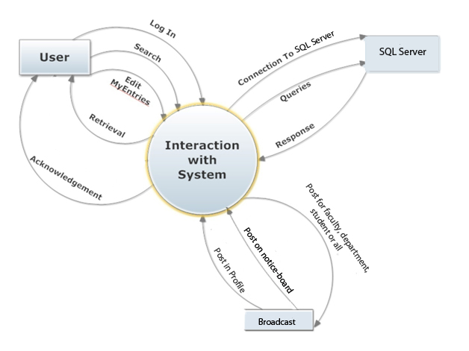

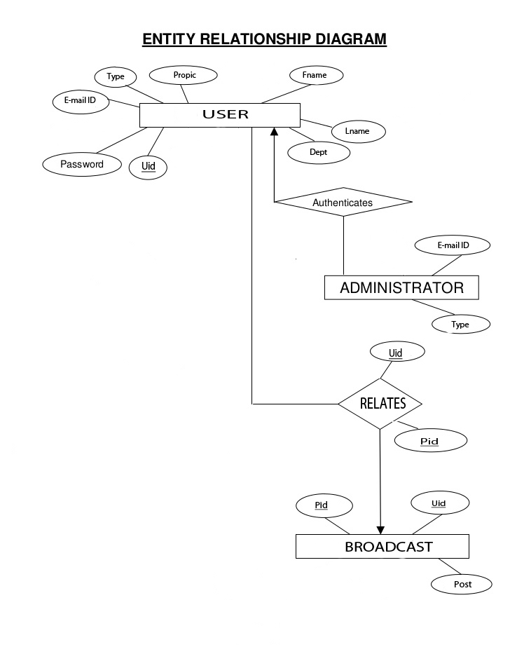

**MODULES**

**Module 1: Log-in System**

Through this system the user can create a new account or an existing user can log on to his/her account. The user can log in to the system through his/her email id and password. The uniqueness of any account holder is determined through the email-id. First time users need to sign up and make a new account. After they have filled in all the details and declared themselves as student or teachers. If they are approved by the administrator depending on the authenticity of the email-id and type they provide, they are directed to the home page or else they are not allowed to register if they are not members of “TECHO”.

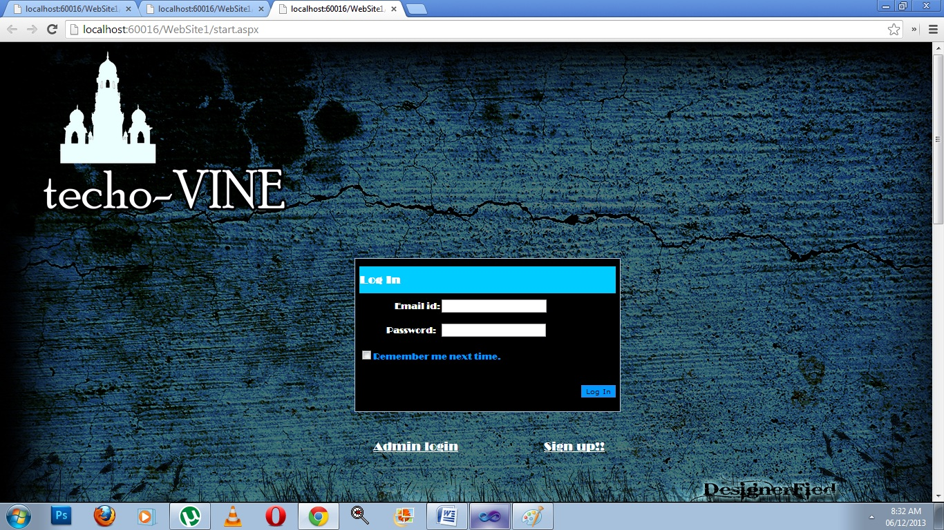

**Module 2: ADMINSTRATOR PANEL**

First, the administrator will have to log in using his username and password which is unique. Then, he is given the rights to insert, delete or view the database of the university which shows the email address of the members and also states whether the user is a Student or Faculty. Inserting the same email id will violate the validation and this way, the uniqueness of the users is maintained.

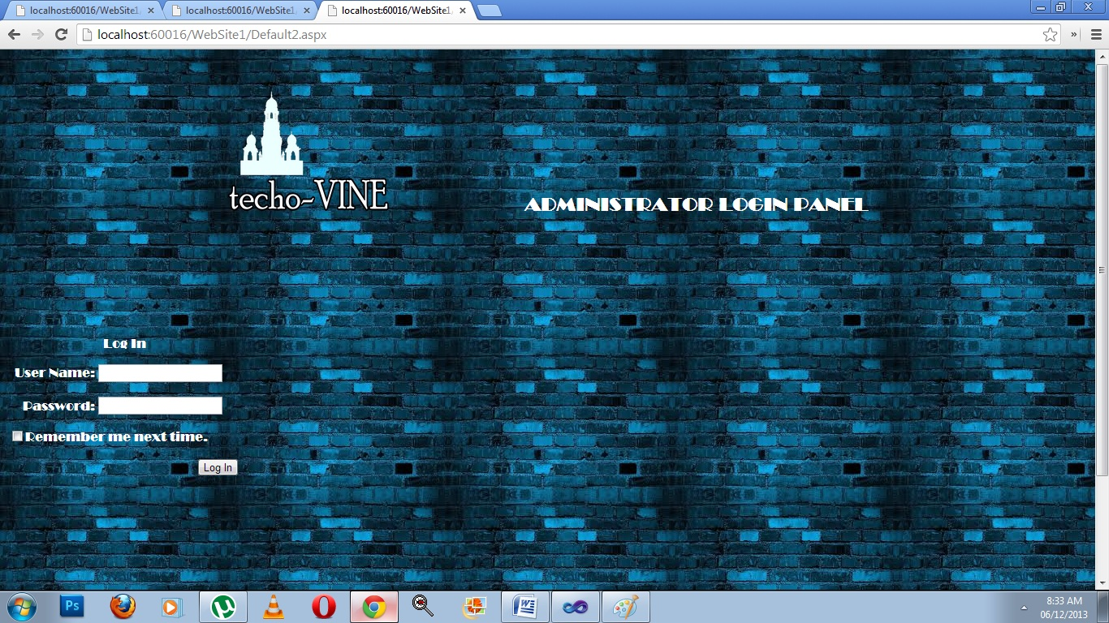

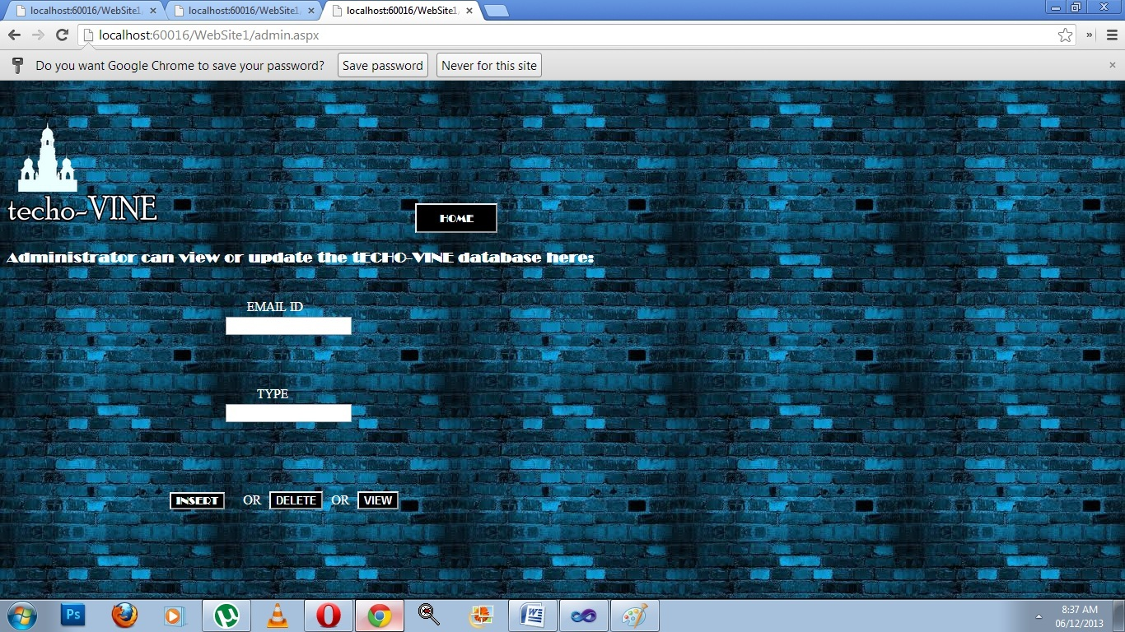

**Module 3: My Account**

Each and every user has a personal profile which is editable. The profile displays the user’s profile picture, status and other basic information along with his/her posts. The user can upload a new profile picture or update the status.

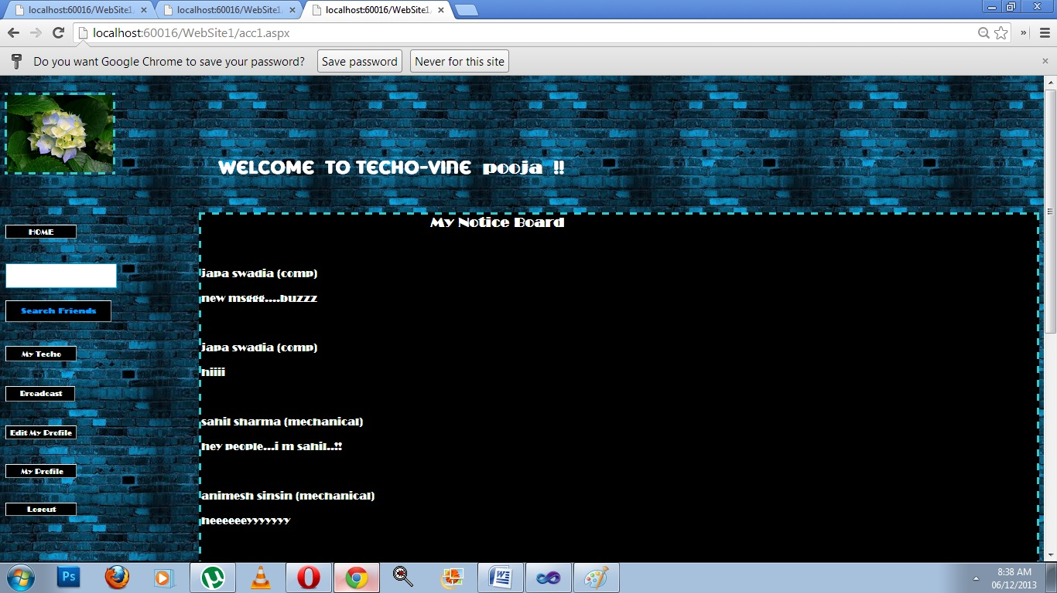

**Module 4: Searching Friends**

The home page displays an option called Search Friends through which a user can search and access the profiles of other users. After entering a few letters of the entire name of the person the user will be directed to another page. On this page there are links to the different profiles.

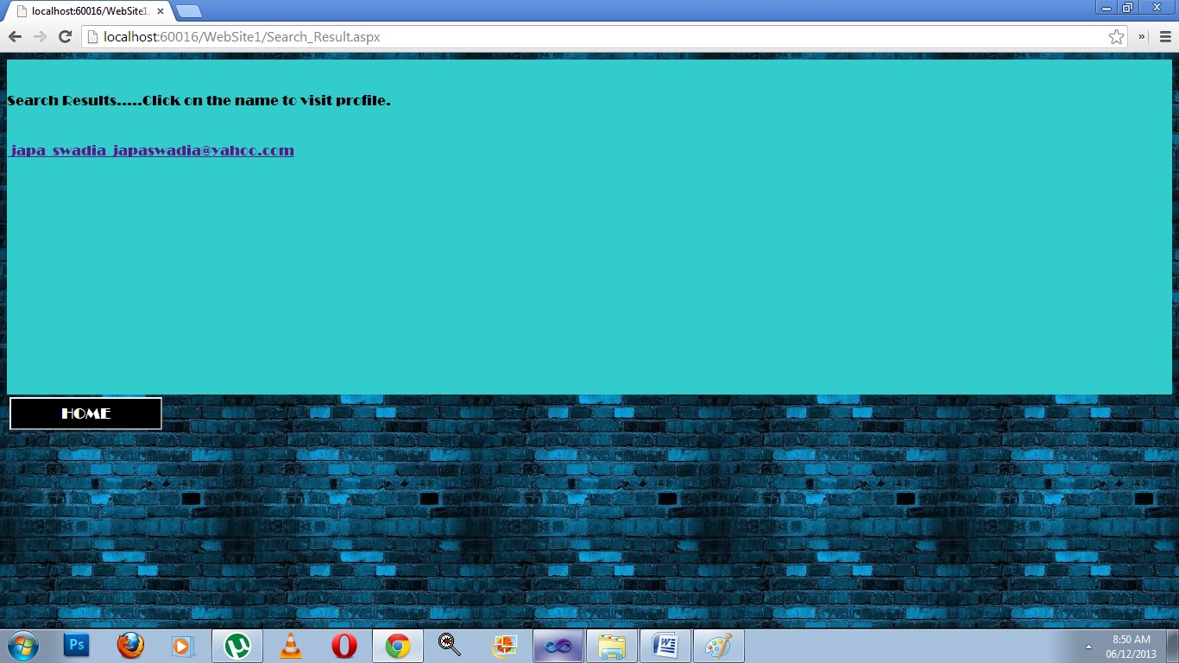

This module also allows you to view your friends’ profiles.

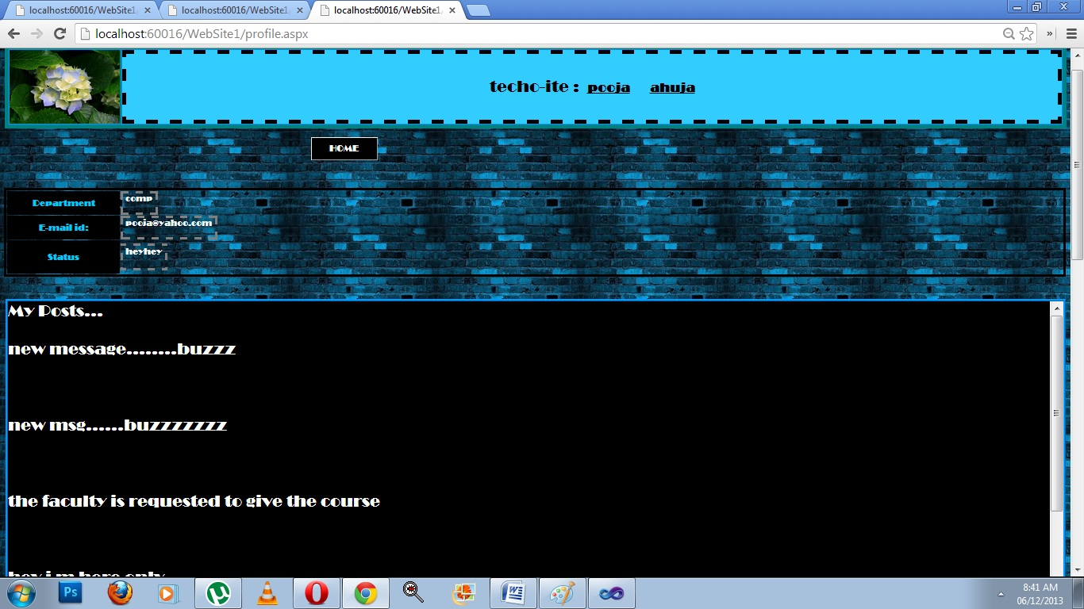

**Module 4: Broadcast**

The user can broadcast important information through this option. When a user clicks on this option he/she is directed to a page wherein the user can type the message. After that the user is provided with four different options (Faculty only, Students only, Department, Entire Techo) so that he/she can decide whom to post the message to. Once this is done the concerned message will be displayed on the notice board of every person belonging to the group for which the message was meant as well as in the user’s own profile.

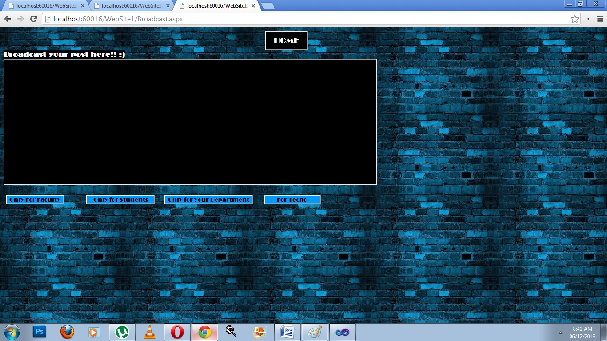

**Module 5: Edit My Profile**

Using this feature a user can edit his/her profile with ease.

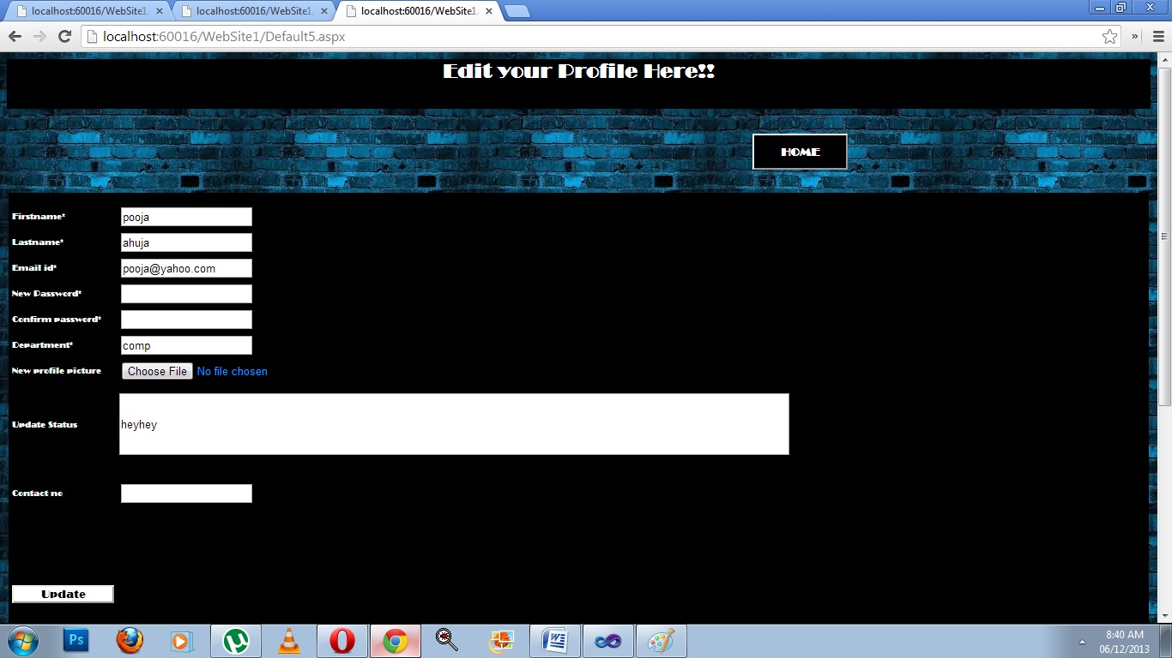

**Module 6: My Techo**

This page is admin-controlled. If a user wishes to share some thoughts or pictures of Techo, they can be mailed to the admin who will review them and then upload them on this page which can then be viewed by all the users.

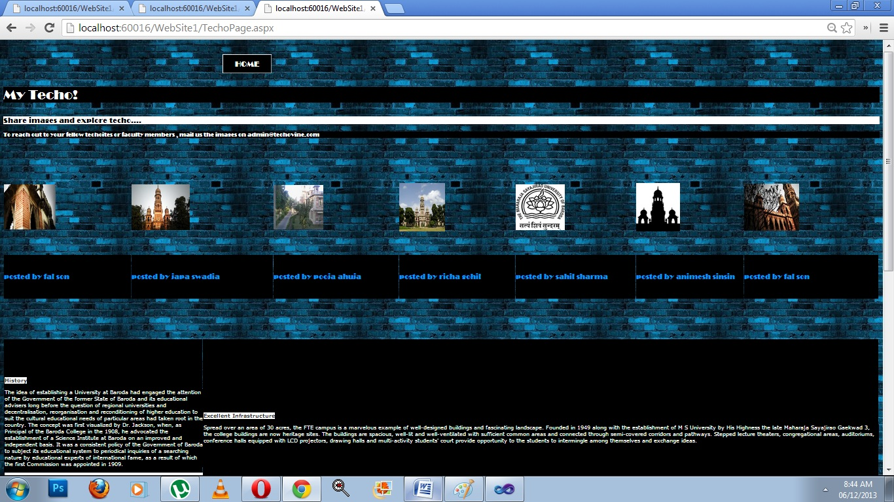

**THE FUTURE SCOPE**

The database is expandable to any limit and the system is compatible for a large number of users as well.

By assimilating advanced features provided by the .NET Framework, the scope of this system can be substantially expanded. Facilities like chatting and messaging can be included to enhance the interaction among the users.

The site can further be transformed into a formal social networking site by incorporating features like Likes and Comments and posting pictures along with written posts.