References:

https://www.researchgate.net/publication/256298039_E_-Hospital_Management_Hospital_Information_Systems_-_Changing_Trends
https://mocdoc.in/blog/a-detailed-view-of-hospital-management-system-hms
https://www.nlm.nih.gov/pubs/factsheets/medline.html
https://health.ebsco.com/products/

Search History of my browser:
I have attached my browser history of the day on which I have created my assignment and refer online information.

https://www.slideshare.net/iffi910/hospital-management-systemdatabase

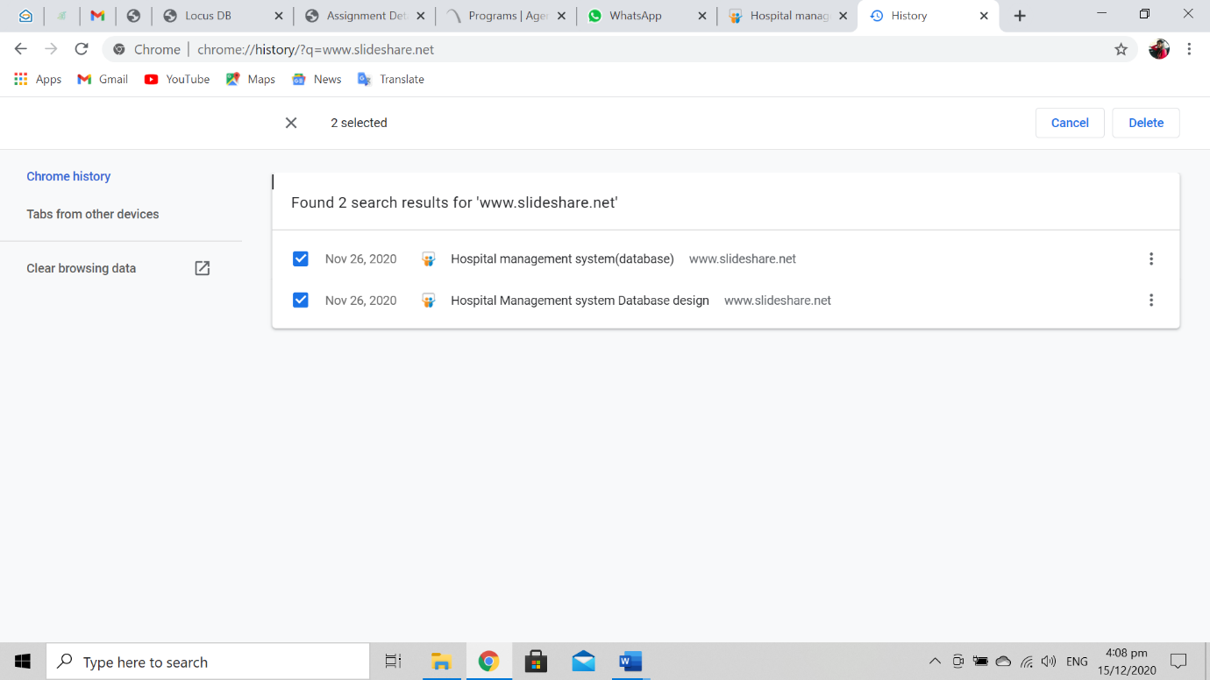
This is my assignment content :
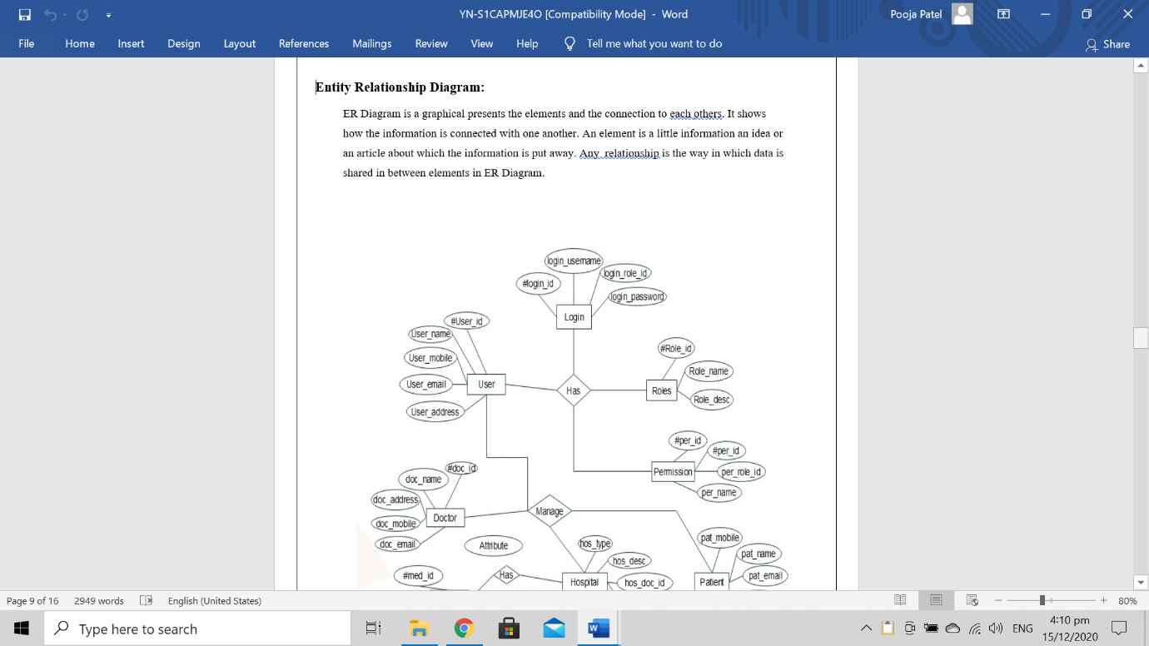

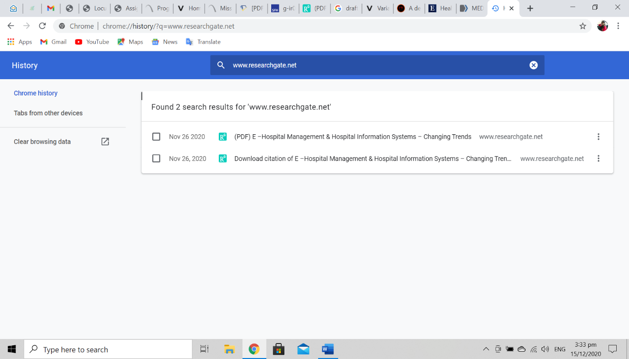
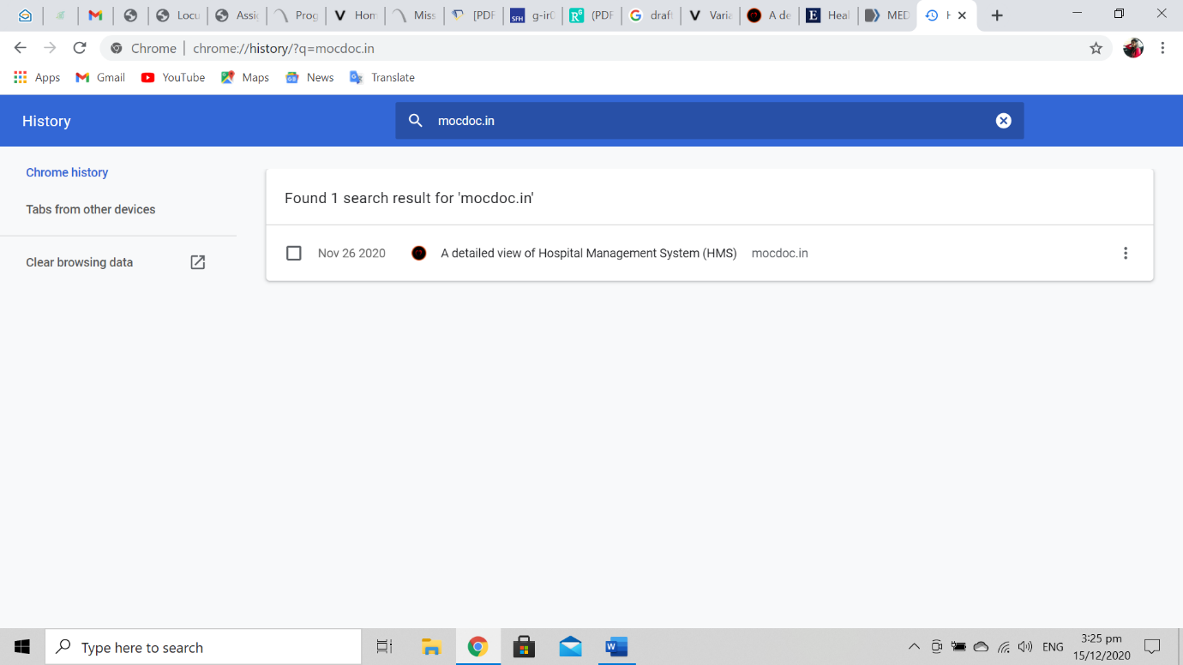
In this field I refer from above site:
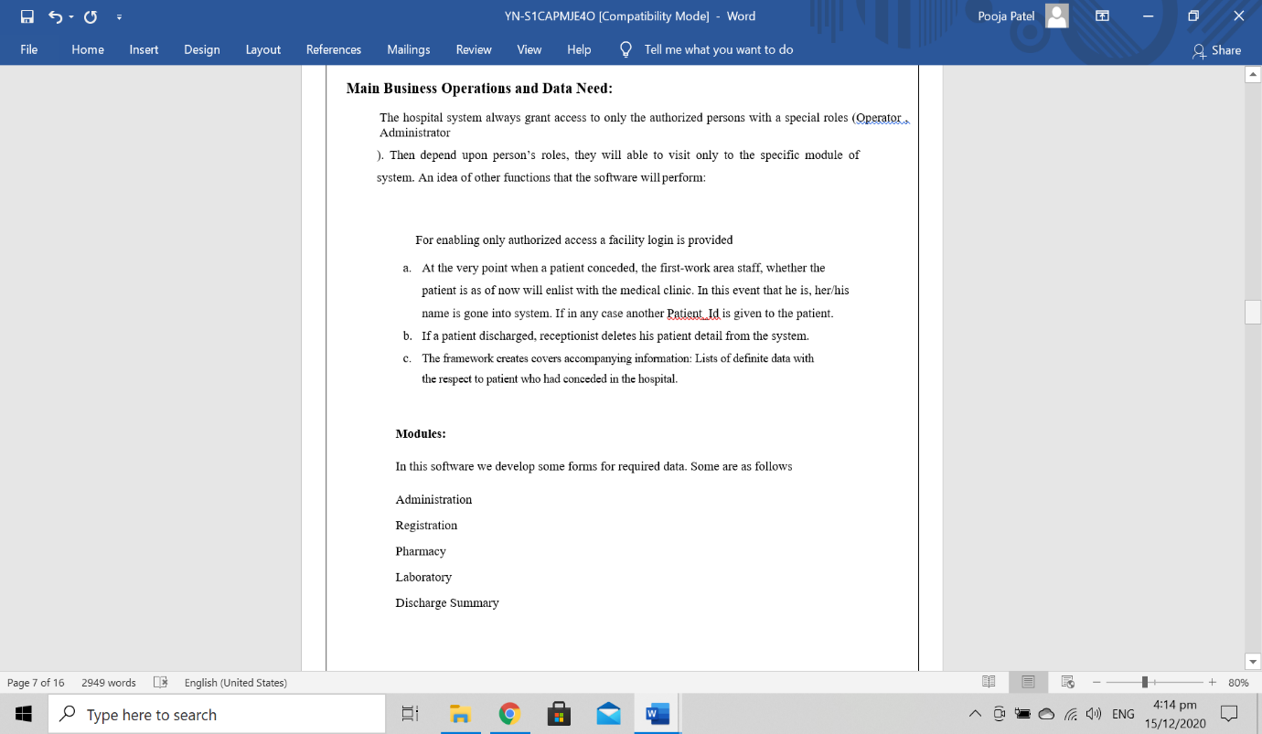

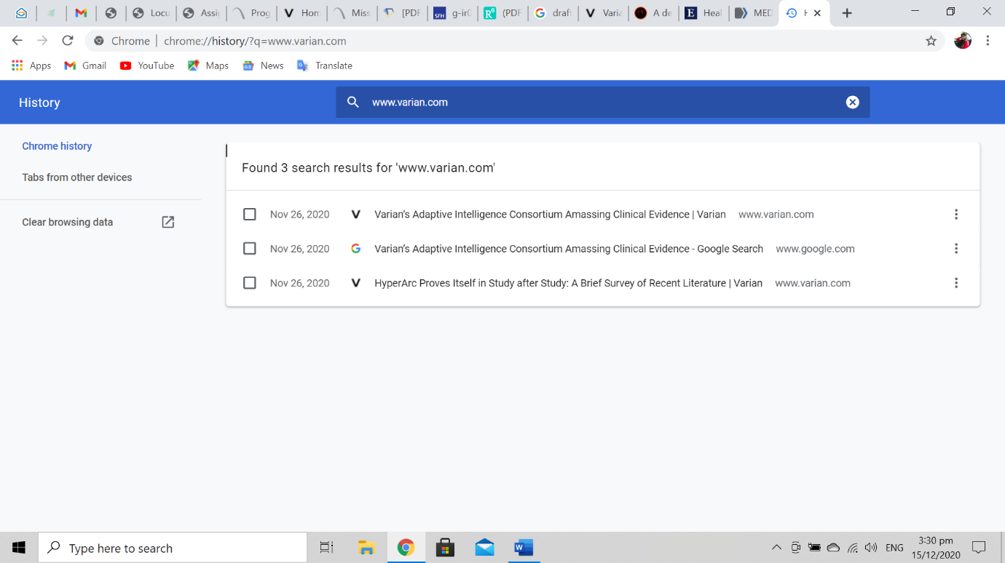
This also is my assignment page:
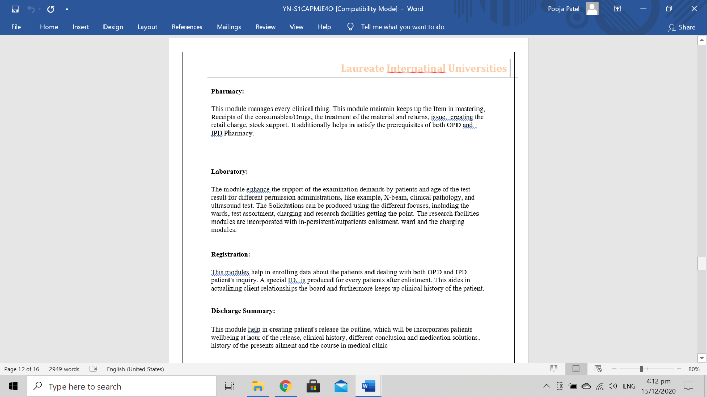

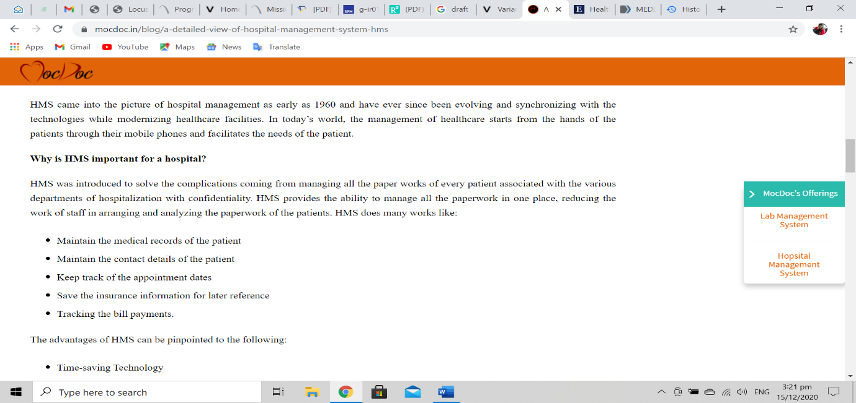

Assignment page on implement system:
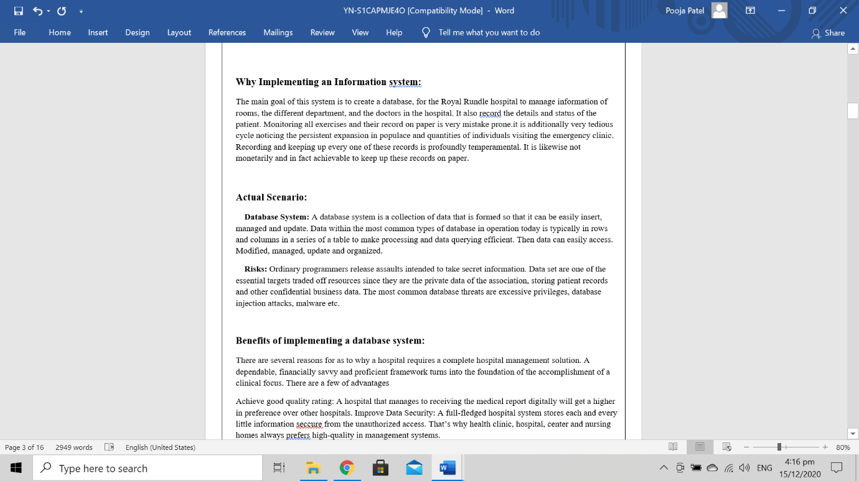

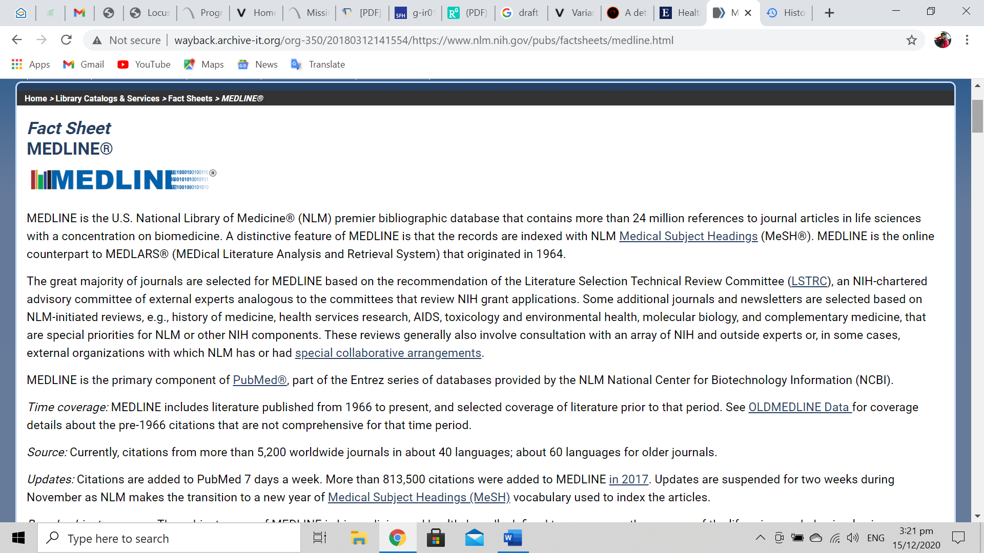

15-12-2020
Respected sir,

This is to ensure you that I have write my own assignment. I did not copy paste from other source.
I refer some online websites for my knowledge to create data. I just go through with some online
Blogs and content for clarity of my visions.

I have mentioned some pervious reference link from which I get some ideas to create management system at the business vision. I also add some proof of my search history as well.

Sincerely,

