1. Create a VPC and create 3 instances in 3 different VPCs

2. I have used Linux AMI small instance

Security group configurations:

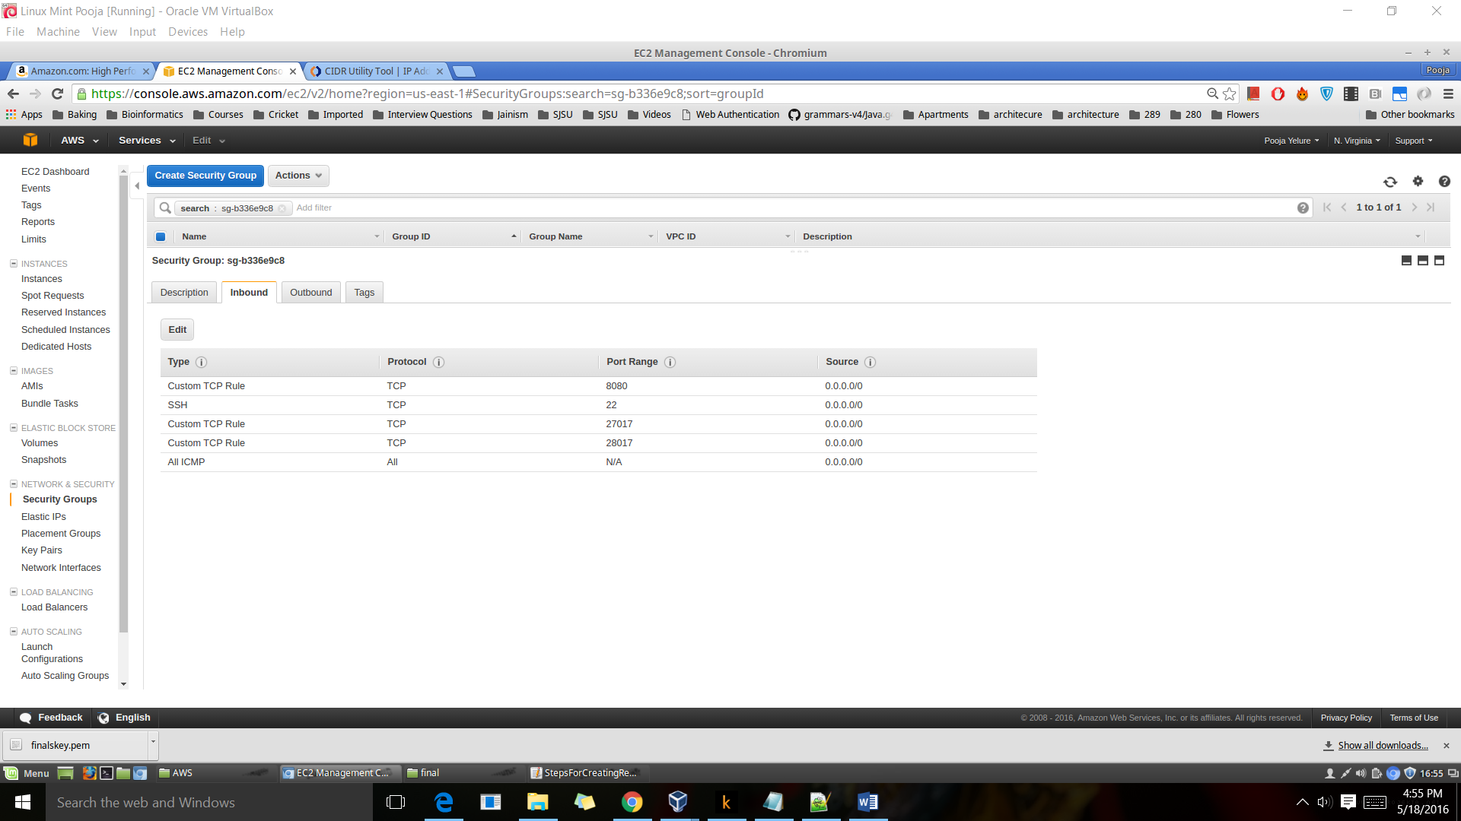

**Installing MongoDB**

1. **Open the following file** sudo vi /etc/yum.repos.d/mongodb-org-3.2.repo
2. **Copy paste the following lines in it**

[mongodb-org-3.2]

name=MongoDB Repository

baseurl=https://repo.mongodb.org/yum/amazon/2013.03/mongodb-org/3.2/x86_64/

gpgcheck=1

enabled=1

gpgkey=https://www.mongodb.org/static/pgp/server-3.2.asc

1. sudo yum install -y mongodb-org

**Other settings: - Do these on all instances**

* Open the file: **sudo vi /etc/mongod.conf** and comment out the line **“ bindIp: 127.0.0.1”**
* Execute the following commands:

**sudo mkdir -p /data/db/**

**sudo chown -R `id -u` /data/db**

* Assign public Elastic IPs to all of them
* Log in to all the nodes
* On terminal type **hostname** – It will return a string in format **ip-XX-XX-XX-XX**. Copy that string.
* Open the /etc/hosts file : **sudo vi /etc/mongod.conf**
* **Add a new line and add**

**127.0.0.1** ip-XX-XX-XX-XX

* Now add the IPs for the other 2 nodes also (make sure you copy their hostnames)

Example:

160.0.1.121 ip-XX-XX-XX-XX (host name of node2)

160.0.2.3 ip-XX-XX-XX-XX (hostname of node3)

**Running mongdb**

On all the 3 nodes, run the command

**mongod --port 27017 --dbpath /data/db/ --replSet rs0 --httpinterface –rest**

In another terminal, log in to any one of the nodes. This node will become primary

Run the following commands

**mongo**

**rs.initiate()**

**rs.add(“host name of node 2”)**

**rs.add(“host name of node 3”)**