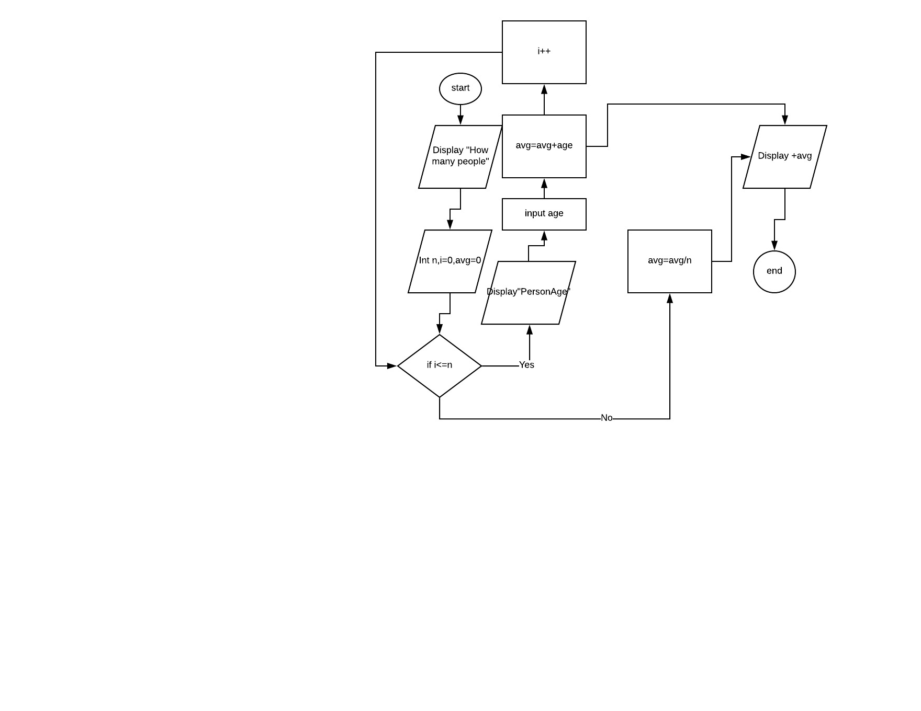

***FlowChart:-***

***Algorithm***

1. Let n
2. let i=0
3. let avg=0
4. let age
5. Display : “ how many people ?”
6. Input n
7. Set i = 0
8. Set avg = 0
9. For (i = 0; i <=n ;) {
10. Output : “Person Age“ + i
11. Input age
12. Avg = avg + age
13. I++
14. LOOP
15. avg = avg / n
16. Output : “average age is “ + avg
17. END

Trace

|  |  |  |  |  |  |  |
| --- | --- | --- | --- | --- | --- | --- |
| Line no. | Input buffer | n | i | Avg | age | Output |
| 1. | - | - | x | x | x | - |
| 2. | - | - | - | x | x | - |
| 3. | - | - | - | - | x | - |
| 4. | - | - | - | - | - | - |
| 5. | - | - | - | - | - | “How many people” |
| 6. | 4 | 4 | - | - | - | - |
| 7. | - | 4 | 1 | - | - | - |
| 8. | - |  | 1 | 0 | - | - |
| 9. | - | 4 | 1 | 0 | - | - |
| 10. | - | 4 | 1 | 0 | - | “PersonAge “ + i |
| 11. | - | 4 | 1 | 0 | 20 | - |
| 12. | - | 4 | 1 | 20 | 20 | - |
| 13. | - | 4 | 2 | 20 | 20 | - |
| 14. | - | 4 | 2 | 20 | - | - |
| 15. | - | 4 | 2 | 20 | - | “PersonAge“ + i |
| 16. | - | 4 | 2 | 20 | 22 | - |
| 17. | - | 4 | 2 | 42 | 22 | - |
| 18. | - | 4 | 3 | 42 | 22 | - |
| 19. | - | 4 | 3 | 42 | - | - |
| 20. | - | 4 | 3 | 42 | - | “PersonAge “ + i |
| 21. | - | 4 | 3 | 42 | 28 | - |
| 22. | - | 4 | 3 | 70 | 28 | - |
| 23. | - | 4 | 4 | 70 | 28 | - |
| 24. | - | 4 | 4 | 70 | - | - |
| 25. | - | 4 | 4 | 70 | - | “PersonAge “ + i |
| 26. | - | 4 | 4 | 70 | 26 | - |
| 27. | - | 4 | 4 | 96 | 26 | - |
| 28. | - | 4 | 5 | 96 | 26 | - |
| 29. | - | 4 | 5 | 96 | 26 | - |
| 30. | - | 4 | 5 | 24 | 26 | - |
| 31. | - | 4 | 5 | 24 | 26 | “Avg” + avg |
| 32. | - | 4 | 5 | 24 | 26 | “Avg” + avg |