**ASSIGNMENT – 2**

**Part2. Fig 3.2**

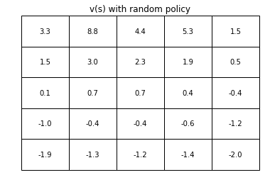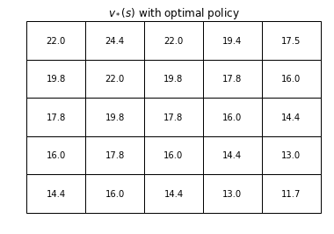

**Part 4. Fig 3.5**

**Part 6.**

**Example 4.1**

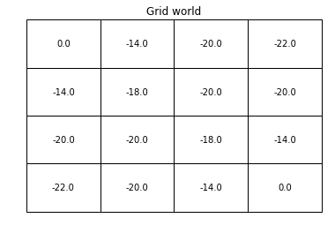

**With Value Iteration : Convergence in 4 iterations**

|  |  |
| --- | --- |
| **V*(s)** | **pi*(s)** |
|  |  |

**With Policy Iteration : Convergence in 3 iterations**

|  |  |
| --- | --- |
| **V*(s)** | **pi*(s)** |
|  |  |

**Part 7.**