Two Stage Job Title Identification System for Online Job Advertisements

To predict job title using web based application then double click on ‘runServer.bat’ file to start server and get below page

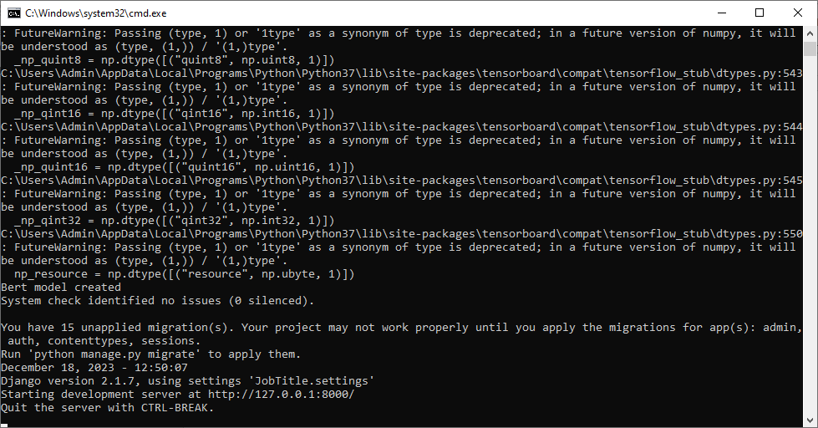

In above screen server started and now open browser and enter URL as <http://127.0.0.1:8000/index.html> and press enter key to get below page

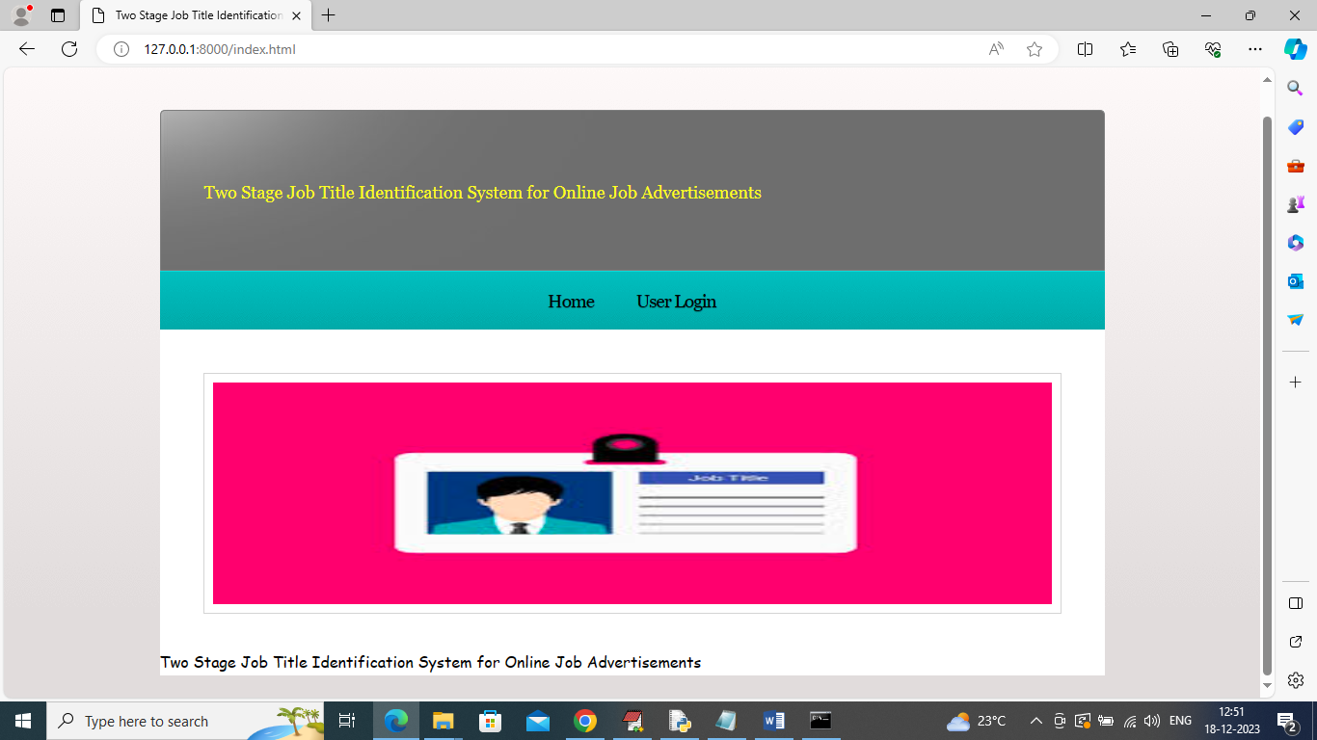

In above screen click on ‘User Login’ to get below page

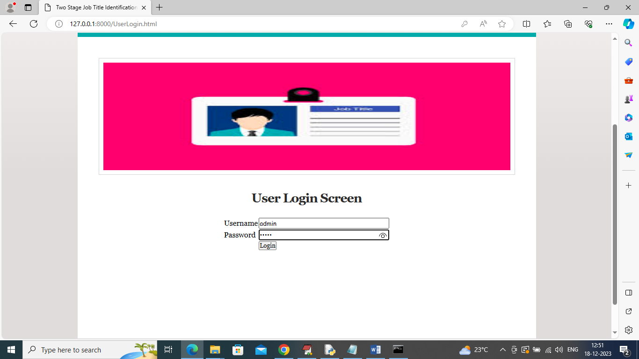

In above screen user is login and after login will get below page

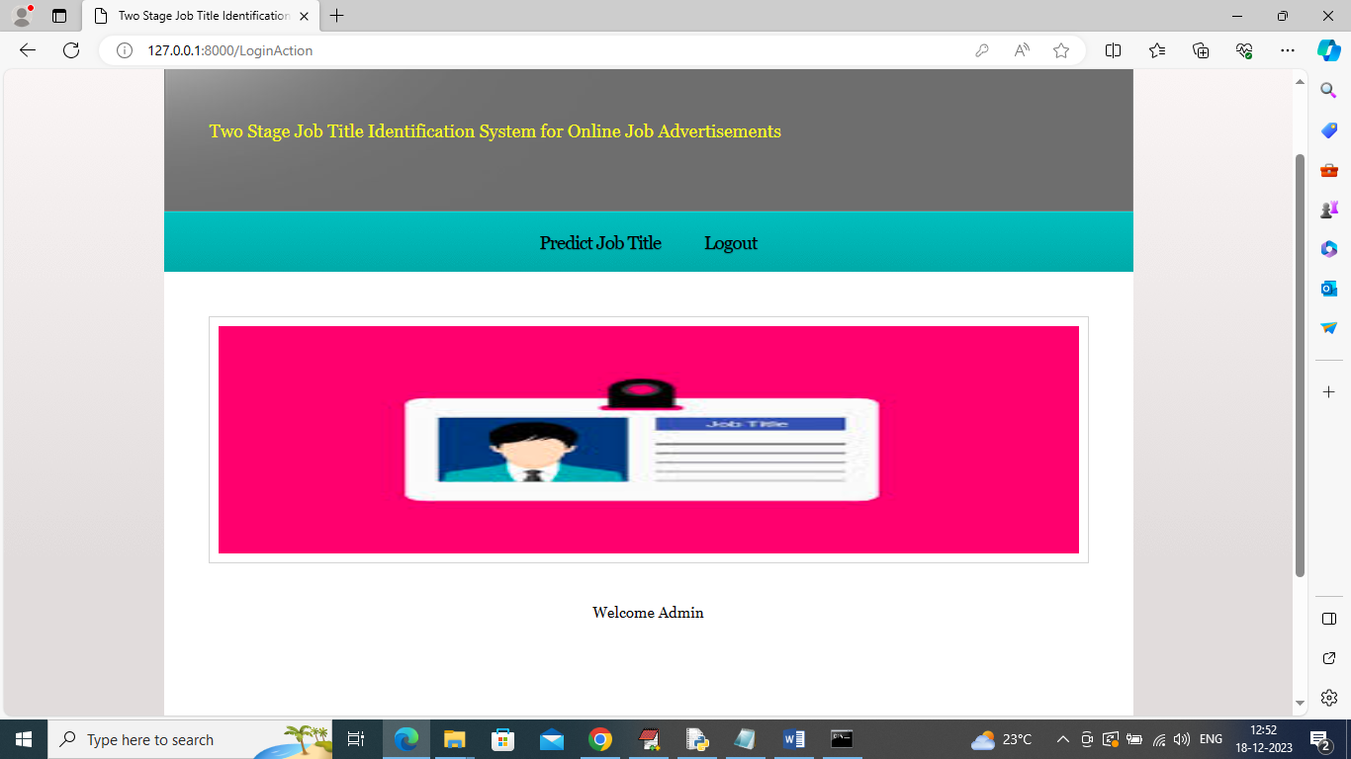

In above screen click on ‘Predict Job Title’ link to get below page

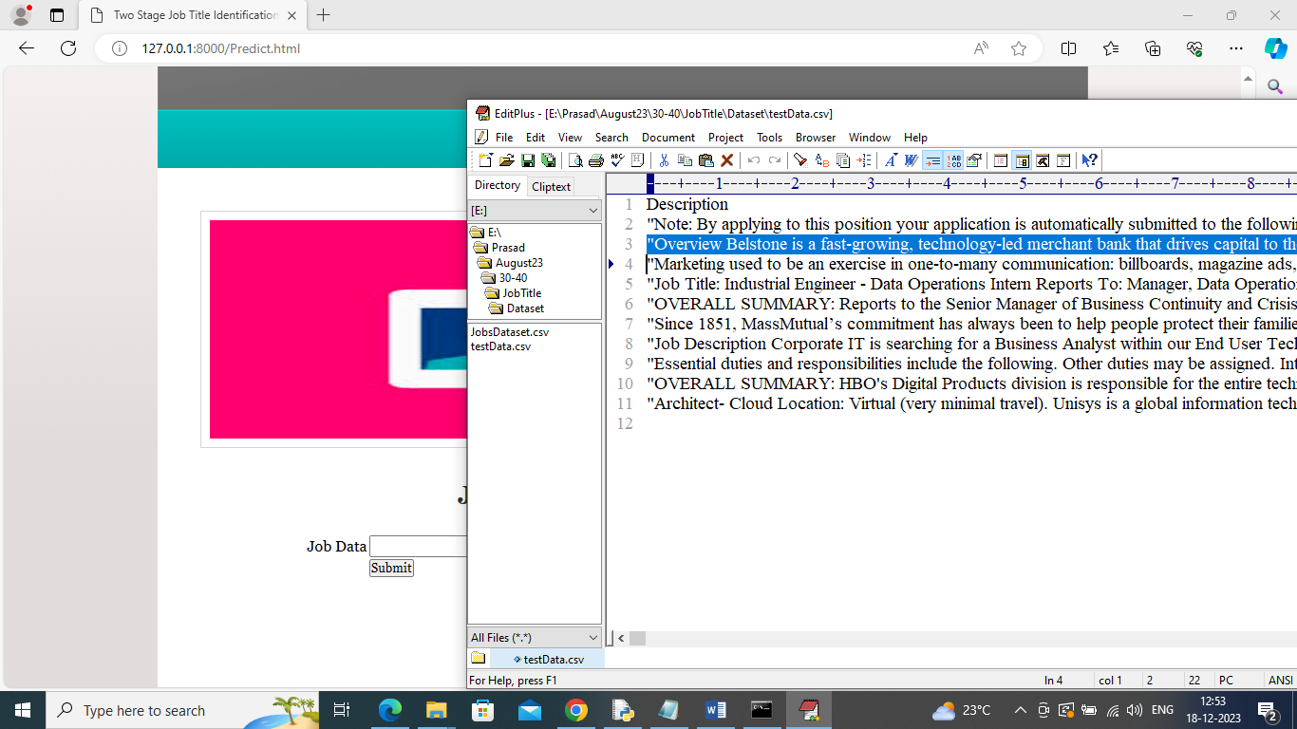

In above screen from ‘testData.csv’ file copy one line of job description and then paste in text field and then press button to get job title prediction

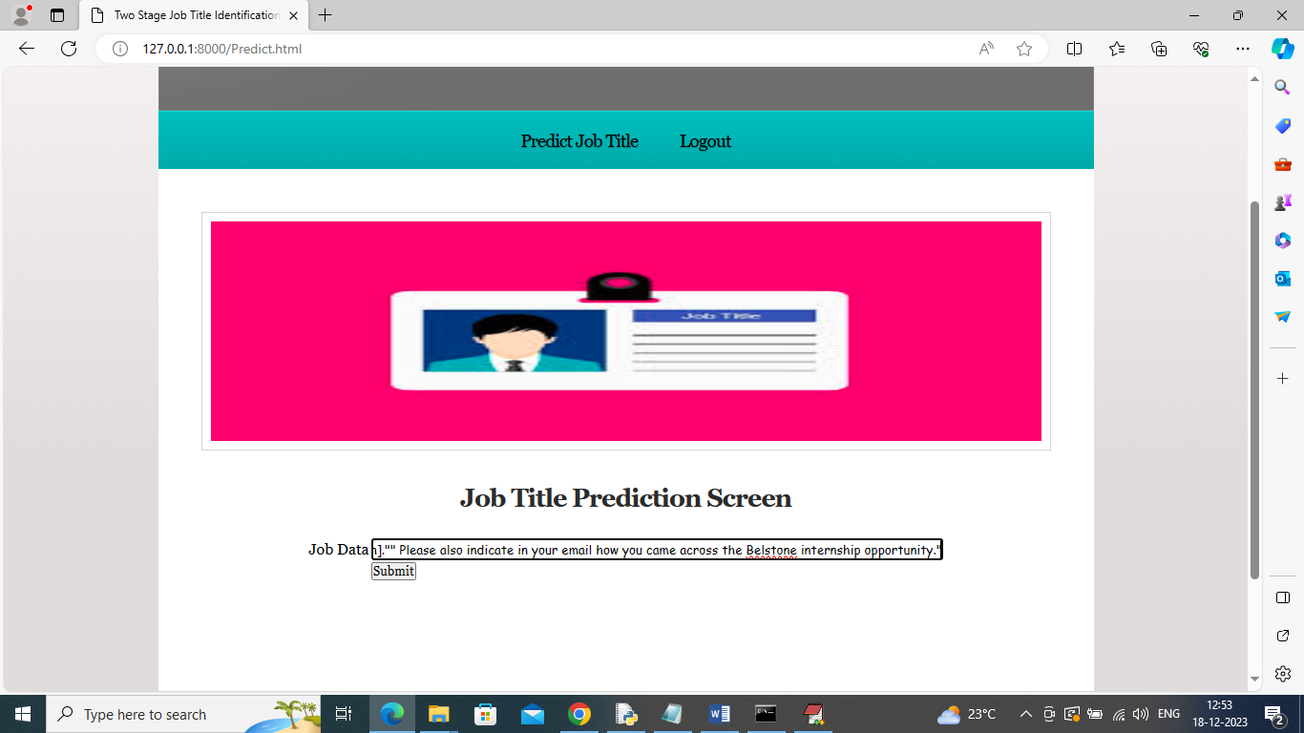

In above screen entered some job description and then press button to get below page

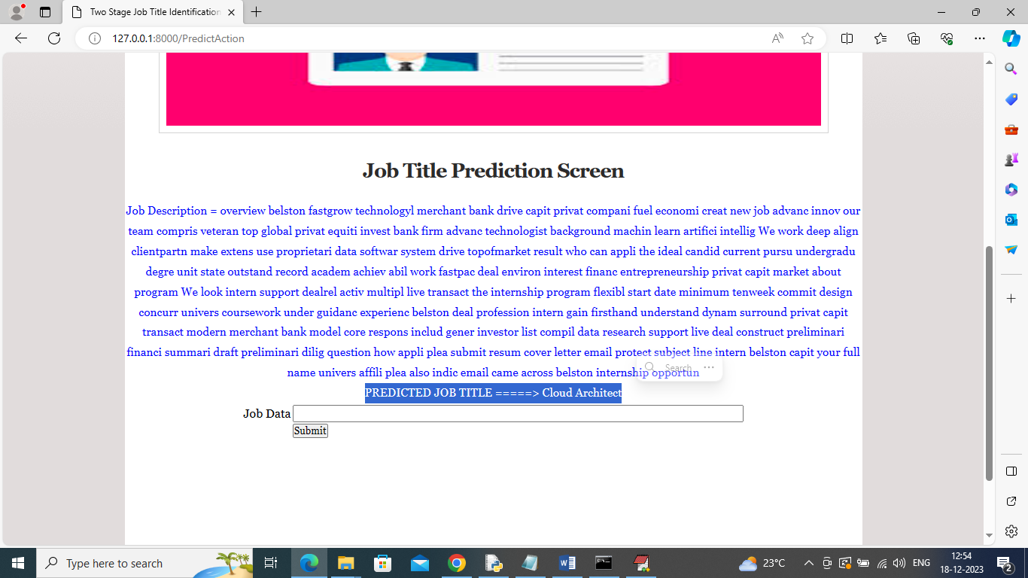

In above screen for given description we can see predicted job title in last line of the output. Similarly you can enter other test data and get output