***Magical Millets***

***“Know Your Millets”***

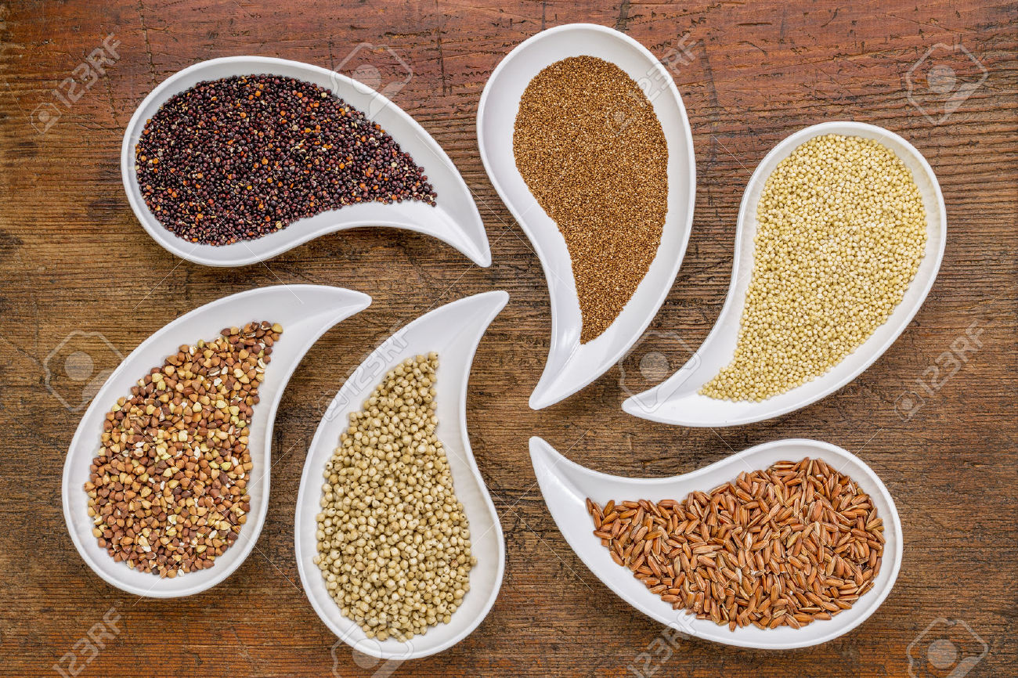

***Greeting’s to everyone!***

***It’s me the Millet!***

***For those who have obliterated me, it’s time to retrace and bring back our vanished cultural heritage. Retrieve my values, benefits and think about how effortlessly I can be a part of your day to day lives.***

1. **Introduction:** Millet is the name given to a group of cereals other than wheat, rice, maize & barley. By any nutritional parameter, millets are miles ahead of rice and wheat In terms of their mineral content. In this fashion, nutrient to nutrient, every single millet is extraordinarily superior to rice and wheat and therefore is the solution for the malnutrition that affects a vast majority of the Indian population.
2. **Why Millets?**: Millets are grown in appreciable amount in India and are providing important nutrients in diets, and even surviving in drought prone fields. But millets are rare today in most of the Indian cuisine. Awareness about millets and their health related benefits and of recipes prepared with millets is not optimum among population. This translates to very little returns in terms of economics for farmers cultivating these millets.

Even in areas where millets are produced in quite appreciable quantities, very few families consume millets. There is a rich cultural background and culinary heritage of millets in nearly every corner of the world that have almost vanished in the last couple of decades. Increasing the status of millets locally and globally would go a long way in reviving traditional millets and moving towards a more sustainable food chain system. It is also required to popularize that all the millets can now be processed without tedious and tiring manual operations. Proper nutrition and Sound exercise are critical elements for a healthy life. So promoting and popularizing millets is a natural collaboration to sustain a healthy lifestyle.

1. **A Brief History of Millets:** Millets or better say nutri-cereals have been discovered first at archaeological sites in China, India, Europe and different parts of Africa. Millets have been an important part of the staple diet among many communities across the globe. Researchers have found millets popping up in literature, sculptures, paintings, traditional folk songs and religious compositions.

Millets are extremely hardy crops like Proso millet that requires approximately 70 days only for harvesting. This property of short cultivation tenure is the reason that probably made millets the staple grain of the communities across Central Asia, and also enabled them to spread far as these communities moved from one place to another place.

If we compare millets with other major cereals to other cereal grains, first do not ask much from the soil and climate and are not susceptible to pests either in the field or during storage. Considering how likely it would be that early humans would be able to access dry, rain fed lands as compared to wetlands, and it becomes apparent that millets would be the go-to-grain to meet dietary needs. In fact, as we move forward in time, we see that as agricultural communities were able to avail of irrigation, more and more of them have lost out on their millet heritage. In India, millets continue to be a significant part (but eroding fast) of tribal communities.

1. **Cultivating Millets:** Millets are known to be farmer friendly cultivars. In many communities, millets are considered the ‘unconcerned cultivator’s crop’! Farmers really need to do just two things in a season: go to the field to sow seeds and then return after 3 months to harvest the grains. Millets need almost no inputs, grow even in extremely less fertile soils, don’t need deep ploughing, can be sown with minimal tools or machines. With timely and good rains at the right time, the farmer can expect a good harvest. Using some improved agricultural techniques and practices, farmers can get a good harvest even when the rains are not up to mark.

Most of the millet cultivation takes place in the Kharif period, i.e. during the monsoon season. In areas that receive more than 800mm of rains, many of the millets can be cultivated in the second season, i.e. as a Rabi crop (during the post monsoon, early winter months). And in some places with the right soil and geography, a few millets can even grow in the third season, during the dark days of winter, drawing on residual moisture in the soil and the dew that precipitates.

Millets are extremely defiant to pest attacks. This is the quality of millets that comes in very handy when planning a mixed crop farm cultivated using non pesticide management techniques. A few rows of millets separating rows of more susceptible leguminous crops is a common practice in farms in different parts of the world.

1. **Millets and Environment:** Millets have emerged to survive in extremely rough climatic conditions without any need for human intervention. But so far, most varieties developed have preserved this characteristic, adapting them to thrive in fairly diverse environments. In the current situation of worsening conditions due to climate change, it is these features that have brought millets back into the focus of researchers and policy makers seeking to develop a more sustainable food system.

Millets being rain fed crops do not require standing water in their fields, so there is no need for big dams to be built; ecology to be disrupted by reservoirs; elaborate canal systems to be created to get water to the farms etc. Millets do not need any fertility enhancement or pesticides, insecticides to grow well and yield a good harvest. Millets are extremely nutritious grains. Their high nutrient content makes them desirable not just to humans, but also to birds and other animals too.

Millets have also played an important role in nurturing soils and improving their fertility and texture, thereby increasing the yield and hence the returns to the farmer. Once the root system is established, millets can survive many dry weeks. Once it starts raining, the plants jump back to life and yield something by the end of the season. Millets are thus fairly effective at aggregating nutrients. If we are conscious in closing the nutrient loop locally, we can realize a manifold increase in soil health. Millets are thus environmentally, ecologically, economically friendly sources of food and nutrition.

1. **Millet Types**
   1. Pearl Millet
   2. Barnyard Millet
   3. Sorghum Millet
   4. Foxtail Millet
   5. Finger Millet
   6. Kodo Millet
   7. Little Millet
   8. Proso Millet

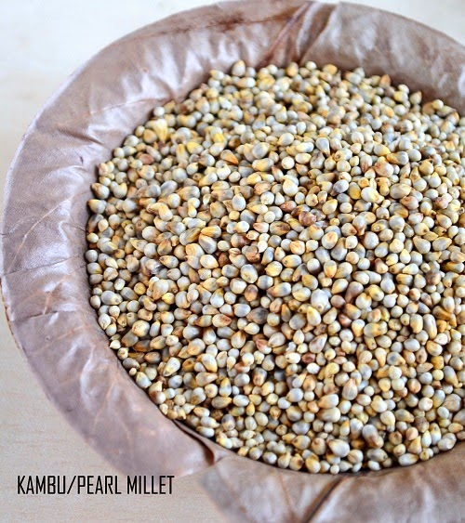

*English Name: Pearl millet*

*Scientific Name: Pennisetum Typhoideum*

*Bengali : Bajra*

*Gujarati : Bajri*

*Hindi : Bajra*

*Kannada : Sajje*

*Marathi : Bajri*

*Oriya : Bajra*

*Punjabi : Bajra*

*Tamil : Kambu*

*Telugu : Sajja*

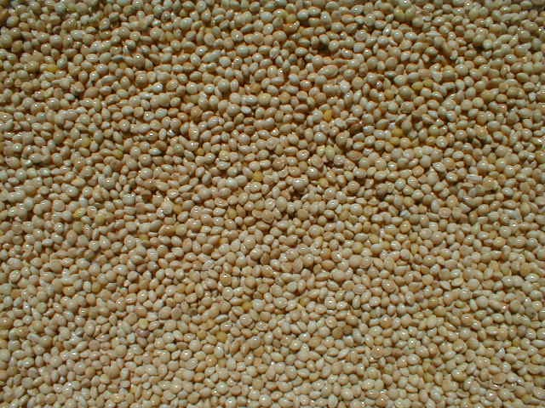

*English Name: Barnyard Millet*

*Scientific Name:Echinochloa Frumantacea*

*Bengali : Shyama/ shyamula*

*Gujarati : Sama*

*Hindi : Sanwa*

*Kannada : Oodalu*

*Marathi : Shamul*

*Oriya : Khira*

*Punjabi : Swank*

*Tamil : Kuthiraivolly*

*Telugu : Udalu, Kodisama*

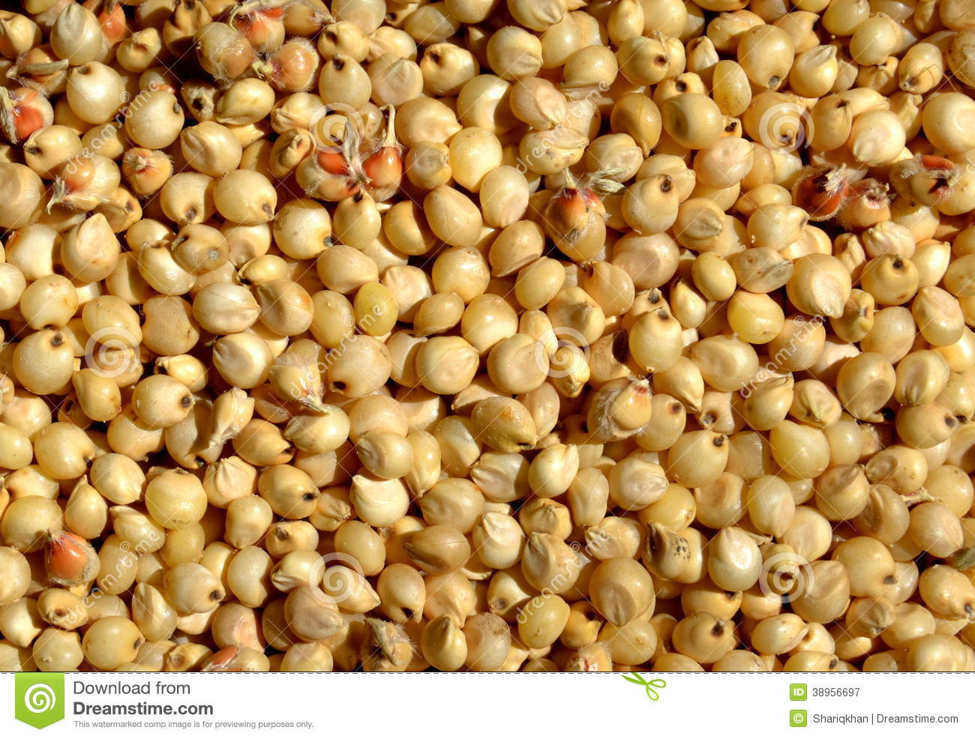

*English Name: Sorghum Millet*

*Scientific Name: Sorghum Vulgare*

*Bengali : Jowar*

*Gujarati : Jowari, Juar*

*Hindi : Jowari, Juar*

*Kannada : Jola*

*Marathi : Jowari, Jondhala*

*Oriya : Juara*

*Punjabi : Jowar*

*Tamil : Cholam*

*Telugu : Jonna*

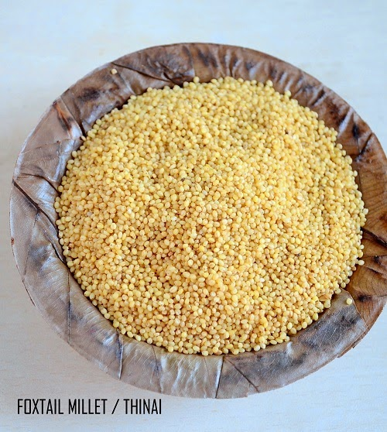

*English Name: Foxtail Millet*

*Scientific Name: Setarai Italica*

*Bengali : Kaon*

*Gujarati : Kang*

*Hindi : Kakum*

*Kannada : Navane*

*Marathi : Kang, Rala*

*Oriya : Kanghu, Kangam, Kora*

*Punjabi : Kangni*

*Tamil : Tenai*

*Telugu : Korra*

*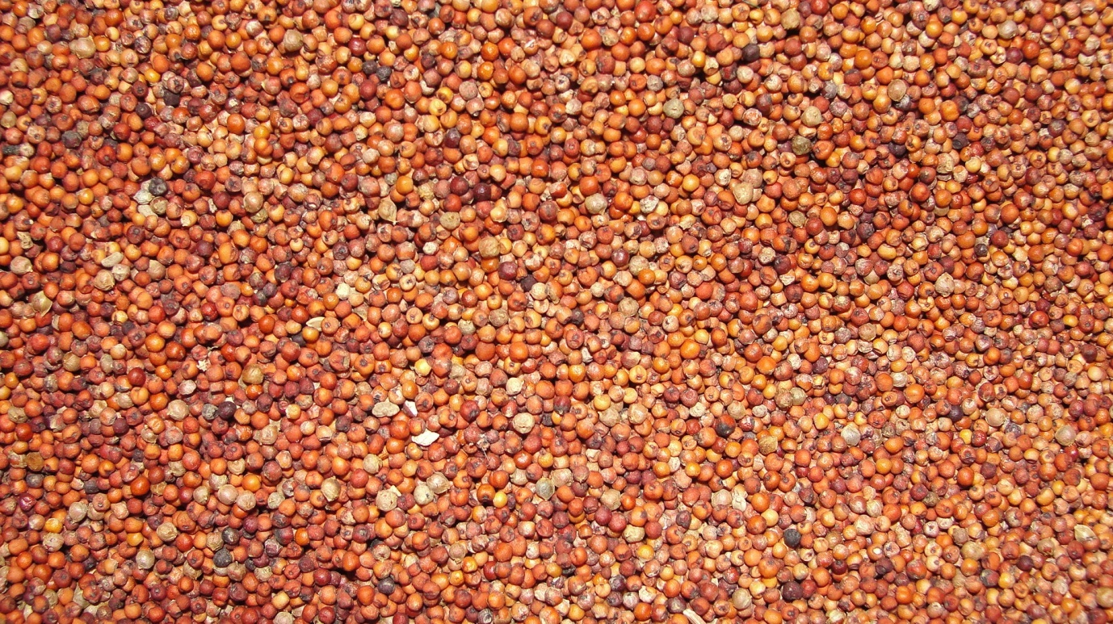English Name: Finger Millet*

*Scientific Name: Eleusine Coracana*

*Bengali : Marwa*

*Gujarati : Nagli, Bavto*

*Hindi : Ragi, Mandika,*

*Marwah*

*Kannada : Ragi*

*Marathi : Nagli, Nachni*

*Oriya : Mandia*

*Punjabi : Mandhuka, Mandhal*

*Tamil : Keppai, Ragi, Kelvaragu*

*Telugu : Ragi Chodi*

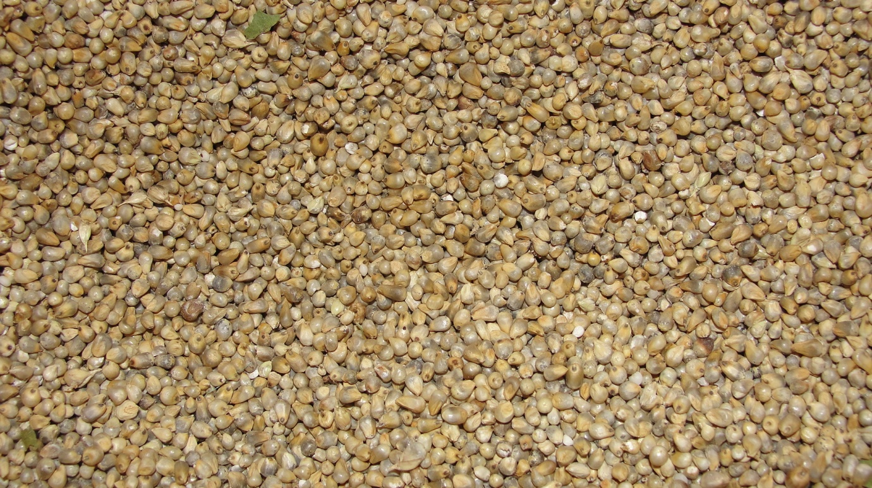

*English Name: Kodo Millet*

*Scientific Name: Paspalum Scrobiculatum*

*Bengali : Kodo*

*Gujarati : Kodra*

*Hindi : Kodon*

*Kannada : Harka*

*Marathi : Kodra*

*Oriya : Kodua*

*Punjabi : Kodra*

*Tamil : Varagu*

*Telugu : Arikelu, Arika*

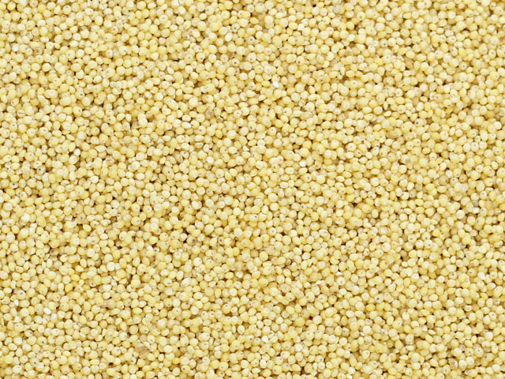

*English : Little Millet*

*Scientific Name: Panicum Miliare*

*Bengali : Sama*

*Gujarati : Gajro; Kuri*

*Hindi : Kutki, Shavan*

*Kannada : Same, Save*

*Marathi : Sava, Halvi, vari*

*Oriya : Suan*

*Punjabi : Swank*

*Tamil : Samai*

*Telugu : Samalu*

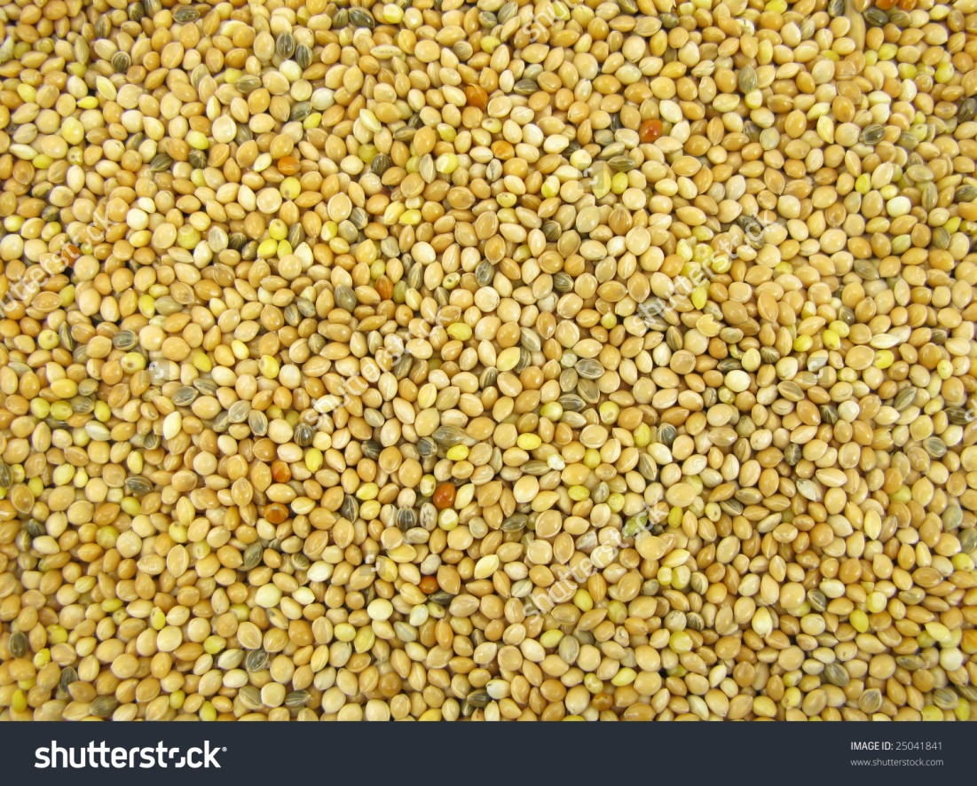

*English : Common Millet/Proso Millet*

*Scientific Name: Panicum Miliaceum*

*Bengali : Cheena*

*Gujarati : Cheno*

*Hindi : Chena; Barri*

*Kannada : Baragu*

*Marathi : Vari*

*Oriya : China Bachari bagmu*

*Punjabi : Cheena*

*Tamil : Pani varagu*

*Telugu : Variga*

1. **Sorghum Millet:** 
   1. Gluten free food - Recommended for gluten intolerant and celiac patients.
   2. Relatively low glycemic index and low glycemic load food - reduces the risk of diabetes mellitus
   3. Invisible fat - lowers low-density lipoprotein (LDL) and improves high-density lipoprotein (HDL) cholesterol
   4. Low calorie food - beneficial for obesity, diabetes and CVD
   5. Rich source of antioxidants & polyphenols – reduces oxidative stress and carcinogenic properties
   6. Bile acid & steroid binding properties - beneficial for obesity and CVD
   7. Good Source of Nitrilosides – salicylates - fights against arthritis and rheumatism
   8. Rich in dietary fiber - Beneficial for obesity, diabetes, CVD and inflammatory bowel disease and acts as a detoxifying agent
2. **Pearl millet:**
   1. Beneficial in treating stomach ulcers: Pearl millet is recommended for curing stomach ulcers. The most common cause for stomach ulcers is excess acidity in the stomach after food intake. Pearl millet is one of the very few foods that turns the stomach alkaline and prevents formation of stomach ulcers or reduces the effect ulcers.
   2. Beneficial for heart health: The lignin and phyto-nutrients in millet act as strong antioxidants thus preventing heart related diseases. This is why, pearl millet is considered good for heart health.
   3. Beneficial due to high amount of magnesium: Pearl millet contains high concentration of magnesium which helps reduce severity of respiratory problems for asthma patients and is also effective in reducing migraine attacks
   4. Helps in bone growth development and repair: Pearl millet has a large amount of phosphorus. Phosphorus is very essential for bone growth and development as well as for development of ATP which is the energy currency of our body.
   5. Reduces cancer risk: All millets are known to reduce the risk of cancer occurrence and pearl millet is no exception because of high amount of magnesium and the compound phytate.
   6. Helps in weight loss: Pearl millet can aid the process of weight loss as it is high in fiber content. Owing to its fiber content it takes longer for the grain to move from the stomach to the intestines. This way, pearl millet satiates hunger for a long period of time and thus helps in lowering the overall consumption of food.
   7. Beneficial for diabetes: Pearl millet is very effective for controlling diabetes. Because of its high fiber content, it digests slowly and releases glucose into the blood at a slower rate as compared to other foods.
   8. Reduces cholesterol: It is common knowledge that Pearl Millet is suggested for people suffering from high cholesterol levels. Pearl millet contains a type of phytochemical called phytic acid which is believed to increase cholesterol metabolism and stabilise the levels of cholesterol in the body
   9. Contains all the essential amino acids: Amino acids are essential for smooth functioning of our body. Pearl millet is one of the few foods which have all the essential amino acids required in it.
   10. Beneficial in preventing gall stones: The high fiber content in pearl millet is also known to reduce the risk of gall stone occurrence. The insoluble fiber content in pearl millet reduces the production of excessive bile in our system.
   11. Anti-allergic properties: Pearl millet is a treasure trove of beneficial properties. The grain is very digestible as such and has a very low probability of causing allergic reactions.
3. **Finger millet**:
   1. Finger millet for losing weight: Ragi contains an amino acid called tryptophan which lowers appetite and helps in keeping weight in control. Ragi gets digested at a slower rate thus keeps one away from intake of excessive calories.
   2. Finger millet for bone health: Ragi is rich in calcium which helps in strengthening bones. It is an excellent source of natural calcium for growing children and aging\ people. Ragi consumption helps in development of bones in growing children and in maintenance of bone health in adults.
   3. Finger millet/Ragi for diabetes: Finger millet's phytochemical help in slowing digestion process. This helps in controlling blood sugar level in condition of diabetes.
   4. Finger millet/Ragi for lowering blood cholesterol: Finger millet contains amino acids Lecithin and Methionine which help in bringing down cholesterol level by eliminating excess fat from Liver.
   5. Finger Millet/Ragi for protein/ amino acids: Ragi is rich in amino acids which are vital in normal functioning of body and are essential for repairing body tissues.
4. **Foxtail Millet:**
   1. Helps control blood sugar levels when consumed on regular basis. It showed lowered triglyceride levels, LDL/VLDL cholesterol and increase in HDL cholesterol It is known for its low glycemic index- gradual increase in blood sugar after food intake when compared to rice
   2. Ideal food for people suffering from diabetes and gastric problems
   3. Reduces risk of heart attack
   4. Helps in the development of body tissue and energy metabolism.
   5. Rich in anti-oxidants.
5. **Proso Millet:**
   1. Proso millet is the best alternative crop for diversifying and intensifying winter wheat-based dry land production systems.
   2. The protein content is similar to that of wheat, but it contains no gluten.
   3. It is rich in vitamins and minerals such as copper and magnesium.
   4. Proso millets are good sources of magnesium and phosphorus. Magnesium has the ability to help reduce the effects of migraine and heart attacks, while, phosphorus is an essential component of adenosine triphosphate (ATP) a precursor to energy in the body.
6. **Barnyard Millet:** 
   1. Barnyard millet is one of the hardiest millets, which is called by another name viz., Japanese barnyard millet.
   2. It is a fair source of protein, which is highly digestible and is an excellent source of dietary fibre with good amounts of soluble and insoluble fractions.
   3. Japanese barnyard millet grains have been used as a functional food for patients with allergic diseases, including atopic dermatitis.
7. **Kodo Millet:**
   1. Kodo millet is small millet and a minor grain crop in India.
   2. The fibre content in kodo millet is very high. They are rich in B vitamins (niacin, B6 and folic acid) and minerals (calcium, iron, potassium, magnesium and zinc).
   3. Regular consumption of kodo millet is very beneficial for postmenopausal women suffering from signs of cardiovascular disease like high blood pressure and high cholesterol levels.
   4. The nutritional value of the kodo millet protein is slightly better than that of foxtail millet but is comparable to that of other\ small millets. As with other food grains, the nutritive value of kodo millet protein could be improved by supplementation with legume protein.
8. **Little Millet:**
   1. Little millet contains about 7% protein, like other millets it is also a good source of slow digesting carbohydrates, dietary fibre and micro nutrients.
   2. The phenolic compounds in little millet are responsible for the prevention and reduction of oxidative stress, exhibits anti-cancer, anti-diabetic and anti-hypertensive properties.
   3. The flavonoids are present in small quantities which act as antioxidant and play many roles in disease prevention.
9. **Nutritional Potential of Millets**

|  |  |  |  |  |  |  |  |
| --- | --- | --- | --- | --- | --- | --- | --- |
|  | Energy (Kcal) | Carbohydrates (g) | Protein (g) | Fat (g) | Crude Fiber (g) | Calcium (mg) | Iron (mg) |
| Sorghum Millet | 349 | 72.6 | 10.4 | 1.9 | 1.6 | 25 | 4.1 |
| Pearl Millet | 361 | 67.5 | 11.6 | 5 | 1.2 | 42 | 8 |
| Finger Millet | 328 | 72 | 7.3 | 1.3 | 3.6 | 344 | 3.9 |
| Foxtail Millet | 331 | 60.9 | 12.3 | 4.3 | 8 | 31 | 2.8 |
| Barnyard Millet | 307 | 65.5 | 6.2 | 2.2 | 9.8 | 20 | 5 |
| Kodo Millet | 309 | 65.9 | 8.3 | 1.4 | 9 | 27 | 0.5 |
| Little Millet | 341 | 67 | 7.7 | 4.7 | 7.6 | 17 | 9.3 |
| Proso Millet | 341 | 70.4 | 12.5 | 1.1 | 2.2 | 14 | 0.8 |

***Source: National Institute of Nutrition, Hyderabad (2007)***

**Vitamin Profile**

|  |  |  |  |  |  |  |  |  |
| --- | --- | --- | --- | --- | --- | --- | --- | --- |
|  | Carotene (mg) | Vitamin B1 (mg) | Vitamin B2 (mg) | Vitamin B3 (mg) | Vitamin B6 (mg) | Folic Acid (mg) | Vitamin C (mg) | Vitamin E (mg) |
| Sorghum Millet | 47 | 0.38 | 0.15 | 4.3 | 0.21 | 20 | - | 12 |
| Pearl Millet | 132 | 0.38 | 0.21 | 2.8 | - | 45.5 | - | 19 |
| Finger Millet | 42 | 0.42 | 0.19 | 1.1 | - | 18.3 | - | 22 |
| Foxtail Millet | 32 | 0.59 | 0.11 | 3.2 | - | 15 | - | 31 |
| Barnyard Millet | 0 | 0.33 | 0.1 | 4.2 | - | - | - | - |
| Kodo Millet | 0 | 0.15 | 0.09 | 2 | - | 23.1 | - | - |
| Little Millet | 0 | 0.3 | 0.09 | 3.2 | - | 9 | - | - |
| Proso Millet | 0 | 0.41 | 0.28 | 4.5 | - | - | - | - |

***Source: National Institute of Nutrition, Hyderabad (2007)***

1. **Millets : The Nutritional Potential**

* Millets helps to lower blood glucose levels and improves insulin response. Besides, the magnesium present in millets is a co-factor in various enzymes involved in the secretion of insulin and metabolism of glucose in the body. Whole grains improve insulin sensitivity by lowering glycemic index of the diet by increasing content of fibre, magnesium and vitamin-E.
* Glycemic Index is a scale that ranks carbohydrates by how much they raise the blood glucose levels compared to a reference food. Millets have a low Glycemic index compared to most other cereals. Since millets have a low Glycemic index they increase satiety by decreasing hunger because it slows the rate of digestion.
* Millets are a rich source of phosphorus which is an important mineral for energy production and is an essential component of ATP – the energy store of the body. It also forms an essential part of nervous system and cell membranes.
* Millet is such a grain that should be included in the list of heart-healthy choices because of its status as a good source of magnesium. Magnesium increases insulin sensitivity and lowers triglycerides. It also acts as a co-factor for more than 300 enzymes.
* Lignans present in millets are converted to mammalian lignans and entero-lactone by the healthy gut micro flora in our body which is thought to protect against breast cancer as well as heart diseases.
* Millets have amazing fatty acid profiles. One might have heard about rice bran oil – the oil extracted from the bran of paddy rice. The fatty acid content in each of the millets is much higher than that in paddy or wheat and the composition of the fatty acids are way more beneficial than what is found in paddy. One has to keep in mind an important aspect of cereal grains – almost all the mineral and fatty acids and a good proportion of the fibre content is found in the bran layer. So one *needs to make sure that the millet grains are unpolished*, sometimes also referred to as whole grain millet rice, and have suffered minimal bran loss. Polishing millets removes the bran layer leading to major loss of nutrients. But it makes the over-all processing easier and allows for larger scale processing.

1. **Processing of Millets**

The three most widely available millets in the market place today – Sorghum, Pearl millet and Finger millet – are naked grains, i.e. do not have a husk layer. Processing these for human consumption is essentially a matter of cleaning and grading the grains. They are then ground up to either their flour form or into grits making them ready for cooking. This ease of processing is one of the reasons for these grains to persist in the local communities’ diets.

There are six other commonly cultivated millets – Foxtail, Little, Kodo, Proso, Barnyard, and Brown Top – that have a hard cellulosic husk layer that humans cannot digest. Together they are sometimes referred to as small millets. The removal of the husk layer thus becomes the primary task of processing these grains. Once removed, we get the respective millets’ rice, i.e. foxtail millet rice, little millet rice, kodo millet rice, proso millet rice, barnyard millet rice and brown top millet rice. These millet rices are then used in preparations in the same form and method that paddy rice is used in different cuisines.

To remove the husk from the grain, one can use two forces – impact or shear. A stone grinding mill- manual or motor powered-employs shear force while manual pounding or centrifugal hulling machines use impact force. Large scale processing of small millets compromises the nutritional value of the millet rice output by removing the bran layer completely. But the pest infestation problem continues to be severe and most processors resort to chemical methods of cleaning their products pest free.

1. **Millets in the Merchandise**

Finger millet, Pearl millet and Sorghum are three millets that are available at affordable prices in different shops across the country. The other millets – Foxtail, Little, Kodo, Proso, and Barnyard are a little harder to find in today’s market place. The lack of access to good quality processing weakens the supply chain and needs to be addressed at the earliest. The weak supply chain leads to a significant increase in risks and therefore in the pricing of the finished products.

There are a few fairly simple ways to identify if the millet rice you are buying is polished or not.

1. Carefully observe the colour of the millet rice kernels. If it is a bright and shiny white, it is most likely polished grains. Semi polished millet rices have a dull off white colour and the unpolished ones are typically fairly colourful.
2. Pick up a fistful of the material in one of your palms; pour the millet rice gradually into the other palm. Repeat the process a few times and if the millet rice is polished you shall observe some dust sticking to your palm and fingers. If it is unpolished, the millet dust will be negligible.
3. Hold a fistful of material in one of your hands for a say, 15 seconds. Empty your hand and with the palm open, feel the area in which the material was being held with a finger of the other hand. If it is as dry as the region away from the contact with the rice, the millet rice has been polished. Unpolished millets have a good proportion of their bran intact. Given the high fatty acid content, it will leave traces of oil on the palm and this is easily felt by a finger from the other hand.

***“Let us conserve our culture, cultural crops and efforts towards strengthening production and commercial returns to endorse livelihoods”***

