VISVESVARAYA TECHNOLOGICAL UNIVERSITY
“JnanaSangama”, Belgaum -590014, Karnataka.

LAB REPORT
on

Machine Learning (23CS6PCMAL)

Submitted by
Pooja Rajshekhar Arabi(1BM23CS413)

in partial fulfillment for the award of the degree of
BACHELOR OF ENGINEERING
in
COMPUTER SCIENCE AND ENGINEERING


B.M.S. COLLEGE OF ENGINEERING
(Autonomous Institution under VTU)
BENGALURU-560019
Sep-2024 to Jan-2025

B.M.S. College of Engineering,
Bull Temple Road, Bangalore 560019
(Affiliated To Visvesvaraya Technological University, Belgaum)
Department of Computer Science and Engineering


CERTIFICATE

This is to certify that the Lab work entitled “Machine Learning (23CS6PCMAL)” carried out by Pooja Rajshekhar Arabi (1BM23CS413), who is bonafide student of B.M.S. College of Engineering. It is in partial fulfillment for the award of Bachelor of Engineering in Computer Science and Engineering of the Visvesvaraya Technological University, Belgaum. The Lab report has been approved as it satisfies the academic requirements in respect of an Machine Learning (23CS6PCMAL) work prescribed for the said degree.

Dr. Kavitha Sooda Professor & HOD
Department of CSE, BMSCE
Lab faculty Incharge Name Assistant Professor Department of CSE, BMSCE

Index
Sl.  No. | Date | Experiment Title | Page No.
1 | 21-2-2025 | Write a python program to  import and export data using Pandas library functions | 1
2 | 3-3-2025 | Demonstrate various data pre-processing techniques for a given dataset | 4
3 | 10-3-2025 | Implement Linear and Multi-Linear Regression algorithm using appropriate dataset | 9
4 | 17-3-2025 | Build Logistic Regression Model for a given dataset | 15
5 | 24-3-2025 | Use an appropriate data set for building the decision tree (ID3) and apply this knowledge to classify a new sample. | 20
6 | 7-4-2025 | Build KNN Classification model for a given dataset. | 25
7 | 21-4-2025 | Build Support vector machine model for a given dataset | 30
8 | 5-5-2025 | Implement Random forest ensemble method on a given dataset. | 35
9 | 5-5-2025 | Implement Boosting ensemble method on a given dataset. | 37
10 | 12-5-2025 | Build k-Means algorithm to cluster a set of data stored in a  .CSV file. | 42
11 | 12-5-2025 | Implement Dimensionality reduction using Principal Component Analysis (PCA) method. | 47

Github Link: https://github.com/pooja695/ML.git

Program 1

Write a python program to import and export data using Pandas library functions Screenshot:
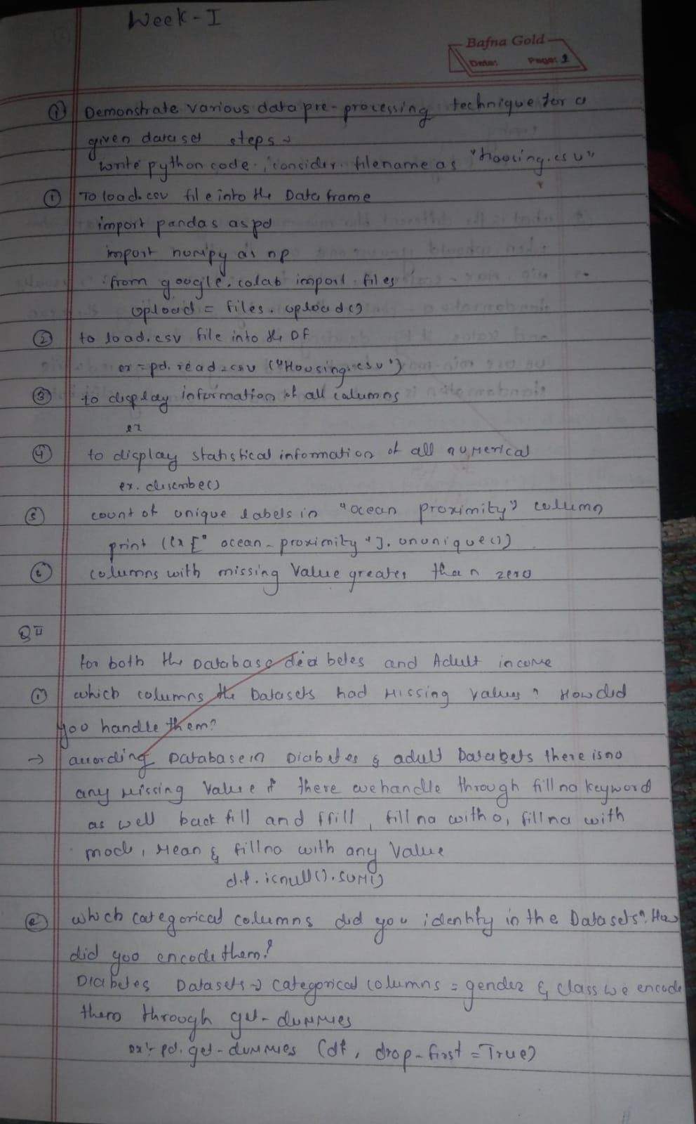

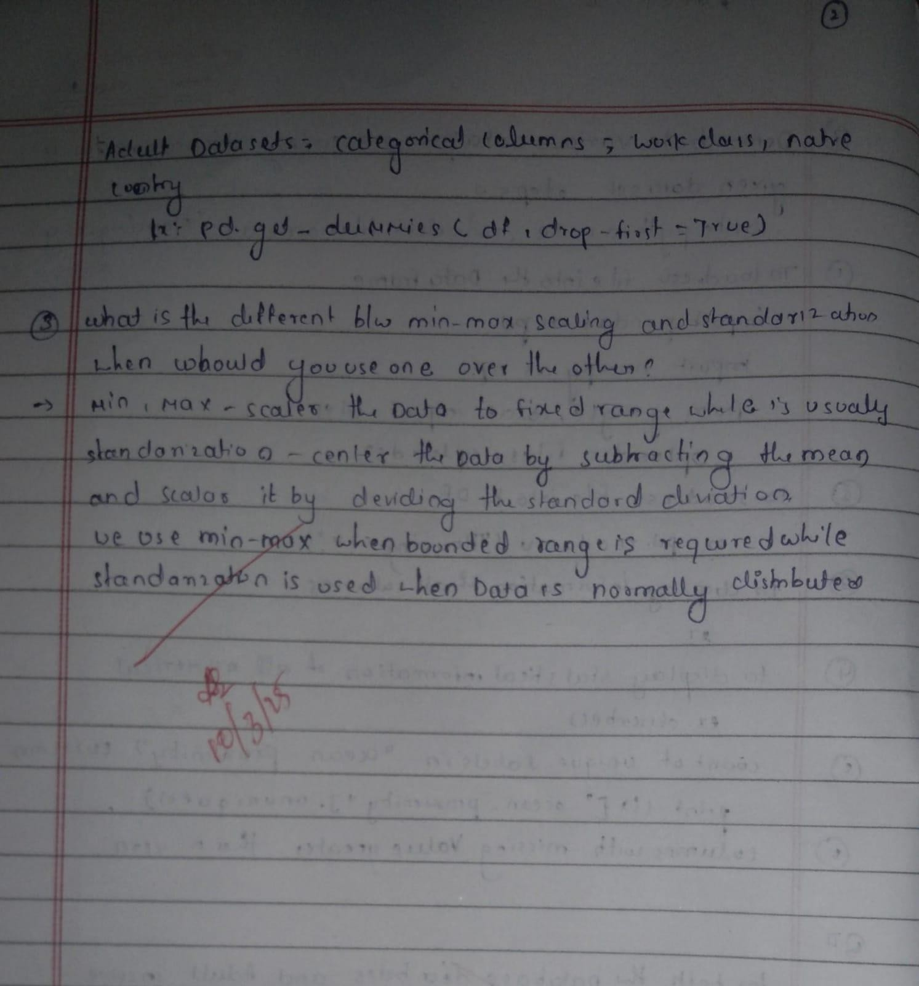

Code:
import pandas as pd import numpy as np
import matplotlib.pyplot as plt
from sklearn.model_selection import train_test_split from sklearn.impute import SimpleImputer
from sklearn.preprocessing import OrdinalEncoder, OneHotEncoder, StandardScaler, MinMaxScaler from scipy import stats

df = pd.read_csv('/content/Dataset of Diabetes .csv') print(df.head())
print("\nShape:", df.shape) print("\nInfo:")
print(df.info()) print("\nSummary Statistics:") print(df.describe())
missing_values = df.isnull().sum() print("\nMissing Values:") print(missing_values[missing_values > 0])
categorical_cols = df.select_dtypes(include=['object']).columns print("\nCategorical Columns Identified:", categorical_cols)
if len(categorical_cols) > 0:
df = pd.get_dummies(df, columns=categorical_cols, drop_first=True) print("\nDataFrame After One-Hot Encoding:")
print(df.head()) else:
print("\nNo Categorical Columns Found in the Dataset.") numerical_cols = df.select_dtypes(include=['number']).columns scaler = MinMaxScaler()
df_minmax = df.copy()
df_minmax[numerical_cols] = scaler.fit_transform(df[numerical_cols]) scaler = StandardScaler()
df_standard = df.copy()
df_standard[numerical_cols] = scaler.fit_transform(df[numerical_cols]) print("\nDataFrame after Min-Max Scaling:")
print(df_minmax.head()) print("\nDataFrame after Standardization:") print(df_standard.head())

df1 = pd.read_csv('/content/adult.csv') print(df1.head())
print("\nShape:", df1.shape) print("\nInfo:") print(df1.info())
missing_values = df1.isnull().sum() print("\nMissing Values:") print(missing_values[missing_values > 0]) print("\nSummary Statistics (numeric only):") print(df1.describe())

Program 2

Demonstrate various data pre-processing techniques for a given dataset Screenshot:
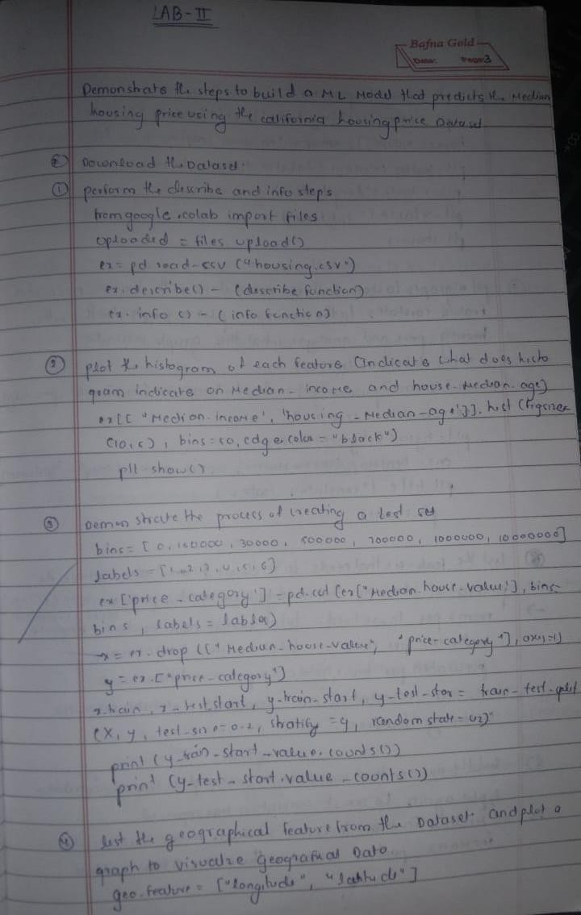

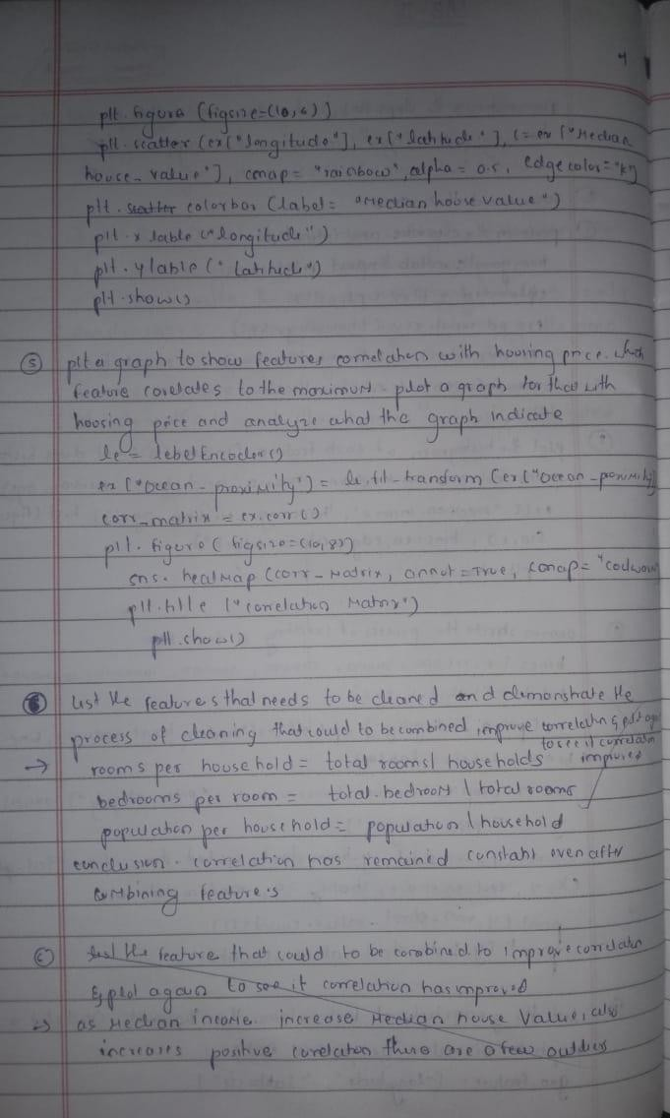

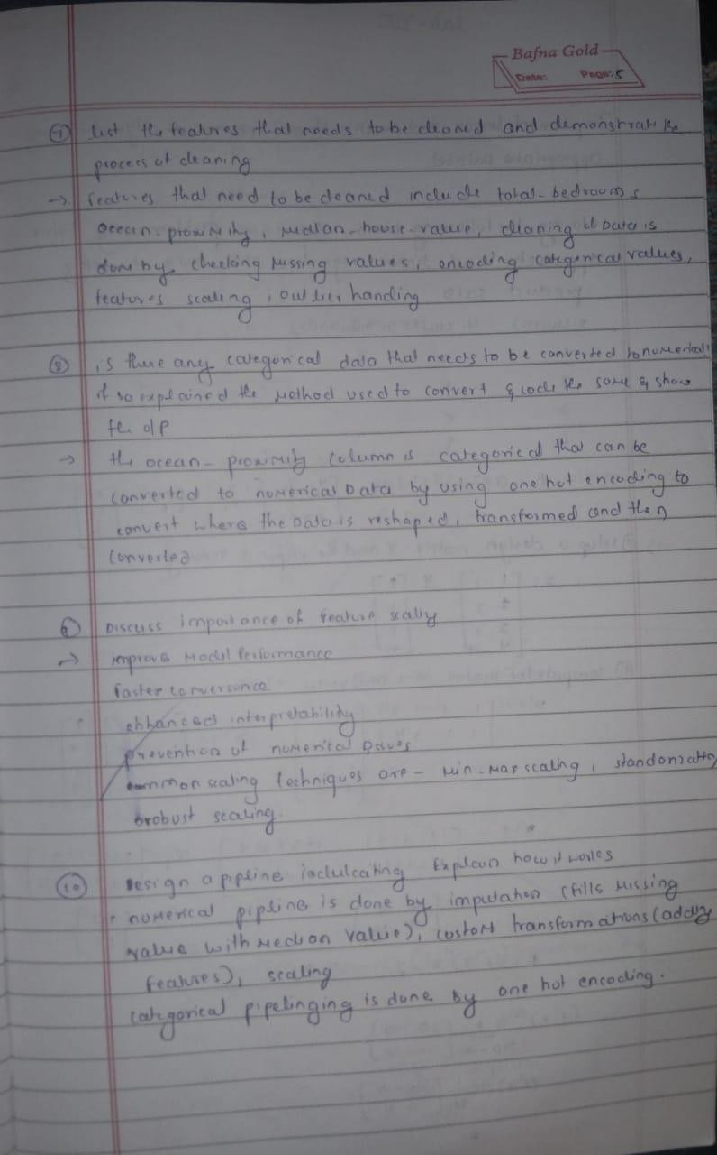

Code:

import pandas as pd import numpy as np import seaborn as sns
import matplotlib.pyplot as plt
from sklearn.model_selection import train_test_split
from sklearn.preprocessing import OneHotEncoder, StandardScaler from sklearn.impute import SimpleImputer
from sklearn.base import BaseEstimator, TransformerMixin from sklearn.pipeline import Pipeline
from sklearn.compose import ColumnTransformer
# Load data
df = pd.read_csv('housing.csv')

# Histogram plots
sns.histplot(df['median_income'], kde=True, color='green') plt.show()
sns.histplot(df['housing_median_age']) plt.show()
# Train-test split with stratification
df["income_cat"] = pd.cut(df["median_house_value"],
bins=[0, 100000, 200000, 300000, 400000, np.inf],
labels=[1, 2, 3, 4, 5])
X = df.drop("median_house_value", axis=1) y = df["median_house_value"]
X_train, X_test, y_train, y_test = train_test_split(X, y, test_size=0.2,
stratify=df["income_cat"], random_state=42)

# Geographical scatter plot train_set = X_train.copy()
train_set["median_house_value"] = y_train train_set.plot(kind="scatter", x="longitude", y="latitude", alpha=0.4,
s=train_set["population"]/100, label="population",
figsize=(10, 7), c="median_house_value", cmap=plt.get_cmap("jet"), colorbar=True)
plt.legend() plt.show()
# Correlation matrix
numerical_columns = df.select_dtypes(include=['float64', 'int64']) correlation_matrix = numerical_columns.corr() print(correlation_matrix["median_house_value"].sort_values(ascending=False))

# Scatter plot
df.plot(kind="scatter", x="median_income", y="median_house_value", alpha=0.1) plt.show()
# Feature engineering
df["income_households"] = df["median_income"] * df["households"]

# Recalculate correlation
numerical_columns = df.select_dtypes(include=['float64', 'int64']) correlation_matrix = numerical_columns.corr()

print(correlation_matrix["median_house_value"].sort_values(ascending=False))

df.plot(kind="scatter", x="income_households", y="median_house_value", alpha=0.1) plt.show()
# Handle missing values
df = df.dropna(subset=["total_bedrooms"])

# One-hot encode categorical column df1 = pd.read_csv('housing.csv')
hc = df1[["ocean_proximity"]] encoder = OneHotEncoder()
hc_encoded = encoder.fit_transform(hc).toarray()
hc_1hot_df = pd.DataFrame(hc_encoded, columns=encoder.get_feature_names_out(hc.columns)) print(hc_1hot_df.head())
# Custom transformer for new features
class CombinedAttributesAdder(BaseEstimator, TransformerMixin): def init (self, add_bedrooms_per_room=True):
self.add_bedrooms_per_room = add_bedrooms_per_room def fit(self, X, y=None):
return self
def transform(self, X):
rooms_per_household = X[:, 3] / X[:, 5] population_per_household = X[:, 4] / X[:, 5] if self.add_bedrooms_per_room:
bedrooms_per_room = X[:, 2] / X[:, 3]
return np.c_[X, rooms_per_household, population_per_household, bedrooms_per_room] else:
return np.c_[X, rooms_per_household, population_per_household]

# Identify columns
num_attribs = df1.drop("ocean_proximity", axis=1).columns cat_attribs = ["ocean_proximity"]
# Numeric pipeline num_pipeline = Pipeline([
('imputer', SimpleImputer(strategy="median")), ('attribs_adder', CombinedAttributesAdder()), ('std_scaler', StandardScaler()),
])

# Full pipeline
full_pipeline = ColumnTransformer([ ("num", num_pipeline, num_attribs), ("cat", OneHotEncoder(), cat_attribs),
])

# Prepare dataset housing = df1.copy()
housing_prepared = full_pipeline.fit_transform(housing) print("Shape of processed data:", housing_prepared.shape

Program 3
- Implement Linear and Multi-Linear Regression algorithm using appropriate dataset

Screenshot:

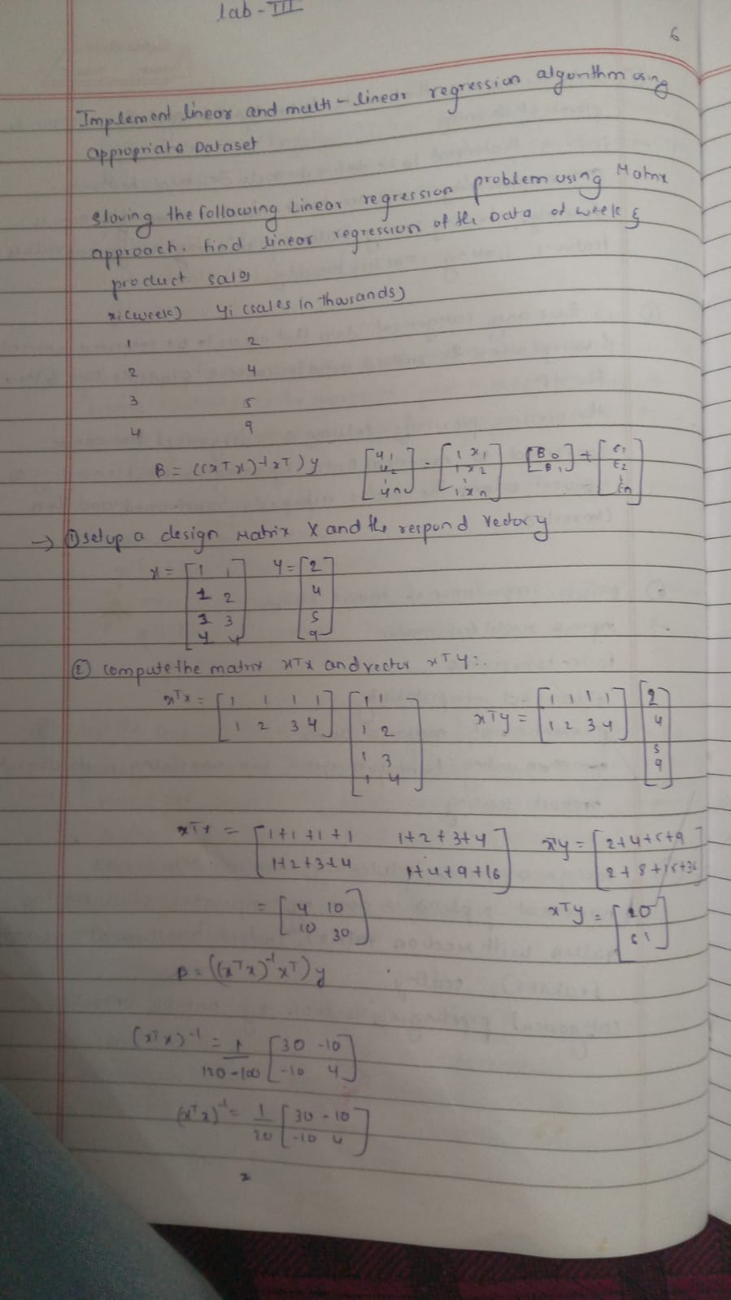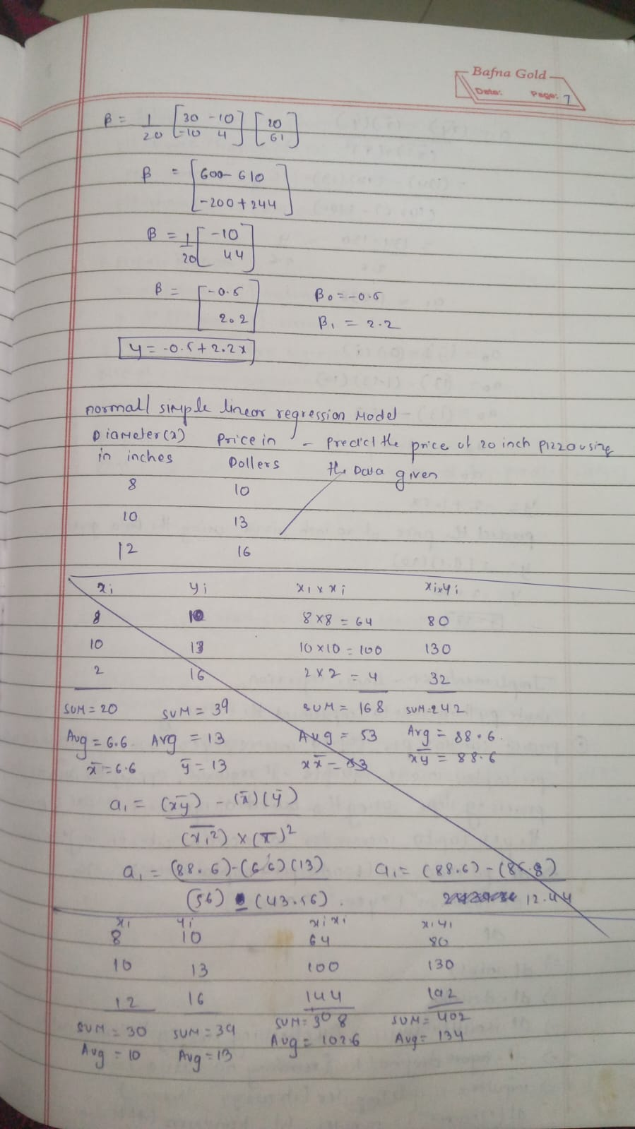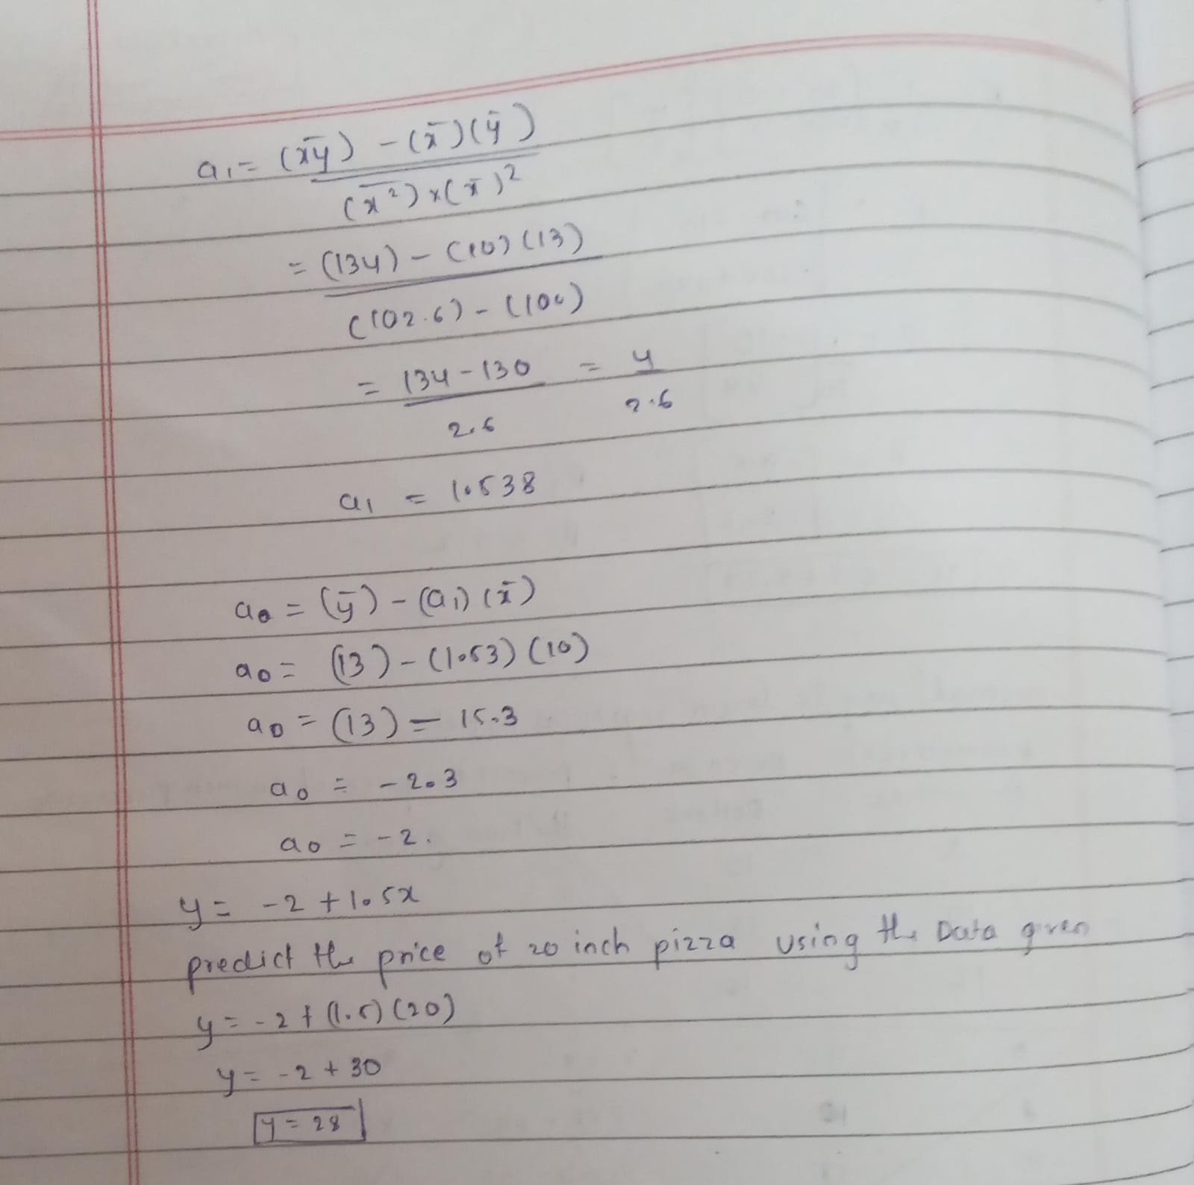
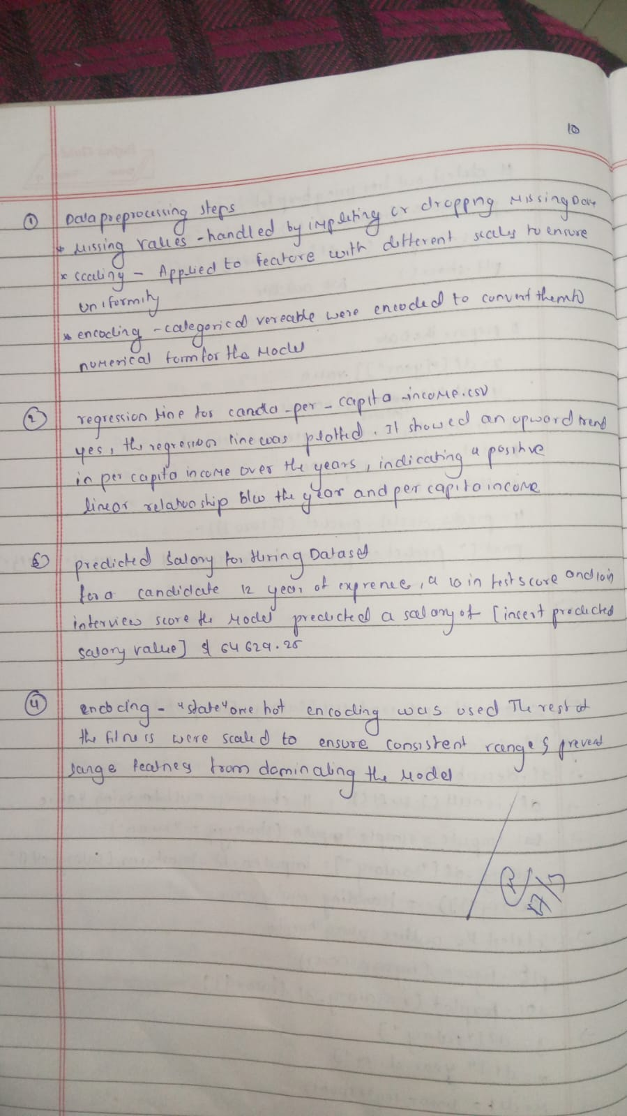
Code:

import pandas as pd import numpy as np
from sklearn import linear_model import matplotlib.pyplot as plt

df = pd.read_csv('/content/housing_area_price.csv') plt.xlabel('area')
plt.ylabel('price')
plt.scatter(df.area, df.price, color='red', marker='+')

new_df = df.drop('price', axis='columns') price = df.price

reg = linear_model.LinearRegression() reg.fit(new_df, price) reg.predict([[3300]])
reg.coef_ reg.intercept_
3300 * 135.78767123 + 180616.43835616432
reg.predict([[5000]])

df = pd.read_csv('/content/homeprices_Multiple_LR.csv') df.bedrooms = df.bedrooms.fillna(df.bedrooms.median())

reg = linear_model.LinearRegression() reg.fit(df.drop('price', axis='columns'), df.price) reg.coef_
reg.intercept_ reg.predict([[3000, 3, 40]])
112.06244194 * 3000 + 23388.88007794 * 3 + -3231.71790863 * 40 + 221323.00186540384

df1 = pd.read_csv('/content/canada_per_capita_income.csv') X = df1.year.values.reshape(-1, 1)
y = df1['per capita income (US$)']

model = LinearRegression() model.fit(X, y) model.predict([[2020]])

df1 = pd.read_csv('/content/canada_per_capita_income.csv') X = df1.year.values.reshape(-1, 1)
y = df1['per capita income (US$)']

model = LinearRegression() model.fit(X, y)

plt.figure(figsize=(8, 6)) plt.scatter(X, y, color='blue')
plt.plot(X, model.predict(X), color='red') plt.xlabel('Year')
plt.ylabel('Per Capita Income (US$)')
plt.title('Per Capita Income in Canada over Time') plt.grid(True)
plt.show()

df = pd.read_csv('/content/salary.csv')
X = df.iloc[:, :-1].values y = df.iloc[:, 1].values

from sklearn.impute import SimpleImputer imputer = SimpleImputer(strategy='mean') X = imputer.fit_transform(X)

model = LinearRegression() model.fit(X, y) model.predict([[12]])

df = pd.read_csv('/content/hiring.csv')
df['experience'] = pd.to_numeric(df['experience'], errors='coerce')

imputer = SimpleImputer(strategy='mean') df['experience'] = imputer.fit_transform(df[['experience']])
df['test_score(out of 10)'] = imputer.fit_transform(df[['test_score(out of 10)']])

X = df.drop('salary($)', axis='columns') y = df['salary($)']

model = LinearRegression() model.fit(X, y) model.predict([[2, 9, 6]])
model.predict([[12, 10, 10]])

df = pd.read_csv('/content/1000_Companies.csv')
X = df.iloc[:, :-1].values y = df.iloc[:, 4].values

from sklearn.preprocessing import LabelEncoder, OneHotEncoder from sklearn.compose import ColumnTransformer
labelencoder = LabelEncoder()
X[:, 3] = labelencoder.fit_transform(X[:, 3])

ct = ColumnTransformer(transformers=[('encoder', OneHotEncoder(), [3])], remainder='passthrough') X = ct.fit_transform(X)
X = X[:, 1:]

from sklearn.model_selection import train_test_split
X_train, X_test, y_train, y_test = train_test_split(X, y, test_size=0.2, random_state=0)

regressor = LinearRegression() regressor.fit(X_train, y_train)
regressor.predict([[1, 0, 91694.48, 515841.3, 11931.24]])

Program 4

Build Logistic Regression Model for a given dataset Screenshots:
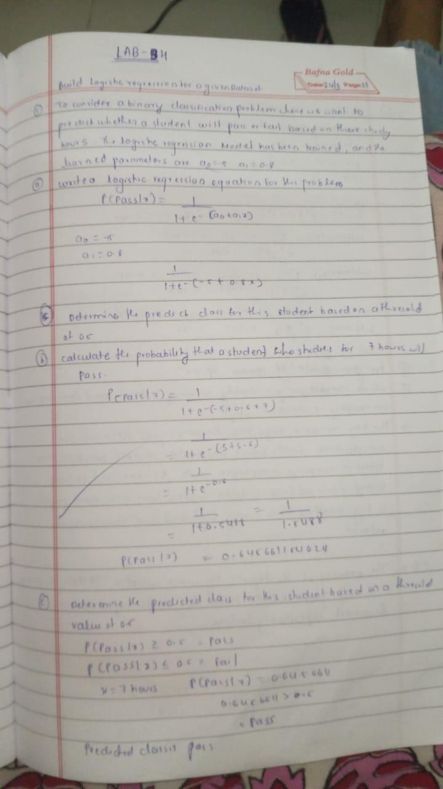

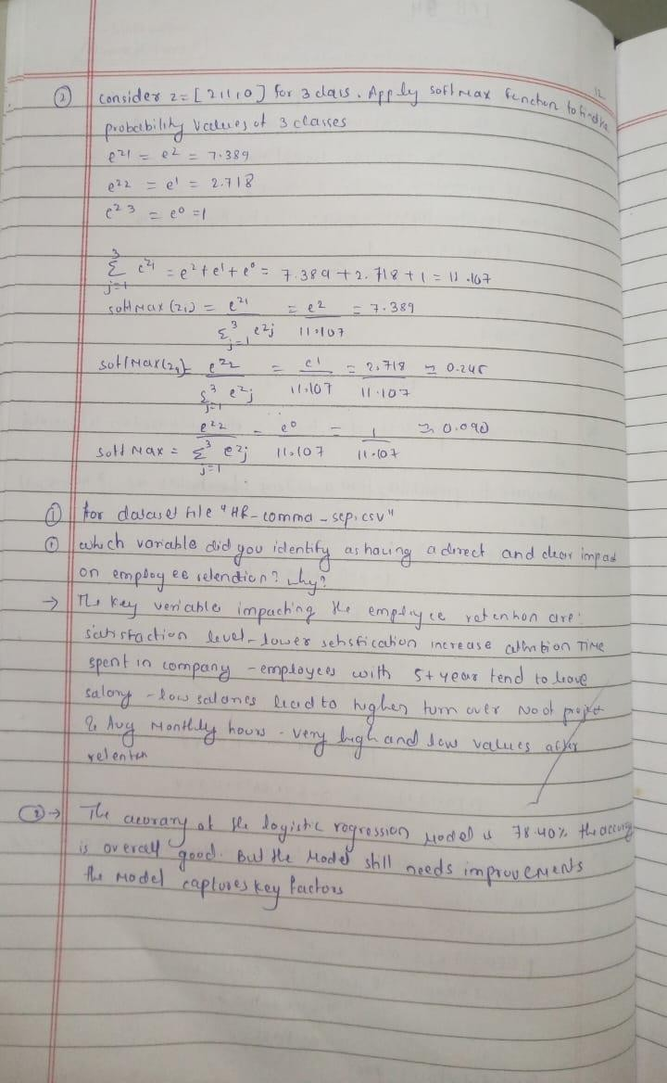

Code:

import pandas as pd
from matplotlib import pyplot as plt
# %matplotlib inline
#"%matplotlib inline" will make your plot outputs appear and be stored within the notebook.

df = pd.read_csv("insurance_data.csv") df.head()
plt.scatter(df.age,df.bought_insurance,marker='+',color='red') from sklearn.model_selection import train_test_split
X_train, X_test, y_train, y_test =
train_test_split(df[['age']],df.bought_insurance,train_size=0.9,random_state=10) X_train.shape

X_test

from sklearn.linear_model import LogisticRegression model = LogisticRegression()
model.fit(X_train, y_train)

X_test y_test
y_predicted = model.predict(X_test) y_predicted

model.score(X_test,y_test) model.predict_proba(X_test)
y_predicted = model.predict([[60]]) y_predicted

#model.coef_ indicates value of m in y=m*x + b equation
model.coef_

#model.intercept_ indicates value of b in y=m*x + b equation
model.intercept_

#Lets defined sigmoid function now and do the math with hand
import math def sigmoid(x):
return 1 / (1 + math.exp(-x))

def prediction_function(age):
z = 0.127 * age - 4.973 # 0.12740563 ~ 0.0127 and -4.97335111 ~ -4.97
y = sigmoid(z) return y

age = 35 prediction_function(age)

"""0.37 is less than 0.5 which means person with 35 will not buy the insurance"""
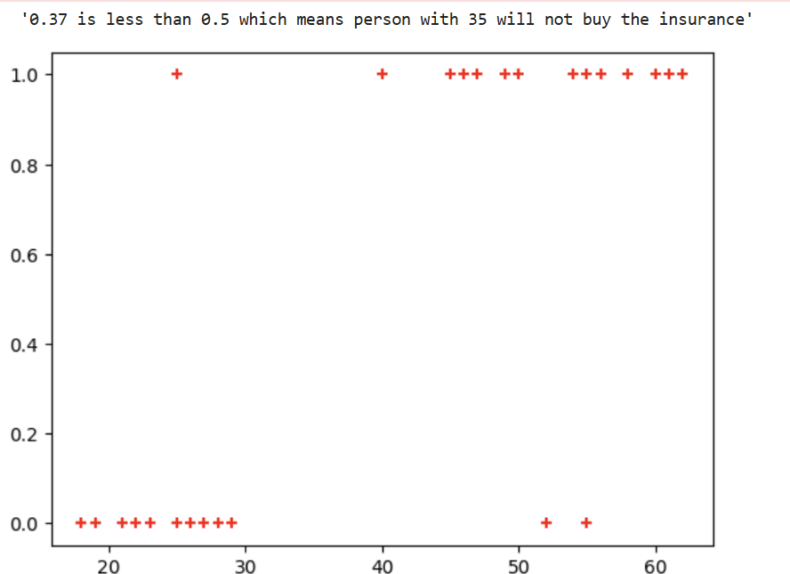
# Import necessary libraries
import pandas as pd
from sklearn.datasets import load_iris
from sklearn.model_selection import train_test_split from sklearn.linear_model import LogisticRegression from sklearn.metrics import accuracy_score
from sklearn import metrics import matplotlib.pyplot as plt
# Load the Iris dataset
iris = pd.read_csv("iris.csv") iris.head()

X=iris.drop('species',axis='columns')# Features (sepal length, sepal width, petal length, petal width)
y = iris.species # Target labels (0: Setosa, 1: Versicolor, 2: Virginica)

# Split the dataset into 80% training and 20% testing
X_train, X_test, y_train, y_test = train_test_split(X, y, test_size=0.2, random_state=42)

# Initialize the Multinomial Logistic Regression model
# Use 'multinomial' for multi-class classification and 'lbfgs' solver
model = LogisticRegression(multi_class='multinomial')

# Train the model on the training data
model.fit(X_train, y_train)

# Make predictions on the test data
y_pred = model.predict(X_test)

# Calculate the accuracy of the model on the test data
accuracy = accuracy_score(y_test, y_pred)

# Display the accuracy
print(f"Accuracy of the Multinomial Logistic Regression model on the test set: {accuracy:.2f}") confusion_matrix = metrics.confusion_matrix(y_test, y_pred)
cm_display = metrics.ConfusionMatrixDisplay(confusion_matrix = confusion_matrix, display_labels = ["Setosa", "Versicolor", "Virginica"])
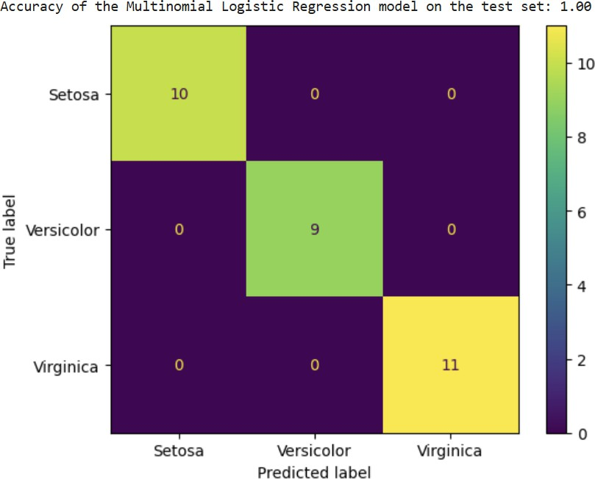
cm_display.plot() plt.show()

Program 5
- Use an appropriate data set for building the decision tree (ID3) and apply this knowledge to classify a new sample.

Screenshots:
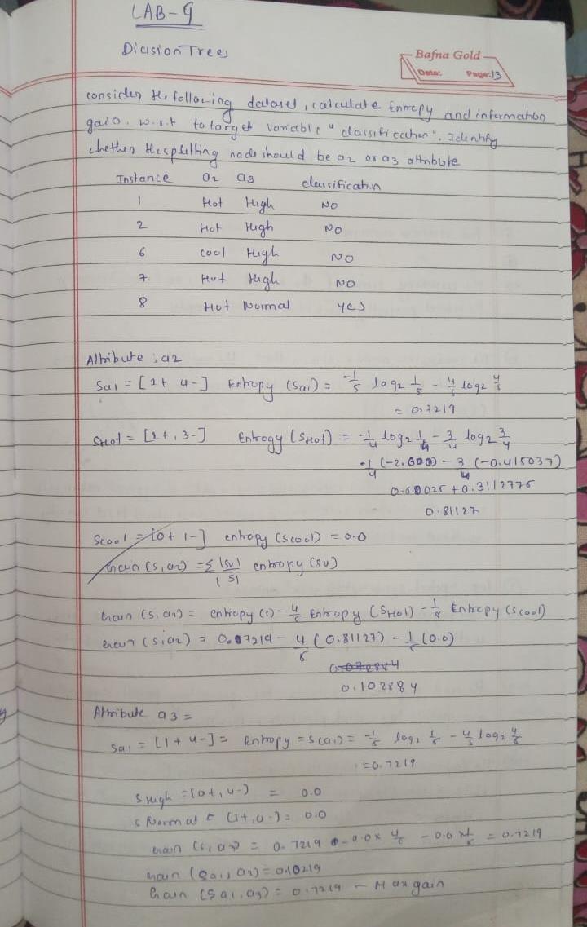

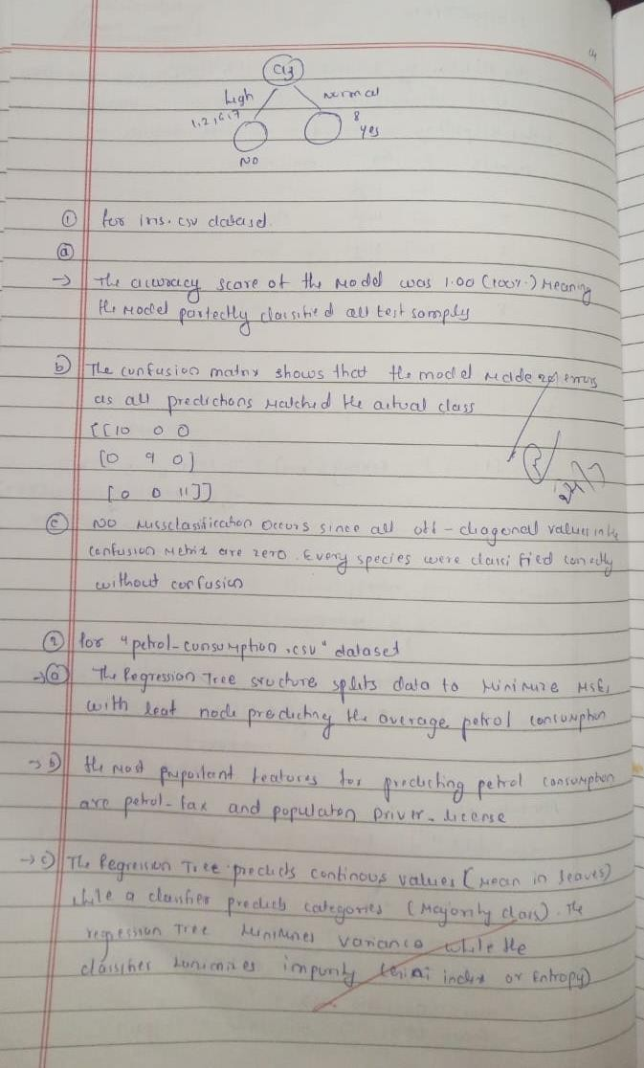

Code: import pandas as pd
from sklearn.model_selection import train_test_split from sklearn.tree import DecisionTreeClassifier
from sklearn.metrics import accuracy_score, confusion_matrix, classification_report import matplotlib.pyplot as plt
from sklearn.tree import plot_tree

# Load the iris dataset (make sure iris.csv is in the working directory)
iris = pd.read_csv("iris.csv")
# Assuming the last column is the target (species) and the rest are features.
X = iris.iloc[:, :-1]
y = iris.iloc[:, -1]

# Split data into training and testing sets (80% training, 20% testing)
X_train, X_test, y_train, y_test = train_test_split(X, y, test_size=0.2, random_state=42)
# Initialize and train the Decision Tree classifier
clf_iris = DecisionTreeClassifier(criterion='entropy', random_state=42) clf_iris.fit(X_train, y_train)
# Make predictions and evaluate the model
y_pred_iris = clf_iris.predict(X_test)
accuracy_iris = accuracy_score(y_test, y_pred_iris) conf_matrix_iris = confusion_matrix(y_test, y_pred_iris)

print("IRIS Dataset Decision Tree Classifier") print("Accuracy:", accuracy_iris) print("Confusion Matrix:\n", conf_matrix_iris)
print("Classification Report:\n", classification_report(y_test, y_pred_iris))

# Visualize the decision tree
plt.figure(figsize=(12, 8))
plot_tree(clf_iris, filled=True, feature_names=X.columns, class_names=clf_iris.classes_) plt.title("Decision Tree for IRIS Dataset")
plt.show()
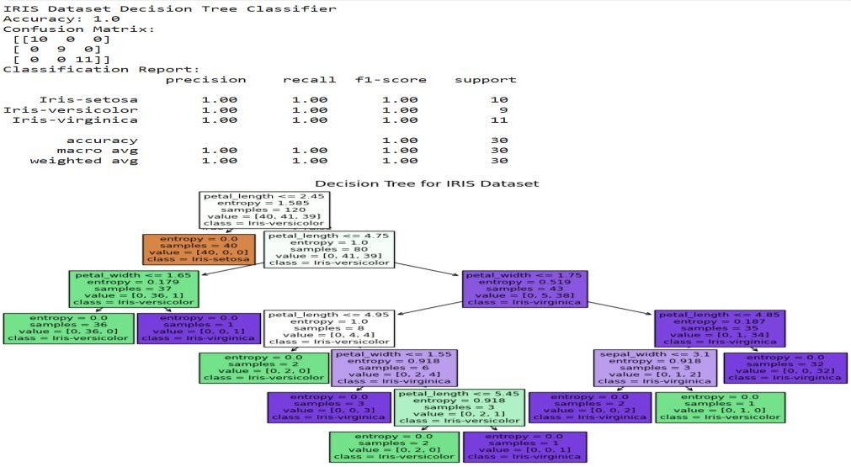
import pandas as pd

from sklearn.model_selection import train_test_split from sklearn.tree import DecisionTreeClassifier
from sklearn.metrics import accuracy_score, confusion_matrix, classification_report import matplotlib.pyplot as plt
from sklearn.tree import plot_tree

# Load the drug dataset (make sure drug.csv is in the working directory)
drug = pd.read_csv("drug.csv")

# Since the target column is 'Drug', drop it from the features
X_drug = drug.drop('Drug', axis=1) y_drug = drug['Drug']

# If there are categorical features, perform necessary encoding
from sklearn.preprocessing import LabelEncoder le = LabelEncoder()
# Encode features that are categorical
for col in X_drug.select_dtypes(include='object').columns: X_drug[col] = le.fit_transform(X_drug[col])
# Also encode the target variable if necessary
y_drug = le.fit_transform(y_drug)

# Split the data (80% training, 20% testing)
X_train_d, X_test_d, y_train_d, y_test_d = train_test_split(X_drug, y_drug, test_size=0.2, random_state=42)
# Initialize and train the Decision Tree classifier using entropy criterion clf_drug = DecisionTreeClassifier(criterion='entropy', random_state=42) clf_drug.fit(X_train_d, y_train_d)

# Make predictions and evaluate the model
y_pred_drug = clf_drug.predict(X_test_d) accuracy_drug = accuracy_score(y_test_d, y_pred_drug)
conf_matrix_drug = confusion_matrix(y_test_d, y_pred_drug)

print("Drug Dataset Decision Tree Classifier") print("Accuracy:", accuracy_drug) print("Confusion Matrix:\n", conf_matrix_drug)
print("Classification Report:\n", classification_report(y_test_d, y_pred_drug))

# Visualize the decision tree
plt.figure(figsize=(12, 8))
plot_tree(clf_drug, filled=True, feature_names=X_drug.columns, class_names=[str(cls) for cls in clf_drug.classes_])
plt.title("Decision Tree for Drug Dataset") plt.show()

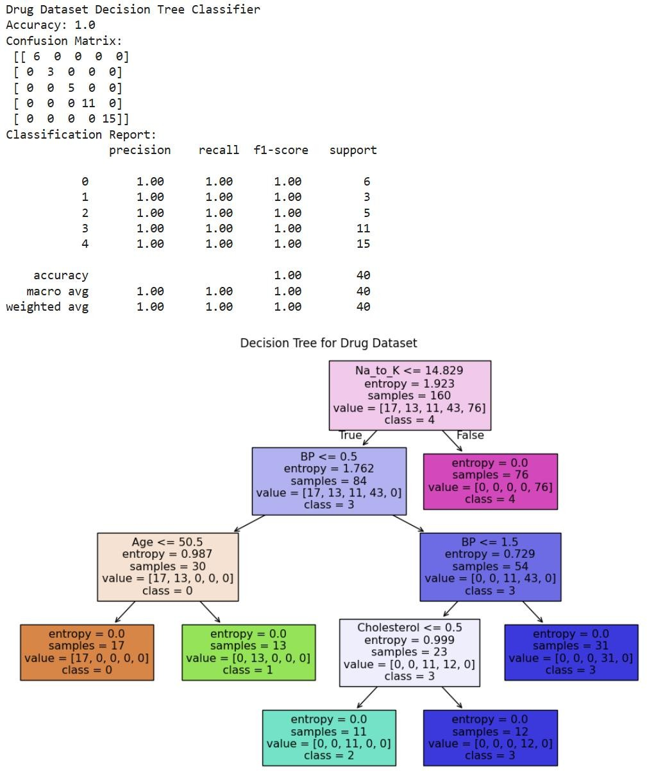

Program 6
- Build KNN Classification model for a given dataset.

Screenshots:
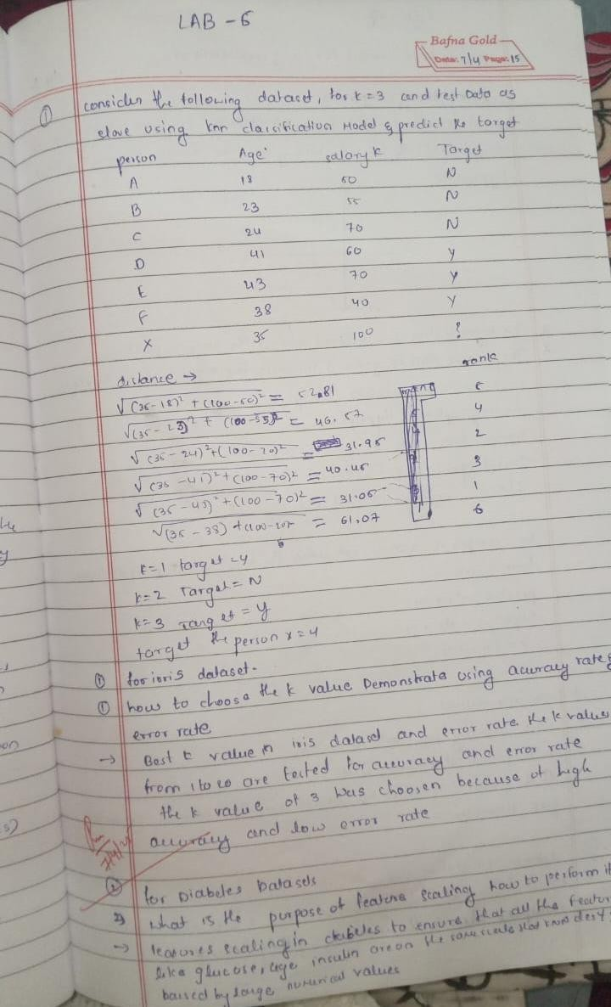

Code:

import pandas as pd import numpy as np
import matplotlib.pyplot as plt import seaborn as sns

# For model building and evaluation
from sklearn.model_selection import train_test_split from sklearn.preprocessing import StandardScaler from sklearn.neighbors import KNeighborsClassifier
from sklearn.metrics import accuracy_score, confusion_matrix, classification_report
# Part 1: IRIS Dataset #
# Load the iris dataset (ensure iris.csv is in the same directory or provide correct path)
iris_df = pd.read_csv("iris.csv")

# Separate features and target
X_iris = iris_df.drop("species", axis=1) y_iris = iris_df["species"]

# Split the data (80% training, 20% testing)
X_train_iris, X_test_iris, y_train_iris, y_test_iris = train_test_split( X_iris, y_iris, test_size=0.2, random_state=42

)

# Choose a value for k; here K=3 is used as an example.
knn_iris = KNeighborsClassifier(n_neighbors=3)

# Train the model on training data
knn_iris.fit(X_train_iris, y_train_iris)

# Predict on test data
y_pred_iris = knn_iris.predict(X_test_iris)
# Calculate accuracy score
acc_iris = accuracy_score(y_test_iris, y_pred_iris) print("IRIS Dataset Accuracy Score:", acc_iris)
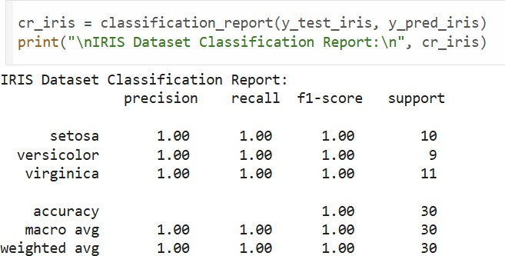
# Compute confusion matrix and classification report cm_iris = confusion_matrix(y_test_iris, y_pred_iris) print("\nIRIS Dataset Confusion Matrix:\n", cm_iris)

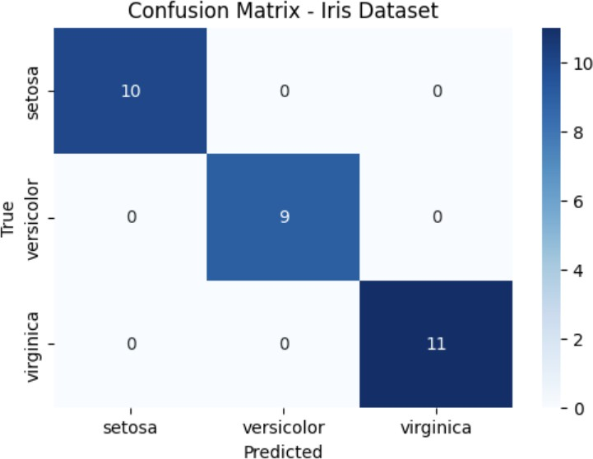
# Part 2: Diabetes Dataset #
# Load the diabetes dataset (ensure diabetes.csv is in the same directory or provide correct path)
diabetes_df = pd.read_csv("diabetes.csv")

# Separate features and target (Outcome column is assumed to be the target)
X_diabetes = diabetes_df.drop("Outcome", axis=1) y_diabetes = diabetes_df["Outcome"]

# Perform feature scaling on the features
scaler = StandardScaler()
X_scaled_diabetes = scaler.fit_transform(X_diabetes)
# Split the scaled data (80% training, 20% testing)
X_train_diab, X_test_diab, y_train_diab, y_test_diab = train_test_split( X_scaled_diabetes, y_diabetes, test_size=0.2, random_state=42
)
# Choose a value for k; here K=5 is used as an example.
knn_diabetes = KNeighborsClassifier(n_neighbors=5)

# Train the model on training data
knn_diabetes.fit(X_train_diab, y_train_diab)

# Predict on test data
y_pred_diab = knn_diabetes.predict(X_test_diab)
# Calculate accuracy score
acc_diab = accuracy_score(y_test_diab, y_pred_diab) print("Diabetes Dataset Accuracy Score:", acc_diab) # Compute confusion matrix and classification report
cm_diab = confusion_matrix(y_test_diab, y_pred_diab) print("\nDiabetes Dataset Confusion Matrix:\n", cm_diab)

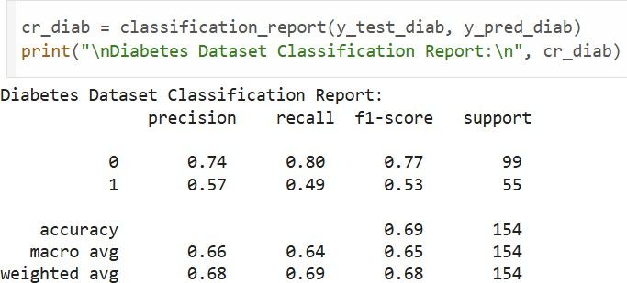
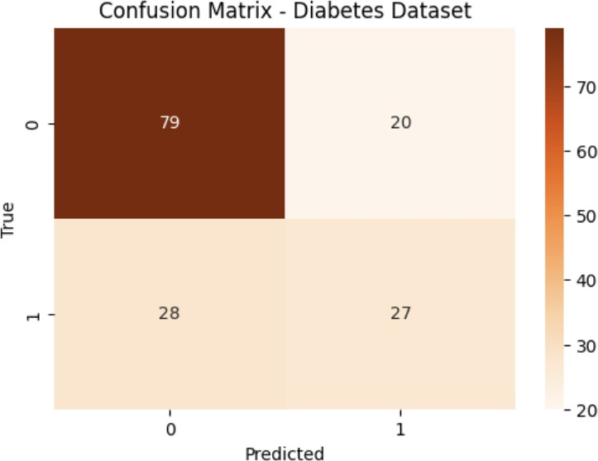
# Load the Dataset # # Load heart.csv (make sure the file is in your working directory) heart_df = pd.read_csv("heart.csv")

# Display the first few rows to check the data
heart_df.head()
# Data Preparation # # Separate features and target
X_heart = heart_df.drop("target", axis=1) y_heart = heart_df["target"]

# Perform feature scaling (important for distance-based algorithms like KNN)
scaler = StandardScaler()
X_scaled = scaler.fit_transform(X_heart)

# Split data into training and testing sets (80% train, 20% test)
X_train, X_test, y_train, y_test = train_test_split(X_scaled, y_heart, test_size=0.2, random_state=42)
# Finding the Best k #
# We will try a range of k values (neighbors) and select the one with maximum accuracy.
k_range = range(1, 21) accuracy_scores = []
for k in k_range:

knn = KNeighborsClassifier(n_neighbors=k) knn.fit(X_train, y_train)
y_pred = knn.predict(X_test)
acc = accuracy_score(y_test, y_pred) accuracy_scores.append(acc)
print(f"k = {k} --> Accuracy: {acc:.4f}")
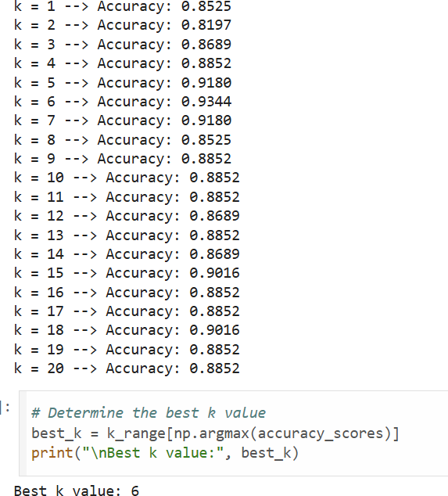
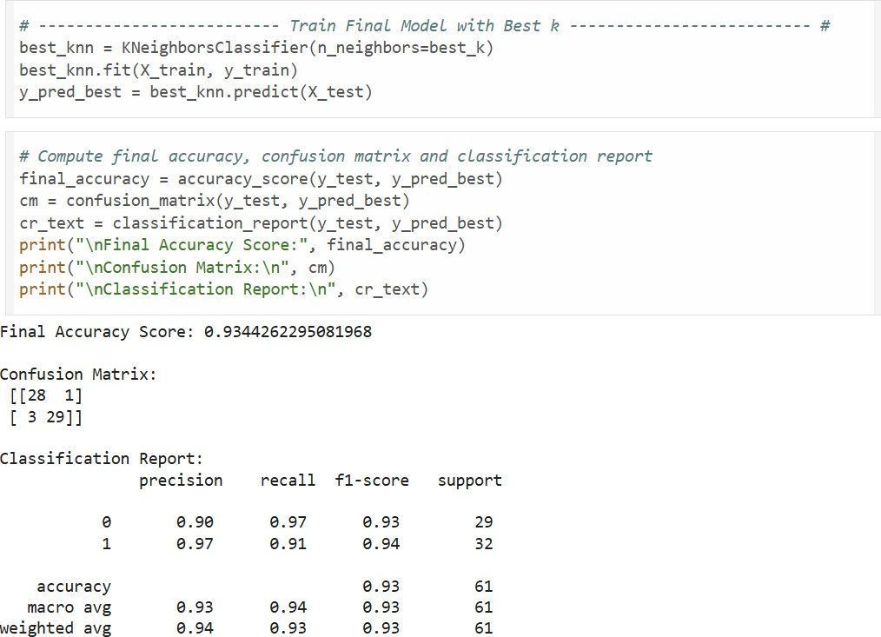

Program 7
4)Build Support vector machine model for a given dataset

Screenshots:
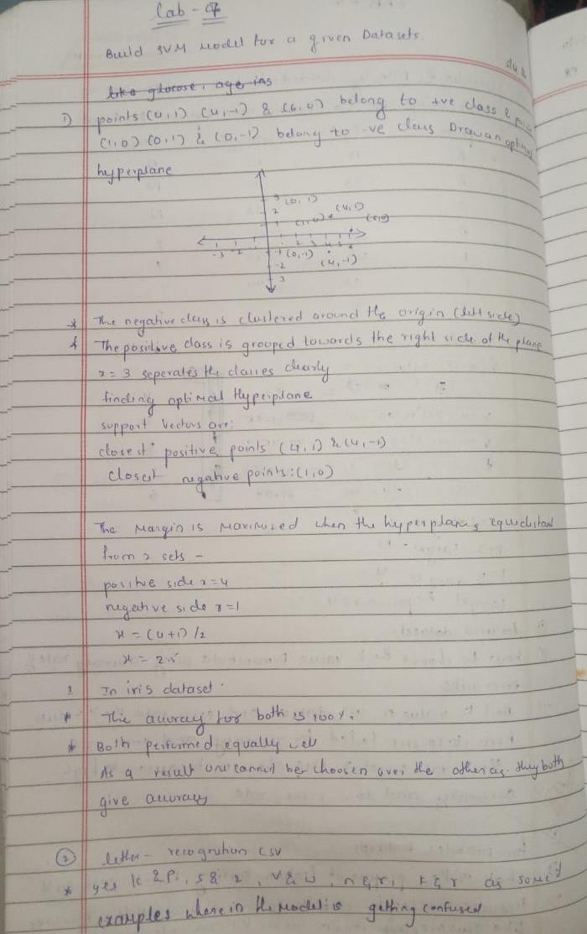

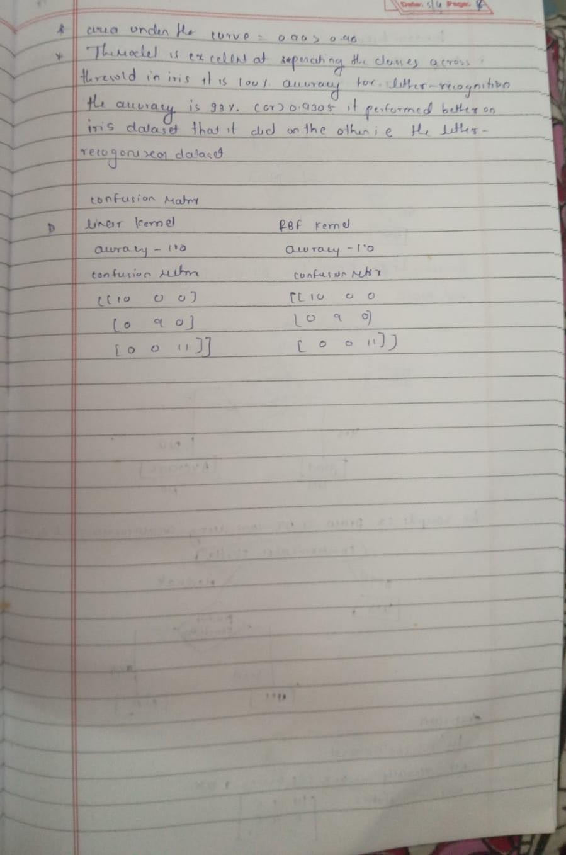

Code:

import numpy as np
import matplotlib.pyplot as plt from sklearn.svm import SVC # Data points
X = np.array([[4, 1], [4, -1], [6, 0], [1, 0], [0, 1], [0, -1]])
y = np.array([1, 1, 1, -1, -1, -1])

# Fit linear SVM with a very large C to approximate hard-margin
clf = SVC(kernel='linear', C=1e6) clf.fit(X, y)
# Extract model parameters
w = clf.coef_[0]
b = clf.intercept_[0]

# Compute decision boundary and margins
xx = np.linspace(-1, 7, 500) yy = -(w[0] * xx + b) / w[1]

# Margin offset: distance = 1/||w||
margin = 1 / np.linalg.norm(w)
yy_down = yy - np.sqrt(1 + (w[0] / w[1])**2) * margin yy_up = yy + np.sqrt(1 + (w[0] / w[1])**2) * margin

# Plotting
plt.figure(figsize=(8, 6))
plt.scatter(X[y == 1, 0], X[y == 1, 1], c='blue', marker='o', label='Positive class')
plt.scatter(X[y == -1, 0], X[y == -1, 1], c='red', marker='s', label='Negative class') plt.plot(xx, yy, 'k-', label='Decision boundary')
plt.plot(xx, yy_down, 'k--', label='Margin lines') plt.plot(xx, yy_up, 'k--')
plt.xlabel('x')
plt.ylabel('y') plt.legend()
plt.title('Optimal Hyperplane and Margins') plt.grid(True)
plt.show()
print(f"Hyperplane: {w[0]:.3f}x + {w[1]:.3f}y + ({b:.3f}) = 0")
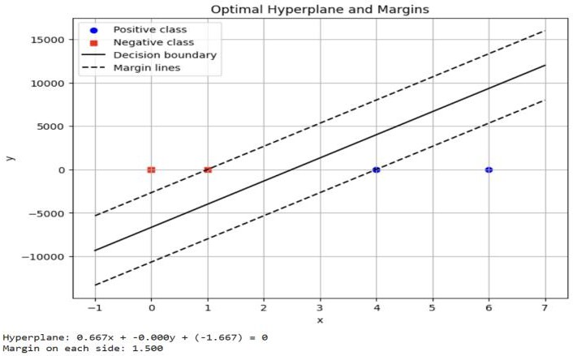
print(f"Margin on each side: {margin:.3f}")

import pandas as pd

# Load both datasets
iris_df = pd.read_csv("/content/iris.csv")
# 1. IRIS DATASET - SVM with RBF and Linear Kernels
X_iris = iris_df.drop("species", axis=1) y_iris = iris_df["species"]
# Encode labels
le_iris = LabelEncoder()
y_iris_encoded = le_iris.fit_transform(y_iris)
# Split dataset
X_train_iris, X_test_iris, y_train_iris, y_test_iris = train_test_split(X_iris, y_iris_encoded, test_size=0.2, random_state=42)

# Train models
svm_rbf = SVC(kernel='rbf') svm_linear = SVC(kernel='linear')
svm_rbf.fit(X_train_iris, y_train_iris) svm_linear.fit(X_train_iris, y_train_iris)
# Predictions
y_pred_rbf = svm_rbf.predict(X_test_iris) y_pred_linear = svm_linear.predict(X_test_iris) # Accuracy and Confusion Matrix
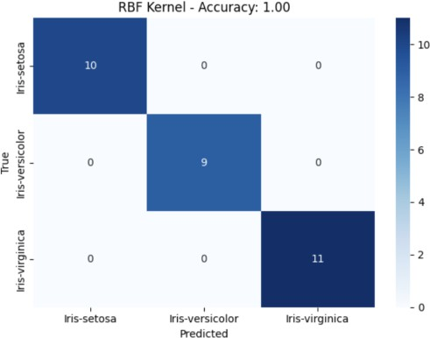
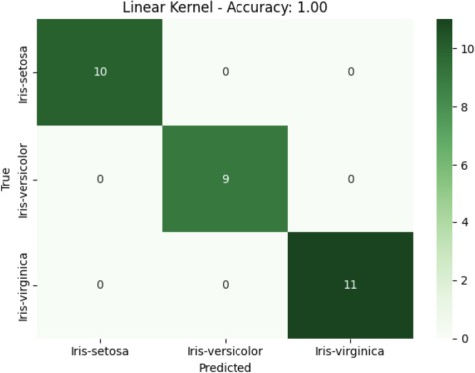
acc_rbf = accuracy_score(y_test_iris, y_pred_rbf) acc_linear = accuracy_score(y_test_iris, y_pred_linear) cm_rbf = confusion_matrix(y_test_iris, y_pred_rbf) cm_linear = confusion_matrix(y_test_iris, y_pred_linear)
# Load dataset
letter_df = pd.read_csv("/content/letter-recognition.csv") # Update path if needed
letter_df['letter'] = LabelEncoder().fit_transform(letter_df['letter'])
# Split features and labels
X = letter_df.drop('letter', axis=1) y = letter_df['letter']

# Train-test split
X_train, X_test, y_train, y_test = train_test_split(X, y, test_size=0.2, random_state=42)
# Standardize
scaler = StandardScaler()
X_train = scaler.fit_transform(X_train) X_test = scaler.transform(X_test)

# Train SVM
svm = SVC(kernel='rbf', probability=True) svm.fit(X_train, y_train)
y_pred = svm.predict(X_test) y_prob = svm.predict_proba(X_test)
# Accuracy and Confusion Matrix
print("Accuracy:", accuracy_score(y_test, y_pred)) print("Confusion Matrix:\n", confusion_matrix(y_test, y_pred))
# ROC and AUC (one-vs-rest)
y_test_bin = label_binarize(y_test, classes=np.unique(y)) n_classes = y_test_bin.shape[1]

fpr = dict() tpr = dict()
roc_auc = dict()

for i in range(n_classes):
fpr[i], tpr[i], _ = roc_curve(y_test_bin[:, i], y_prob[:, i]) roc_auc[i] = auc(fpr[i], tpr[i])
# Plot ROC Curve
plt.figure(figsize=(10, 7))
colors = cycle(['aqua', 'darkorange', 'cornflowerblue', 'green', 'red', 'purple'])

for i, color in zip(range(n_classes), colors): plt.plot(fpr[i], tpr[i], color=color, lw=2,
label=f'Class {i} (AUC = {roc_auc[i]:0.2f})')

plt.plot([0, 1], [0, 1], 'k--', lw=2) plt.xlabel("False Positive Rate") plt.ylabel("True Positive Rate") plt.title("Multi-class ROC Curve") plt.legend(loc="lower right") plt.grid()
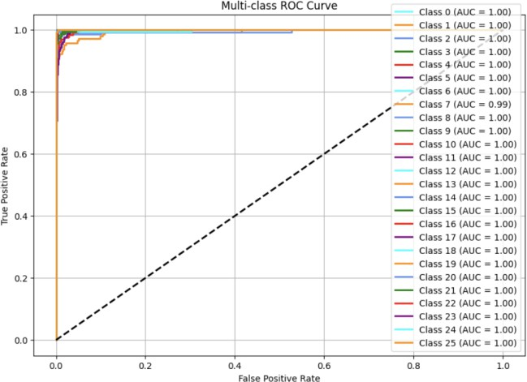
plt.show()

Program 8 8)Implement Random forest ensemble method on a given dataset Screenshots:
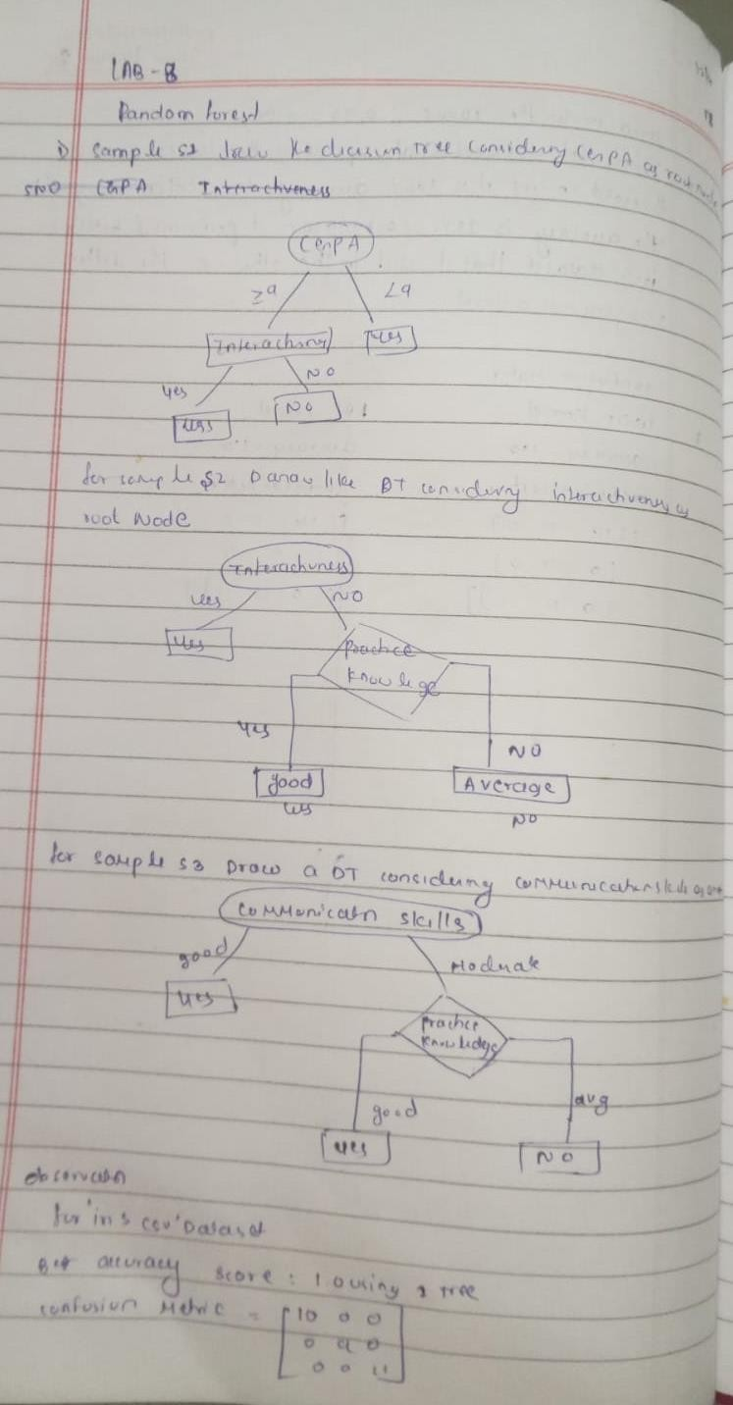

Code: import pandas as pd
from sklearn.model_selection import train_test_split from sklearn.ensemble import RandomForestClassifier
from sklearn.metrics import accuracy_score, confusion_matrix import matplotlib.pyplot as plt
# Load the dataset
df = pd.read_csv("iris.csv") # Adjust filename if needed
# Prepare data
X = df.drop(columns=["species"]) # Assuming 'species' is the target column
y = df["species"]
# Split dataset
X_train, X_test, y_train, y_test = train_test_split(X, y, test_size=0.2, random_state=42)

# Default Random Forest with 10 trees
rf_default = RandomForestClassifier(n_estimators=10, random_state=42) rf_default.fit(X_train, y_train)
y_pred_default = rf_default.predict(X_test) acc_default = accuracy_score(y_test, y_pred_default)
conf_matrix_default = confusion_matrix(y_test, y_pred_default)
print(f"Default RF (10 trees) Accuracy: {acc_default}") print("Confusion Matrix:\n", conf_matrix_default)

# Try different numbers of trees to find the best
best_acc = 0
best_n = 10 acc_list = []
for n in range(1, 101):
rf = RandomForestClassifier(n_estimators=n, random_state=42) rf.fit(X_train, y_train)
y_pred = rf.predict(X_test)
acc = accuracy_score(y_test, y_pred) acc_list.append((n, acc))
if acc > best_acc:
best_acc = acc best_n = n
best_conf_matrix = confusion_matrix(y_test, y_pred)
print(f"\nBest Accuracy: {best_acc} using {best_n} trees") print("Best Confusion Matrix:\n", best_conf_matrix)
# Plot accuracy vs number of trees x_vals, y_vals = zip(*acc_list) plt.plot(x_vals, y_vals, marker='o') plt.title("Accuracy vs Number of Trees") plt.xlabel("Number of Trees") plt.ylabel("Accuracy")
plt.grid(True) plt.show()
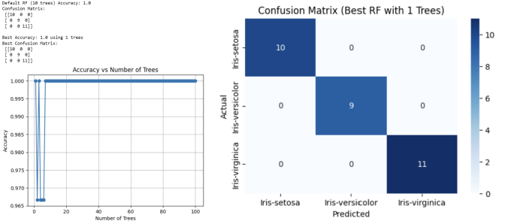

Program 9 9)Implement Boosting ensemble method on a given dataset. Screenshots: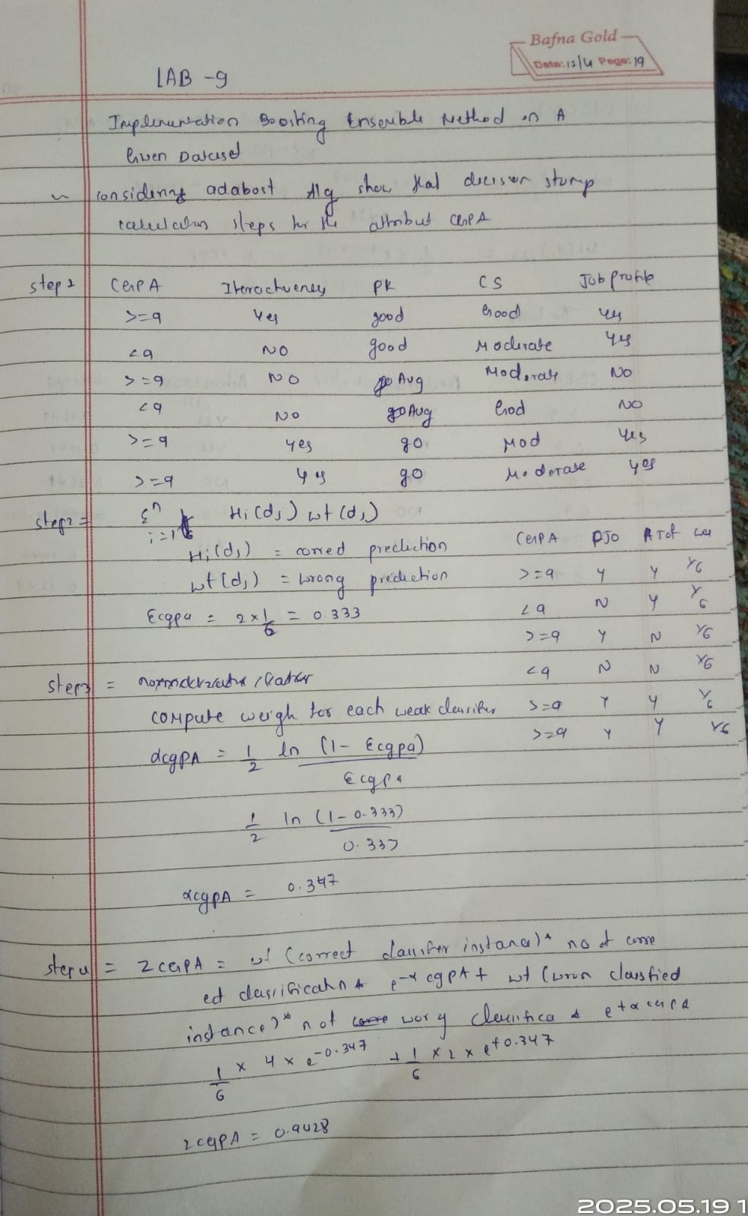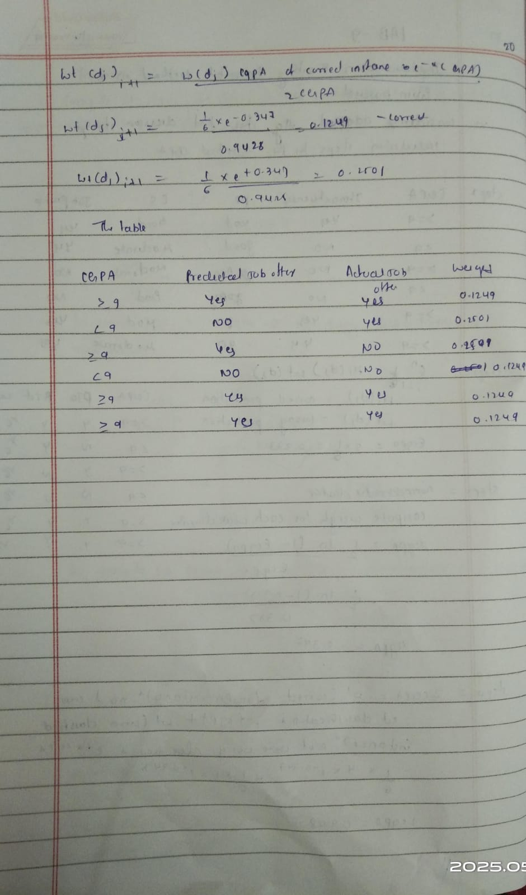
Code: import pandas as pd
import matplotlib.pyplot as plt
from sklearn.model_selection import train_test_split, cross_val_score from sklearn.preprocessing import OneHotEncoder, StandardScaler from sklearn.compose import ColumnTransformer
from sklearn.pipeline import Pipeline
from sklearn.ensemble import AdaBoostClassifier
from sklearn.metrics import accuracy_score, confusion_matrix, ConfusionMatrixDisplay

# Load dataset
data = pd.read_csv('income.csv')
# Display basic info print("First five rows:") print(data.head())
print(f"\nDataset shape: {data.shape}")
# Define features and target target_column = 'income_level' y = data[target_column]
X = data.drop(columns=[target_column])
# Identify categorical vs numerical columns
categorical_cols = X.select_dtypes(include=['object', 'category']).columns.tolist() numerical_cols = X.select_dtypes(include=['int64', 'float64']).columns.tolist() print(f"\nNumerical columns: {numerical_cols}")
print(f"Categorical columns: {categorical_cols}")
# Preprocessor: scale numericals, one-hot encode categoricals
preprocessor = ColumnTransformer( transformers=[
('num', StandardScaler(), numerical_cols),
('cat', OneHotEncoder(handle_unknown='ignore'), categorical_cols)
]
)

# Initial AdaBoost model with 10 estimators
pipeline = Pipeline([ ('preprocess', preprocessor),
('clf', AdaBoostClassifier(n_estimators=10, random_state=42))
])
# Split into train/test sets
X_train, X_test, y_train, y_test = train_test_split( X, y, test_size=0.2, random_state=42, stratify=y
)
# Train and evaluate initial model pipeline.fit(X_train, y_train) y_pred = pipeline.predict(X_test)
initial_acc = accuracy_score(y_test, y_pred)
print(f"Initial test accuracy (n_estimators=10): {initial_acc:.4f}")
# Hyperparameter tuning: find best n_estimators tree_counts = list(range(10, 201, 10)) # 10,20,...,200 cv_scores = []
for n in tree_counts: model = Pipeline([
('preprocess', preprocessor),
('clf', AdaBoostClassifier(n_estimators=n, random_state=42))
])
scores = cross_val_score(
model, X_train, y_train, cv=5, scoring='accuracy', n_jobs=-1
)
mean_score = scores.mean() cv_scores.append(mean_score)
print(f"n_estimators={n}: CV mean accuracy={mean_score:.4f}")

# Plot CV accuracy vs. number of estimators
plt.figure()
plt.plot(tree_counts, cv_scores, marker='o') plt.title('AdaBoost CV Accuracy vs. n_estimators') plt.xlabel('Number of Estimators')
plt.ylabel('CV Mean Accuracy') plt.grid(True)
plt.tight_layout() plt.show()
# Determine optimal number of trees
best_score = max(cv_scores)
best_n = tree_counts[cv_scores.index(best_score)]
print(f"\nBest CV accuracy={best_score:.4f} with n_estimators={best_n}")

# Retrain and evaluate best model
best_model = Pipeline([ ('preprocess', preprocessor),
('clf', AdaBoostClassifier(n_estimators=best_n, random_state=42))
])
best_model.fit(X_train, y_train) y_best = best_model.predict(X_test)
best_test_acc = accuracy_score(y_test, y_best)
print(f"Test accuracy with best n_estimators ({best_n}): {best_test_acc:.4f}")
# Plot comparison of initial vs. best test accuracy
plt.figure()
plt.bar(['n=10', f'n={best_n}'], [initial_acc, best_test_acc]) plt.title('Test Accuracy: Initial vs. Optimized') plt.ylabel('Accuracy')
plt.ylim(0, 1)
plt.tight_layout() plt.show()

# Plot confusion matrix for best model
cm = confusion_matrix(y_test, y_best)
labels = best_model.named_steps['clf'].classes_
disp = ConfusionMatrixDisplay(confusion_matrix=cm, display_labels=labels) plt.figure()
disp.plot(cmap=plt.cm.Blues)
plt.title('Confusion Matrix for Best AdaBoost Model') plt.tight_layout()
plt.show()
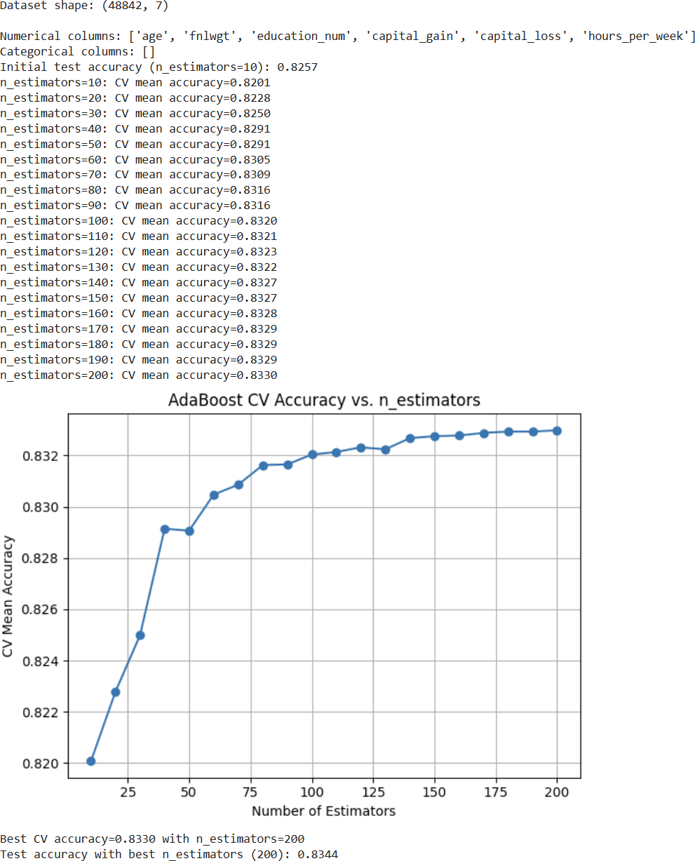
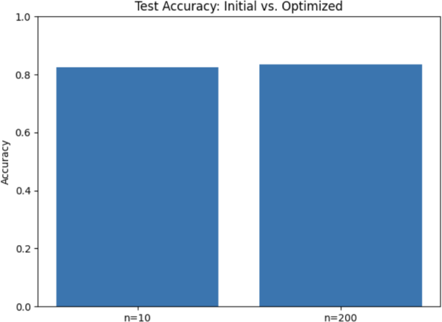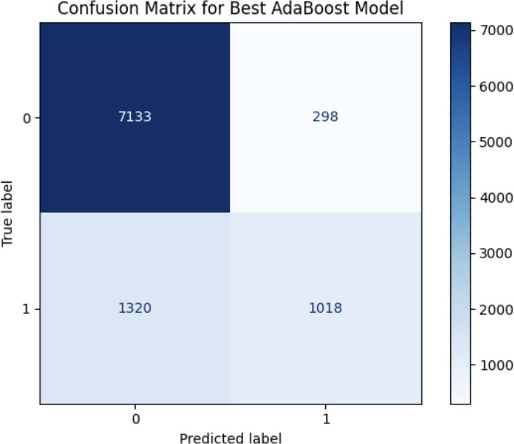

Program 10
- Build k-Means algorithm to cluster a set of data stored in a .CSV file. Screenshots:

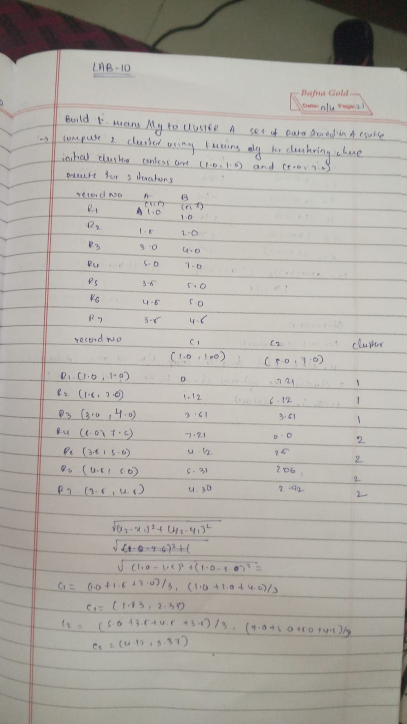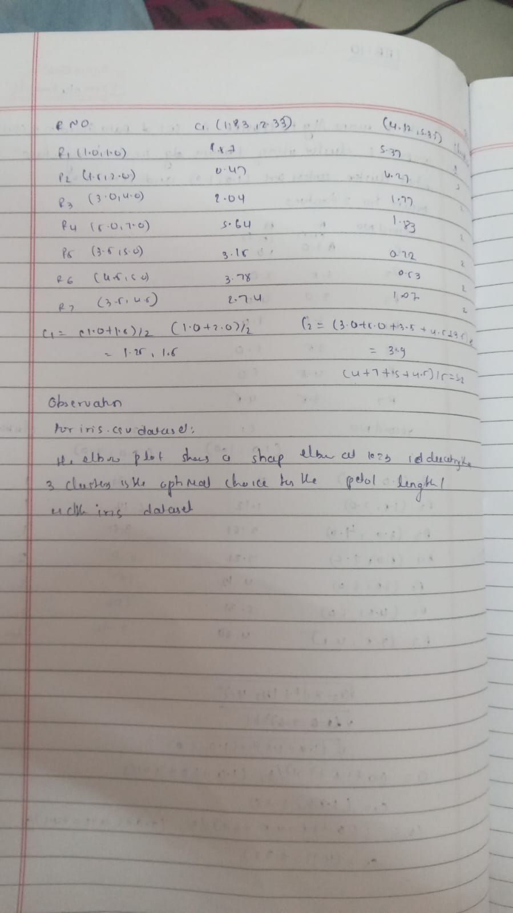

Code:
import pandas as pd import numpy as np
import matplotlib.pyplot as plt
from sklearn.datasets import load_iris
from sklearn.preprocessing import StandardScaler from sklearn.cluster import KMeans
from sklearn.metrics import confusion_matrix, ConfusionMatrixDisplay
def load_data(csv_path='iris.csv'): """
Try loading from csv_path; if not found, load via sklearn.
Expects columns: sepal_length, sepal_width, petal_length, petal_width, species. Returns DataFrame with a 'species' column.
"""
try:
df = pd.read_csv(csv_path)
# Fixed typo here: use c.strip().replace, not ace()
df.columns = [c.strip().replace(' ', '_') for c in df.columns] except FileNotFoundError:
iris = load_iris()
df = pd.DataFrame( data=np.c_[iris['data'], iris['target']],
columns=iris['feature_names'] + ['target']
)
df.columns = [c.strip().replace(' (cm)', '').replace(' ', '_') for c in df.columns]
df['species'] = df['target'].map(lambda x: iris['target_names'][int(x)]) return df
def preprocess(df): """
Select only petal_length & petal_width, then standard-scale. Returns scaled numpy array.
"""
X = df[['petal_length', 'petal_width']].values scaler = StandardScaler()
X_scaled = scaler.fit_transform(X) return X_scaled, scaler

def plot_elbow(X_scaled, max_k=10): """
Compute KMeans inertia for k=1..max_k and plot the elbow curve. Returns list of inertias.
"""
inertias = []
ks = range(1, max_k + 1) for k in ks:
km = KMeans(n_clusters=k, random_state=42) km.fit(X_scaled)
inertias.append(km.inertia_) plt.figure(figsize=(6, 4))

plt.plot(ks, inertias, 'o-', linewidth=2) plt.xlabel('Number of clusters (k)') plt.ylabel('Inertia')
plt.title('Elbow Method for Optimal k') plt.xticks(ks)
plt.grid(True, linestyle='--', alpha=0.5) plt.tight_layout()
plt.show() return inertias
def run_kmeans(X_scaled, k): """
Fit KMeans with k clusters, return labels and fitted model. """
km = KMeans(n_clusters=k, random_state=42) labels = km.fit_predict(X_scaled)
return km, labels

def plot_confusion(df, labels, k): """
Builds and displays a confusion matrix comparing true species vs. cluster. """
species_names = df['species'].unique()
species_to_num = {name: idx for idx, name in enumerate(species_names)} true_nums = df['species'].map(species_to_num)

cm = confusion_matrix(true_nums, labels) disp = ConfusionMatrixDisplay(
confusion_matrix=cm, display_labels=[f"Cluster {i}" for i in range(k)]
)
fig, ax = plt.subplots(figsize=(6, 6)) disp.plot(ax=ax, cmap='Blues', colorbar=True) ax.set_xlabel('Predicted Cluster') ax.set_ylabel('True Species')
plt.title('K-Means Clustering Confusion Matrix') plt.tight_layout()
plt.show()
cm_df = pd.DataFrame( cm,
index=[f"True: {name}" for name in species_names], columns=[f"Cluster {i}" for i in range(k)]
)
print("\nConfusion Matrix (counts):") print(cm_df)

def main():
# 1) Load data
df = load_data('iris.csv')
if 'species' not in df.columns:
print("Error: 'species' column not found.") return

# 2) Preprocess
X_scaled, scaler = preprocess(df)

# 3) Elbow plot to decide k
print("Generating elbow plot to find optimal k...") inertias = plot_elbow(X_scaled, max_k=10)
# 4) From the elbow you’ll typically see a bend at k=3
optimal_k = 3
print(f"Choosing k = {optimal_k} (you can adjust this based on the plot).")

# 5) Run K-Means and assign clusters
km_model, labels = run_kmeans(X_scaled, optimal_k) df['cluster'] = labels
# 6) Visualize clusters in feature space
plt.figure(figsize=(6, 4)) plt.scatter(
X_scaled[:, 0], X_scaled[:, 1],
c=labels, cmap='viridis', edgecolor='k', s=50
)
centroids = km_model.cluster_centers_ plt.scatter(
centroids[:, 0], centroids[:, 1],
marker='X', c='red', s=200, label='Centroids'
)
plt.xlabel('Scaled Petal Length') plt.ylabel('Scaled Petal Width')
plt.title(f'K-Means Clusters (k={optimal_k})') plt.legend()
plt.grid(True, linestyle='--', alpha=0.5) plt.tight_layout()
plt.show()

# 7) Confusion matrix vs. true species
plot_confusion(df, labels, optimal_k)
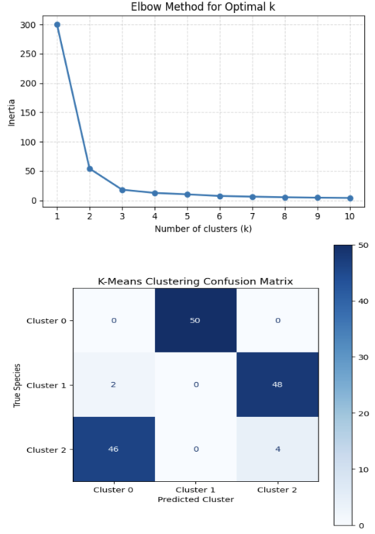
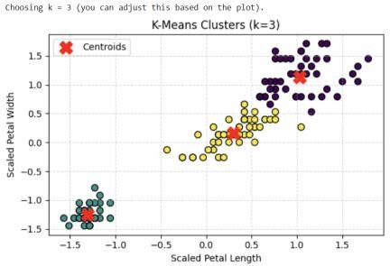
if name == " main ": main()

Program 11
- Build k-Means algorithm to cluster a set of data stored in a .CSV file. Screenshots:
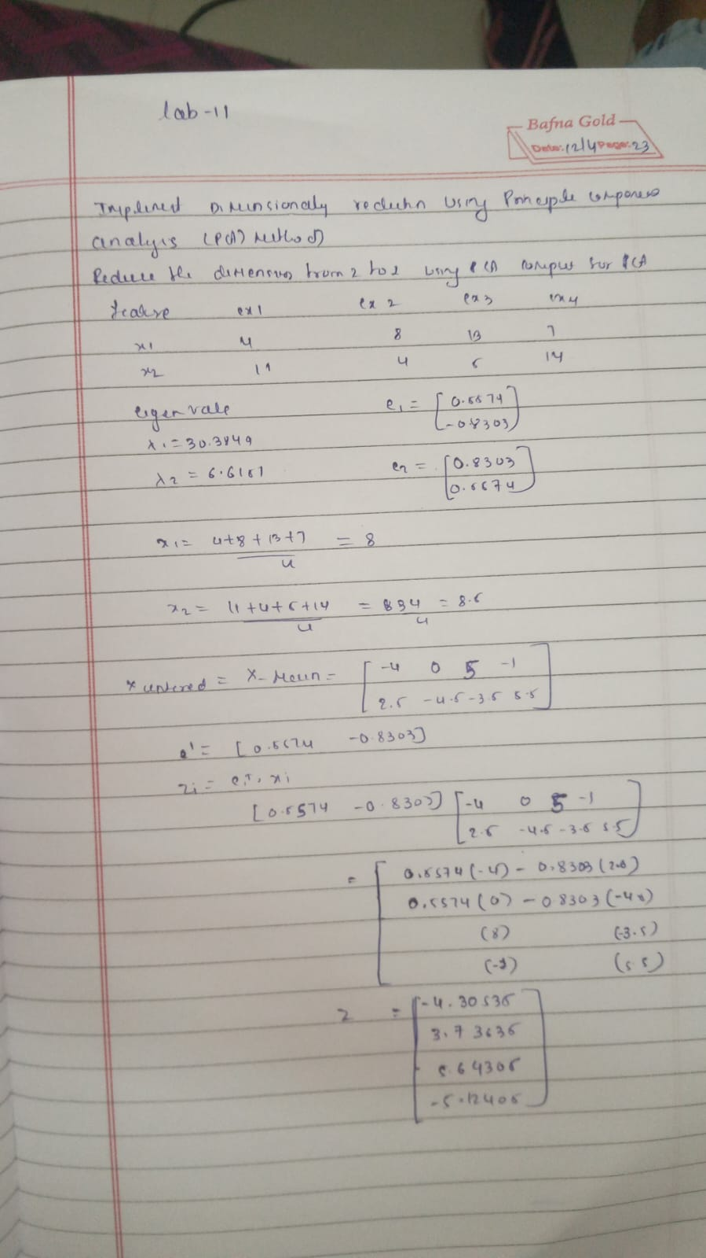
Code: import pandas as pd

df = pd.read_csv("heart.csv")
# Step 3: Split Features and Target
X = df.drop("target", axis=1) y = df["target"]
# Step 4: Preprocessing
from sklearn.model_selection import train_test_split
from sklearn.preprocessing import StandardScaler, OneHotEncoder from sklearn.compose import ColumnTransformer
from sklearn.pipeline import Pipeline
categorical_features = ["cp", "thal", "slope"]
numerical_features = [col for col in X.columns if col not in categorical_features]

preprocessor = ColumnTransformer(transformers=[ ("num", StandardScaler(), numerical_features), ("cat", OneHotEncoder(), categorical_features)
])

# Step 5: Train/Test Split
X_train, X_test, y_train, y_test = train_test_split(X, y, test_size=0.2, random_state=42)

# Step 6: Models
from sklearn.linear_model import LogisticRegression from sklearn.svm import SVC
from sklearn.ensemble import RandomForestClassifier from sklearn.metrics import accuracy_score
models = {
"Logistic Regression": LogisticRegression(max_iter=1000), "SVM": SVC(),
"Random Forest": RandomForestClassifier()
}
# Step 7: Train and Evaluate Models (Before PCA)
print("Accuracy Before PCA:") results = {}
for name, model in models.items(): pipeline = Pipeline(steps=[
("preprocessor", preprocessor), ("classifier", model)
])
pipeline.fit(X_train, y_train) y_pred = pipeline.predict(X_test)
acc = accuracy_score(y_test, y_pred) results[name] = acc
print(f"{name}: {acc:.4f}")

from sklearn.decomposition import PCA

print("\nAccuracy After PCA (n_components=5):") pca_results = {}
for name, model in models.items(): pipeline_pca = Pipeline(steps=[
("preprocessor", preprocessor), ("pca", PCA(n_components=5)), ("classifier", model)
])
pipeline_pca.fit(X_train, y_train) y_pred_pca = pipeline_pca.predict(X_test)
acc_pca = accuracy_score(y_test, y_pred_pca) pca_results[name] = acc_pca
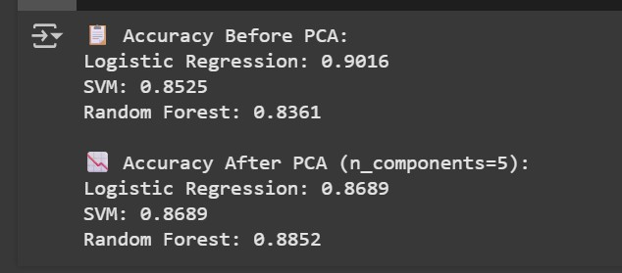
print(f"{name}: {acc_pca:.4f}")

