Resume

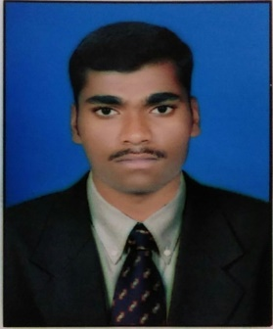

More Shivanand Gangadhar.

7028533310

[moreshivanand11@gmail.com](mailto:moreshivanand11@gmail.com)

* Career Objective:-

Self-Motivated and hardworking fresher seeking an opportunity.

To work in a challenging environment to prove my skills and utilize my knowledge and intelligence int the growth of the organization.

* Key Skills:-

Language :- C,C++,Core Java, HTML,CSS,Mobile Application Development.

Platform :- Android

Database :- Oracle 10 g , MS-Access

Operating System :- Windows 7,8,10

* Strengths:-
* Ability to grasp the new skills quickly.
* Excellent communication skills.
* Positive Mindset.
* Smart-Working & hardworking.
* Academic Qualification :-
* MCA Pursuing in JSPM NTC affiliated by Savitribai Phule Pune University.
* BCA (Bachelor Of Computer Application)From Rajendra Mahavidhyalay Khandala with 62.53% in 2017.
* HSC From Rajendra Jr. College Khandala with 59.38% in 2014.
* SSC From Rajendra Vidyalaya Khandala with 64.60% in 2012.
* Academic Projects Undertaken:-

Project Name:- Maharashtra Tourism

Environment:- Windows xp,7

Database:- MS Access

Role:-Developer

**“Maharashtra Tourism”**is formed to promote, preserve and stimulate the unique Information Website. India have many states which attracts so many Cultures. Like Maharashtrian , Gujarati , Kerala , Karnataka etc. as well as north Indian & South Indian , East & West Indian States but the Maharashtra Is a very Long Historical State**.**

In the state Maharashtra so many tourism Places are There & shown in the websites like forts, Hill Stations ,Caves, beaches ,Shrines.

This website Trying to shown all the look Of Maharashtra Tourism. This website help to know the Maharashtra Tourism Places to other states as well as other countries.

* PERSONAL VITAE:-
* Name **:-** Shivanand Ganagadhar More.
* DOB **:-**  28 Nov 1996.
* Hobbies **:-**  Programming , Watching technical videos on YouTube.
* Languages known **:-**  Can Speak, Read, Write English, Marathi & Hindi.
* DECLARATION:-

I hereby declare that above information about me is true and correct to the best of my knowledge**.**

Date:- Place:- Signature