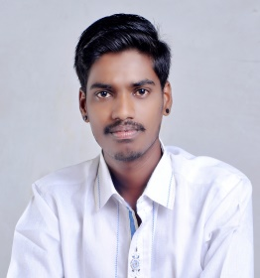**RESUME**

**GANESH BABAN GAIKWAD**

**Email id**: ganeshgaikwad865@gmail.com **mobile no**: 9604075766

**CAREER OBJECTIVE**

Seeking a position to utilize my skills and abilities in information technology fields that offers educational growth while being resourceful, innovative and flexible.

|  |  |
| --- | --- |
|  |  |

**ACADEMIC CREDENTIALS**

|  |  |  |  |  |  |  |  |  |  |
| --- | --- | --- | --- | --- | --- | --- | --- | --- | --- |
| |  | | --- | | **Qualification** | | |  | | --- | | **University / Board** | | |  | | --- | | **Institutes** | | |  | | --- | | **Year** | | |  | | --- | | **Percentage** | |
| MCA | Pune University | JSPM NTC | 2020 | pursuing |
| BCA | Pune University | Garware College | 2017 | 55.60% |
| HSC | Maharashtra Board | Garware College | 2014 | 53.80% |
| SSC | Maharashtra Board | M.E.S Boys High | 2012 | 63.80% |

**TECHNICAL SKILLS**

* **Language :** C, C++,Core Java, Android.
* **Databases :** MySQL , SQLite.
* **Operating System:** Windows 8,10.
* **Tools :**  dev cpp ,eclipse ,Android.

**INTERPERSONAL SKILLS**

* Curious about Computer Programming
* Quick Learner

**HOBBIES / INTEREST**

* Swimming
* Listening songs

**PERSONAL DETAILS**

* **Father's Name :** Baban Sambhaji Gaikwad.
* **Permanent Address :** Sai nagar ,khori Sr no. 6/27,Hingane Khurd sinhagad road, pune 51.
* **Date of Birth :** 15 Dec, 1995
* **Language Known :** Marathi, Hindi, English.
* **Marital Status :** Unmarried
* **Nationality / Religion :** Indian.
* **Contact :** +91 - 9604075766.

**DECLARATION**

I hereby declare that all the above information is true to best of my knowledge.

**Date:- Ganesh Baban Gaikwad**

**(Yours Faithfully)**